Mostly textbook; wording changed

Chapter 3: Counting

This chapter deals with questions of that pose the question how many solutions are there to some question, x.

3.1 The Product Rule. (The mn rule from Statistics)

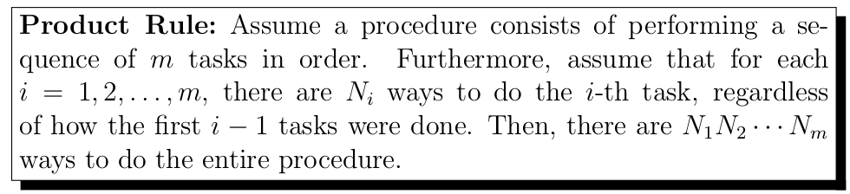

3.1.1 Counting Bitstrings of length n

To apply the product rule, we specify the procedure and the tasks needed.
- The procedure is “write down a bitstring of length n”
- for the i-th task is “write down one bit”

As tasks are independent of one another and choosing the i-th bit is done the same way regardless of how you picked the i-1 bits, we can apply the product rule with for and we can see that there are to do the entire procedure. The 2 represents the boolean nature of bits and n is the variable length of the string representing how many times you have to choose one of the two options.

Theorem 3.1.1 For any integer , the number of bitstrings of length n is equal to

3.1.2 Counting Functions

With two sets, A and B of sizes and , respectively. How many functions are there?

Write down the set A as . Any function is completely specified by the values , where each such value can be any element of B.

We again must specify the “procedure” and the “tasks”:
- The procedure is “specify the values “
- for the i-th task is “specify the value ”

*procedural specification of values is not explicit but implicit. (n, n-1, n-2,....etc)

Since no specification has been made on the mapping of the elements. For each i, can be any of the n elements of B. As a result, there are ways to do the task, regardless of how we did the fist i-1 tasks. By the product Rule, there are ways to do the entire procedure, and hence this many functions .

Theorem 3.1.2 Let and be integers, let A be a set of size m, and let B be a set of size n. The number of functions is equal to

Counting one-to-one functions from set A of size m to B of size n

Note, when m > n there are no one-to-one functions from a set with m elements to a set with n elements.

With , There are n ways to choose the value of the function at . because the function is one-to-one, the value of the function at can be picked in n-1 ways (as the value at a_1 may not be used again). In general, the value of the function at a_k can be chosen in n-k+1 ways. By the product rule, there are one-to-one functions from a set with elements to one with elements.

For example, there are 5*4*3=60 one-to-one functions from a set with three elements to a set with five elements.

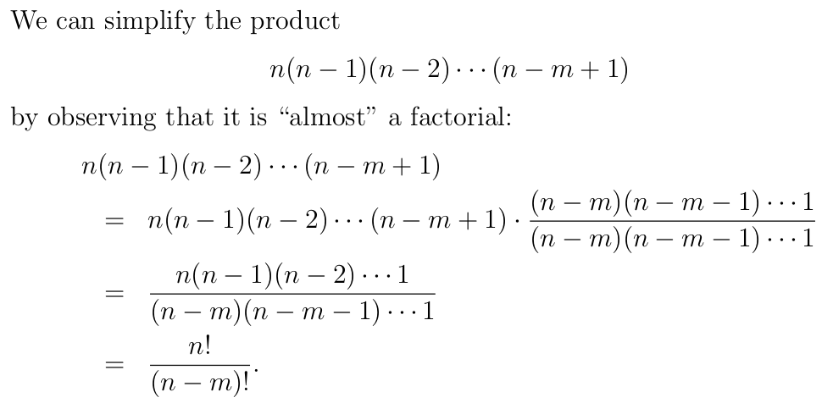

With the multiplication of what equates to 1 we create a true factorial of over the factorial equivalent to the denominator of our multiplication.

Theorem 3.1.3 Let and be integers, let A be a set of size m, and let B be a set of size n.

- If m>n, then there is no one-to-one function
- If m \le n, then the number of one-to-one functions is equal to

3.1.3 Placing Books on Shelves

Let and be integers, and consider books and book shelves Placing the books means that

- choosing a shelf
- choosing position on that shelf with regards to other books (or empty self)

Bookshelves need not be occupied. We assume that each shelf could support all books.

Again the product rule is used in a similar way.
- The procedure is “place the m books on the n shelves”
- for , the -th task is “place book on the shelves”. When placing book we can place it on the far left or far right of any shelf or between any two of the books that have already been placed

When placing the first book, there are only empty shelves, therefore there are ways to do the first task.

In the second task, we have to place book . Since has already been placed, we have the following possibilities for placing :
- We place on the far left of any of the n shelves
- We place immediately to the right of

With this additional option it follows that ways to do the second task, regardless of how the first task was done.

Generally, in the -th task, we have to place book . Since have already been placed, we have the following possibilities for placing :
- We place on the far left of any of the n shelves.
- We pace immediately to the right of one of
As a result there are ways to do the -th task. Note that this is true regardless of how we did the fist -1 tasks.

In opposition to the last example, the options are growing with each placement instead of reducing the number of one-to-one functions available. So by the product rule there are ways to do the entire procedure, noticing this resembles a factorial we simplify much like above.

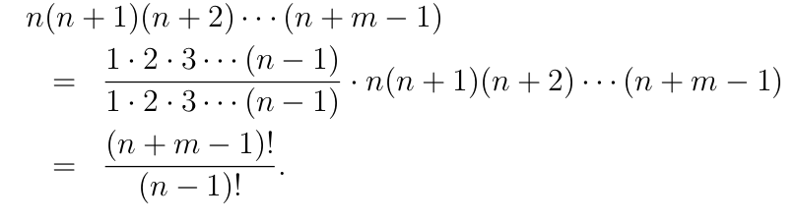

Theorem 3.1.4 Let and be integers. The number of ways to place m books on n book shelves is equal to

3.2 the Bijection Rule

counting Subsets

let be an integer and let S be a set with n elements. How many subsets does S have? If n=0, then and there is only one subset of S, namely S itself, Assume from now on that . As we will see below, asking for the number of subsets of S is exactly the same as asking the number of bit stings of length n
Let A and B be finite sets. (which must contain the same number of elements, by definition of bijeciton)

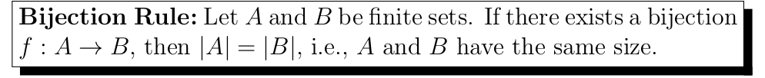

from theorem 3.1.1, the set B has size Therefore, if we can show that there exists a bijection , then, according to the Bijections Rule, we have and, thus, the number of subsets of S is equal to .

each subset of S Corresponds to a unique bitstring on length n, representing membership in the subset, and each bitstring of length n corresponds to a unique subset of S. Therefore, this function f is a bijection between A and B.

thus, we have shown that there exists an bijection . This, together with theorem 3.1.1 and the bijection rule, implies the following result:

theorem 3.2.1 For any , the number of subsets of a set of size n is equal to

3.3 The Complement rule

Consider strings of 8 characters, each character being a lower-case letter or digit. Such a string is called a valid password if it contains at least one digit. How many valid passwords are there? The most efficient way to solve this problem is to begin by counting the strings that do not contain any digit.

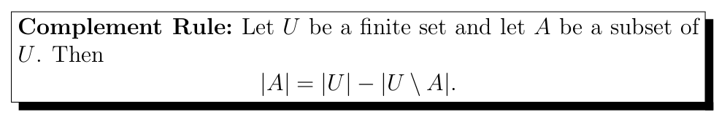

In this case, is the set of all strings consisting of 8 characters, each character being a lower-case letter or a digit, and let be the set of all valid passwords, i.e., all strings in that contain at least one digit. Note that U\A is the set of all stings of 8 characters, each character being a lower-case letter or a digit, that do not contain any digit.

By the product Rule, the set U has size 36^8, because each string in U has 8 characters, and there are 26+10=36 choices for each of the 8 characters. Then, by the compliment Rule, the number of valid passwords is equal to

3.4 The Sum Rule
Super straight forward.
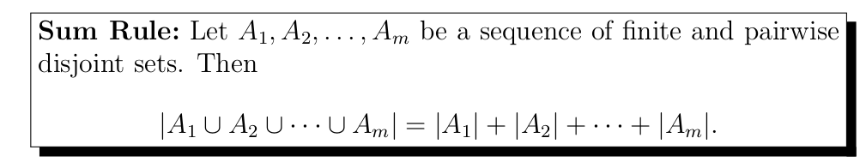

3.5 The principle of Inclusion and Exclusion

The principle of inclusion and exclusion applies to two finite sets A and B that are not necessarily disjoint. How can we determine the size of the union ?

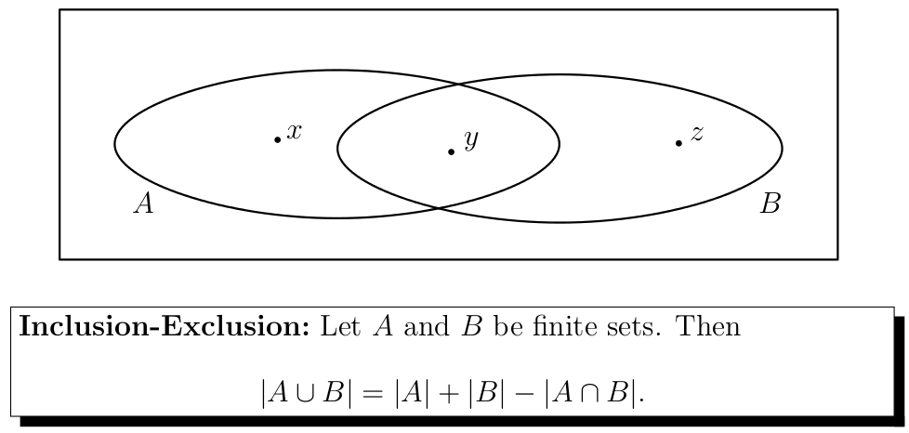

The subtraction eliminates the elements that are counted twice. (in the case of two sets)

This is exemplified by counting bitstrings with positions occupied by specified values. Like 010 at the end or 111 at the start.

The principle of inclusion and exclusion is easily applicable to larger number of sets. In the case of three sets:

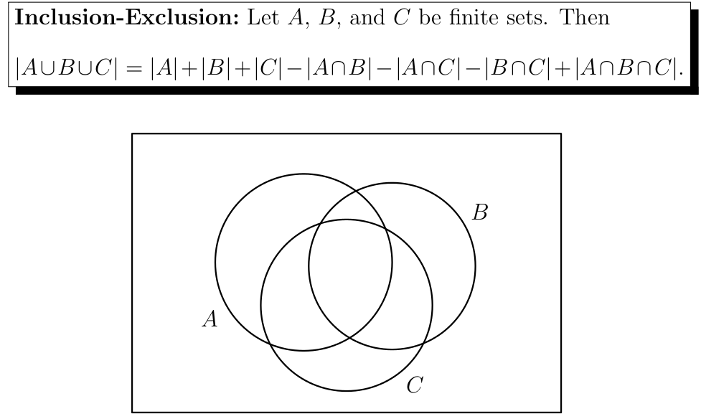
Same reason for subtractions, must be more involved with three sets

3.6 Permutations and Binomial Coefficients

A Permutation of a finite set S is an ordered sequence of the elements of S, in which each element occurs exactly once.

Theorem 3.6.1 Let be an integer and let S be a set with n elements there are exactly n! Permutations of S.

The proof is more or less the straight product rule.

Definition 3.6.2 Let n and k be integers. We define the binomial coefficient to be the number of k-element subsets of an n-element set.

Counting this number can be done in many different ways, we will show two.

By the product rule:

The second way as follows
- Write down all subsets of S having size k
- For each of these subsets, write down a list of all k! Permutations of this subset.

If we put all these lists together, then we obtain a big (ordered sequence of k pairwise distinct list in which each element appears only once. In other words since the big list has size , it follows that

Theorem 3.6.3 Let n and k be integers with . Then

3.6.2 Newton's Binomial Theorem

NBT allows us to determing the coefficent of any expansion in the form of in terms of x and y.

3.6.5 Newton's binomial theorem For any integer , we have

Proof. The expressino is a product of n terms By expanding this term we get a term for each . The term sought is found by

- choosing of the terms
- taking in each of the k chosen terms (don't overthink this)
- taking in each of the other terms

Since there are ways to do this, the coefficent of is equal to

An answer to the question what is the coeffiecient of in is simply

An answer to the question what is the coeffiecient of in

=

*that is the entire answer, Do not overthink

Theorem 3.6.6 for any integer , we have

3.7 Combinatorial Proofs

in a combinatorial proof, we show the validity of an identity, by interpretting it as a counting problem.

Theorem 3.7.1 For Integers n and k with , we have

=

3.7.1 proof The claim is proved using theorem 3.6.3
to obtain a combinatorial proof, let S be a set with n elements.

recall: is the number of ways to choose elements from the set , which is the same as the number of ways not to choose elements from the set //
c

proof can also be shown using theorem 3.6.4

The number of bitstrings of length with exatcly many 1s is equal to

The number of bitstrings of length with exatcly many 0s is equal to

Since these two quantities are equal, this leads us to Pascal's Identity

Theorem 3.7.2 (Pascal's Identity) For integers n and k with , we have

As above, proof is found with 3.6.3. A combinatorial proof is found by letting S be a set with n+1 elements. Counting is done in two different ways.

First, by definition, the number of k-element subsets of S is equal to

In the second way, we choose an element x in S and consider the set . Any k-element subset of S is of one of the following two types:

- The k-element subset of does not contain
  - any such subset is a k-elemtn subset of . Since has size , there are many k-element subsets of that do not contain
- The k-element subset of contains

Let and be integers

