**Abstract:**

Drowsiness detection systems in vehicles have become increasingly important to ensure road safety and prevent accidents caused by driver fatigue. Traditional methods rely on physiological signals like eye movements and head position, but they may not always be reliable. This paper proposes a novel approach using facial expressions and neural networks for drowsiness detection in vehicles. By analyzing facial features and expressions captured through onboard cameras, combined with sophisticated neural network algorithms, the proposed system aims to accurately identify signs of drowsiness in real-time. The integration of facial recognition technology with neural networks offers a promising solution for early detection of driver fatigue, thereby enhancing road safety and reducing the risk of accidents.

**Introduction:**

Driving while drowsy is a significant safety concern, contributing to a large number of accidents and fatalities on the roads worldwide. Despite awareness campaigns and regulations, many drivers continue to underestimate the dangers of driving while fatigued. Traditional methods of drowsiness detection in vehicles primarily rely on physiological signals such as eye movements and head position. However, these methods may not always be effective, especially if the driver tries to stay awake by engaging in distracting activities.

To address this challenge, there is a growing interest in developing advanced drowsiness detection systems that leverage emerging technologies such as facial recognition and neural networks. Facial expressions can provide valuable insights into a driver's mental state and level of alertness. By analyzing facial features such as eye closure, yawning, and changes in facial expressions, it is possible to detect signs of drowsiness in real-time.

This paper proposes a drowsiness detection system for vehicles that utilizes facial expressions and neural networks. The system works by capturing images of the driver's face using onboard cameras and processing them through a neural network model trained to recognize drowsiness-related patterns. By continuously monitoring the driver's facial expressions, the system can accurately identify signs of drowsiness and issue timely alerts to prevent accidents.

The remainder of this paper is organized as follows: Section 2 provides an overview of related work in the field of drowsiness detection systems. Section 3 describes the proposed methodology, including data collection, preprocessing, feature extraction, and neural network architecture. Section 4 presents experimental results and performance evaluation metrics. Finally, Section 5 concludes the paper with a discussion of future research directions and potential applications of the proposed drowsiness detection system.

NOVELTIES:-

For the project on drowsiness detection system in vehicles using facial expressions and neural networks, here are some potential novelties and areas of exploration:

1. **Multi-modal Data Fusion:** Incorporating multiple data sources such as facial expressions, eye movements, head position, and physiological signals (e.g., heart rate variability) to enhance the accuracy and robustness of drowsiness detection.
2. **Dynamic Threshold Adjustment:** Developing adaptive algorithms that dynamically adjust the threshold for drowsiness detection based on individual driver characteristics, environmental conditions, and driving context to minimize false alarms and improve detection accuracy.
3. **Real-time Feedback and Intervention:** Integrating the drowsiness detection system with vehicle control mechanisms to provide real-time feedback to the driver, such as audible alerts, seat vibrations, or automated steering correction, to prevent accidents and promote safe driving behavior.
4. **Personalization and User Profiles:** Implementing machine learning techniques to create personalized user profiles for each driver, allowing the system to adapt its detection algorithms and sensitivity levels based on individual patterns of behavior, sleep quality, and fatigue tolerance.
5. **Behavioral Pattern Analysis:** Employing advanced pattern recognition algorithms to analyze long-term behavioral data and identify subtle changes in driving behavior and facial expressions that may indicate early signs of drowsiness or fatigue.
6. **Driver State Monitoring:** Extending the scope of the drowsiness detection system to monitor other aspects of the driver's cognitive and emotional state, such as stress levels, distraction, and cognitive workload, to provide comprehensive insights into driver behavior and well-being.
7. **Integration with Smart Infrastructure:** Integrating the drowsiness detection system with smart infrastructure and connected vehicle networks to enable data sharing, real-time monitoring, and coordinated responses across multiple vehicles and traffic management systems.
8. **Ethical and Privacy Considerations:** Addressing ethical and privacy concerns related to the collection and storage of sensitive biometric data, ensuring compliance with data protection regulations, and implementing robust security measures to safeguard against unauthorized access and misuse of personal information.

By exploring these novelties and areas of research, the drowsiness detection system can be further enhanced to provide more accurate, reliable, and user-friendly solutions for improving road safety and preventing accidents caused by driver fatigue.

APPLICATION AREAS

The drowsiness detection system in vehicles using facial expressions and neural networks has various application areas, including:

1. **Automotive Industry:** Integration of the system into vehicles to enhance driver safety by alerting drivers when they show signs of drowsiness, reducing the risk of accidents caused by driver fatigue.
2. **Fleet Management:** Implementation of the system in commercial fleets to monitor driver alertness and reduce the likelihood of fatigue-related accidents, improving the overall safety and efficiency of fleet operations.
3. **Public Transportation:** Deployment of the system in buses, trains, and other public transportation vehicles to ensure the safety of passengers and minimize the risk of accidents caused by fatigued drivers.
4. **Long-Haul Trucking:** Adoption of the system in long-haul trucks to mitigate the risk of fatigue-related accidents among truck drivers, who often face long hours of continuous driving.
5. **Emergency Response Vehicles:** Integration of the system into emergency response vehicles, such as ambulances and fire trucks, to ensure that drivers remain alert and responsive during critical situations.
6. **Personal Vehicles:** Installation of the system in personal vehicles to provide drivers with real-time alerts and reminders to take breaks or rest when showing signs of drowsiness, thereby preventing accidents and improving road safety.
7. **Research and Development:** Use of the system in research studies and experimental settings to gather data on driver behavior, fatigue patterns, and the effectiveness of interventions, contributing to advancements in the field of driver safety and human-computer interaction.
8. **Insurance Industry:** Collaboration with insurance companies to offer incentives for drivers who use the drowsiness detection system, leading to reduced insurance premiums for safer driving practices.
9. **Healthcare Sector:** Integration of the system with healthcare platforms to monitor the sleep patterns and driving behavior of individuals with sleep disorders or medical conditions that affect alertness, facilitating early intervention and treatment.
10. **Smart Cities:** Deployment of the system as part of smart city initiatives to enhance road safety, reduce traffic accidents, and improve the overall quality of life for urban residents through the implementation of innovative technologies and infrastructure solutions.

BLOCK DIAGRAMS:-

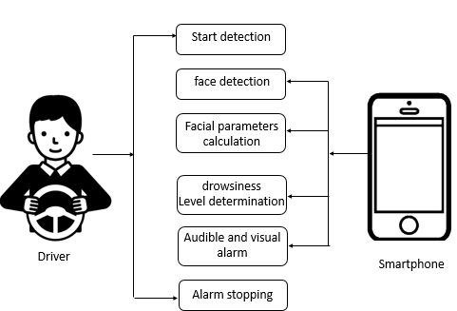

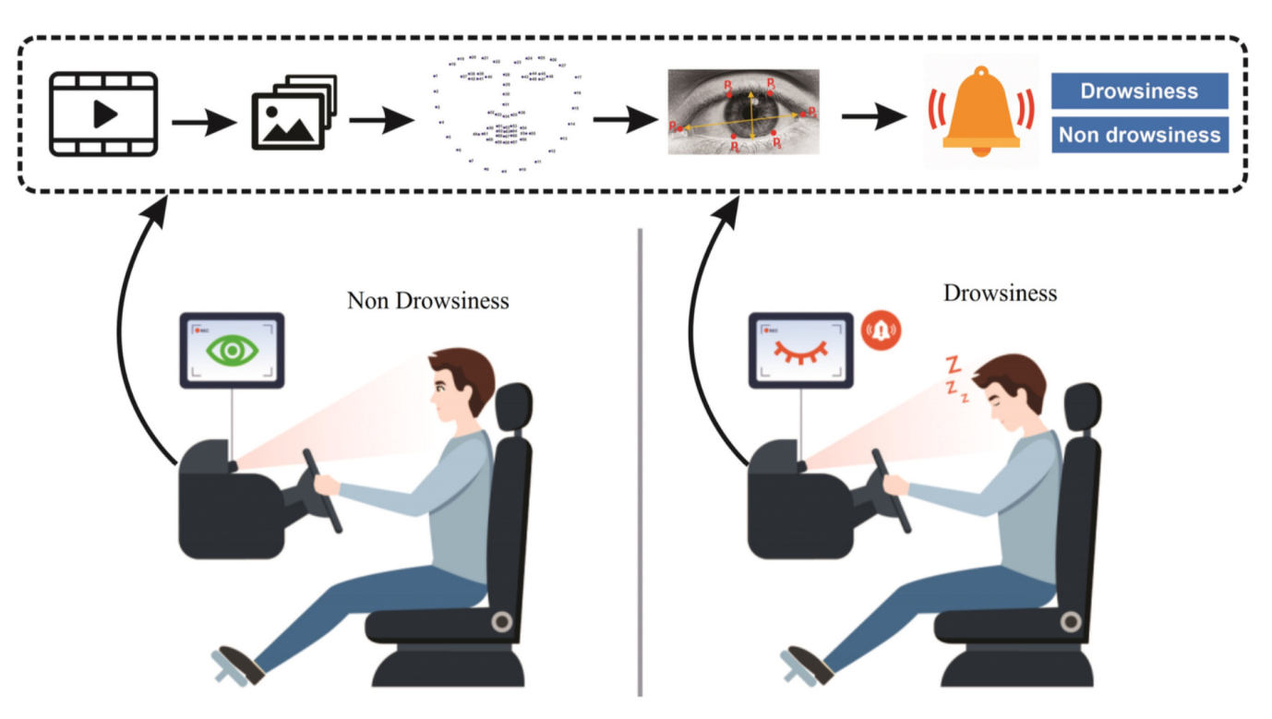

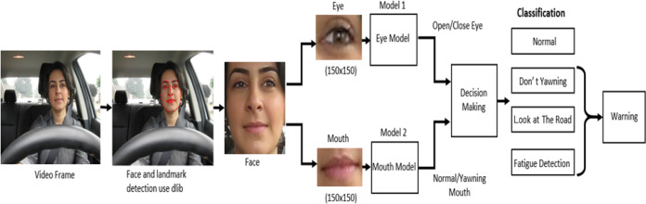

LITERATURE PAPER REVIEWS

PAPER 1:-

TITLE

Drowsy Driver Detection System Using Eye Blink Patterns

AUTHORS:-

Taner Danisman, Ian Marius Bilasco, Chabane Djeraba, Nacim Ihaddadene

2010

METHODOLOGY:-

The methodology used in the content of danisman2010.pdf is a real-time approach that detects visual changes in eye locations using the horizontal symmetry feature of the eyes which does not require any initialization procedure. The proposed system is composed of a video camera and software that regularly checks the eye of the driver to detect the eye blink duration. The system detects eye blinks with a 94% accuracy and a 1% false positive rate.

BENEFITS:-

The methodology used in the content of danisman2010.pdf is a real-time approach that detects visual changes in eye locations using the horizontal symmetry feature of the eyes which does not require any initialization procedure. The proposed system is composed of a video camera and software that regularly checks the eye of the driver to detect the eye blink duration. The system detects eye blinks with a 94% accuracy and a 1% false positive rate.

LIMITATIONS

The methodology used in the content of danisman2010.pdf is a real-time approach that detects visual changes in eye locations using the horizontal symmetry feature of the eyes which does not require any initialization procedure. The proposed system is composed of a video camera and software that regularly checks the eye of the driver to detect the eye blink duration. The system detects eye blinks with a 94% accuracy and a 1% false positive rate.

PAPER-2

A Drowsy Driver Detection System Based on a New Method of Head Posture Estimation

AUTHORS:-

Ines Teyeb, Olfa Jemai, Mourad Zaied, and Chokri Ben Amar

2014

METHODOLOGY:-

The methodology used in the content titled "teyeb2014.pdf" involves a proposed method for head posture estimation based on the extraction of reference and non-reference images coordinates from the face bounding box. The method involves computing the angle of head inclination and distances between the extracted coordinates to estimate the head state. The proposed approach exhibits high performances, which involves the robustness of the new method. The paper explains the proposed algorithm of head posture estimation, the possible states of head inclination, and the experimental results showing the robustness of the system. The paper concludes with a discussion on possible enhancements.

BENIFITS

The content titled "teyeb2014.pdf" discusses a proposed drowsy driver detection system based on a new method of head posture estimation. The system aims to monitor a driver's level of vigilance and detect drowsiness, which is a major cause of road accidents. The proposed method involves the extraction of reference and non-reference images coordinates from the face bounding box to estimate the head state. The paper explains the proposed algorithm of head posture estimation, the possible states of head inclination, and the experimental results showing the robustness of the system. The paper concludes with a discussion on possible enhancements. Overall, the benefits of this system include improved road safety and reduced risk of accidents caused by drowsy driving.

LIMITATIONS

The content titled "teyeb2014.pdf" discusses a proposed drowsy driver detection system based on a new method of head posture estimation. The system aims to monitor a driver's level of vigilance and detect drowsiness, which is a major cause of road accidents. The proposed method involves the extraction of reference and non-reference images coordinates from the face bounding box to estimate the head state. The paper explains the proposed algorithm of head posture estimation, the possible states of head inclination, and the experimental results showing the robustness of the system. The paper concludes with a discussion on possible enhancements. Overall, the benefits of this system include improved road safety and reduced risk of accidents caused by drowsy driving.

PAPER 3

IOT based Real-time Drowsy Driving Detection System for the Prevention of Road Accidents

ICIIBMS 2018, Track 1: Image Processing, Computer Science and Information technology, Bangkok, Thailand

AUTHORS:-

Md. Yousuf Hossain, Fabian Parsia George

2018

METHODOLOGY:-

The methodology used in the content from hossain2018.pdf involves various studies that were conducted to design systems that can detect driver fatigue and alert the driver beforehand to prevent accidents. The content discusses different approaches used in designing such systems, including vehicle-based measures and psychological measures. The proposed method in the content is based on behavioral measurements, specifically the eye closure ratio, which serves as a non-intrusive technique for detecting driver drowsiness. The content also highlights the advantages and disadvantages of different approaches used in designing such systems.

BENEFITS:-

The methodology used in the content from hossain2018.pdf involves various studies that were conducted to design systems that can detect driver fatigue and alert the driver beforehand to prevent accidents. The content discusses different approaches used in designing such systems, including vehicle-based measures and psychological measures. The proposed method in the content is based on behavioral measurements, specifically the eye closure ratio, which serves as a non-intrusive technique for detecting driver drowsiness. The content also highlights the advantages and disadvantages of different approaches used in designing such systems.\

LIMITAIONS:-

The content from hossain2018.pdf discusses the limitations of the proposed system for detecting driver drowsiness. One of the main limitations is that the system is incapable of serving its purpose at night. This is because the system relies on the eye closure ratio (EAR) to detect drowsiness, and it may not be accurate in low light conditions. Another limitation is that the system may not be able to precisely predict the driver's level of drowsiness in real-time situations. Additionally, the system requires a Raspberry Pi and a Pi camera for tracing the eye movements, which may not be readily available to all users. The content also proposes future work to improve the system and overcome these limitations.

PAPER-4

Real-Time Driver-Drowsiness Detection System Using Facial Features

WANGHUA DENG1 RUOXUE WU12-2019

METHODOLOGY:-

The methodology used in the content 10.1109@ACCESS.2019.2936663.pdf involves the development of a system called DriCare, which is designed to detect driver drowsiness using a commercial camera automobile device, a cloud server, and a commercial cellphone. The system analyzes the driver's face tracking, facial key-state, and head position to evaluate the degree of drowsiness. The content also categorizes related work into three parts: visual object tracking algorithm, facial landmarks recognition algorithm, and methods of driver-drowsiness detection. The paper presents the principle of human face tracking based on the MC-KCF algorithm and the evaluation method for the driver's degree of drowsiness. The effectiveness of the DriCare system is compared with other methods, and the results show that DriCare has better accuracy than other methods.

BENEFITS:-

The methodology used in the content 10.1109@ACCESS.2019.2936663.pdf involves the development of a system called DriCare, which is designed to detect driver drowsiness using a commercial camera automobile device, a cloud server, and a commercial cellphone. The system analyzes the driver's face tracking, facial key-state, and head position to evaluate the degree of drowsiness. The content also categorizes related work into three parts: visual object tracking algorithm, facial landmarks recognition algorithm, and methods of driver-drowsiness detection. The paper presents the principle of human face tracking based on the MC-KCF algorithm and the evaluation method for the driver's degree of drowsiness. The effectiveness of the DriCare system is compared with other methods, and the results show that DriCare has better accuracy than other methods.

LIMITATIONS:-

The methodology used in the content 10.1109@ACCESS.2019.2936663.pdf involves the development of a system called DriCare, which is designed to detect driver drowsiness using a commercial camera automobile device, a cloud server, and a commercial cellphone. The system analyzes the driver's face tracking, facial key-state, and head position to evaluate the degree of drowsiness. The content also categorizes related work into three parts: visual object tracking algorithm, facial landmarks recognition algorithm, and methods of driver-drowsiness detection. The paper presents the principle of human face tracking based on the MC-KCF algorithm and the evaluation method for the driver's degree of drowsiness. The effectiveness of the DriCare system is compared with other methods, and the results show that DriCare has better accuracy than other methods.

PAPER-5

Driver Drowsiness Detection System Based on Visual Features

AUTHOR:-

Fouzia, Roopalakshmi R, Jayantkumar A Rathod, Ashwitha S Shetty, Supriya k Alva’s Institute of Engineering And Technology, Shobhavana Campus, Mijar, Moodbidri-2018

METHODOLOGY:-

The content with the source "06bdf84310176feb6b42749e410d324b.pdf" provides an overview of open research challenges related to detecting driver drowsiness. The content discusses various methods proposed by researchers to detect drowsiness in drivers, such as using physiological signals, brain-computer interfaces, and image processing techniques. The content also highlights the limitations of existing methods and suggests areas for further research. Overall, the content provides a systematic overview of the challenges and opportunities in the field of driver drowsiness detection

ADVANTAGES:-

The content with the source "06bdf84310176feb6b42749e410d324b.pdf" provides an overview of open research challenges related to detecting driver drowsiness. The content discusses various methods proposed by researchers to detect drowsiness in drivers, such as using physiological signals, brain-computer interfaces, and image processing techniques. The content also highlights the limitations of existing methods and suggests areas for further research. Overall, the content provides a systematic overview of the challenges and opportunities in the field of driver drowsiness detection

LIMITATIONS:-

The content with the source "06bdf84310176feb6b42749e410d324b.pdf" discusses the limitations of existing methods for detecting driver drowsiness. The accuracy of some of the existing systems is slightly less compared to others, and defects in the EEG monitor can decrease the detection of drowsiness. Additionally, the method based on EOG (electrooculography) is slightly less accurate than some of the other systems. The content also suggests areas for further research to improve the accuracy of driver drowsiness detection systems. Overall, the content provides a comprehensive overview of the limitations and challenges in the field of driver drowsiness detection.

PAPER-6

Intelligent Video-Based Drowsy Driver Detection System under Various Illuminations and Embedded Software Implementation’

2015 International Conference on Consumer Electronics-Taiwan (ICCE-TW)

AUTHORS:-

Wei-Liang Ou, Ming-Ho Shih, Chien-Wei Chang, Xue-Han Yu, and Chih-Peng Fan Department of Electrical Engineering, National Chung Hsing University, Taiwan, R.O.C.

METHODOLOGY:-

The system is split into two cascaded computational procedures: (1) the driver eyes detection and (2) the drowsy driver detection. The driver eyes detection includes five functions, which comprise the pre-processing, face detection, face boundary detection, eye-glasses bridge detection, and eyes detection. The drowsy driver detection includes five functions, which include the edge filtering in ROI, binarization, iris location, open/closed eyes detection, and drowsy detection. The proposed system uses NIR-based facial image processing to detect the driver's drowsy condition without/with glasses effectively. The system has been tested, and the average processing frame rates are up to 45 fps in a PC at a 3.4GHz operational frequency, and the detection rate will be up to 91%.

ADVANTAGES

The system is split into two cascaded computational procedures: (1) the driver eyes detection and (2) the drowsy driver detection. The driver eyes detection includes five functions, which comprise the pre-processing, face detection, face boundary detection, eye-glasses bridge detection, and eyes detection. The drowsy driver detection includes five functions, which include the edge filtering in ROI, binarization, iris location, open/closed eyes detection, and drowsy detection. The proposed system uses NIR-based facial image processing to detect the driver's drowsy condition without/with glasses effectively. The system has been tested, and the average processing frame rates are up to 45 fps in a PC at a 3.4GHz operational frequency, and the detection rate will be up to 91%.

LIMITATIONS:-

The content titled "ou2015.pdf" discusses the limitations of a proposed system for detecting driver drowsiness. One limitation is that the system relies on facial image processing, which may not be effective if the driver's face is obscured or not visible. Additionally, the system may not be able to detect drowsiness caused by factors other than closed eyes, such as microsleeps or inattention. Finally, the system's accuracy may be affected by external factors such as lighting conditions or the driver's physical characteristics. Despite these limitations, the proposed system provides an effective and reliable solution for detecting driver drowsiness, which can help prevent accidents caused by fatigue driving.

PAPER 7:-

Driver Safety Development: Real‑Time Driver Drowsiness Detection System Based on Convolutional Neural Network

AUTHORS:-

Maryam Hashemi1  · Alireza Mirrashid1  · Aliasghar Beheshti Shirazi-2020

METHODOLOGY

The content titled "10.1007@s42979-020-00306-9.pdf" discusses a methodology for driver drowsiness detection using behavioral measures and machine learning techniques. The methodology involves several steps, including region of interest selection, eye region preparation, and data collection. The authors also discuss the different physiological signals that can be used to infer drowsiness, such as ElectroEncephaloGram (EEG), ElectroOculoGram (EOG), and activities of the autonomous nervous system from ElectroCardioGram (ECG), among others. The paper also compares different approaches to drowsiness detection, such as vehicle-based and signal-based methods, and discusses the advantages and disadvantages of each. Finally, the authors propose a new system for drowsiness detection that captures a stream of frames, selects the eye region, and applies landmark points to access the region of interest

BENEFITS:-

The content titled "10.1007@s42979-020-00306-9.pdf" discusses the benefits of using facial feature-based methods for driver drowsiness detection. These methods can evaluate the driver's eye state in real-time without invasive instruments, and they are inexpensive and more accessible than other methods. The paper also discusses the advantages of using artificial neural networks for drowsiness detection, such as their ability to handle complex data and their high accuracy. Additionally, the authors propose a new system for drowsiness detection that can prevent accidents arising from drowsiness, which is a significant benefit for road safety

LIMITATIONS:-

The content titled "10.1007@s42979-020-00306-9.pdf" discusses the limitations of the proposed approach for driver drowsiness detection. One limitation is that there is a trade-off between the size of the dataset and accuracy. Deeper networks with more hidden layers and parameters show better performance and need a bigger dataset. Therefore, there is a compromise between the number of available data and the number of parameters. Additionally, there is a great variety of visual parameters that should be considered during data collection, such as lighting conditions, the ethnicity of the driver, angle, and location of the camera, humidity, the eye color, and glasses. Considering all of these variables is not possible, and the authors selected the most significant parameters. Nevertheless, eliminating other parameters can affect the result in the real situation.