**CONTENTS**

|  |  |  |
| --- | --- | --- |
| SL.NO | Content | Page Number |
| 1. | Certificate | 2 |
| 2. | Acknowledgement | 3 |
| 3. | Introduction | 4 |
| 4. | Program Layout | 6 |
| 5. | Header files and functions | 7 |
| 6. | Source Code | 9 |
| 7. | Screenshots | 50 |
| 8. | Bibliography | 56 |

CERTIFICATE

This is to certify that this project report “Library Management” is the bona fide work of Subhayan Roy of XII L of Indian School Bahrain, who carried out the investigatory project work as per the requirement of CBSE practical work during the year 2015-16 under my supervision.

**Signature of Teacher Signature of Examiner**

ACKNOWLEDGEMENT

Apart from the efforts I have taken, the successful completion of any project depends largely on the encouragement and guidelines of many others. I take this opportunity to express my gratitude to the people who have been instrumental in the successful completion of this project.

I would like to show my greatest appreciation to my Computer Science teacher MRS.SMITHA JOHN. I feel motivated and encouraged every time under her guidance. I would also like to thank Mr Pius Mathew for helping me throughout the project. Without their encouragement and guidance this project would not have materialized. I am grateful for the constant support and help.

Last but not the least I would like to thank the Indian School Bahrain for providing all the necessary facilities.

**Introduction to C++**

**C++**  is a general-purpose programming language . It has imperative, object-oriented and generic programming features, while also providing facilities for low-level memory manipulation.

It was designed with a bias toward system programming and embedded, resource-constrained and large systems, with performance, efficiency and flexibility of use as its design highlights.[]](https://en.wikipedia.org/wiki/C%2B%2B#cite_note-Stroustrup1-3) C++ has also been found useful in many other contexts, with key strengths being software infrastructure and resource-constrained applications, including desktop applications, servers (e.g. e-commerce,web search or SQL servers), performance-critical applications (e.g. telephone switches or space probes), and entertainment software.[]](https://en.wikipedia.org/wiki/C%2B%2B#cite_note-applications-4) C++ is a compiled language, with implementations of it available on many platforms and provided by various organizations, including the FSF, LLVM, Microsoft, Intel and IBM.

**HISTORY:**

Bjarne Stroustrup, a Danish computer scientist, began his work on C++'s predecessor "C with Classes" in 1979. The motivation for creating a new language originated from Stroustrup's experience in programming for his Ph.D. thesis. Stroustrup found that Simula had features that were very helpful for large software development, but the language was too slow for practical use, while BCPL was fast but too low-level to be suitable for large software development. When Stroustrup started working in AT&T Bell Labs, he had the problem of analyzing the UNIX kernel with respect to distributed computing. Remembering his Ph.D. experience, Stroustrup set out to enhance the Clanguage with Simula-like features.[[7]](https://en.wikipedia.org/wiki/C%2B%2B#cite_note-evolving-7) C was chosen because it was general-purpose, fast, portable and widely used. As well as C and Simula's influences, other languages also influenced C++, including ALGOL 68, Ada, CLU and ML.

**Encapsulation enforces modularity**

Encapsulation refers to the creation of self-contained modules that bind processing functions to the data. These user-defined data types are called "classes," and one instance of a class is an "object." For example, in a payroll system, a class could be Manager, and Pat and Jan could be two instances (two objects) of the Manager class. Encapsulation ensures good code modularity, which keeps routines separate and less prone to conflict with each other.

**Inheritance Passes "Knowledge" Down**Classes are created in hierarchies, and inheritance allows the structure and methods in one class to be passed down the hierarchy. That means less programming is required when adding functions to complex systems. If a step is added at the bottom of a hierarchy, then only the processing and data associated with that unique step needs to be added. Everything else about that step is inherited. The ability to reuse existing objects is considered a major advantage of object technology.

Object-oriented programming allows procedures about objects to be created whose exact type is not known until runtime. For example, a screen cursor may change its shape from an arrow to a line depending on the program mode. The routine to move the cursor on screen in response to mouse movement would be written for "cursor," and polymorphism allows that cursor to take on whatever shape is required at runtime. It also allows new shapes to be easily integrated.

**CLASSES AND OBJECTS**

In object-oriented programming,a class is a construct that is used to define a distinct type.The class is Instantiated into instances of itself-refferet to as class.A class defines Constituent members that enable its instances to have state and behavior.Classes therefore define the type of their instances

**PROGRAM LAYOUT**

Book Deposit

Search book

Display Book

Add Book

BOOK ADMINISTRATION

Display Member

Search Member

Issue Book

Add Member

MEMBER ADMINISTRATION

LIBRARY MANAGEMENT SYSTEM

**Header Files and Functions**

Header files used in project

1. #include<conio.h>

2. #include<stdio.h>

3. #include<string.h>

4. #include<stdlib.h>

5. #include<fstream.h>

6. #include<math.h>

**Functions used in project**

1. void mainmenu()
2. void design()
3. void displaymember()
4. void addmember()
5. void searchmember();
6. void display()
7. void issuebook()
8. void bookdeposit()
9. void search()
10. void addbook()
11. void bookmenu()
12. void membermenu()
13. void delay()
14. void intro()
15. void welcome()
16. void password()

**Member functions of class Book**

1. intretbookno()
2. intretnoofcopy()
3. char* retbname()
4. char*retauthor()
5. void showbook()
6. void getbook()

**Member functions of class Member**

1. int ret()
2. void showmembers()
3. void getmembers()

SOURCE CODE

#include<iostream.h>

#include<conio.h>

#include<stdio.h>

#include<string.h>

#include<stdlib.h>

#include<fstream.h>

class Member

{ char name[20];

float fee;

longtelno;

int regno;

public:

int ret()

{ returnregno;

}

void showmembers();

void getmembers();

};

void Member::showmembers()

{

cout<<"Member Details";

cout<<endl;

cout<<"Registration Number:"<<regno;

cout<<endl;

cout<<"Name:"<<name;

cout<<endl;

cout<<"Telephone Number:"<<telno;

cout<<endl;

}

void Member:: getmembers()

{ clrscr();

gotoxy(25,5);

cout<<"Enter Registration Number";

cin>>regno;

gotoxy(25,7);

cout<<"Name";

gets(name);

gotoxy(25,11);

cout<<"Telephone number";

cin>>telno;

}

void displaymember()

{ clrscr();

ifstream fin;

fin.open("members.dat", ios::binary|ios::in);

Member M;

while(fin.read((char*)&M,sizeof(M)))

M.showmembers();

fin.close();

}

void addmember() // function to add members

{

clrscr();

charch;

inti,n;

Member m;

ofstream fout;

fout.open("members.dat",ios::binary|ios::app);

gotoxy(25,11);

cout<<"Enter how many members you want to add";

cin>>n;

for(i=0;i<n;i++)

{ clrscr();

gotoxy(25,11);

cout<<"ADDING A NEW MEMBER";

gotoxy(25,12);

cout<<"Enter the details of the new member";

gotoxy(25,14);

cout<<"Press any key to continue";

getch();

m.getmembers();

fout.write((char*)&m,sizeof(m));

gotoxy(25,16);

cout<<"Member Added";

gotoxy(25,18);

clrscr();

}

fout.close();

}

class Book

{char bname[20];

char author[15];

public:

int bcode;

int noofcopy;

int retbookno()

{ return bcode;

}

int retnoofcopy()

{ return noofcopy;

}

char* retbname()

{ return bname;

}

char*retauthor()

{ return author;

}

void showbook()

{

cout<<"Book Details";

cout<<endl;

cout<<"Book Number:"<<bcode;

cout<<endl;

cout<<"Name:"<<bname;

cout<<endl;

cout<<"Author"<<author;

cout<<endl;

cout<<"Number of copies"<<noofcopy;

}

void getbook()

{ clrscr();

gotoxy(25,5);

cout<<"Enter Book Number";

cin>>bcode;

gotoxy(25,7);

cout<<"Name";

gets(bname);

gotoxy(25,11);

cout<<"Author";

gets(author);

gotoxy(25,15);

cout<<"Number of copies";

cin>>noofcopy;

}

};

void display() // function to display book details

{

Book B;

clrscr();

ifstream fin;

fin.open("book.dat", ios::binary|ios::in);

while(fin.read((char*)&B,sizeof(B)))

B.showbook();

fin.close();

}

void issuebook() // function to issue a book

{ int studentno;

int bookno;

Book B;

Member M;

int found=0;

clrscr();

cout<<"\n BOOK ISSUE ...";

cout<<"\n Enter The student's admission no.";

cin>>studentno;

fstream f1,f2;

f1.open("members.dat",ios::in|ios::out|ios::binary);

f2.open("book.dat",ios::in|ios::out|ios::binary);

while(f1.read((char*)&M,sizeof(M)) && found==0)

{

if(studentno==M.ret())

{

found=1;

cout<<"\n\n\tEnter the book no. ";

cin>>bookno;

while(f2.read((char*)&B,sizeof(B)))

{

if(B.retbookno()==bookno)

{

getch();

if(B.noofcopy==0)

{

cout<<endl;

cout<<"There are no copies left in the library";

cout<<endl;

cout<<"Please borrow another book";

}

else

{B.noofcopy=B.noofcopy-1;

Int bos=-1*sizeof(B);

f2.seekp(bos,ios::cur);

f2.write((char*)&B,sizeof(B));

cout<<endl;

cout<<"Thanks for borrowing";

}

}

else

cout<<"This book does not exist";

}

}

else

cout<<"This student record does not exist";

getch();

f1.close();

f2.close();

}

}

void bookdeposit() // function to deposit a book

{ Member M;

Book B;

int studentno;

int bookno;

int found=0;

int day; int fine;

clrscr();

cout<<"\nBOOK DEPOSIT";

cout<<"\n Enter The student's admission no.";

cin>>studentno;

fstream f1,f2;

f1.open("members.dat",ios::in|ios::out|ios::binary);

f2.open("book.dat",ios::in|ios::out|ios::binary);

while(f1.read((char*)&M,sizeof(M)) && found==0)

{

if(studentno==M.ret())

{

found=1;

while(f2.read((char*)&B,sizeof(B)))

{ cout<<"Enter the book code of the book to be returned"; cin>>bookno;

if(B.retbookno()==bookno)

{gotoxy(25,15);

B.noofcopy=B.noofcopy+1;

intbos=-1*sizeof(B);

f2.seekp(bos,ios::cur);

f2.write((char*)&B,sizeof(B));

cout<<endl;

cout<<"\n Book deposited in no. of days";

cin>>day;

if(day>15)

{

fine=(day-15)*10;

cout<<"\n\nFine has to deposited Rs. "<<fine;

}

}

else

cout<<"This book has not been issued";

}

}

else

cout<<"Student record does not exist";

cout<<"Go back to main menu";

mainmenu();

}

f1.close();

f2.close();

}

void addbook() // function to add a book to the library

{

clrscr();

charch;

int i,n;

Book B;

ofstream fout;

fout.open("book.dat",ios::binary|ios::app);

gotoxy(25,11);

cout<<"Enter how many books you want to add";

cin>>n;

for(i=0;i<n;i++)

{ clrscr();

gotoxy(25,11);

cout<<"ADDING A NEW Book";

gotoxy(25,12);

cout<<"Enter the details of the new book";

gotoxy(25,14);

cout<<"Press any key to continue";

getch();

B.getbook();

fout.write((char*)&B,sizeof(B));

gotoxy(25,16);

cout<<"Book Added";

gotoxy(25,18);

clrscr();

fout.close();

}

voidmainmenu();

mainmenu();

}

void bookmenu() // function to display book menu

{int optionmember;

gotoxy(25,5);

cout<<"1. Add Book";

gotoxy(25,7);

cout<<"2.Display Book";

gotoxy(25,11);

cout<<"3. Search a Book";

gotoxy(25,13);

cout<<"Enter your choice ";

cin>>optionmember;

switch(optionmember)

{case 1 : addbook();

break;

case 2 : display();

break;

case 3: search();

break;

default: gotoxy(25,15);

cout<<"Invalid choice";

}

}

void search() // function to search for a book

{ clrscr();

int bookno;

charch;

int p=0;

do

{ gotoxy(25,5);

cout<<"TO SEARCH FOR A Book";

gotoxy(25,7);

cout<<"ENTER THE Book Code";

cin>>bookno;

ifstream fin;

fin.open("book.dat",ios::binary|ios::in);

Book B;

while(fin.read((char*)&B,sizeof(B)))

{ if(bookno==B.bcode)

{ clrscr();

B.showbook();

p=1;

}

}

if(p==0)

{ gotoxy(25,5);

cout<<"Invalid registration number";

}

gotoxy(25,7);

cout<<"Press any key to continue";

getch();

fin.close();

clrscr();

gotoxy(25,9);

cout<<"DO YOU WANT TO SEARCH FOR ANOTHER MEMBER?(Y/N):";

cin>>ch;

} while(ch=='Y');

}

void searchmember();

void searchmember() // function to search for a member

{ clrscr();

int registerno;

char ch;

int p=0;

do

{ gotoxy(25,5);

cout<<"TO SEARCH FOR A MEMBER";

gotoxy(25,7);

cout<<"ENTER THE REGISTRATION NUMBER OF THE MEMBER";

cin>>registerno;

ifstream fin;

fin.open("members.dat",ios::binary|ios::in);

Member m;

while(fin.read((char*)&m,sizeof(m)))

{ if(registerno==m.ret())

{ clrscr();

m.showmembers();

p=1;

}

}

if(p==0)

{ gotoxy(25,5);

cout<<"Invalid registration number";

}

gotoxy(25,7);

cout<<"Press any key to continue";

getch();

fin.close();

clrscr();

gotoxy(25,9);

cout<<"DO YOU WANT TO SEARCH FOR ANOTHER MEMBER?(Y/N):";

cin>>ch;

} while(ch=='Y');

}

void membermenu() // function to display member menu

{ clrscr();

int optionmember;

gotoxy(25,5);

cout<<"1. Add Member";

gotoxy(25,7);

cout<<"2.Display members";

gotoxy(25,11);

cout<<"3. Search a member";

gotoxy(25,13);

cout<<"4. Issue a book";

gotoxy(25,15);

cout<<"5.Return a book";

gotoxy(25,17);

cout<<"Enter your choice ";

cin>>optionmember;

switch(optionmember)

{case 1 : addmember();

break;

case 2 : displaymember();

break;

case 3 : searchmember();

break;

case 4: issuebook();

break;

case 5:bookdeposit();

break;

default: gotoxy(25,15);

cout<<"Invalid choice";

}

}

void mainmenu() // function to display mainmenu

{ clrscr();

int option;

gotoxy(25,5);

cout<<"MAIN MENU";

gotoxy(25,7);

cout<<"1.Member Administration";

gotoxy(25,9);

cout<<"2.Book Administration";

gotoxy(25,11);

cout<<"Enter your option";

cin>>option;

switch(option)

{case1: membermenu();

break;

case 2: bookmenu();

break;

default: gotoxy(25,13);

cout<<"Invalid Choice!! Better luck next time";

}

}

void design() // design along border

{ int x=0,y=0,i,j,m=100,n=100,p=0,q=0,r=0,s=0;

for(i=0;i<=100;i++)

{gotoxy(x,y);

cout<<"*";

x++;

gotoxy(m,n);

cout<<"*";

m++;}

for(i=0;i<=100;i++)

{gotoxy(p,q);

cout<<"*";

p++;}

for(j=0;j<=100;j++)

{ gotoxy(r,s);

cout<<"*";

s++;}

}

void welcome() // welcome screen

{ char ch;

int i,j=0;

gotoxy(11,3);

cout<<'L';

gotoxy(15,3);

cout<<'L';

gotoxy(11,4);

cout<<'L';

gotoxy(15,4);

cout<<'L';

gotoxy(11,5);

cout<<'L';

gotoxy(15,5);

cout<<'L';

gotoxy(11,6);

cout<<'L';

gotoxy(11,7);

cout<<'L';

gotoxy(13,6);

cout<<'L';

gotoxy(15,6);

cout<<'L';

gotoxy(15,7);

cout<<'L';

gotoxy(12,7);

cout<<'L';

gotoxy(14,7);

cout<<'L';

for(i=18;i<22;i++)

{ gotoxy(18+j,3);

cout<<'I';

j++;

}

j=0;

for(i=18;i<22;i++)

{ gotoxy(18+j,7);

cout<<'I';

j++;

}

j=0;

for(i=19;i<22;i++)

{ gotoxy(19+j,5);

cout<<'I';

j++;

}

j=0;

for(i=3;i<7;i++)

{ gotoxy(23,3+j);

cout<<'B';

j++;

}

j=0;

for(i=23;i<27;i++)

{gotoxy(23+j,7);

cout<<'B';

j++;

}

j=0;

for(i=29;i<33;i++)

{ gotoxy(29+j,3);

cout<<'R';

j++;

}

j=0;

for(i=4;i<7;i++)

{ gotoxy(29,i);

cout<<'R';

}

j=0;

for(i=29;i<33;i++)

{ gotoxy(29+j,7);

cout<<'R';

j++;

}

j=0;

for(i=3;i<7;i++)

{ gotoxy(35+j,3);

cout<<'A';

j++;

}

j=0;

for(i=3;i<8;i++)

{ gotoxy(35,i);

cout<<'A';

j++;

}

for(i=36;i<39;i++)

{ gotoxy(i,7);

cout<<'A';

}

for(i=3;i<8;i++)

{ gotoxy(38,i);

cout<<'A';

}

for(i=3;i<8;i++)

{ gotoxy(41,i);

cout<<'R';

}

for(i=42;i<46;i++)

{ gotoxy(i,3);

cout<<'R';

}

for(i=4;i<8;i++)

{ gotoxy(43,i);

cout<<'R';

}

for(i=4;i<8;i++)

{ gotoxy(45,i);

cout<<'R';

}

j=0;

for (i=48;i<52;i++)

{ gotoxy(48+j,3);

cout<<'Y';

j++;

}

j=0;

for(i=4;i<7;i++)

{ gotoxy(48,j+4);

cout<<'Y';

j++;

}

j=0;

for(i=48;i<52;i++)

{ gotoxy(48+j,7);

cout<<'Y';

j++;

}

j=0;

for(i=48;i<52;i++)

{ gotoxy(48+j,5);

cout<<'Y';

j++;

}

getch();

mainmenu();

}

void password() //password for project

{ int m;

char str1[50];

char str2[50];

int k=5;

while(k>0)

{ gotoxy(25,10);

cout<<"Username:";

gets(str1);

gotoxy(25,12);

cout<<"Password:";

for(m=0;m<50;m++)

{str2[m]=getch();

if(str2[m]=='\b')

{m-=2;cout<<'\b';

continue;}

if(str2[m]==13)

{str2[m]='\0';

break;}

cout<<'*';}

if(strcmpi(str1,"Subhayan")==0 &&strcmpi(str2,"csproject")==0)

{clrscr();

gotoxy(25,20);

cout<<"Access Granted ";

gotoxy(25,22);

cout<<"Press any key to continue ";

getch();

welcome();

break;

}

else

{clrscr();

gotoxy(25,20);

cout<<"ACCESS DENIED";

gotoxy(25,22);

cout<<"Please try again";

gotoxy(25,24);

k=k-1;

cout<<"You have"<<k<<" "<<"trials remaining";

}

}

}

void main()

{

design();

password();

}

// End of project

SCREENSHOTS

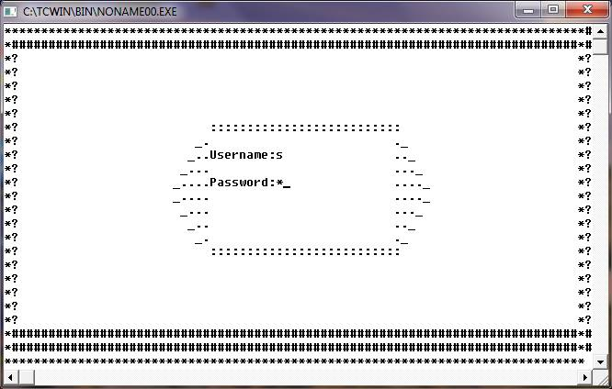

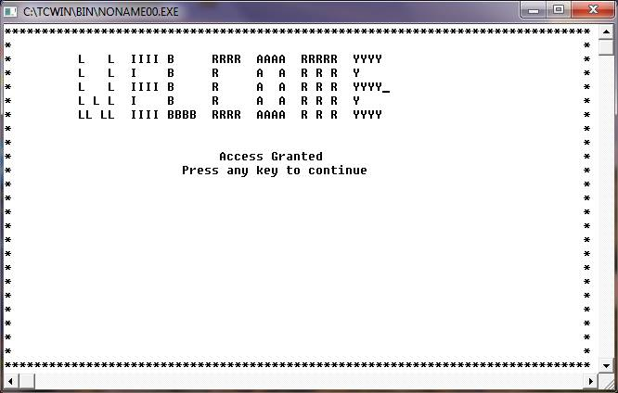

MAIN MENU

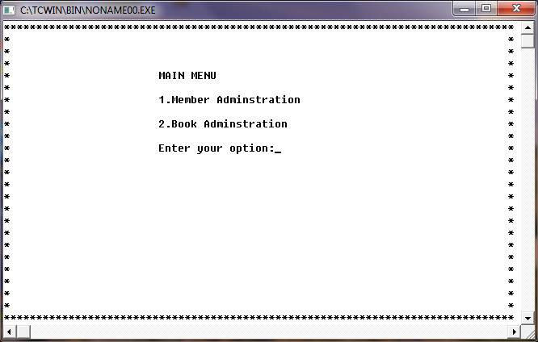

MEMBER ADMINISTRATION

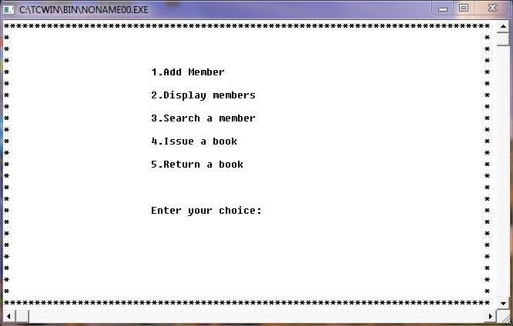

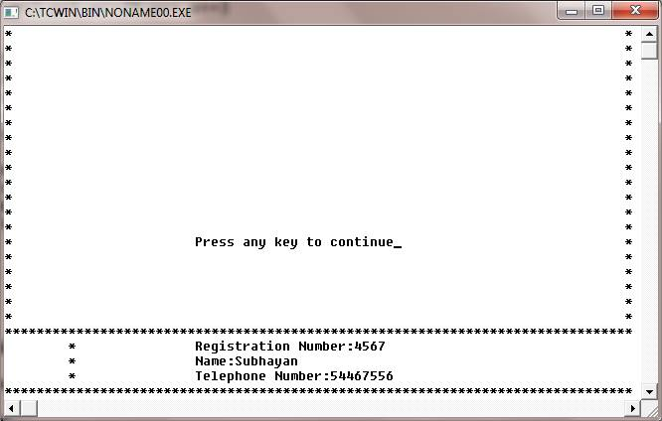

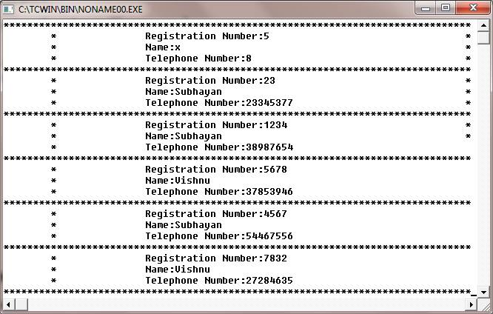

BOOK ADMINISTRATION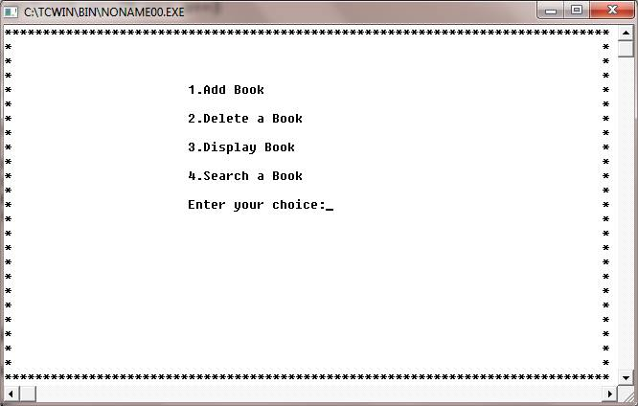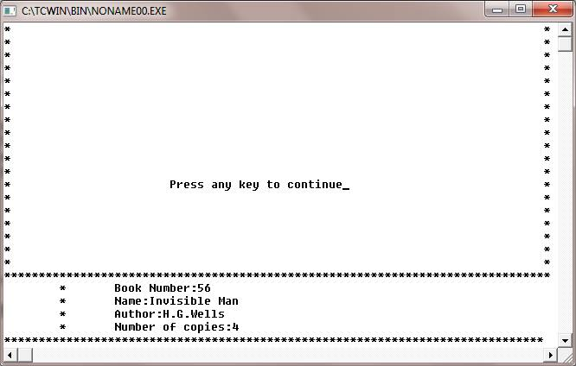

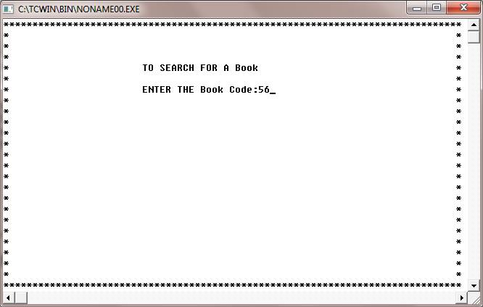

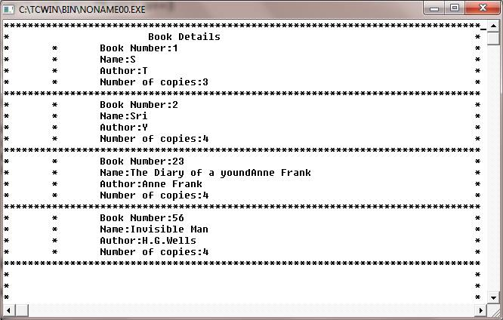

BIBLIOGRAPHY

1. <https://en.wikipedia.org/wiki/C%2B%2B>
2. <http://www.cplusplus.com/>
3. <http://www.stroustrup.com/C++.html>
4. <https://isocpp.org/>