**Steps for Installing and Using Microsoft Visual Studio 2015**

**Step 1:**

Download Visual Studio Community from <https://www.visualstudio.com/en-us/downloads/download-visual-studio-vs.aspx> for free and install

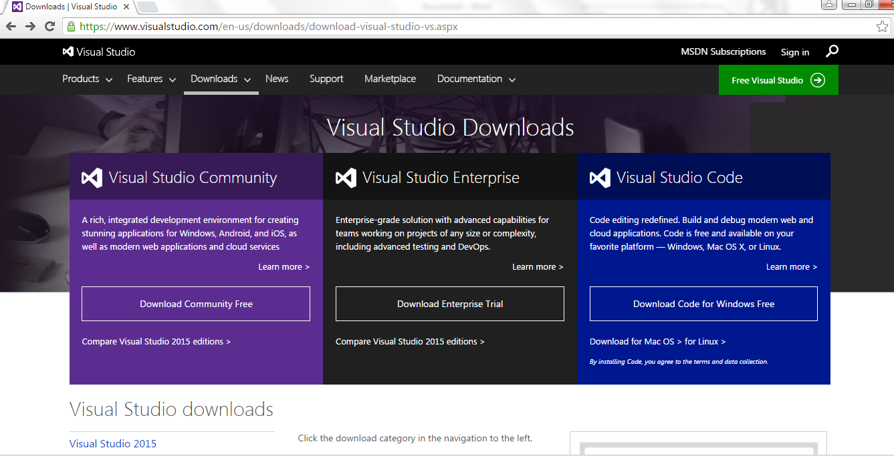

**Step 2:**

Open Visual Studio 2015 from the Start button

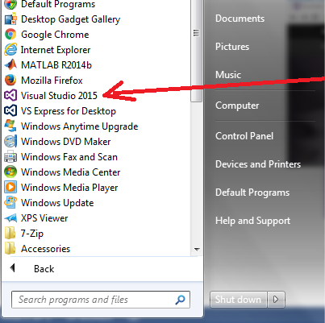

**Step 3:**

To start coding, first create a new Project

File->New->Project

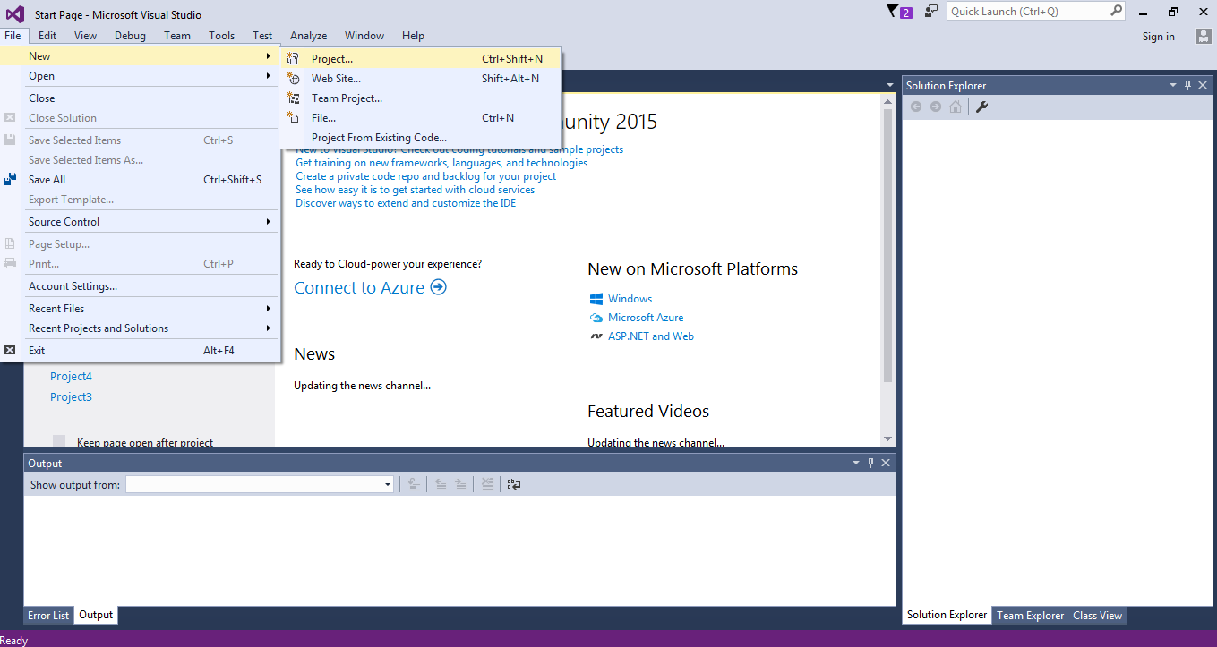

**Step 4:**

Visual C++ -> General -> Empty Project -> Give a name to your project

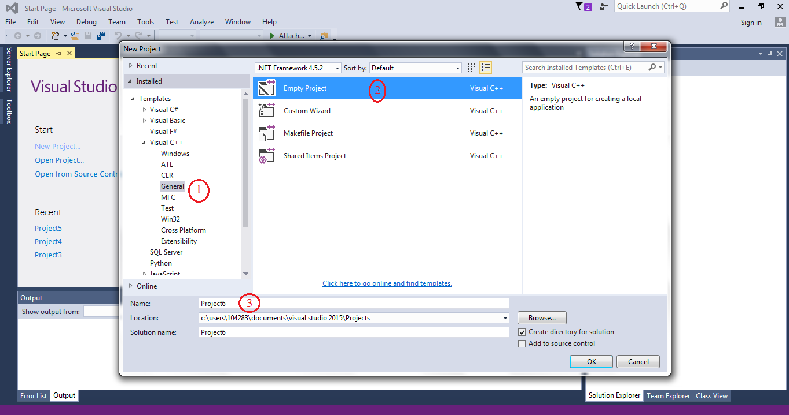

**Step 5:**

Right click at Source File -> Add -> New Item…

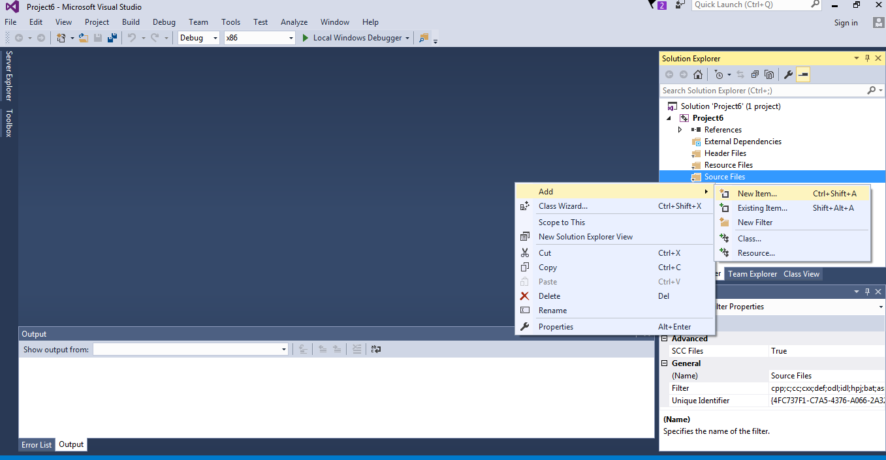

**Step 6:**

Code -> C++ File -> Name your file and make sure to put a .c behind the name of your file (if not, the file will be automatically saved as .cpp which is a C++ program file, not a C program file)

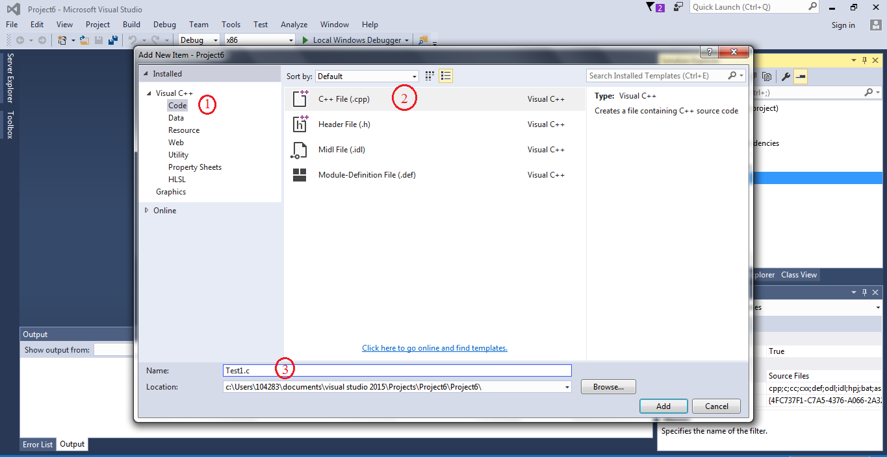

**Step 7:**

Write your code

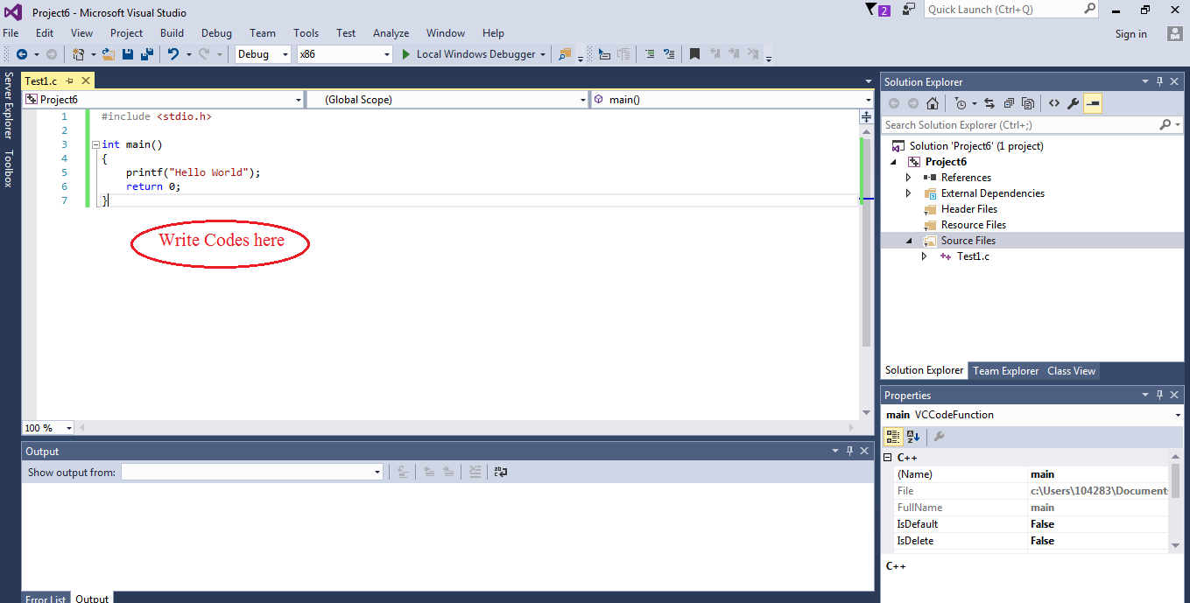

**Step 8:**

To run, first Build your program to make sure there are no errors. If there are errors, double clicking on the error will bring you to the line where the error occurs.

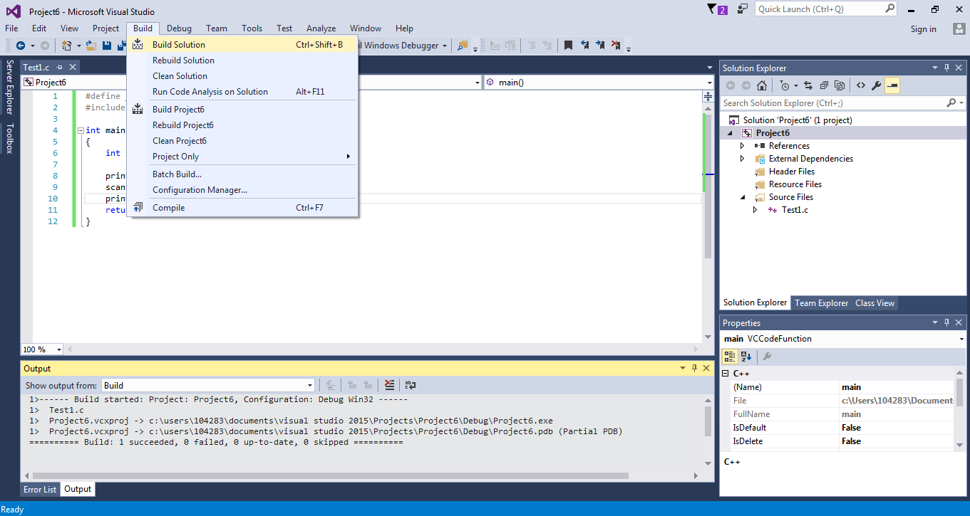

No errors:

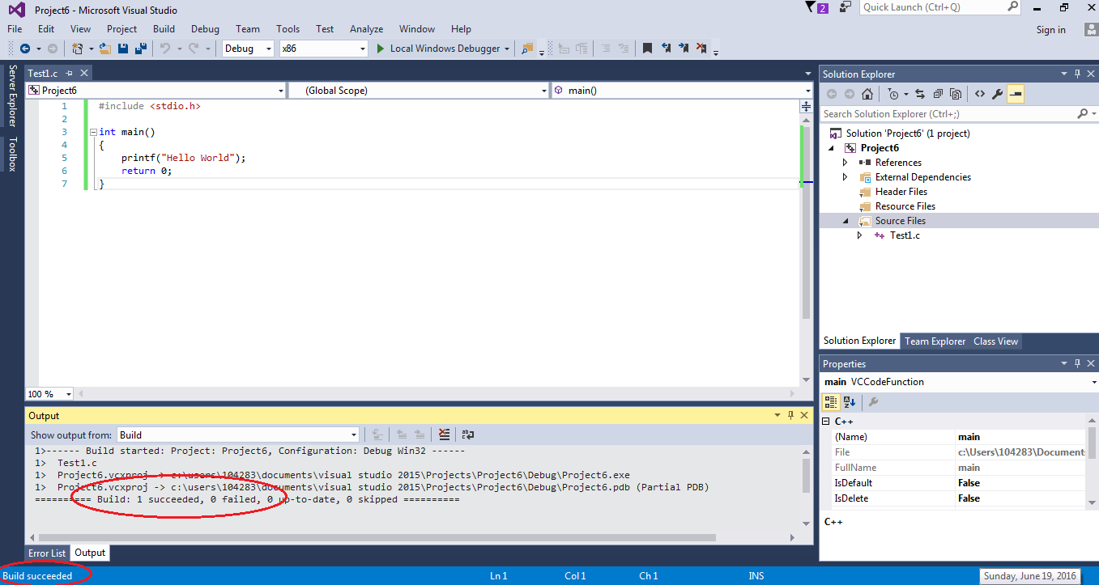

With errors:

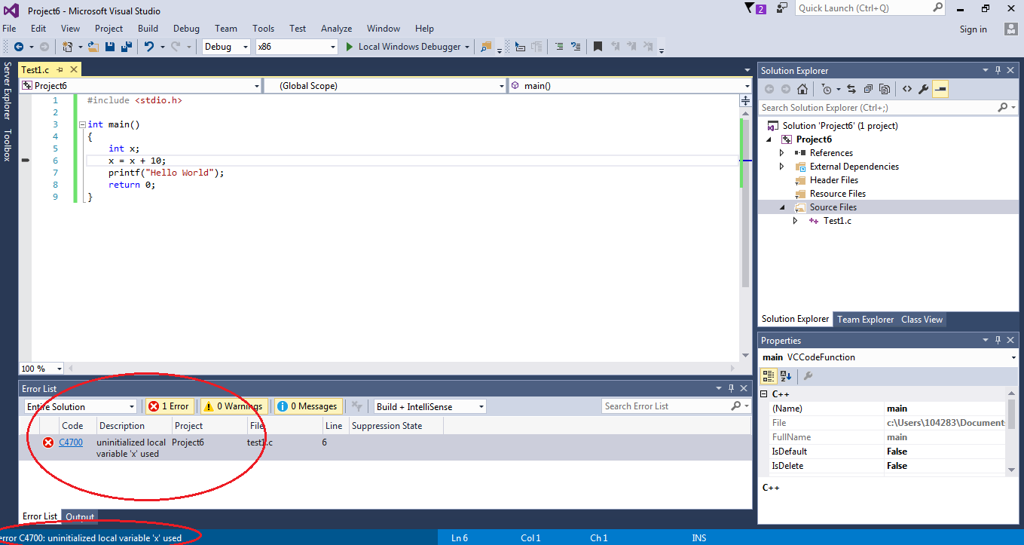

**Step 9:**

After building without errors, you can run the program by going to Debug -> Start Without Debugging. However, you will notice that the output screen closes at the end of the program. To keep the output screen from closing after running the program, you need to change the following settings

Project -> Properties -> Configuration Properties -> Linker -> System -> Subsystem -> Set to Console

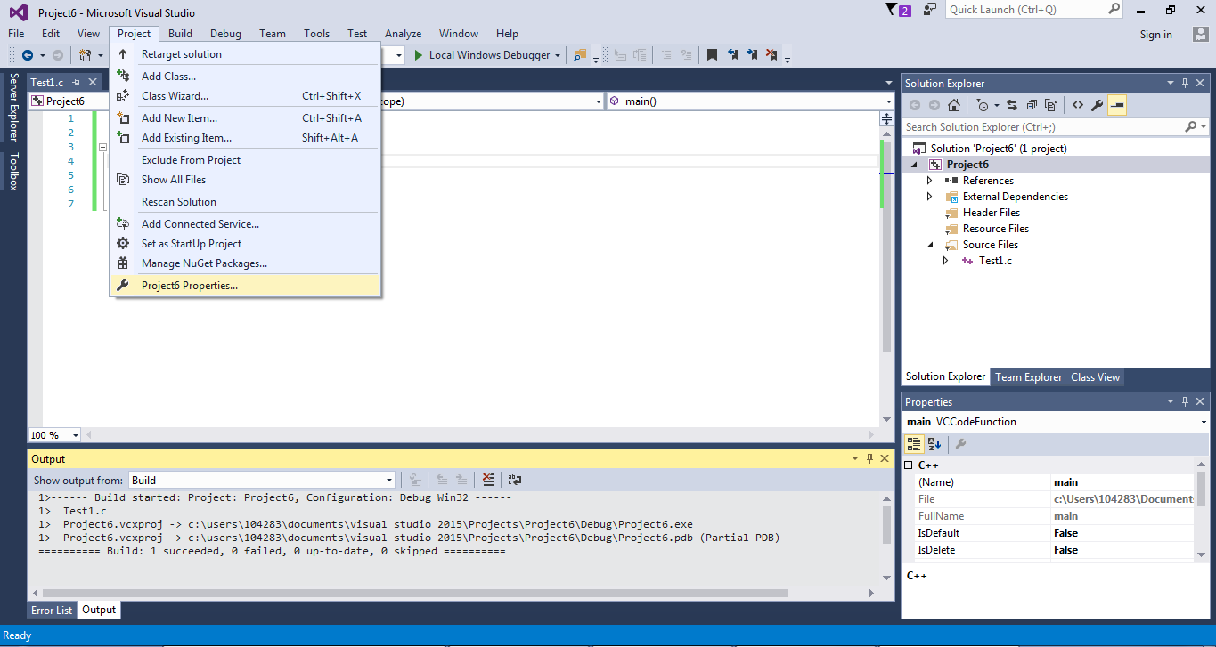

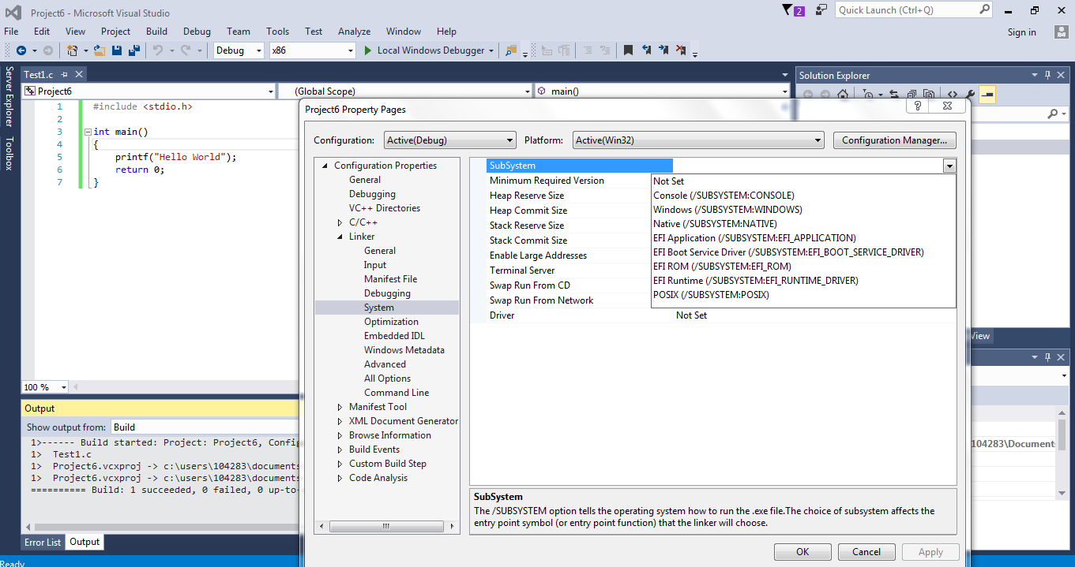

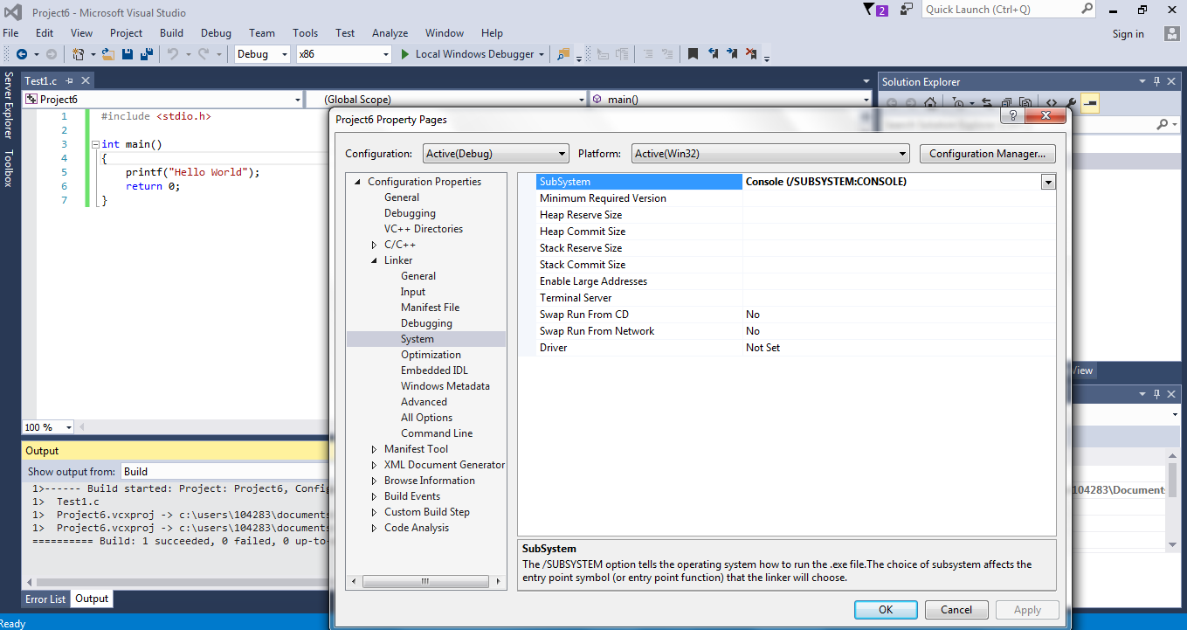

**Step 10:**

Now when you run your code with Debug -> Start Without Debugging, your output window will stay open until you press any key to close the window.

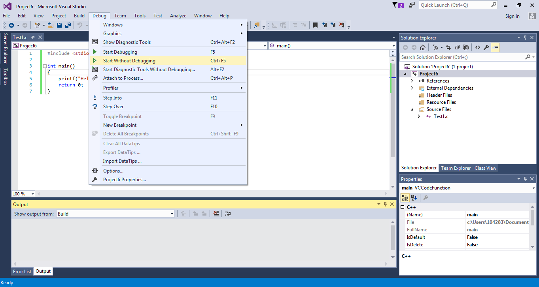

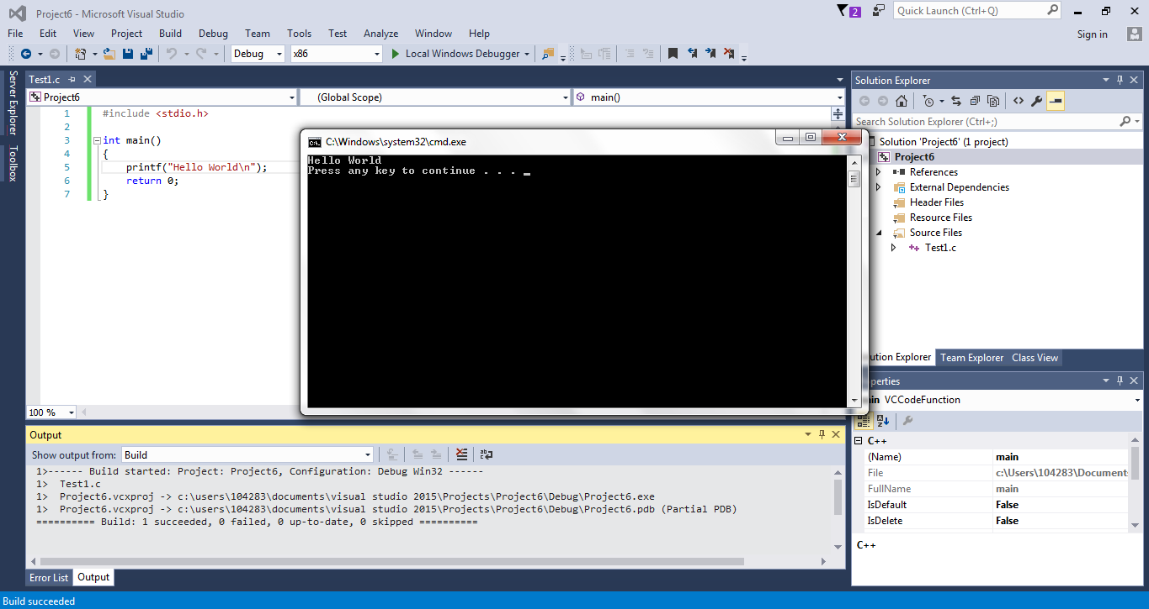

**Error when using scanf()**

When using the scanf() function in your code, the Visual Studio compiler will give out this error warning:

'scanf': This function or variable may be unsafe. Consider using scanf_s instead. To disable deprecation, use _CRT_SECURE_NO_WARNINGS. See online help for details.

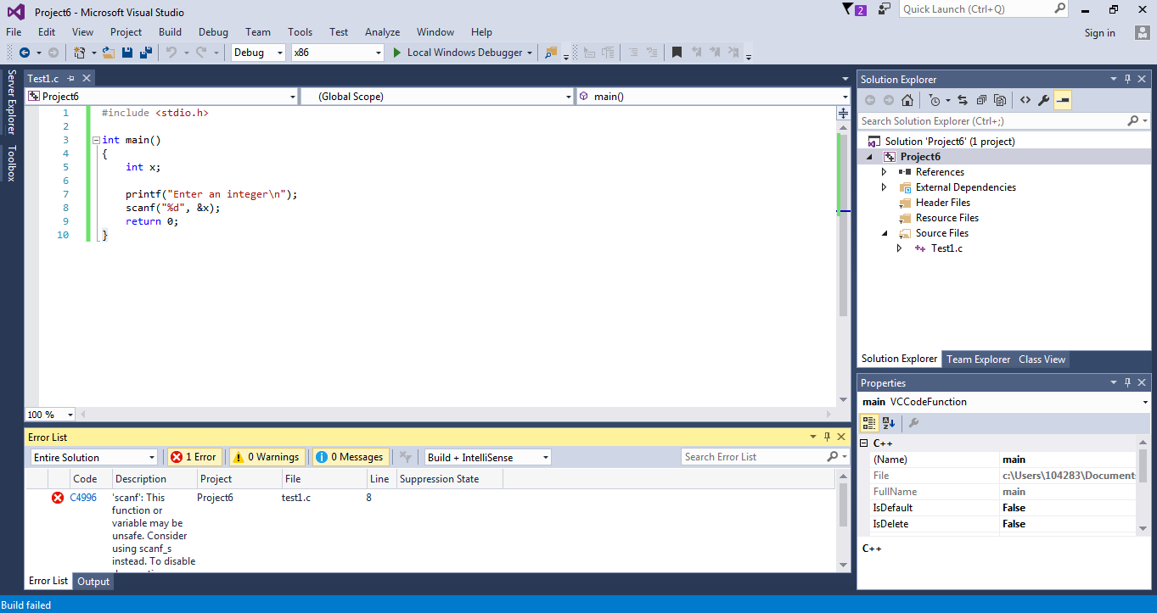

To solve this, write #define _CRT_SECURE_NO_WARNINGS on the top of your #include <stdio.h>

