**REVISION 2 SOLUTIONS**

**Question 1**

(i)

int x=0;

while (x < = 5)

{

printf("Hello\n");

x++;

}

(ii)

int x;

x = 10;

printf("The value of x is %d\n", x);

**Question 2**

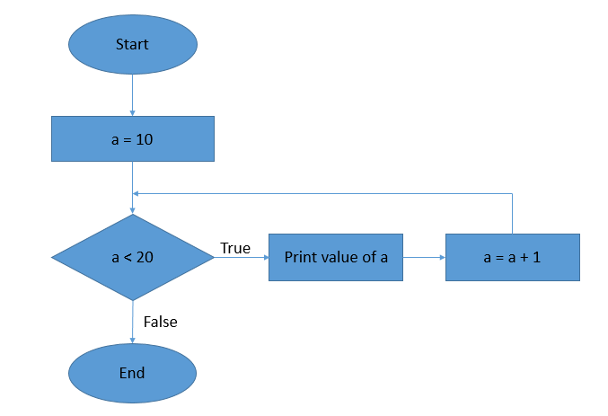

**Question 3**

**Question 4**

