**REVISION 2**

**Question 1**

Write a function square() that will take an integer and return its square, and a function cube() that will take an integer and return its cube. Use your square() and cube() functions to write the functions quartic() and quantic() that returns the fourth and fifth power of an integer, respectively. Use your functions to write a program that prints a table of powers of integers from 1 to 25.

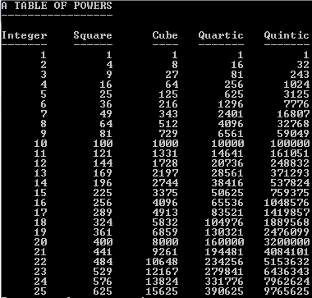

**Question 2**

Write a function that orders the stored values of three characters. Suppose, for example, that c1, c2 and c3 are character variables having the values ‘C’, ‘B’ and ‘D’ respectively. Then the function call order_chars(&c1,&c2,&c3) should cause the stored values of c1, c2 and c3 to be ‘B’, ‘C’ and ‘D’ respectively. Write a program that tests your function.

**Question 3**

A warehouse receives boxes of microchips each day and each of the microchips contains a unique barcode. Write a C program that requires the user to input the barcode into an array one by one and displays all the barcode entered at the end of the program. The program should continuously ask the user to input the barcode value until a value of -1 is entered. Then, the program will terminate and all the barcodes entered will be displayed.