**TUTORIAL 10**

**Question 1**

Write a file called fruits.txt and add the list of fruits below into the file.

Apple

Orange

Grapes

Papaya

Banana

Kiwi

**Question 2**

Read the file created in Question 1 and print out all the fruits found in the file to the screen. Also, the number of fruits found in the file should also be output to the screen.

**Question 3**

Append the file created in Question 1 and add 3 more fruits to the list. The fruits should be entered by the program user.

**Question 4**

Create a multiplication table chosen by the user (multiply from 1 – 12) and save that table in a file.

**Question 5**

***(Telephone-Number Word Generator)*** Standard telephone keypads contain the digits 0 through 9. The numbers 2 through 9 each have three letters associated with them, as is indicated by the following table:

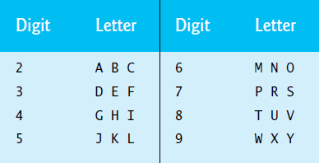

Each seven-digit phone number corresponds to many separate seven-letter words. Unfortunately, most of these represent unrecognizable juxtapositions of letters. It’s possible, however, that the owner of a barber shop would be pleased to know that the shop’s telephone number, 424-7288, corresponds to “HAIRCUT.” The owner of a liquor store would, no doubt, be delighted to find that the store’s telephone number, 233-7226, corresponds to “BEERCAN.” A veterinarian with the phone number 738-2273 would be pleased to know that the number corresponds to the letters “PETCARE.”

Write a C program that, given a seven-digit number, writes to a file every possible seven-letter word corresponding to that number. There are 2187 (3 to the seventh power) such words. Avoid phone numbers with the digits 0 and 1.