ELECTRICAL AND ELECTRONIC ENGINEERING PROGRAMME

Treasure Hunt Game Simulation

SAFETY REGULATIONS AND GUIDELINES FOR STUDENTS

Students performing experimental work in the Engineering laboratory must follow and abide by the following safety regulations and guidelines. Students must complete a safety declaration form before they are allowed to work in the laboratory.

GENERAL

- Students are not allowed to enter the laboratory without the permission of the lecturer or laboratory assistant.
- Unauthorized experimental work in the laboratory is strictly forbidden.
- Prior to the use of laboratory out of timetabled periods, students must apply for usage from relevant laboratory staff.
- Students are not allowed to work alone in the laboratory.
- Bags and books must not be left on benches or on stools and should be placed in designated area. Do not block passageways or fire exits.
- All working spaces must always be kept clean.
- Long hair, ties, jewellery and clothing must never be allowed to hang loose, since any of these items can easily become entangled in the moving parts of machinery, and hence cause serious injury.
- Suitable clothing must be worn; long trousers or jeans are recommended for boys and dresses, slacks or jeans for girls. In particular, sleeveless t-shirts and sleeveless blouses are prohibited.
- Students must wear covered footwear during laboratory and workshop sessions. Sandals, open-toed shoes, slippers or similar footwear are prohibited. Students may be refused entry to the laboratory or workshop if not in proper footwear.
- Storage and/or consumption of food and drink, smoking and the application of cosmetics in the laboratory are not allowed.
- Indiscipline in the laboratory or workshop (e.g. whistling, horseplay etc.) will not be tolerated.
- No reagent, solution or apparatus is to be removed from the laboratory without approval from the lecturer.
- Do not pour waste down the sink unless authorized to do so by your lecturer.
- Defective equipment or broken glassware must be reported to the lecturer or lab assistant.
- Do not run in the laboratory or along corridors. Exercise care when opening and closing doors on entering and leaving the laboratory.
- Laboratory doors must be kept closed at all times during practical classes.
OBJECTIVES
After performing this lab, the students should be able to:
- Write a C program to simulate a treasure hunt game

COMPONENTS/ EQUIPMENTS
C Compiler

IMPLEMENTATION
Write a C program to simulate a treasure hunt game by following the steps below:
- Create an area map by representing the walls using the ‘#’ character and the hunting ground using the ‘.’ character, as shown in Fig. 1.
- Ask the user to determine how many treasures are to be placed in the map and then randomly placed them in the map. The treasures are to be represented by the ‘@’ character, as shown in Fig. 2.
- Starting at the upper left corner, have the user move the cursor around the map to collect the treasures in the map, as shown in Fig. 3. Once each treasure has been collected, that location will be represented by the ‘.’ character, as shown in Fig. 4.
- The game will end when all the treasures have been collected.
- To make the game more challenging, add a timer to the program.The player will be declared as a winner if he/she is able to collect all the treasures in the map within a set time frame, as shown in Fig. 5.

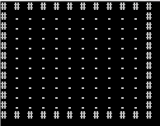
Figure 1: Creating the area map

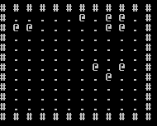
Figure 2: Randomly placing the treasure in the map

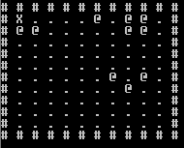
Figure 3: The starting point at the upper left corner

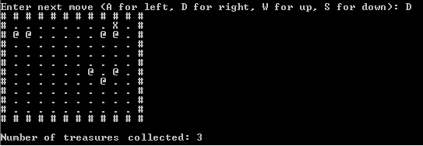
Figure 4: Example of map after 3 treasures were collected

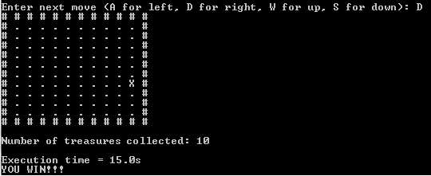
Figure 5: Example of map after collecting all the treasures

