= *Fs = 0.8us*20MHz = 16samples/short sequence

= *Fs = 3.2us*20MHz = 64samples/long sequence

r[n1] = x[n1], r[n1+] = x[n1+]

Z1 = [n1]r[n1 + ]=

r[N1] = x[N1], r[N1+] = x[N1+]

Z2 = [N1]r[N1 + ]= x[N1+]

x[N1+] =

=

=

=

=

Max phase can accurately estimate is

So, max < 1/

max < 1/ for long sequence.

CBER: the probability that a codeword is not correctly decoded at the receiver.

Case I: Using the Hamming (7,4) code, the codeword can detect and correct any single-bit error. So, the probability of a codeword being decoded incorrectly is the probability that 2 or more bit errors.

The probability of 2 or more bit errors:

=

The CBER = 1.657e-10 when plug in pb=10^-4



In Case II, the probability of k subchannels having errors

=

Where Pk = C(7,k) * * (1-* (1-

If Plug in pb=10^-4.5 and pb'=10^-1,:

p1 = 0.0004205

p1' = 0.4783

Pk for k=2 to 7 are: [3.027e-10, 2.019e-8, 5.332e-7, 5.892e-6, 3.499e-5, 0.001278]

The CBER = 0.4798



Case I is better, the overall BER of the system is very lower than case II as approximately 7x10^-4 and the CBER for Case I is also very low at approximately 1.7 x 10^-10 .

: It means case I system is able to provide reliable transmission of the data, even in the presence of channel noise and fading.

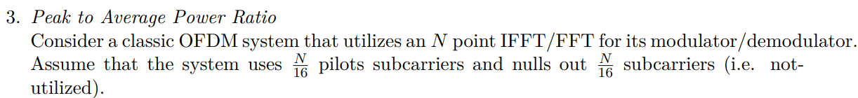

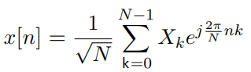

the worst-case peak-to-average power ratio (PAPR) occurs when all subcarriers are in phase and have equal amplitude( assume the pilot subcarriers are all in the same phase/equal amplitude): 15N/16 subcarriers are in the same phase/equal amplitude.

|x[n]| = A), A: the amplitude of each QPSK symbol.

max(|x[n) = 2*

E(|x[n) = ) * SUM(|X[n]),

X[k] : frequency-domain representation of the QPSK symbols, and the sum is over all subcarriers.

the average power of each symbol(QPSK) =

the average power of each I/Q = (1/2)

so, the average power of the time-domain signal is

E(|x[n]) = (1/N) * SUM(|X[k]) =

PAPR = |x[n]/ E(|x[n]) = (2*= 15N/8

The probability of the PAPR exceeding a given threshold gamma (γ) for an OFDM system with NA active subcarriers can be expressed as:

Pr{PAPR(x[n]) > 10} = 1 - (1 - e

i.e. Pr{PAPR(x[n]) 10 } = (1 - e0.99

(1 - e0.99

If take the natural logarithm of both sides:

ln (1 - e ln(0.99)

If solve for NA:

ln(0.99)/ ln (1 – e as ln (1 – e

< 221.368354

Max(



NA = 221; % maximum number of active subcarriers

gamma = logspace(0, 2, 1000); % range of gamma values to plot

ccdf = 1 - (1 - exp(-gamma)).^NA; % calculate the CCDF

loglog(gamma, ccdf); % plot the CCDF in log-log scale

xlabel('\gamma (dB)');

ylabel('CCDF');

title('CCDF of PAPR');

< without fading > < with fading >

< subcarrier f2 only enabled without CP >

< subcarrier f14 only enabled without CP >

< subcarrier f16 only enabled without CP >

< subcarrier f18 only enabled without CP >

After passing through channel it has more constellation due to multi-fading.

<f0 only enabled with CP=16>

<f2 only enabled with CP=16>

<f14 only enabled with CP=16>

<f16 only enabled with CP=16>

<f18 only enabled with CP=16>

With or without CP doesn`t show difference for the same data point.

It seems without equalization it doesn’t have original constellation.

<f0 only enabled with CP=3>

<f2 only enabled with CP=3>

<f14 only enabled with CP=3>

<f16 only enabled with CP=3>

<f18 only enabled with CP=3>

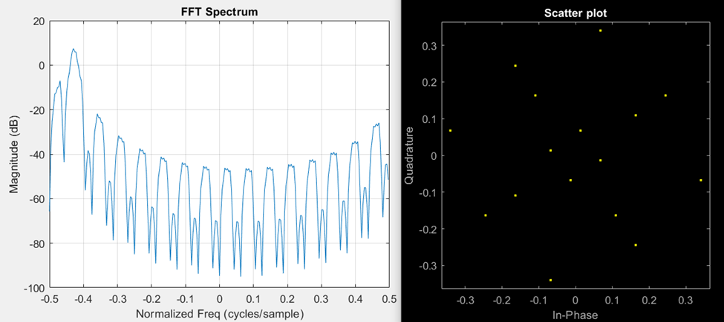



phi = angle(trn_msg_xcorr(193))-angle(trn_msg_xcorr(129))

fo = phi/(2*pi*64)

rxmsg_crr = rxmsg.y.*exp(-1i*2*pi*(fo))

< red: received training sequence, blue: channel coefficient >

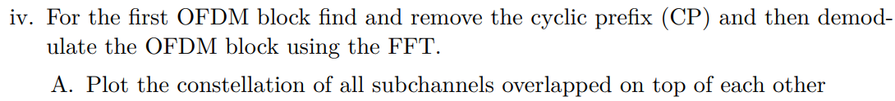

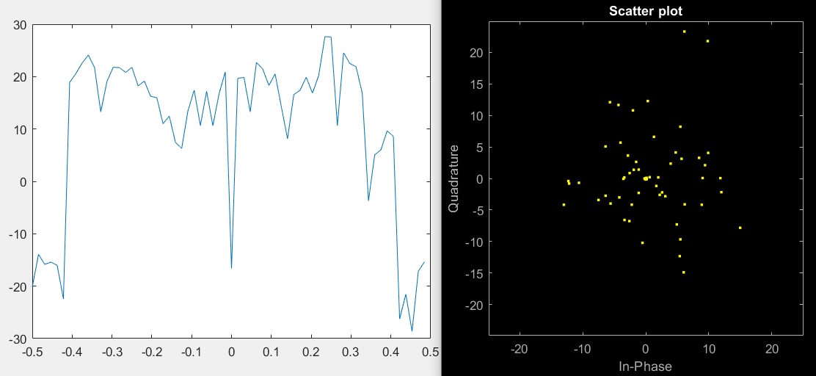



< MATLAB problem 1 code >

FFT = 256;

N =32;

L = 100;

cp_n =3;

n=19;

k_lim = floor( (N - N/4 + 4) / 2 );

%bitmask = [ 1:k_lim (-k_lim:-1) + N ] + 1;

%bitmask = [ 1:32];

bitmask = [ n ];

% Na: number of active data channels

Na = numel(bitmask);

S_mat =zeros(N,L);

rng(0,'twister');

S_mat(bitmask,:) = (randsrc(Na,L)+1i*randsrc(Na,L)) * sqrt(1/2);

s_mat = sqrt(N)*ifft(S_mat); %s_mat is time-domain samples

%s_mat_cp = sqrt(N)*ifft(S_mat_cp);

s_mat_cp = zeros(N+cp_n, L);

s_mat_cp(1:N+cp_n, 1:L ) = [s_mat(1:N, :) ; s_mat(1:cp_n,:)]

s = reshape(s_mat,1,[]);

s_cp = reshape(s_mat_cp,1,[]);

s_fltd = conv(s,[1 zeros(1,15) -1 ]);

s_fltd = s_fltd(1:N*L);

s_fltd_mat = reshape(s_fltd, [N, L]);

s_fltd_mat_1 = s_fltd_mat(1:N/2, :);

s_cp_fltd = conv(s_cp,[1 zeros(1,15) -1 ]);

s_cp_fltd = s_cp_fltd(1:(N+cp_n)*L);

s_cp_fltd_mat = reshape(s_cp_fltd, [N+cp_n, L]);

s_cp_fltd_mat_1 = s_cp_fltd_mat(1:N/2,:)

s_fltd_16 = reshape(s_fltd_mat_1, 1,[]);

s_cp_fltd_16 = reshape(s_cp_fltd_mat_1,1,[]);

S_fft = pwelch(s,nFFT,nFFT/2,[],1,'twosided');

S_fltd_fft = pwelch(s_fltd_16,nFFT,nFFT/2,[],1,'twosided');

S_cp_fltd_fft = pwelch(s_cp_fltd_16,nFFT,nFFT/2,[],1,'twosided');

F = linspace(-0.5,0.5-1/nFFT,nFFT);

figure(1);

plot(F,db(fftshift(S_fft)));

xlabel('Normalized Freq (cycles/sample)')

ylabel('Magnitude (dB)');

title('FFT Spectrum')

grid on;

figure(2)

plot(F,db(fftshift(S_fltd_fft)));

xlabel('Normalized Freq (cycles/sample)')

ylabel('Magnitude (dB)');

title('FFT Spectrum')

grid on;

figure(3)

plot(F,db(fftshift(S_cp_fltd_fft)));

xlabel('Normalized Freq (cycles/sample)')

ylabel('Magnitude (dB)');

title('FFT Spectrum')

grid on;

scatterplot(s(n:32:end))

scatterplot(s_cp(n:N+cp_n:end))

scatterplot(s_fltd_16(n:N/2:end))

scatterplot(s_cp_fltd_16(n:N/2:end))

< code for MALAB problem2>

nFFT = 64;

nFFT1 = 256;

rxmsg = load("C:\Users\epae\OneDrive - Qualcomm\Documents\personal\UCSD\WES268B\ofdm_pkt.mat");

rxmsg_fft = pwelch(rxmsg.y,nFFT,nFFT/2,[],1,'twosided');

F1 = linspace(-0.5,0.5-1/nFFT1,nFFT1);

F = linspace(-0.5,0.5-1/nFFT,nFFT);

figure(1)

plot(F1,db(fftshift(rxmsg_fft)))

trn = [0 rxmsg.s(1:26) zeros(1,10) rxmsg.s(27:52) 0];

trn_ifft = ifft(trn');

trn_fft = fft(trn_ifft.',nFFT)

figure(2)

plot(F,db(fftshift(trn_fft)))

[ trn_msg_xcorr ] = c_corr( rxmsg.y, trn_ifft.');

figure(3)

stem(abs(trn_msg_xcorr).^2)

phi = angle(trn_msg_xcorr(193))-angle(trn_msg_xcorr(129))

fo = phi/(2*pi*64)

fo_vec = exp(-1i*2*pi*(fo*(1:1088-96)));

rxmsg_crr = rxmsg.y(97:1088).*fo_vec;

figure(4)

rxmsg_crr_fft = pwelch(rxmsg_crr,nFFT,nFFT/2,[],1,'twosided');

%rxmsg_crr_fft = fft(rxmsg_crr,nFFT)/sum(rxmsg_crr);

plot(F1,db(fftshift(rxmsg_crr_fft)))

%plot(F,db(fftshift(rxmsg_crr_fft)))

hold on

plot(F1,db(fftshift(rxmsg_fft)))

%plot(F,db(fftshift(rxmsg_fft)))

figure(5)

%rxmsg_crr_tr_fft = pwelch(rxmsg_crr(129-32:129+32-1),nFFT,nFFT/2,[],1,'twosided');

rxmsg_crr_tr_fft = fft(rxmsg_crr(33:96),nFFT);

%plot(F1,db(fftshift(trn_fft)))

plot(F,db(fftshift(trn_fft)))

hold on

%plot(F1, db(fftshift(rxmsg_crr_tr_fft)))

plot(F, db(fftshift(rxmsg_crr_tr_fft)))

%%============================================================

%%< T matrix >

T = zeros(96,32);

%trn = [0 rxmsg.s(1:26) zeros(1,10) rxmsg.s(27:52) 0];

trn_96 = [trn(33:1:64) trn(1:1:64)];

T= toeplitz(trn_96,[trn_96(1) zeros(1,31)]);

%%================================================================

%%================================================================

% <h_ex>

tr_crr= rxmsg_crr(1:96);

stem(tr_crr)

% stem(trn_96)

% stem(rxmsg_crr)

h_ex = pinv(T)*tr_crr.'

H_ex = fft(h_ex,nFFT);

figure(3)

subplot(211)

stem(h_ex);

title('impulse response of h_ex(t)')

ylabel('Magnitude(dB)')

xlabel('frequency')

subplot(212)

plot(-0.5:1/nFFT:0.5-1/nFFT,fftshift(20*log(abs(H_ex))))

title('PSD of channel estimation H(f)')

ylabel('Magnitude(dB)')

xlabel('frequency')

%%=======================================================================

% <check h_ex>

trn_96_check = T*h_ex;

figure(4)

subplot(211)

stem(trn_96)

title('original message preamble')

subplot(212)

stem(trn_96_check)

title('preambgle recovered by H(f)')

%%============================================================

%%============================================================

%%< R matrix >

tr_crr= rxmsg_crr(1:96);

R= toeplitz(tr_crr,[tr_crr(1) zeros(1,31)]);

%%================================================================

% <g_ex>

%trn_96 = [trn(33:1:64) trn(1:1:64)];

g_ex = pinv(R)*trn_96.';

G_ex = fft(g_ex,nFFT);

figure(5)

subplot(211)

stem(g_ex)

title('Impuse response of equalizer g_ex(t)')

ylabel('Magnitude(linear)')

xlabel('time')

subplot(212)

plot(-0.5:1/nFFT:0.5-1/nFFT,fftshift(20*log(abs(G_ex))))

title('PSD of equalizer G(f)')

ylabel('Magnitude(dB)')

xlabel('frequency')

%%=====================q===========================================

% < h_ex*g_ex >

eq_check = conv(h_ex,g_ex);

EQ_check = fft(eq_check,nFFT);

figure(6)

subplot(211)

stem(eq_check)

title('g_ex(t)(*)h_ex(t)')

ylabel('Magnitude(dB)')

xlabel('time')

subplot(212)

plot(-0.5:1/nFFT:0.5-1/nFFT,fftshift(10*log(abs(EQ_check))))

title('G_ex(f)*H_ex(f)')

ylabel('Magnitude(dB)')

xlabel('frequency')

%%=====================q===========================================

% < g_ex(*)msg.y >

rxmsg_eql = conv(g_ex,rxmsg_crr);

p_rxmsg_eql = rxmsg_eql.^2

p_rxmsg_eql_fft = fft(p_rxmsg_eql,nFFT);

figure(7)

subplot(211)

plot(-0.5:1/nFFT:0.5-1/nFFT,fftshift(10*log(abs(p_rxmsg_eql_fft))))

title('PSD of equalized message by g_ex(t)(*)msg(t)')

ylabel('Magnitude(dB)')

xlabel('normalized frequency(fc/fs)')

subplot(212)

plot(-0.5:1/nFFT:0.5-1/nFFT,fftshift(10*log(abs(EQ_check))))

title('Eaulizer check by G_ex(f)*H_ex(f)')

ylabel('Magnitude(dB)')

xlabel('frequency')

%%%%%%%%%%%%%%%%%%%%%%%%%%%%%%%%%%%%%%%%%%%%%%%%%%%%%%%%%%%%%%%%%%%%%%%%%%%%%%%%%%%

figure(8)

ofdm1 = rxmsg_crr(32+64+64+32+16+1:32+64+64+32+16+64);

rxmsg_crr_ofdm1_fft = fft(ofdm1,nFFT);

plot(F, db(fftshift(rxmsg_crr_ofdm1_fft)))

figure(9)

plot(real(rxmsg_crr_ofdm1_fft(1:3)), imag(rxmsg_crr_ofdm1_fft(1:3)), '.')

figure(10)

rxmsg_eql_fft = fft(rxmsg_eql, nFFT);

plot(real(rxmsg_eql_fft(1:3)), imag(rxmsg_eql_fft(1:3)), '.')

figure(11)

plot(real(rxmsg_eql_fft(1:64)), imag(rxmsg_eql_fft(1:64)), '.')