# Python Assignment # 1

# Problem 1 (20 Points).

A store charges $12 per item if you buy less than 10 items. If you buy between 10 and 99 items, the cost is $10 per item. If you buy 100 or more items, the cost is $7 per item. Write a program that takes how many items are bought and prints the total cost.

# Problem 2 (20 Points).

Write a program that generates a list of 20 random numbers between 1 and 100.

1. Print the list.
2. Print the average of the elements in the list.
3. Print the largest and smallest values in the list.
4. Print the second largest and second smallest entries in the list
5. Print how many even numbers are in the list.

# Problem 3 (20 Points).

The Fibonacci numbers are the sequence below, where the first two numbers are 1, and each number thereafter is the sum of the two preceding numbers. Write a program that asks the user how many Fibonacci numbers to print and then prints that many.

1,1,2,3,5,8,13,21,34,55,89...

# Problem 4 (20 Points).

You are given a file named “blood-pressure.csv” which contains blood pressure measurement for some patients. The first column is for patient id and the second column is for blood pressure measurement in the format of mean[min-max] values. Write a function that takes this file as an input and do the folowing tasks:

* 1. prints the lowest and highest blood pressure measurements amongs the patients. The output should be 108 and 178
  2. prints the average of the mean values.

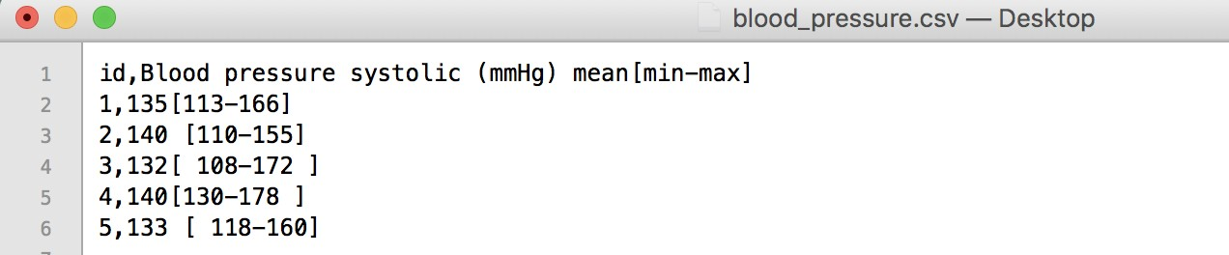

# Problem 5 (20 Points).

You are given a csv (gdp_per_capita.csv) file for GDP per capita taken from World Bank. The file holds data from 1960 to 2017. Write a function that takes this file as an input and do the following tasks for *Turkey*:

1. Calculate the yearly percentage increase compared to previous year and the find the year that has highest increase in terms of percentage.
2. Find the years that GDP per capita decreased compared to the previous year.