**CPT 1110 Introduction to Programming and Logic**

**Final Project**

You have been contracted by Widgets Inc. This is a small company that sells various widgets. They currently do not have any type of inventory tracking system. Your job is to create an inventory management system. This system should be able to (1) print the current inventory, (2) add new items to inventory, (3) remove outdated items from inventory, (4) update the quantity of current inventory items, and (5) search for items in stock.

Task 1: (25pts)

Create a flow chart of how this program would function. Flowcharting software (Visual Logic, Raptor, etc) can be used to prepare this flow chart.

Task 2: (75pts)

Create a menu driven Python program that will accomplish the goals outlined in the job description above. Sample screenshots have been provided for guidance. This is a process you can test with your program.

**Menu Display**

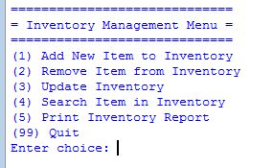

**Print Initial Inventory Items and Quantity (Option 5)**

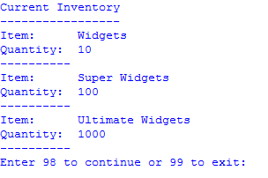

**Adding Big Widgets with a quantity of 50 to inventory (Option 1)**

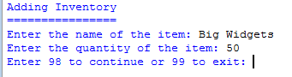

**Removing Standard Widgets from inventory (Option 2)**

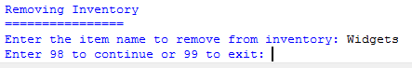

**Added 5 Super Widgets to inventory (Option 3)**

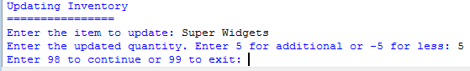

**Removed 10 Ultimate Widgets from inventory (Option 3)**

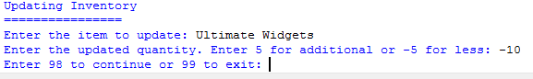

**Searching for the quantity of Ultimate Widgets in inventory (Option 4)**

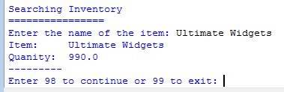

**Printing a report of the current items and quantities in inventory (Option 5)**

