Project Documentation — StagingUpload

# 1. Project Overview

StagingUpload is a Python + PHP project designed to simplify and automate staging uploads for Excel files. Traditionally, preparing staging scripts manually can take 3+ hours per partner, but this project reduces it to just 2–5 minutes by automating the process.  
  
The system supports:  
- Uploading Excel files  
- Configuring staging details with Master ID and Header Row  
- Generating AI-assisted SQL scripts automatically  
- Downloading processed outputs

# 2. Objectives

- Save manual effort and reduce time required for preparing staging scripts  
- Provide a simple web interface (PHP) for uploads  
- Automate Excel header mapping & SQL script generation using Python  
- Ensure version control and reusability across projects

# 3. Project Structure

StagingUpload/  
│── src/ # Python source scripts  
│ └── stagingCreator.py # Main Python script  
│── download.php # File download script  
│── index.php # Web interface  
│── Required.txt # Notes / additional requirements  
│── images/ # Walkthrough screenshots  
│── requirements.txt # Python dependencies

# 4. Technology Stack

- Python 3.8+ → Excel processing, AI-based script generation  
- PHP 7+ → Web interface for upload/download  
- Libraries/Dependencies: Listed in requirements.txt  
- Database: Supports MySQL/PostgreSQL (depending on integration)  
- Version Control: Git

# 5. Setup Guide

Install Python:  
1. Install Python 3.8+  
  
2. (Optional) Create a virtual environment:  
 python -m venv venv  
 venv\Scripts\activate # Windows  
 source venv/bin/activate # Linux/Mac  
  
3. Install dependencies:  
 pip install -r requirements.txt

# 6. Usage

Python Script:  
- Takes Excel input, Master ID, and Header Row  
- Generates SQL insert/update scripts dynamically  
  
Web Interface (index.php):  
- Step 1: Upload Excel file  
- Step 2: Enter Master ID  
- Step 3: Select Header Row  
- Step 4: Get processed output (SQL script)

# 7. Walkthrough

Initial View:  
Upload Excel, enter Master ID, and select Header Row  
(see images/Initial_view.png)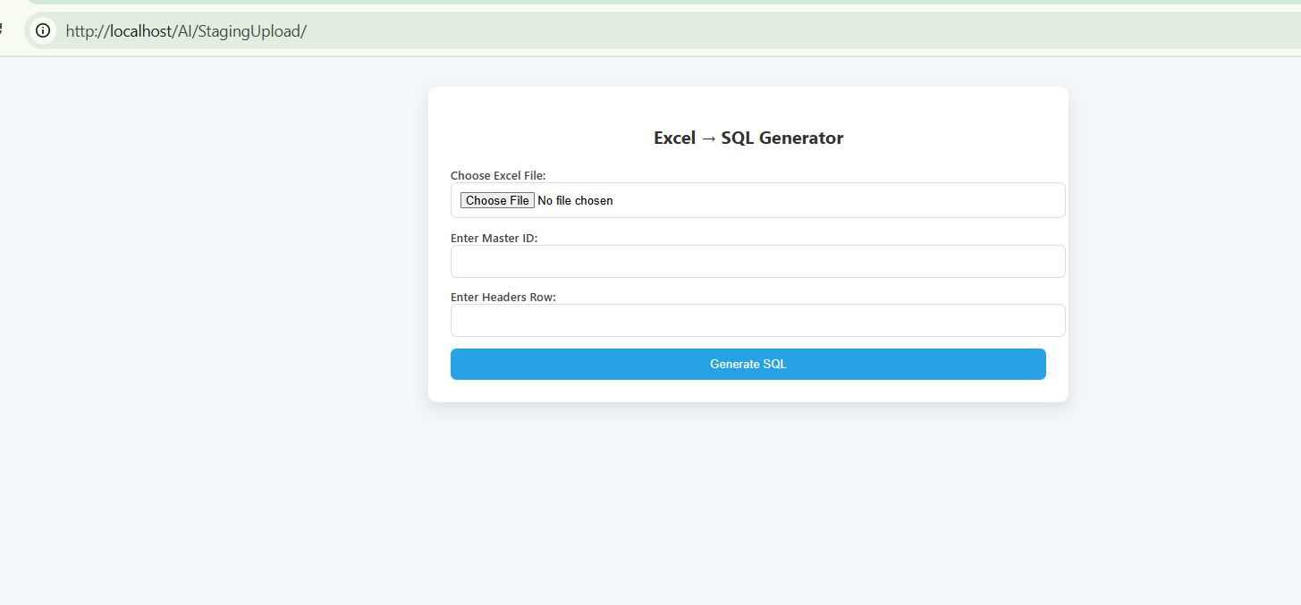

Update With Details:  
System maps headers & generates SQL with AI  
(see images/update_with_details.png)  
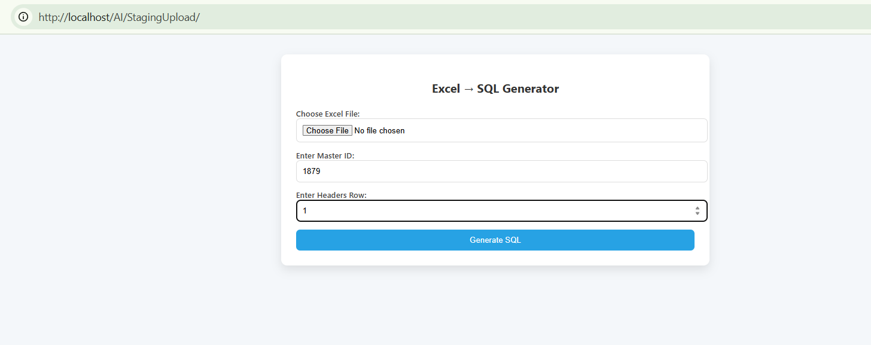

Output:  
Download AI-generated SQL script  
(see images/Output_view.png)

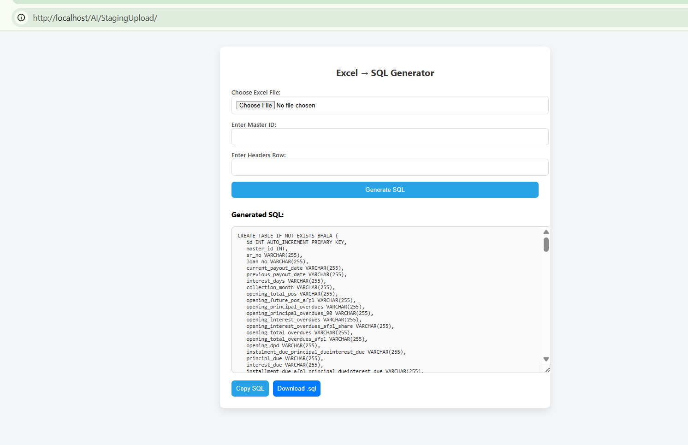

# 8. Version Control

Git-ready setup  
  
.gitignore excludes unnecessary files such as:  
- Python cache files (__pycache__/, *.pyc)  
- Virtual environments (venv/)  
- Logs and temporary files  
- PHP session/cache files

# 9. Benefits

- Time-saving: From 3 hours → 5 minutes  
- Error reduction: Automated header handling  
- Reusable: Works for multiple partners with minimal config  
- Scalable: Easy to extend for new staging requirements