Samiur Rahaman Rejvi  COMPUTER SCIENCE STUDENT | FULL-STACK DEVELOPER | AI AUTOMATION BUILDER  samiurrahamanrejvi@gmail.com | +60 11-3612 1380 | Kuala Lumpur, Malaysia | srrejvi.com  GitHub: srrejvi2 | LinkedIn | WhatsApp | X: @samiur2002 | 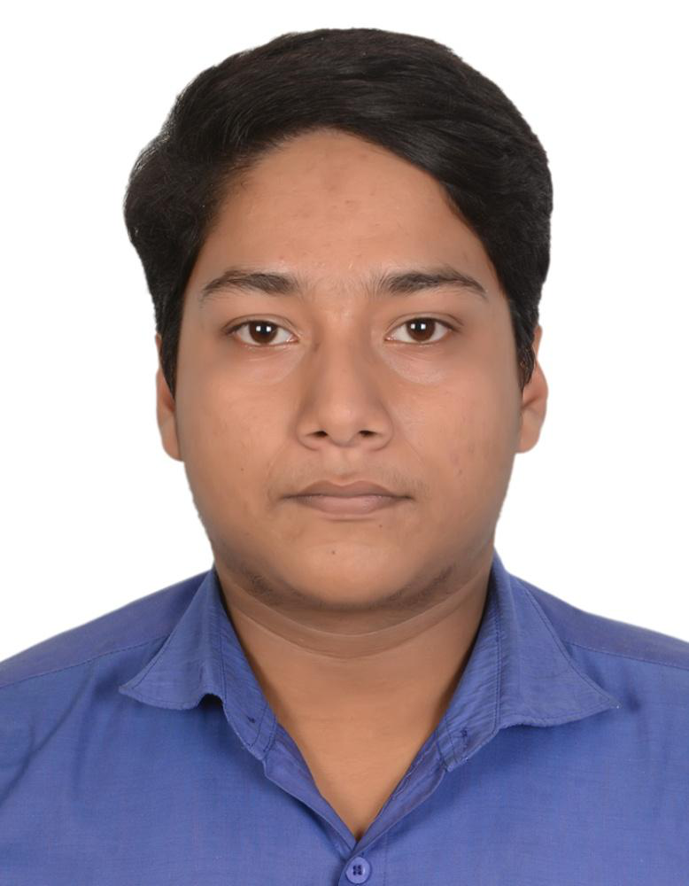
PROFESSIONAL PROFILE
Computer Science student and hands-on developer focused on full-stack web development, AI-assisted workflows, and practical automation. Experienced with JavaScript, Node.js, Firebase, Supabase, Python, and modern AI/automation tools, with a strong interest in building reliable, user-focused digital products. Dean's Award recipient in 2023 and 2025, recognized for academic performance and a consistent problem-solving mindset.
TECHNICAL SKILLS
Programming: Java, JavaScript (ES6+), Python
Web Development: HTML5, CSS3, Responsive UI/UX, Node.js, Express.js, REST APIs
Cloud & Data: Firebase Authentication, Firebase Realtime Database, Supabase
AI & Automation: Google AI Studio, Gemini API, Groq, n8n, CrewAI, LangGraph, Custom Webhooks
Tools: Git/GitHub, Microsoft Word, Excel, PowerPoint, Google Workspace, UptimeRobot, cron-job.org
SELECTED PROJECTS
SR Rejvi Portfolio Studio | Live Project
Node.js, Supabase, Render, custom admin and content tooling
• Developed and deployed a personal portfolio platform with admin-controlled content, article publishing, subscriber capture, persistent media/data storage, and visit analytics.
• Integrated Supabase-backed storage and data persistence with a custom Node.js backend and production deployment workflow.
Live: srrejvi.com
LinkVerse - Social-Networking Platform | University Project
HTML, CSS, JavaScript, Firebase
• Designed and developed a responsive social-networking web application with interactive communication and networking features.
• Integrated Firebase authentication and real-time database functionality for user access and dynamic data.
Backend API Services Showcase | Personal / Open-Source Practice
Node.js, Express.js, REST architecture
• Built foundational server-side services to strengthen route handling, request/response cycles, and REST API structure.
EDUCATION
Bachelor of Computer Science | Ongoing - 2026
University of Geomatika Malaysia, Kuala Lumpur
Higher Secondary Certificate (HSC) | 2022
Pabna Islamia Degree College, Pabna, Bangladesh
Secondary School Certificate (SSC) | 2020
Jagir Hossain Academy, Pabna, Bangladesh
HONORS & ADDITIONAL INFORMATION
Dean's Award  University of Geomatika Malaysia | 2023 & 2025  National High School Programming Contest  Bangladesh | 2016 - National-level participation in logical and algorithmic problem-solving challenges. | Languages  Bengali (Native), English (Professional Working), Hindi (Spoken & Receptive), Urdu (Receptive)  Availability  Full-time, part-time, freelance, remote, collaboration, and research collaboration.

