Project Ideas Object Orientation
Title: Escape from the Medieval Castle

-Virtual Escape Room Notes
- Encapsulation: Each class controls its own behavior
- Object interaction: Player ↔ Room ↔ Puzzle ↔ Clue
- If player makes a mistake-1 minute is taken
- 2 hidden item to gain time back-full restoration of time, or an added 5 minutes. (randomized in all rooms)
- 4-5 rooms
- 3-5 clues per room
- Timer- 30min-1hr
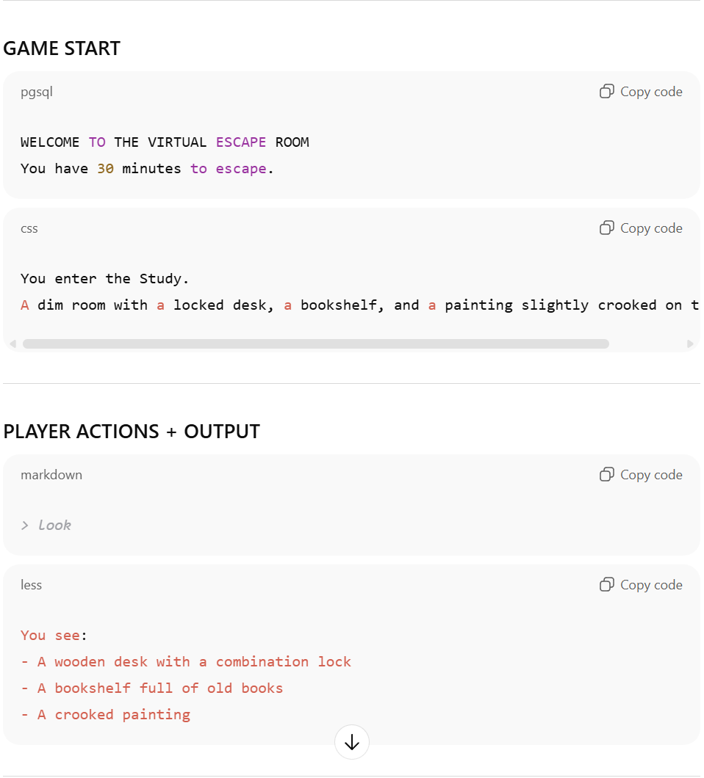
____________________________________________________________________________________
Example Game Flow
- Player enters a room
- Player inspects the room
- Player picks up clues
- Player attempts puzzle
- Solving puzzles unlocks rooms
- Final room = escape success
____________________________________________________________________________________
CLASSES-ATTRIBUTES-BEHAVIORS
Player myPlayer = new player ( )
PLAYER
-----------
+Name: string
+Age: int
+Position: string
-inv [ ]
Time:time (30:00:00)
------------
EnterRoom ( )
exitRoom ( )
examineClue ( )
checkInventory ( )
addItemInventory ( )

CLUE
------------
Name: string
Description: string
-------------
Actions:

ROOMS
-------------
Name: string
Description: string
Challenges [ ]
--------------
Actions:

CHALLENGE
------------
Name: string
Description: string
Completion: int
Clue [ ]
--------------
Actions:

GAMEPLAY NOTES
Overall Idea: Player enters caste, has clues and objects, has to complete 4 challenges, one per room to escape
Story Notes: Player enters an old castle stubbled upon while searching for friends who have gone missing (they didn’t escape the castle-if player fails to escape, they are captured with them-END GAME) the door slams behind him. Player enters the foyer, investigates objects (multiple can be inspected), one opens the large oak door at top of staircase-(door will play a lock sound if clicked on- once opened will make sound). Once player
Theme/Title: Old Castle/
Rooms:
- Foyer (entrance room START)
-
- Library (second room)
- You have entered the library-it is covered in spider webs, and the only light is through the large window barley covered by fallen drapes.
- You see a large old bookcase
- Dungeon (last room)
-
Challenges:
- Foyer Challenge:
- Once completed: “A large oak door opens at the top of the grand staircase- you enter”

- Library Challenge:
-start: The large oak door creaks as it opens (insert door opening noise)
-
-Once Completed: “(what player does to unlock door)…the large bookcase slides to the slide revealing a spiraling dark staircase leading down- you follow it to the end of the stairs till you see a larger room…”

- Dungeon Challenge:
-start: “… the room is barely lit with various flame torches
-Once completed “You uncover/find a set of hatch doors-hoping they head outside you use the key you have found to unlock the large p
Clues (in each room) (player must inspect each to move on):
Foyer:
- Large chest
-When inspected: “You see a large chest on the ground to your right-you open it to find its mainly empty except

Library:
-Book (in book case) contains a hint(display hint once player inspects book): “”-player keeps paper in inventory.

Dungeon:

