Saurabh Raj Singh 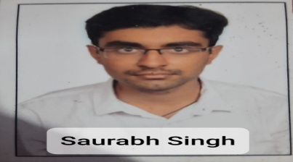

[10janraj@gmail.com](mailto:10janraj@gmail.com) 8840538840 <https://www.linkedin.com/in/saurabh-singh-mern-stack-qa-tester/>

# PROFILE

Looking for a MERN stack engineering role to utilize my background and experience as a software engineer.

# PROFESSIONAL EXPERIENCE

**Full Stack Web Developer** 02/2021-06/2021

Full Stack Web Developer- Intelliplanar Company on Contract Basis

Worked on Social Networking Site with complete knowledge of MERN Stack

Developed and Implemented responsive user interface using React Js Components

Wrote application interface codes using JavaScript following react.js workflows.

**Full Stack Web Developer Trainee** 01/2021 – 04/2021

## OTT App Tester

OTT App Tester- Zee Entertainment Enterprises Limited

Performed manual testing on Zee5 App Globally on Web, Android, and Connecting Devices.

Worked on Jira to create bugs and ticket status.

Smoke Testing, Sanity Testing, Regression Testing functional and ad-hoc testing. Curated Test Reports and bug findings in Reports.

Increased efficiency by 25% through defect Reporting, defect tracking and defect reproducing.

Took logs using Fiddler for the entire Application.

12/2019 – 02/2021

Hyderabad, India

## Grocery App

Built a grocery app Technologies used:

# PROJECTS

01/2021 – 04/2021

Front-End: JavaScript, ReactJs, HTML, CSS, Bootstrap.

Back-End technologies and Database: Node.js, Express.js and MongodB Built the app along with 4 team members

MERN (MongoDB, Express.js, React and Node.js) stack

HTML,CSS,Bootstrap Data Structures

# SKILLS

JavaScript C

Core Java

    

**Bachelor of Technology- CSE,** *ICFAI University*

Hyderabad. CGPA 7.5

# EDUCATION

07/2015 – 12/2019