**The ICFAI Foundation for Higher Education, Hyderabad**

**Faculty of Science and Technology**

**Registration form for Campus Placement Activity, 2018-19\***

**Name: Branch:**

***Father’s Name :Saurabh Raj Singh***

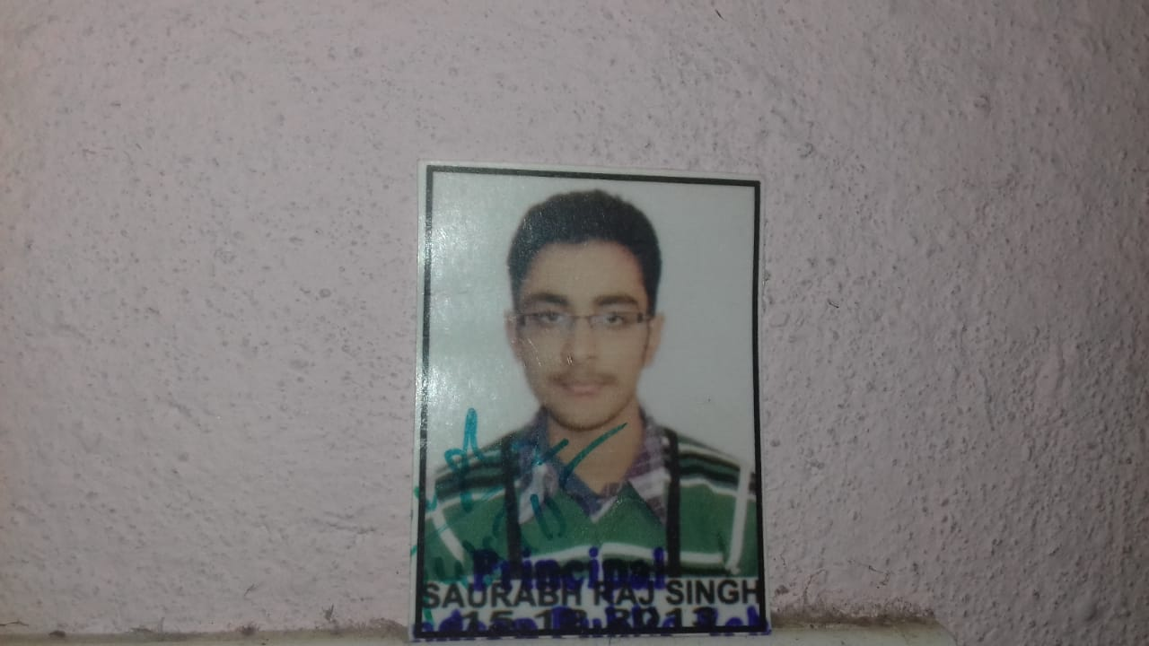

Paste your recent photograph

***Email Id :10janraj@gmail.com***

***Contact Number :8840538840***

***Date of Birth :10 January 1997***

***Address :Sh-3/1a,7k,Vishwanathepuri Colony,Navalpur***

***Basahi,Varanasi,U.P***

***(Any change in the above details should be furnished immediately to the Placement Cell)***

***A. Academic details:***

|  |  |  |  |  |
| --- | --- | --- | --- | --- |
|  | **Year of Passing** | **Name of Board/University** | **% ge / CGPA** | **Backlogs (if any)** |
| **10th Class** | **2012** | **CBSE** | **9.0 CGPA** |  |
| **12th Class** | **2014** | **CBSE** | **85.5%** |  |
| **B. Tech** | **2019** | **IFHE University,Hyderabad** | **8.33 CGPA** |  |

***B. Project Work Details –***

***Title:***

***Portfolio website***

***Whatsapp Webpages***

***Design Navigationbar,Accordian Collapse menu,modal***

***Guide:***

***edwisor.com***

***Youtube videos***

***Co -Guide: edwisor mentor***

***Place of Work:***

***Home based online study***

***C. Any other Program / Course attended, other than the present one –***

***(a) Professional***

* ***Attended workshop on IOT held on 23 June 2017 at Aptron Solutions Pvt. Limited.***
* ***Participated in Aavahan 2K16 in college.***
* ***Participated in Web Designing and Hosting at college on 14th October 2017.***

***(b) Soft Skills***

* ***Setting Goals***
* ***Decision-making***
* ***Time Management***

***D. Your Area/s of professional interest – (Indicate specific functional area of interest. Highlight any niche talent/ knowledge within the functional area where you have additional strength)***

***Coding Skills.***

***E.***

***Strengths:***

* ***I have very positive attitude.***
* ***I used to make good friends.***
* ***I have strong analytical skills and I have desired to learn.***

***Weaknesses:***

***I do not easily give up on things though sometimes I know I couldn't complete the task I'll try until the end***.

***Upon filling this format, I do hereby confirm that I will be attending all the placement drives arranged by the University for which my name will be shortlisted. Further, I do hereby state that I have gone through the placement regulations provided by the University for the year 2018-19 and abide by the same.***

**Signature**

**Saurabh Raj Singh**

**Name: Saurabh Raj Singh**

**Enrolment No:15stuhhcs0109**

***\* It is mandatory for students interested in placements to fill this form and submit to the Placement cell at the time of 7th semester registration on 16th July 2018***

***Also, please mail a copy of this format to the Placement coordinator, FST on placement.fst@ifheindia.org***