1. In the below elements which of them are values or an expression? eg:- values can be integer or string and expressions will be mathematical operators.

*

'hello'

-87.8

-

/

6

* Operators: +, -, *, /
* Values: 'hello', -87.8,6

2. What is the difference between string and variable?

* A string is a literal text string, i.e. 'Hello'. We can declare a string using single, double or triple quotes
* A variable is something that stores data - it can store a string, int, float, class, etc.

3. Describe three different data types.

* **int, or integer**: a number without a fractional part. savings, with the value 100, is an example of an integer.
* **float, or floating point**: a number that has both an integer and fractional part, separated by a point. E.g. 1.2, 1.0
* **str, or string**: a type to represent text. You can use single or double quotes to build a string. E.g. “Sudh”
* **bool, or boolean**: a type to represent logical values. Can only be True or False (the capitalization is important!).

4. What is an expression made up of? What do all expressions do?

* Expression is made up of values, containers, and mathematical operators (operands) e.g   a = 2 + 3     and expressions are used to evaluate the values or represent the result on the screen.

5. This assignment statements, like spam = 10. What is the difference between an expression and a statement?

* Expression is made up of values, containers, and mathematical operators (operands) and the statement is just like a command that a python interpreter executes like print.

6. After running the following code, what does the variable bacon contain?

bacon = 22

bacon + 1

* it gives 23 as execution code

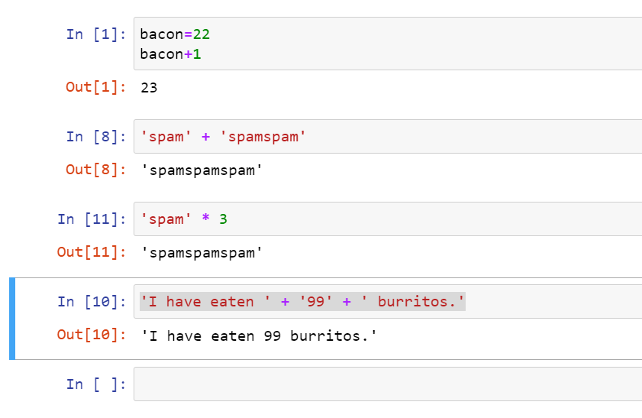

7. What should the values of the following two terms be?

'spam' + 'spamspam'

'spam' * 3

* ‘spamspamspam’
* ‘spamspamspam’

8. Why is eggs a valid variable name while 100 is invalid?

* A variable name must start with a letter or the underscore character
* A variable name cannot start with a number

9. What three functions can be used to get the integer, floating-point number, or string version of a value?

* Integer — int()
* Floating-point —float()
* String — str()

10. Why does this expression cause an error? How can you fix it?

'I have eaten ' + 99 + ' burritos.'

* “99” is an integer and not a string, so the operations are incompatible until “99” is converted into a string. Fix: use str() to convert “99” to a string.