1.What are the two values of the Boolean data type? How do you write them?

* Booleans represent one of two values: True or False.
* The **bool()** function allows you to evaluate any value, and give you **True or False** in return.
* 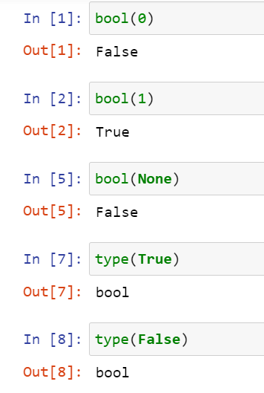
* 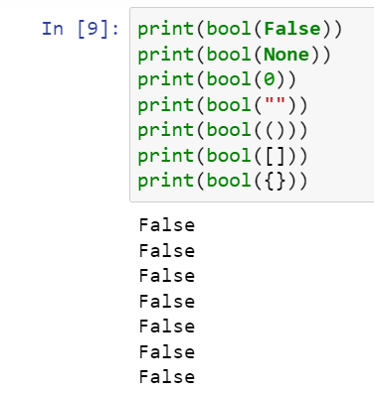

2. What are the three different types of Boolean operators?

* The three basic boolean operators are: **AND, OR, and NOT**

3. Make a list of each Boolean operator's truth tables (i.e. every possible combination of Boolean values for the operator and what it evaluate).

|  |  |  |  |  |  |  |  |
| --- | --- | --- | --- | --- | --- | --- | --- |
| Boolean Operators | | | | | | | |
| AND | | | OR | | | NOT | |
| A | B | A AND B | A | B | A OR B | A | NOT A |
| TRUE | TRUE | TRUE | TRUE | TRUE | TRUE | TRUE | FALSE |
| TRUE | FALSE | FALSE | TRUE | FALSE | TRUE | FALSE | TRUE |
| FALSE | TRUE | FALSE | FALSE | TRUE | TRUE |  |  |
| FALSE | FALSE | FALSE | FALSE | FALSE | FALSE |  |  |

4. What are the values of the following expressions?

(5 > 4) and (3 == 5)

not (5 > 4)

(5 > 4) or (3 == 5)

not ((5 > 4) or (3 == 5))

(True and True) and (True == False)

(not False) or (not True)

* 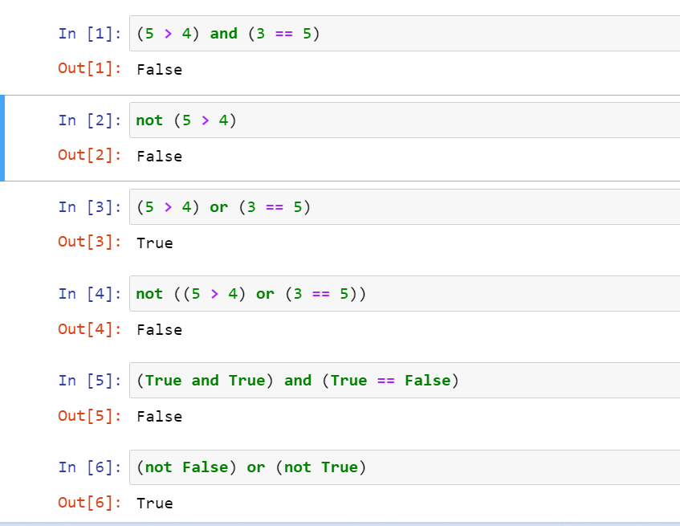

5. What are the six comparison operators?

|  |  |  |
| --- | --- | --- |
| **Operator** | **Name** | **Example** |
| == | Equal | x == y |
| != | Not equal | x != y |
| > | Greater than | x > y |
| < | Less than | x < y |
| >= | Greater than or equal to | x >= y |
| <= | Less than or equal to | x <= y |

6. How do you tell the difference between the equal to and assignment operators?Describe a condition and when you would use one.

* [The “=” is an](https://www.geeksforgeeks.org/operators-c-c/)[assignment operator](https://www.geeksforgeeks.org/assignment-operators-in-c-c/) is used to assign the value on the right to the variable on the left.

For example:

a = 10;

b = 20;

* The ‘==’ operator checks whether the two given operands are equal or not. If so, it returns true. Otherwise it returns false.  
  For example:

5==5

This will return true

7. Identify the three blocks in this code:

spam = 0

if spam == 10:

print('eggs')

if spam > 5:

print('bacon')

else:

print('ham')

print('spam')

print('spam')

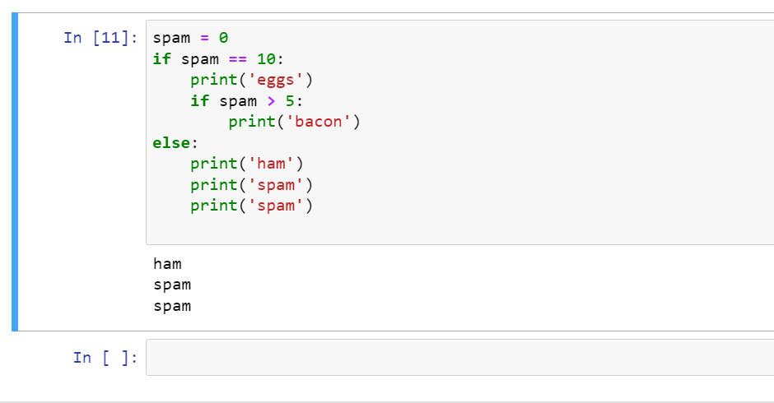

8. Write code that prints Hello if 1 is stored in spam, prints Howdy if 2 is stored in spam, and prints Greetings! if anything else is stored in spam.

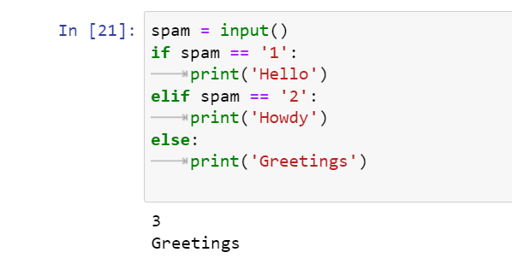

9.If your programme is stuck in an endless loop, what keys you’ll press?

* Ctrl + C .

10. How can you tell the difference between break and continue?

* With the **break** statement we can stop the loop before it has looped through all the items.
* With the **continue** statement we can stop the current iteration of the loop, and continue with the next

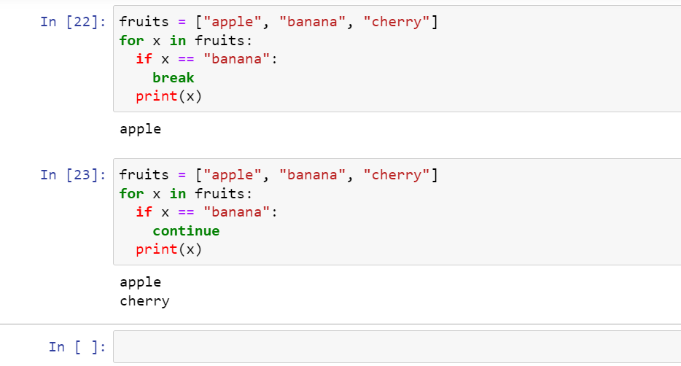

11. In a for loop, what is the difference between range(10), range(0, 10), and range(0, 10, 1)?

* function returns a sequence of numbers,starting from 0 by default,increments by 1 (by default),and ends at a specified number.

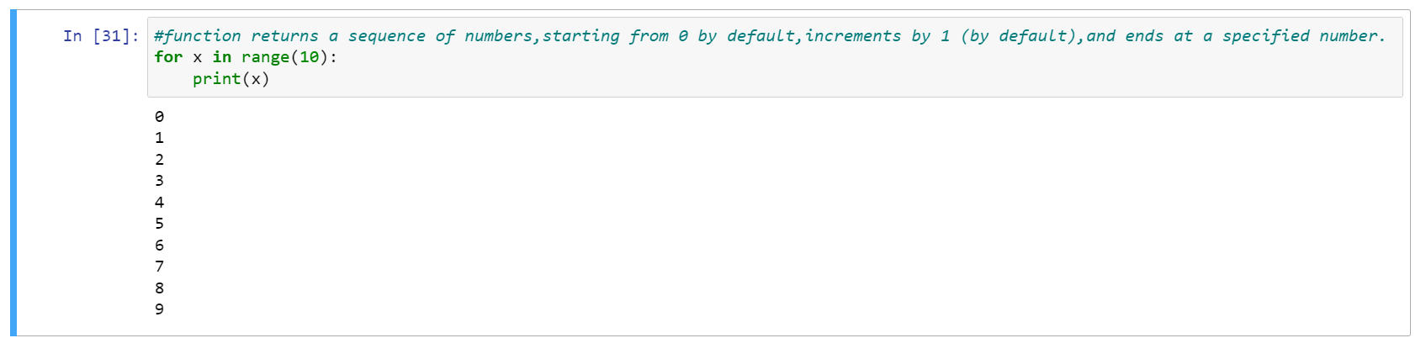

* # function defaults to increment the sequence by 1

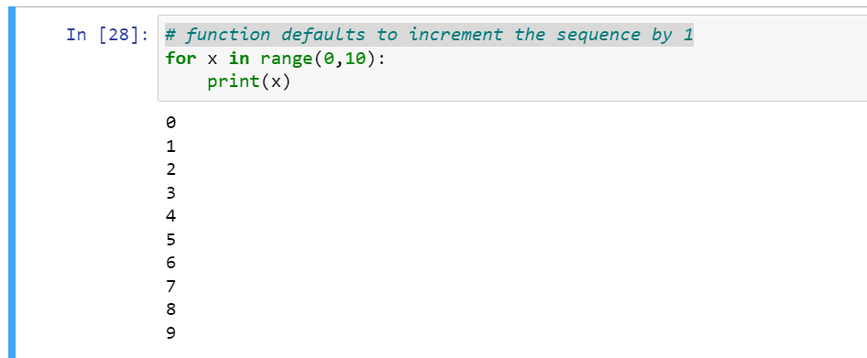

* #Increment the sequence with 1 (star,stop,step)

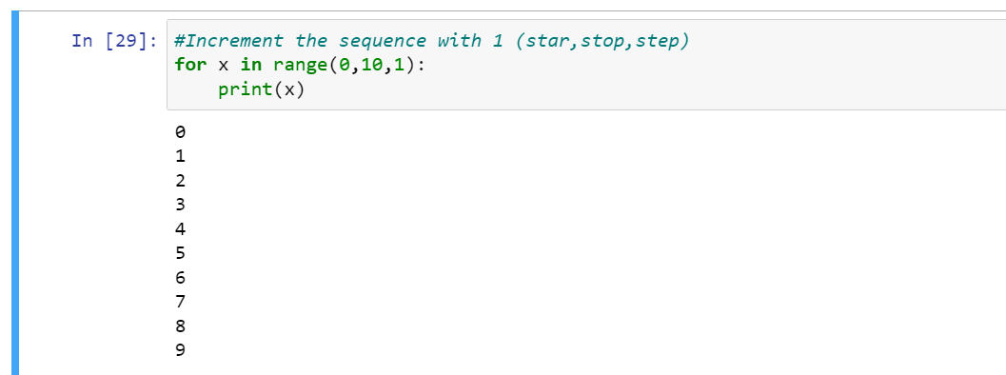

12. Write a short program that prints the numbers 1 to 10 using a for loop. Then write an equivalent program that prints the numbers 1 to 10 using a while loop.

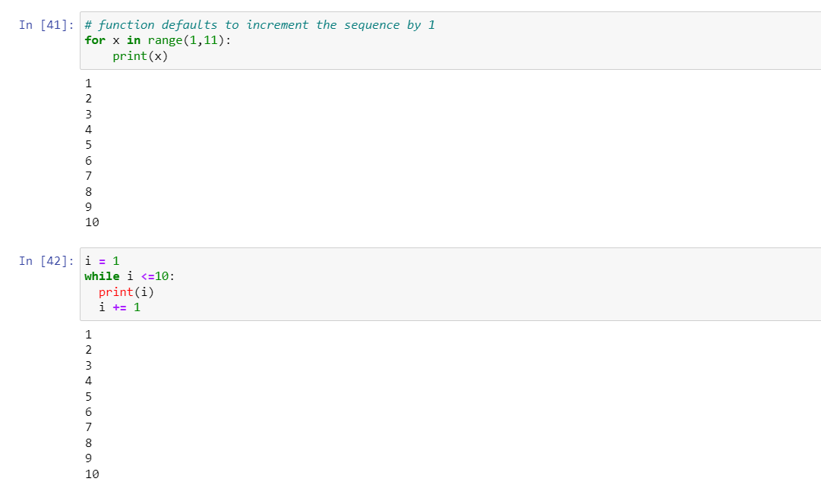

13. If you had a function named bacon() inside a module named spam, how would you call it after importing spam?

* Spam.bacon()