TRAFFIC MANAGEMENT SYSTEM

TEST CASES :
1) Adding new vehicle to queue . 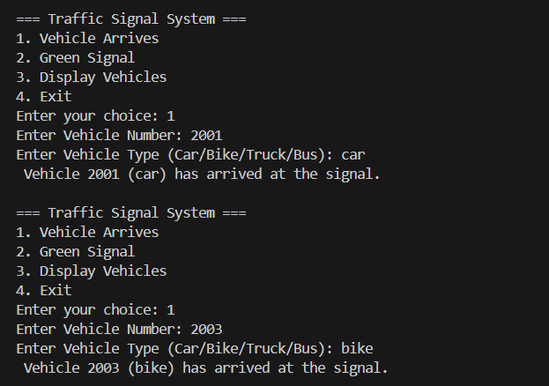

2) Display all Vehicles in queue .
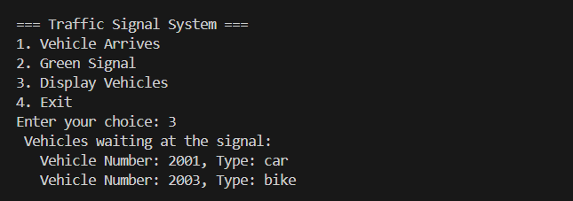

3) Green signal for waiting vehicles .
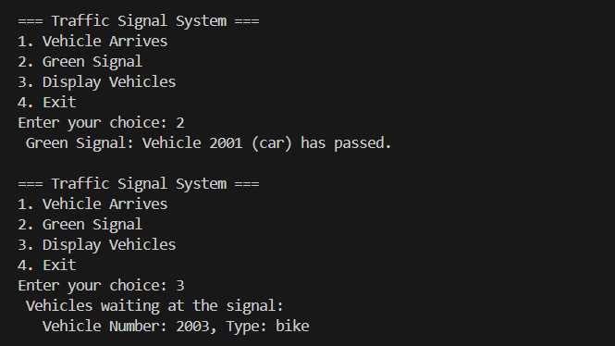

4) Clear all waiting vehicles and Exit .
