Cucumber-Driven-Framework

# Purpose

This document provides step by step instruction for implementing framework.

# Pre-requisites

The user is expected to have basic knowledge on Automation Testing.

# Execution Configuration

## Working with TestNG suite files for browser Automation

We have TestNG XML suite file in the framework under src/test/resources package.Configure testng.xml file with all required Test case, Test suite details.

* For browser Automation, set the following as,
* ExecutionMode – LOCAL
* Browser – CHROME/ FIREFOX/ SAFARI/INTERNET_EXPLORER
* Pass the parameters and call the test classes to be executed as below,

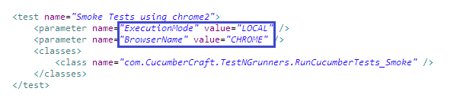

# Working with Mobile Automation using Appium

## Working with Mobile Automation Setting properties

All details of Application & Appium has to be mentioned under Mobile Automation Settings property file as below,

* + - **AppiumURL**: Please provide the Appium running URL, generally it will be http://127.0.0.1:4723/wd/hub
    - **Application_Package_Name**: Provide the Package Name of Android Application
    - **Application_MainActivity_Name**: Provide the Main Activity Name of Android Application.
    - **iPhoneApplicationPath**: Provide the Application path of iOS Application.
    - **iPhoneBundleID**: Provide the iOS application bundle ID.

## Working with TestNG Suite files for Mobile Automation

Configure testng.xml file with all required Test case, Test suite details for Appium automation, do the following

* ExecutionMode – MOBILE
* MobileToolName – APPIUM
* MobileExecutionPlatform - ANDROID/IOS/WEB_ANDROID/WEB_IOS
* DeviceName – Provide the respective device serial name or UDID

