Modular-Driven-Framework

# Purpose

This document provides step by step instruction for implementing framework.

# Pre-requisites

The user is expected to have basic knowledge on Automation Testing.

# Execution Configuration

## Working with Run Manager Workbook

* Configure the Run manager with all required details such as Test Scenario, TestCase, Test Instance, Iteration, and TestConfigurationID.

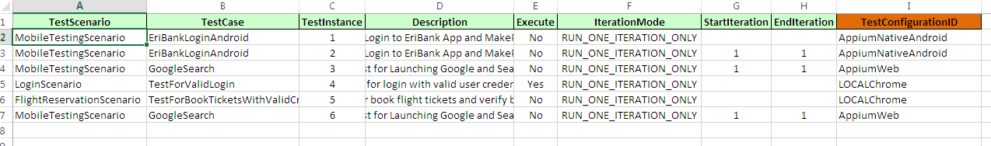

* The TestConfigurationID’s are prepopulated from TestConfigurations Sheet. All Configuration Details are abstracted in separate sheet. Please refer to section 3.3 for Parameters & possible values.
* For browser automation, set the following as,
  + **Execution Mode** – LOCAL
  + **Browser** – CHROME/FIREFOX/CHROME_HEADLESS/

INTERNET_EXPLORER

* + **BrowserVersion** – This option is applicable only when ExecutionMode=GRID.

## Work with TestConfiguration Sheet

* TestConfigurations Sheet contains all execution details mapped to a TestConfigurationID.
* Any New Test Configuration can be added.
* The TestConfigurationID should be Unique Name. The TestConfigurationID can be referred within your Suite Sheets like Regression, Sanity.

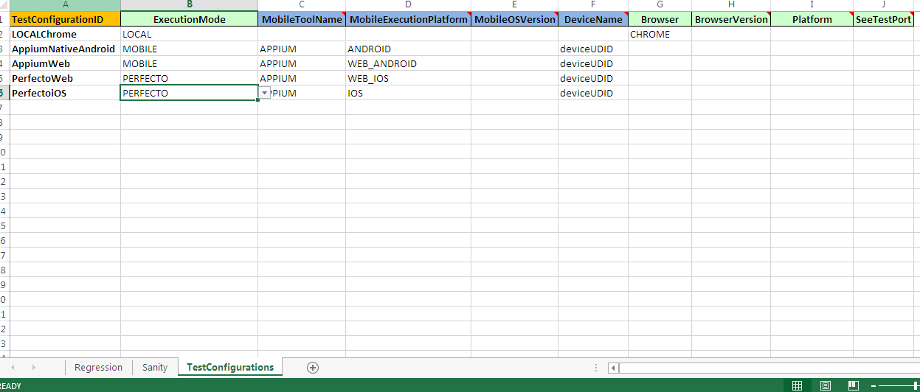

|  |  |  |
| --- | --- | --- |
| Column Name | Possible values | Additional Details |
| TestConfigurationID | Any Valid Unique Name – Should Explain the Respective Configuration |  |
| ExecutionMode | |  | | --- | | LOCAL | | REMOTE | | LOCAL_EMULATED_DEVICE | | REMOTE_EMULATED_DEVICE | | GRID | | MOBILE | |  |
| **MobileToolName** | |  | | --- | | DEFAULT | | APPIUM | | REMOTE_WEBDRIVER | | These Values Depend on the ExecutionMode |
| **MobileExecutionPlatform** | |  | | --- | | ANDROID | | IOS | | WEB_ANDROID | | WEB_IOS | |  |
| **MobileOSVersion** | Version of the Device | Optional value |
| **DeviceName** | Device Name/UDID |  |
| **Browser** | |  | | --- | | CHROME | | FIREFOX | | INTERNET_EXPLORER | | For Mobile it will take default CHROME for Android & SAFARI for iOS. |
| **BrowserVersion** | Version of the browser | Applicable only if ExecutionMode is GRID, also wanted to test for different versions of Browser |
| **Platform** | Platform of OS | Applicable only if ExecutionMode is GRID |

## Points to be noted while using Actions, JavaScriptExecutor, findElements

As Framework implements dynamic polymorphism and we use CustomeWebDriver on Top of all the WebDriver implementation. We would some time required to pass original driver object for few of the implementation like Actions, JavaScriptExecutor.

* To achieve this, use driver.getWebDriver () instead of driver.



# Working with Mobile Automation using Appium

## Working with Mobile Automation Setting properties

All details of Application & Appium has to be mentioned under Mobile Automation Settings property file as below,

* + - **AppiumURL**: Please provide the Appium running URL, generally it will be http://127.0.0.1:4723/wd/hub
    - **Application_Package_Name**: Provide the Package Name of Android Application
    - **Application_MainActivity_Name**: Provide the Main Activity Name of Android Application.
    - **InstallApplicationInDevice**: Helps to install App from below Path into the respective Device
    - **AndroidApplicationPath**: Provide the Application path of Android Application.
    - **iPhoneApplicationPath**: Provide the Application path of iOS Application.
    - **iPhoneBundleID**: Provide the iOS application bundle ID.

## Working with Run Manager for Mobile Automation

Configure the Run manager with all required details such as Test Scenario, TestCase, Test Instance, Iteration, and TestConfigurationID.

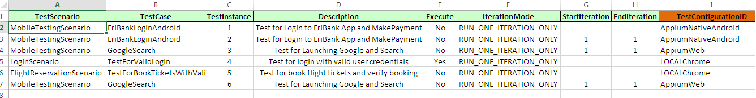

For Appium automation, please change configure as following within TestConfigurations Sheet

* ExecutionMode – MOBILE
* MobileToolName – APPIUM
* MobileOSVersion - Optional
* MobileExecutionPlatform - ANDROID/IOS/WEB_ANDROID/WEB_IOS
* DeviceName – Provide the respective device serial name or UDID

