**Product Analysis**

**Metrics**

- Measurement of an action taken or not taken by the user.

- Ratio/ Rate, which is understandable, measurable, and comparative.

**ACTIVITY**

**AMAZON**Amazon - Hidden meaning of 11 world's most famous logos ...

**Action Metric**

The sales team is onboarding vendors Sellers are onboarded per day

People are making payments MMR (Monthly Recurring Revenue)

**

**Action Metric**

Scanning QR Code to make payment QR code scans per day

User is paying electric bill # of users using Gpay for bills

**FACEBOOK** 

**Action Metrics**

Watching reels before going to bed # of reels watched last night’s hours

Trying to hack your ex’s account # of hack attempts per day

**Blinkit**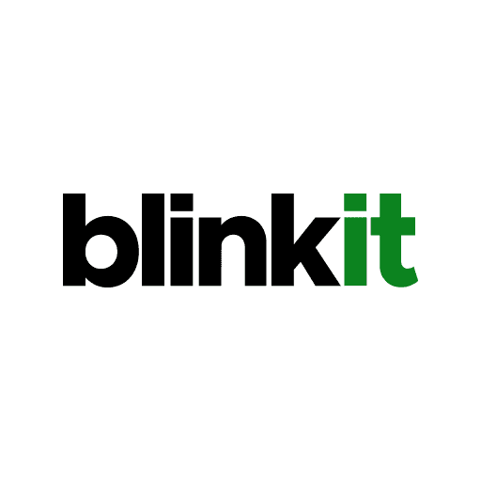

**Action Metrics**

Putting things in the cart in the night Cart addition to transaction waiting time

for checkout tomorrow morning

Removing items from Cart because Items removed from the cart

You exceeded the 20 kgs order capacity

**AARRR/ARM FRAMEWORK**

**Product Metrics**

- Acquisition: User has just landed into the product – App Downloads, Sign Ups, Subscribing to a newsletter

- Activation: User has started using your product – Made first transaction (Grow), First 2000 messages (Slack)

- Retention: User is coming back to use your product – SIPs are regularly made (Grow), Repeat Purchases (Amazon)

- Revenue: User has started referring the product in his/her network – Acquisition via Referrals, Word of Mouth (WoM)

- Referral: User has made a purchase in the product- In-app purchase (Oyo/PUBG), Subscription (Netflix, ordering an item (FlipKart)

**User Metrics**

- User metrics are the ones that help us measure the user experience and interaction across multiple phases of a product and tell us how customers perceive our product.

* Churn Rate

* Retention Rate

* Engagement Time

* Acquisition via Referrals

**Business Metrics**

**-** Business metrics are the ones that help us measure the performance of our business and the impact of product stage and user experience on our business

* Revenue

* Customer Acquisition Cost

* Growth Rate

* Net Profit Margin

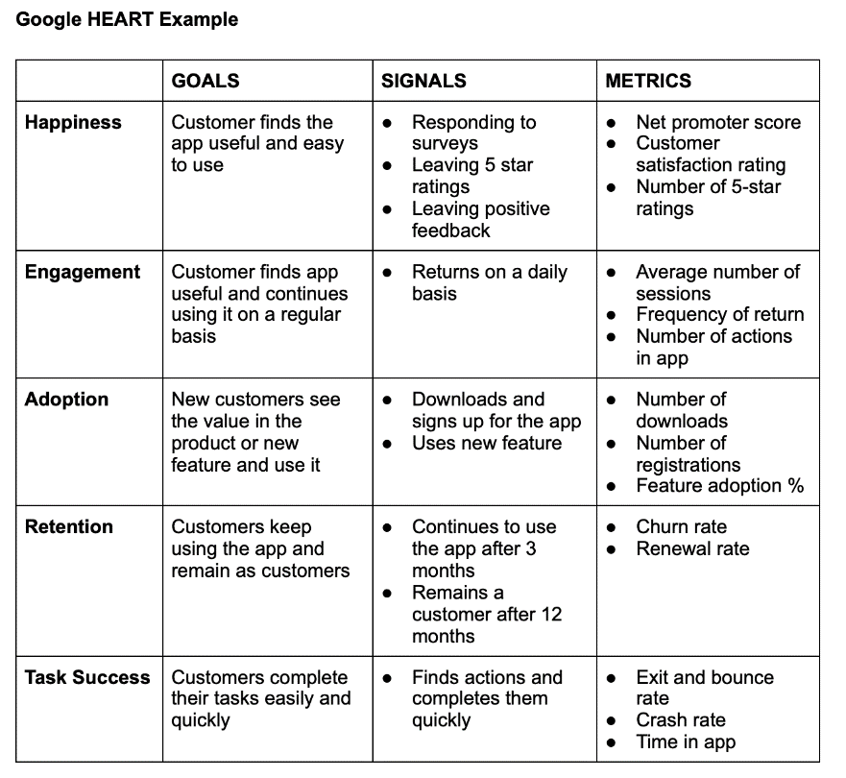

**Vanity vs. Success Metrics**

Metrics are just data but need to provide an output of what could be done from this data.

- Number of customers visiting my website – what if they are doing nothing or half of them are bots?

- Number of social media followers- what if they all were made to follow you by a social media intern you hired?

**Proxy Metrics**

Metrics that can suggest the potential of your product but without any strong evidence

- Number of Free E-book downloads – what if your title was catchy, but your content was very poor?

- Number of people showing interest in your event or PR release – FOMO?

**Success Metrics**

Key Performance Indicators (KPIs) that help you measure the user, business, and product performance

- User KPIs

- Business KPIs

- Product KPIs

