**Technical Product Manager**

**Software – What, why, and How**

**How software works**

Set of instructions, data, or programs used to operate computers and execute specific tasks.

**Modules in a Software**

**-** Logic – the reason behind building

- Data

- API

- Algorithm

**Building Algorithms**

**-** An algorithm is a sequence of instructions that must perform to solve a well-formulated problem.

- It is a method of translating inputs into outputs.

- An algorithm correctly translates every input instance into the correct output. An algorithm is incorrect when there is at least one input instance for which the algorithm gives an incorrect output.

- **Pseudocode** is a way of listing steps that the algorithm takes while being neither too vague nor too formal. For example, the pseudocode to cook Maggi could look like this:

* Put water in a pan.

* If (Water = boiling)

- Add Maggie Masala

- Add Maggie

* Keep flame on until cooked

* Switch off the flame

**Designing a basic algorithm**

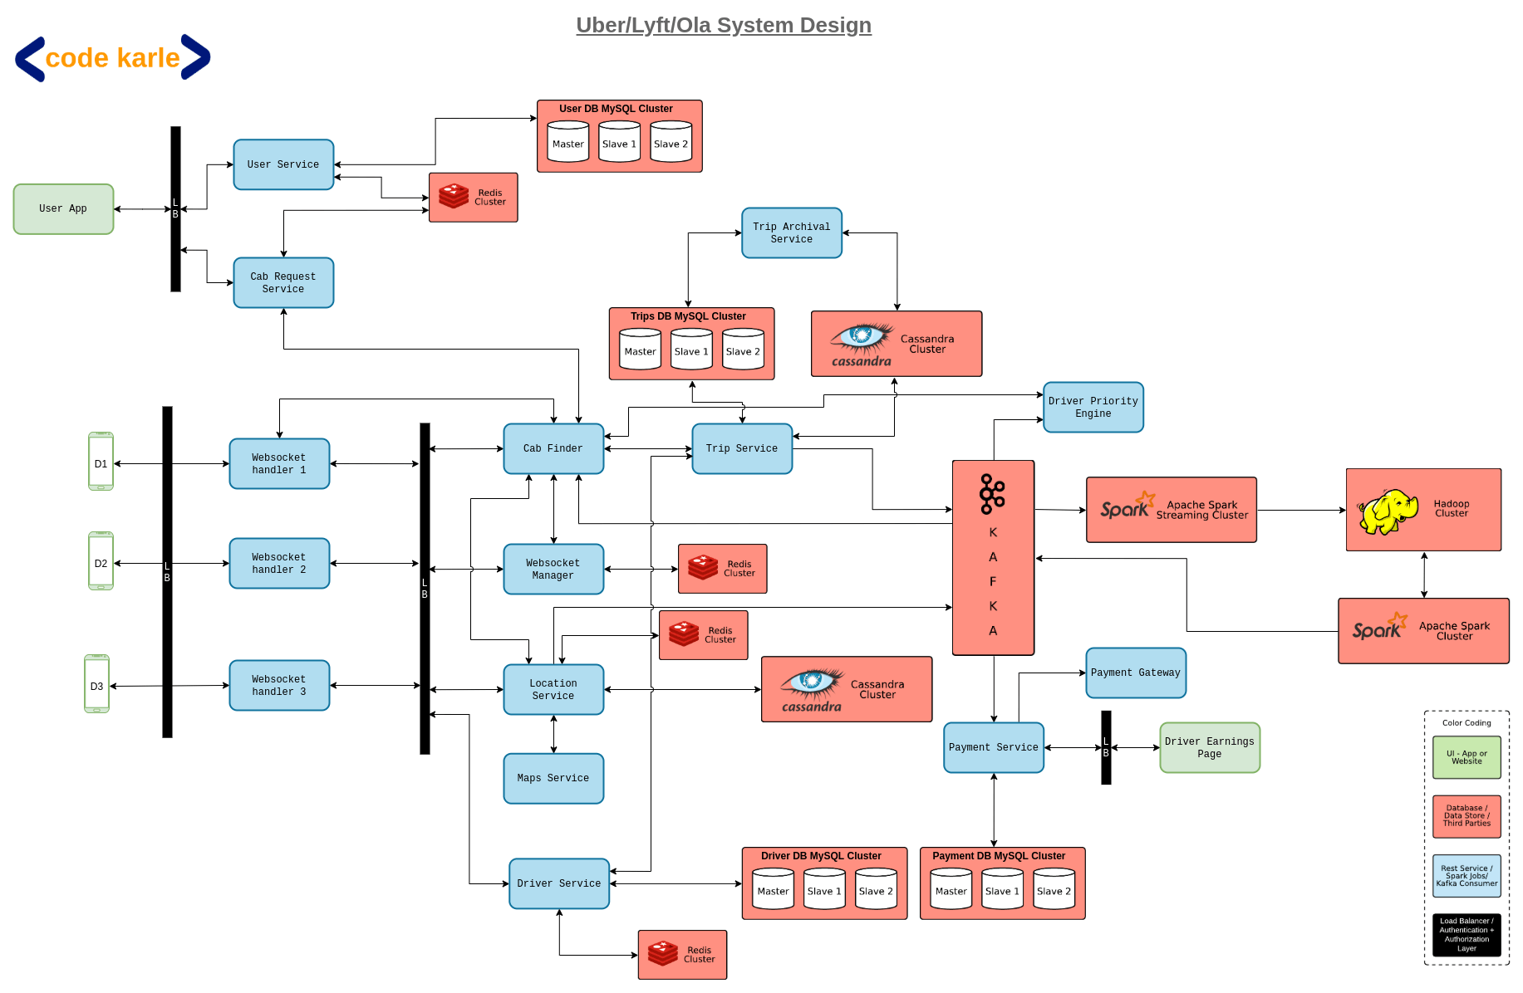

**Data**

Data is a collection of a distinct small unit of information. A database is an organized data collection that can be easily accessed and managed.

**Types of data and databases:**

- Structured vs. Unstructured data

- DBMS (Database Management System)

- Relational Database (RDBMS)

- SQL Databases

- NoSQL Databases

How would the driver data be fetched from the database while booking a cab?

**API**

Request and response between App X and App Y.

- Application Programming Interface (API) is a software intermediary that allows two applications to talk to each other.

- It is a messenger that delivers your request to the provider you are requesting it from and then delivers the response back.

- It is independent of the programming language.

- API operations could include –

* Reading the requested data (GET)

* Creating a new record (POST)

* Updating an existing record (PUT)

* Deleting an existing record (DELETE)

APIs Examples

1. User Authentication

2. Payment and Pricing

3. Query/ Search

4. Recommendation

**Let’s discuss API calls for a Ride Sharing App**

**User Related:**

- User Authorization

- Get a User Profile

- Get User Trip History

- Get Requests

**Product Related**

- Get Products [Uber Pool, Uber Auto, Uber Premium, etc.]

- Get Estimated Time

- Get an Estimate Price

**Create Ride Request**

**-** Estimate

- Start Location

- End Location

- Fare ID

**Ride Status**

- Get Trip Status

**What is the role of a TPM in all of this?**

- Customer-Centric Approach – Helping the tech team understand WHY something needs to be built

- Understand both customer pain points and technical team efficiency to solve WHAT needs to be built

- Working with technical teams to understand WHEN to release features in the market

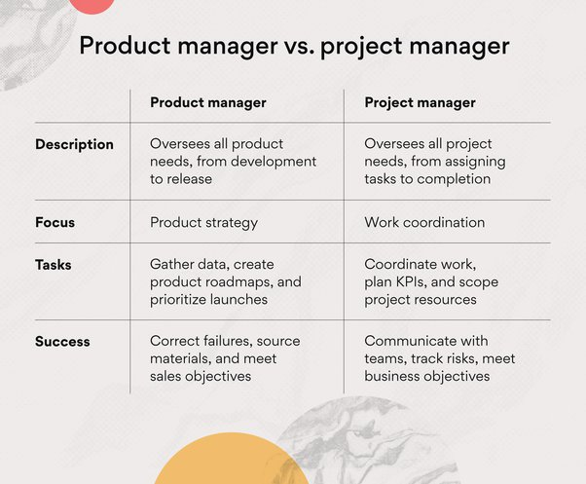

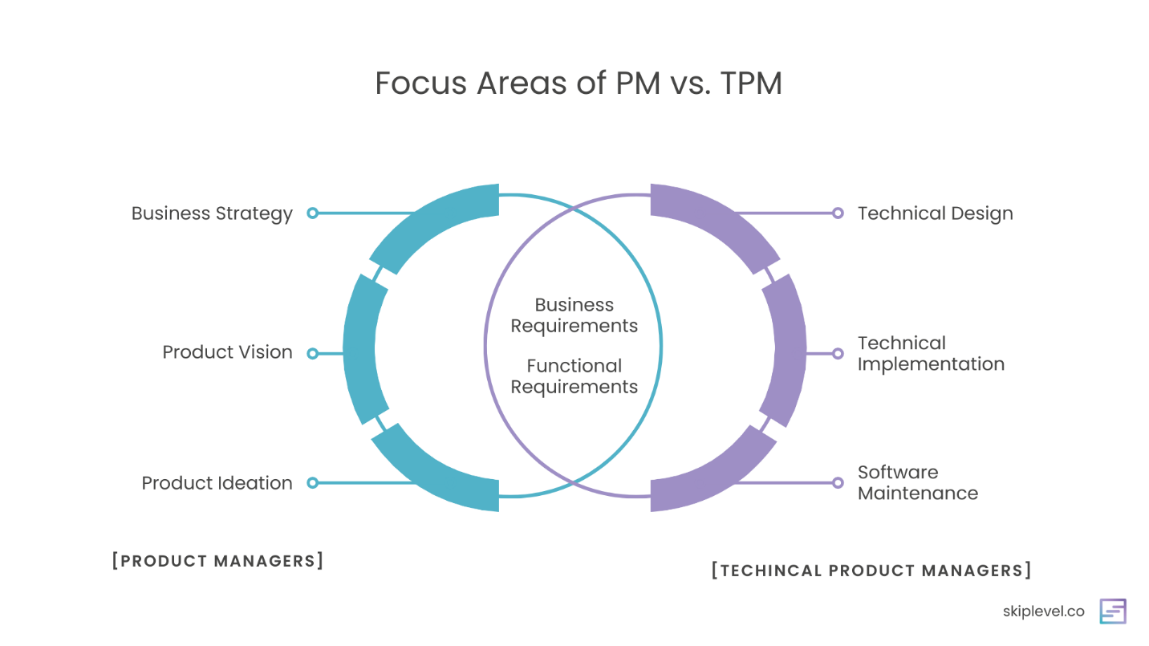

**AI – ML for Product Managers**

An “intelligent” computer uses AI to think like a human and perform tasks on its own. Machine Learning is how a computer system develops its intelligence.

**When to use ML**

**-** Complex problem solving

- Volume of data is large/growing fast

- Personalized experience is needed

- Some errors are acceptable in the output

- Training data is high-quality: complete, clean, unbiased

- Training data can be used w/o impacting privacy

**When not to use ML**

**-** Rule-based approach can be/should be used

- Data that does not change often

- Output accuracy required is 100%

- Interpretability is essential

- Lack of good training data

**Knowledge Check Activity**

***Which problems are good candidates for an ML-based solution?***

1. Which videos on a streaming platform should be marked ‘kid safe.’

- Accuracy required is 100%

- Initial screening can be ML-based, and final screening requires Human intervention

2. Which resumes should be shortlisted for interview

- Is the volume of data going to be large?

- Will the ML training be bias-free (such that it can pick from a diverse set of candidates)

**3. Which products will sell in high volumes during the next holiday season**

- Is the volume of sales data extensive?

- Availability of clean Data

- Is this a complex problem? (Many data points to consider (past sales, external factors such as weather data, demographic data, etc.)

4. In which city should we open a warehouse in Eastern India

- Is the volume of sales data large?

- Is the data changing/variable data?

- Is this a complex problem? (Many data points to consider?)

**5. Which product should be shown in the “you may also like” widget based on past purchase history**

**-** Is volume data changing fast?

- Is the volume of data large?

- Personalization?

**How Does Google Search Work?**

**Solve this! –** You are working as a Product Manager with Flipkart. How will you improve the Search feature?