**Skills of Product Management:**

**1. Personal: Empathy, Interpersonal Skills, Team Management**

Understand the customer’s pinpoints by being in the customer’s shoes. Should be good at interpersonal skills.

**2. People: Stakeholder Management, Communication, Leadership**

Extremely good at communicating vision.

**3. Process: Context, Analytical Thinking**

**4. Product: Industry Knowledge, Product Lifecycle, Technical Knowhow**

Product as a skill. Understand the industry. Knowledge about all the happy and unhappy flows. It is not only the functional flow part but also the technology flow part. PM does not code but should be very well versed about how the has been written. Should know how the technology work behind the scenes.

**5. Project: Planning, Monitoring**

PM is about getting the fixed work done within the cost and timelines in the best possible fashion.

---

**First Principal Thinking**

Thinking by the roots. Thinking by the fundamentals rather than through analogy.

---

**Product Lifecycle and Its Stages**

Problem Space (DISCOVER & DEFINE) & Solution Space (DEVELOP & DELIVER)

Engineers and Scientists – start thinking about solutions when given a problem.

Whenever it comes to PM, it must be 50-50. Whenever a problem is given, we must think and ask why. Think more about the problem and less about the solution.

(5 Whys)

(Double Dimond Framework)

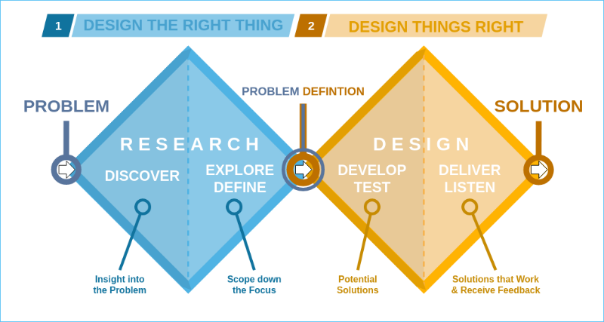

---

**Product Development Process:**

**Conceive:** Ideas are born, market and user research are done, problem and solution space are defined, and a product concept is finalized.

Example: Google Maps

**Plan:** Launch planning is done, marketing and communication strategies are made, and the product is launched.

**Develop:** Wireframes, mark-ups, prototypes are built, sprints are executed, and testing is done.

* Follow Agile or waterfall. Writing the code by developers through sprints. Finally, realizing the product.

**Launch:** Launch planning is done, marketing and communication strategies are made, and the product is launched.

* How we can attract users. How can we sell this product to the right customers?
* Expose this product to 20% and extend it to a large population.

**Refine:** Understanding the usage and likeability of your product, how it can be improved, and what to build next.

* How many people are using the product.
* What customers find helpful and not proper about the product.
* Taking feedback from the customers and putting it back into the product.

**Retire:** End-of-life (EOL) of the product, removing from the market and executing change management.