**Product Management Skills More Learning:**

1. **Product Management Fundamentals**

* **What is a Product?**

There is a consumer problem that must be addressed. If you are solving that problem and delivering that solution to the user, it can also be monetized. The product must be a standardized experience to some degree.

One person responsible for managing the products is called the product manager.

**Customer:**

* What does he want>
* What are his pain points?
* How to make his experience better?

**Business**

* What makes more profit?
* What increases customer LTV?
* LTV – Life Time Value of the Customer

**Technology**

* What can be delivered through technology?
* How can tech be used to solve a problem that isn’t humanly possible?

You are not creating a product for yourself.

**PM Skills:**

* Personal
* People
* Project
* Product
* Process

Product Manager vs. Product Manager

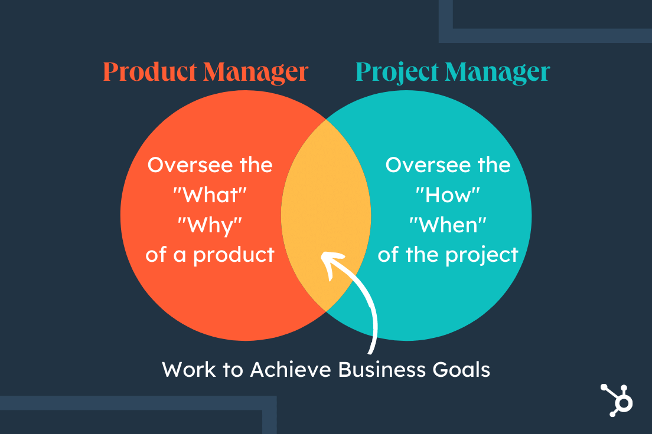

1. **First Principles Thinking**

Difference between the chef and the cook.

* All of us are cooks. Chefs create this thing. He or she understands what spices are and understands what enhances the flavor.
* “A first principle is a basic, foundational proposition or assumption that cannot be deducted from any other proposition or assumption” – Elon Musk.
* You need to bring it down to lowers possible way to the primary component.

**First Principles Thinking**

* Understand the current and desired state.
* Start asking why
* Test Hypothesis
* Iterate
* Go back to step 3 until this hypothesis is validated or invalidated.

New Product Development -> Introduction -> Growth Maturity Decline -> Withdrawal

Commercialization

Operations

1. **Product Lifecycle**

New Product Development -> Introduction -> Growth Maturity Decline -> Withdrawal

Commercialization

Operations

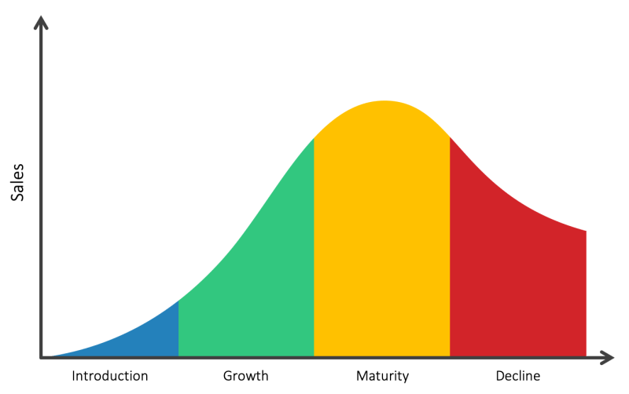

1. **Product Development process using real-time products**

Conceptualize – where ideas are born

Planning – where features are defined and what you want to do. Where user stories are written.

Develop – where most of the work happens, where prototypes are built. Sprints are executed.

Launch – big scale or small scale. Develop the marketing strategy.

Refine – how the product can be improved.

Retire* - End-of-Life of the product.

What can be developed in Uber which is not there in Uber?

**[1] Conceptualize**

Problem 1: Fix the driver of choice.

Problem 2: (Self Drive) Car will be delivered to us.

Problem Statement: who will want this feature?

Why do you not select Uber itself?

Sol: Comfort, privacy, you don’t have to own a car.

**[2] Planning**

**Tech Prospective**

How to deliver value?

Changes in App.

**[3] Develop** different features in App. (Create new UI)

**From an operational perspective:** We still need drivers where drivers can drop the car at home.

**From a development perspective, create a flow for the sprints.**

**[4] Launch and** talk to the marketing team about launching the product. Who is going to be the target segment?

**[5] Refine:** Are people using it? What is the rating? Feedback from customers.

**[6] Retire**