**PRODUCT DESIGN AND USER EXPERIENCE**

- Design: How it works? How it makes you feel? How do you get to experience that product?

The idea behind where makes the product more useful.

-User experience: How visually attractive. How you can navigate and take the decision you want.

The font, visualizations, and animations.

- UX is slightly more important than UI.

**Can you recall products with great design?**

Zoom, Netflix, Amdocs

Yahoo Mail – is very difficult to use. Lotus Notes, Outlook – Not convenient, Gmail – Simple to use.

-Simplify a product to make it simple, like no more buttons for iPhone removing the keypad.

**Can you recall products with bad decisions?**

- TV remote controls. Have so many options—bad design category.

-Should see what the user might experience.

**Understanding UX Experience**

- UX means the overall experience your user feels after using your product.

- UX Design puts users at the center of the product to design any solution.

- UI design, Integration design, and Visual design can impact your overall UX Design.

**Design Thinking**

The process by which we put the users at the center.

**5-stage thinking process:**

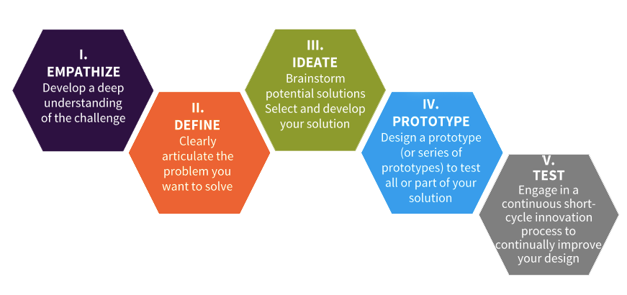

**1. Empathize:**

Your ability to put yourself in the person’s shoes and be able to feel what they might be going through.

* Conducting interviews.
* Bodystroming
* Engaging with Extreme Users
* Five Why Method. Keep finding answers until we get to a conclusion.
* Assuming a beginner’s mindset

**Empathy Maps**

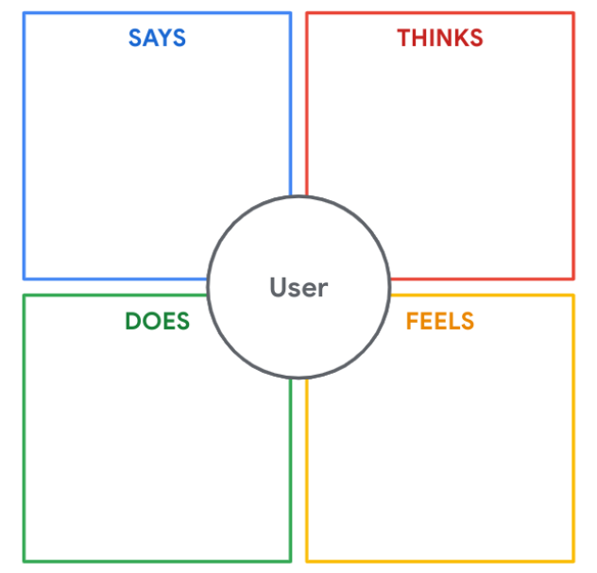

**User Persona –** Visual representation of a typical customer.

**Point of View Statement:**

**[User … (description)]** **needs [Need … (verb)]** because **[Insight … (compelling statement)]**

**Ex-** **A working professional who lives very far away from her office** needs **access to a shared car 8-10 times a week for 40-60 minutes** because **they would rather share a car with more people as this is cheaper and safe.**

***Options for “How might we to statement”***

- How might we give a person access to a shared car when they need it?

- How might we help people feel more comfortable living without a car?

- How might we provide alternative forms of transformation when a car isn’t strictly necessary?

**2. Define:** What exactly is the problem there? Define one or two problems you are going to solve in this design thinking process.

**3. Ideate:** Thinking of possible solutions.

- Brainstorm: The best idea

- Worst Possible Idea

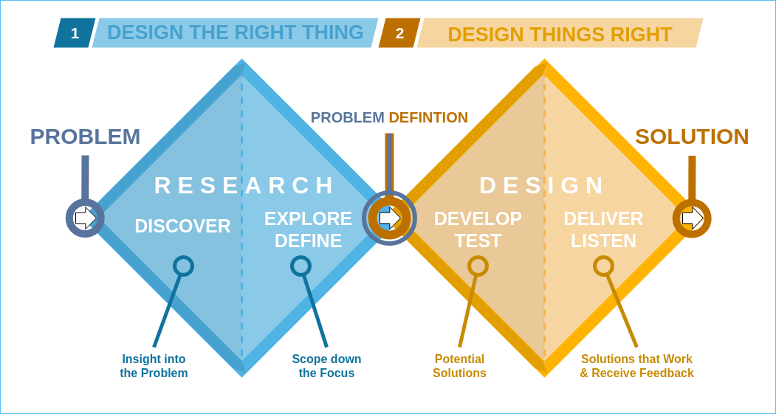

**4. Prototype:** Create a physical prototype that is workable. For digital, create a wireframe that can be given to the user to test.

- Rough sketch of a particular solution.

- Incremental addition to the existing product after thorough review.

**5. Test:** Whatever you have developed, you are putting the user to use it.

- Iterative and Non-linear model.

- You can start from any stage or return to a stage as and when you want.

- You can even run multiple stages in parallel.