**PRODUCE STRATEGY AND ROAD MAPPING:**

**Product Strategy** – Planning short-term and long-term execution plans. How do you want to plan the product development process? Which plan has the highest amount of output?

**Strategy** – Plan to execute something that we believe is true.

Definition – a plan of action or policy to designed achieve a major or overall aim.

Product Strategy and product roadmap are different. Product Strategy is like achieving big goals.

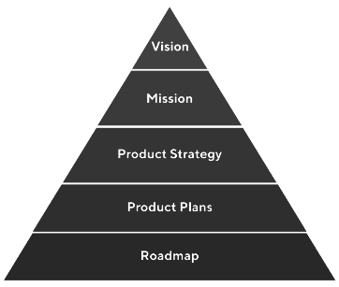

**Roadmap** – What are you doing?

**Mission and Vision** – Comes from CEO, CXO, and VP people sitting at the very top. (What you aspire to be?)

**Execution** – Engineers, Designers.

**PM Vacuum** – Product Strategy and Roadmap.

* Try to take the company's mission and vision, create a strategy and roadmap, and make it easy for the development team to execute to ensure we are moving in the right direction.
* Product Strategy is a bridge between your high-level vision and your roadmap’s specifics.
* It takes you from the current product (where you are today) to the future product (where you will be.)
* Product Strategy is not a straight line but has infinite paths.

HOW TO CHOOSE THE RIGHT PATH AND NOT GET DISTRACTED?

1. Top-down/Bottom-up- strategy – Business strategy vs. Consumer-centric design strategy.

2. Business Strategy:

- Whom am I competing with?

- What are my business objectives?

- How does the company benefit from my efforts?

3. Consumer-centric Strategy:

- Whom am I competing for? (and why)

- What do they care about?

- Why my company and I are the best places to solve this?

**DOES ZOMATO LAUNCH A SOCIAL MEDIA APP?**

What is Zomato’s objective? To attract all foodies coming to the social media app. Which places have better Italian food served?

Interviewer Questions – What is companies’ mission? What is the company’s mission in the coming 5 years? What if social media app is integrated into the whole scheme of things?

**SHOULD APPLE LAUNCH A VALUES-FOR-MONEY RANGE OF SMARTPHONES?**

**Value:**

- The outcome of your product (Happiness, money, growth)

- Commodity, Goods, Services

- PMs are faced with designing future systems, integrating current technology to stage experiences, and guiding transformations for people.

FEATURES

USERS

POSITIONING

PRICING

**1. PRODUCT VISION**

- The future state of your customers: the destination you want to reach, which emerges from the value provided by your product.

- Inspiring, strategically sound, documented, and well-communicated to the entire team.

- Focused, Emotional, Practical, and Pervasive.

- When you build for everyone, you build for no one.

- Identify your niche and go for it.

PRODUCT VISION:

FOR … [target audience]

WHO … [need, what]

[product name] IS A … [market category]

THAT … [one key benefit]

UNLIKE … [competition or current situation]

OUR PRODUCT … [competitive advantage]

**GOALS:** Zoom Car

Product

User Goal

Business Goal

To help people commute comfortably without the to drive a car without owning it and visit.

Hussle of owning a vehicle at multiple hill stations with my friends

**ACTIVITY:**

**Discussion Product Vision Value Proposition User Goal**

**Statement**

**GMAIL**

**ZOMATO**

**ROADMAPPING: THEMES TO TASKS**

Planning the whole journey.

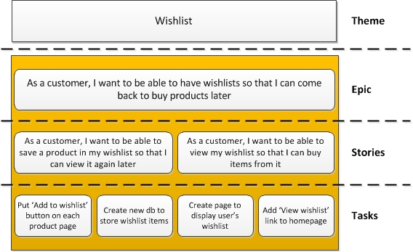

**ROADMAPS:**

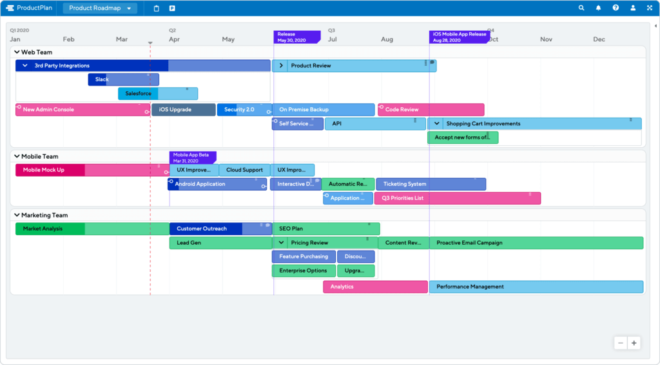

**PRIORITIZATION FRAMEWORKS**

1. MoSCoW (Must have, should have, could have, Won’t Have)

2. RICE (Rich, Impact, Confidence, Effort)

3. Value vs. Complexity

4. Weighted Scoring

**CONCLUSION: TELLING YOUR PRODUCT STORY**

1. Example: Hero Journey

- Pick a particular persona and talk about their problem

- to the level, people empathize with the user and root for them

- Talk through your solution from their lens

- Use pictures and videos where possible

2. Before After Bridge

3. AIDA – Action Interest Desire Action

4. PPPP – Promise Picture Push Proof