**AGILE PRODUCT MANAGEMENT**

WHAT IS AGILE?

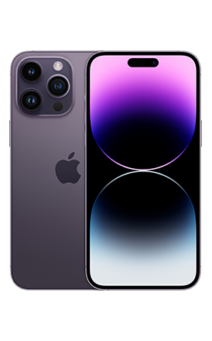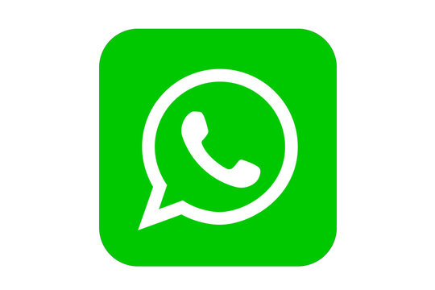

- Everything is manufactured, delivered, and shipped in just one go. But there is no same concept of improving the same product. We must build the new product all together.

- The is one piece or one product that is manufactured and developed in its entirety in just one go.

**Waterfall Model:**

Building a product like a mobile phone will eventually go with the waterfall model.

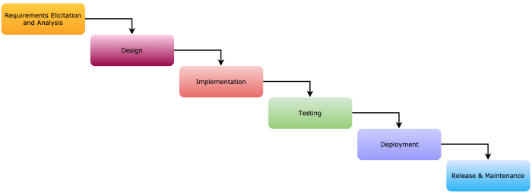

1. Requirement Gathering: Understanding what customers want.

2. Analysis: How to build a product around it? What the product should be.

3. Design: How should the product look and feel? (UI/ UX, Prototype Design)

4. Development: Let’s develop it, finally!

5. Testing: Hurry. It is developed. But is it working properly?

6. Deployment: Everything is fine. Let’s ship it to the customer.

7. Maintenance: Our customers might want some support during product usage. Let’s support them.

**Agile Model:**

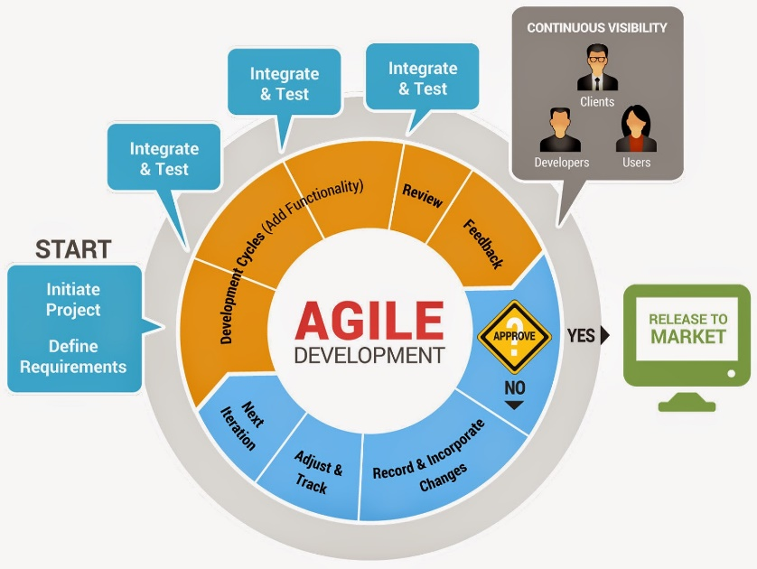

Agile Model – This is cyclic or iterative in nature.

After the product deployment, we review the product. What it is looking for is a live product. Are people like it? What is the set of features mostly used? What type of users are using the product, and what kind of users are not using the product? These steps are done before launching the product.

Once we launch the product, there go the multiple processes of agile life cycles.

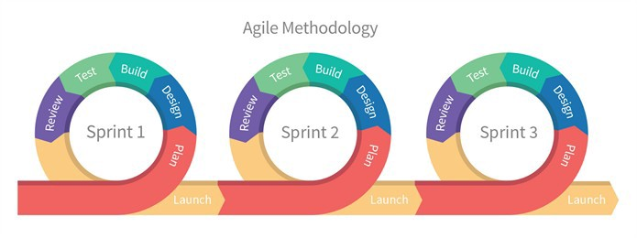

**Summary:**

**-** Agile is a way of working that focuses on moving quickly and delivering value to customers in a shorter time.

- The way Agile is executed in Product Management is using the concept of shorter sprints, focusing on one specific objective.

- Agile focuses on iteratively developing and improving the product rather than doing it all at once.

*But wait, Is Agile all about shorter cycles, multiple iterations, sprints, bla bla bla?*

**AGILE VALUES**

1. Individuals and Interactions over Processes and Tools.

2. Working Software over Comprehensive Documentation.

3. Customer Collaboration over Contract Negotiation.

4. Responding to change over Following a Plan.

**AGILE PRINCIPLES:**

Recall the following situations:

- You went to a restaurant, ordered your food but later decided to cancel/ change it. How did the waiter or the restaurant respond? (Embracing the change)

- You had to convey something to your team member. How did you do it? (Face-to-face)

- Have you ever gotten a suit stitched? How many visits did it take? (Early delivery)

- How many times a year do you and your manager meet to discuss your performance and appraisal? (Motivation and Trust)

**BUILDING MVP (minimum viable product) USING AGILE**

**MVP Stories!!**

Think of a product or business idea that helps people enjoy eating something in the evening or in the moment of celebration.

CUPCAKE BUSINESS –

Would people not have enjoyed anything else in the evening?

Why didn’t we build a cake in the first version?

Why did we shift from cupcakes to pastries and then a cake?

**Your MVP is not the only way to solve the problem.**

**MVP –** A Minimum Viable Product is a version of a new product that allows the team to collect the maximum amount of validated learning about customers with the least effort.

Parameters: Effort (Low), Customer Acceptance (High), Business Learnings (High), Value Delivered (Mid), Value Delivered (Mid), Market Acceptance (Mid), Minimum Features (Min), Time 2 Marker (Low)