**PRODUCT LAUNCH AND MARKETING**

**PRODUCT LIFECYCLE**

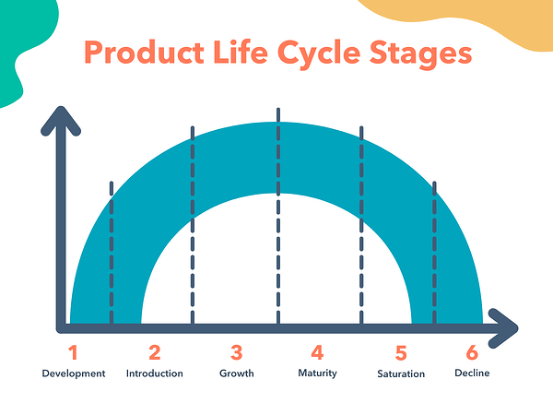

The launch strategy starts at the beginning.

ROLE OF A PMM

- You work as a bridge between Product Manager & Sales and Marketing team.

- Work with multiple stakeholders to launch the product and keep the product up in the market.

- Establish clear launch objectives and responsibilities.

- Owner of pre, during, and post-launch strategy and execution.

PURCHASING PROCESS

The purchasing behavior of Customers – Users don’t just buy products; they experience feelings.

**AIDA Framework**

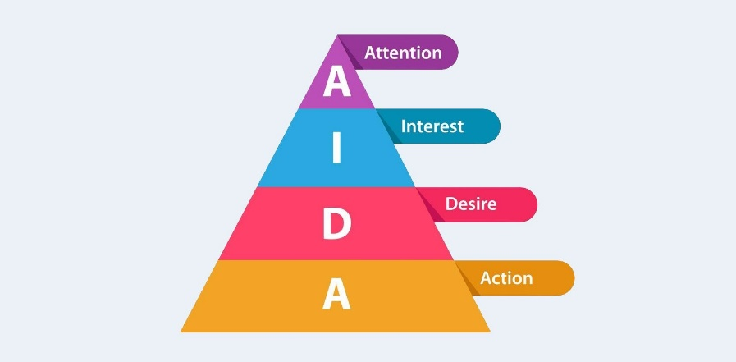

**LAUNCH AND MARKETING FRAMEWORK**

**4P FRAMEWORK**

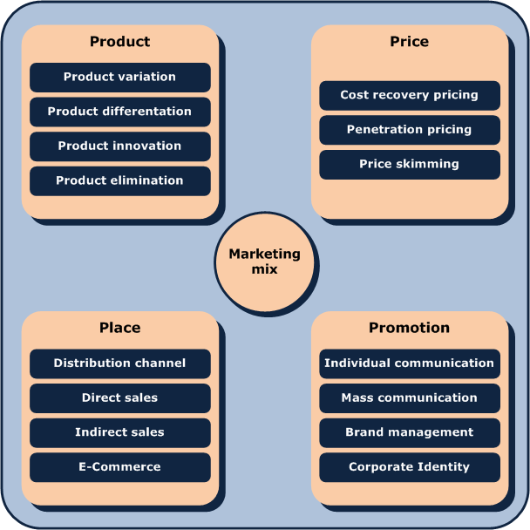

**WHOM ARE YOU CREATING VALUE FOR? – Identify the ng right users**

**STP FRAMEWORK**

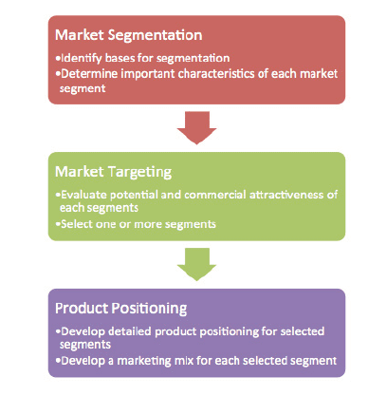

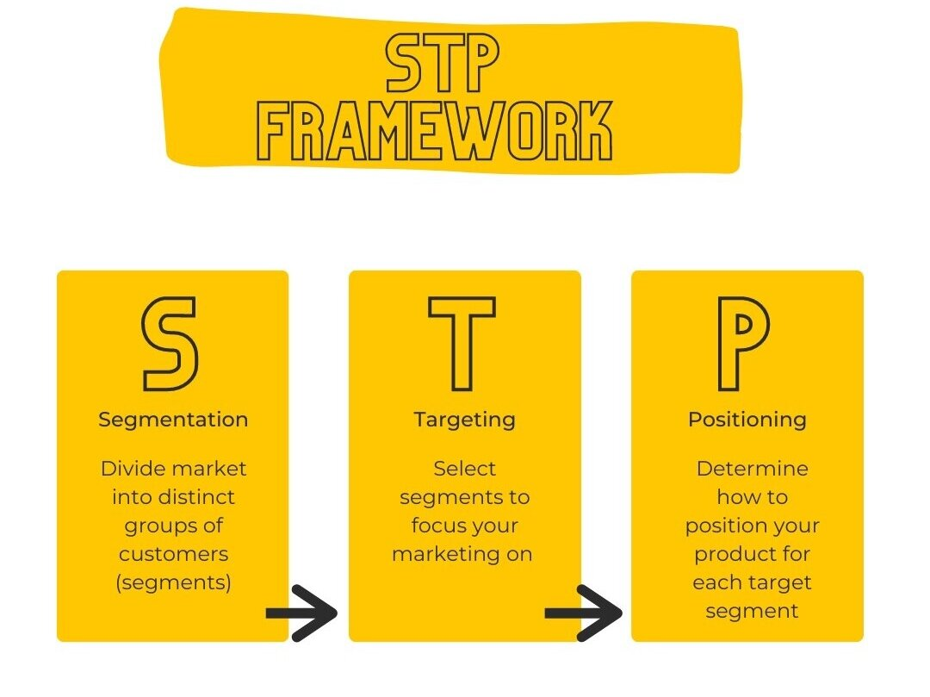

**Activity**

Uber has decided to launch a new feature – ‘Group,’ using which a group of people can reduce and join ride groups. Identify the right segment to target and create a positioning strategy.

**GTM STRATEGY CHECKLIST**

**-** What are you launching? (Get a complete understanding of the product)

- Why are you launching? (What are the goals – acquisition, revenue, profitability, virality, etc.)

- For whom are we launching? (All users vs. niche)

- Where are we launching? (One channel vs. multiple channel – online vs. physical vs mix)

- How long is the launch going to be? (Big Bang vs. Minions)

- How are we going to talk about the launch? (Launch communication and campaigns)

- Why are people going to connect with the launch? (Connect with the user’s psychology or problems)

- What are the assets used in the launch? Website, social media, App, Email, Brochures, Pamphlets)

- How Are we managing people and partners? (Internal teams, external distributors/partners)

- Are we going to rest something before the launch? (Beta test, dogfooding, A/B Testing)

- How are we going to measure this? (Metrics)

- What are we going to do next? (Data-driven decision-making)

- Can our users become our marketers? (WoM, Referrals, Waitlist push)

**PRICING STRATEGY**

**Can the product even be monetized?**

**-** Stickiness – Retention – Are people even using this product?

- Other similar products in the market and their monetization strategy

- Product Performance (Number of users, Growth rate, Market Share)

**Users and Product – Can money bind them?**

**-** Whom are we going to charge? What is their psychology of money?

- What is the value of this product for users in their daily lives?

- If not allowed to use this product anymore, how will users be impacted?

- What do they pay or don’t pay for what kind of value and why, and at what price?

**Pricing in Product – The Last Step!**

- When to charge the customers during the product engagement? (MVP -> MVR -> MVA)

- Would the customers be willing to pay for the entire product or just a part of it? What do we charge for?

- How much should be charged, and in what model? (One-time, recurring, etc.)

**Assignment**

Think of innovative marketing campaigns and pricing methodology to achieve two business goals for NETFLIX

1. User Acquisition
2. Revenue