Protocolo de entrevista semiestructurada

Un mapeo multidimensional de las tensiones en las humanidades digitales en América Latina.

Sergio Rodríguez Gómez

Mapping DH at UIUC

I am mapping different tensions around digital humanities practices and discourses in Latin America. These tensions should not necessarily be understood as antagonistic or dichotomic, but as the basis of a multi-dimensional space in which different people, projects and institutions can take different positions and move or enclose the frontiers of the field. The dimensions I am interested in are the following: the dimension of humanistic tradition (how humanities and humanism are conceived inside digital humanities), the dimension of community formation (how DH communities create in relation to institutions, communities of practice, activist groups, etc.), the dimension of digital epistemology (how “the digital” is conceived, used or studied in DH), and the dimension of infrastructures (how standards, software, organization, knowledge, etc. limit or propitiate DH practices).

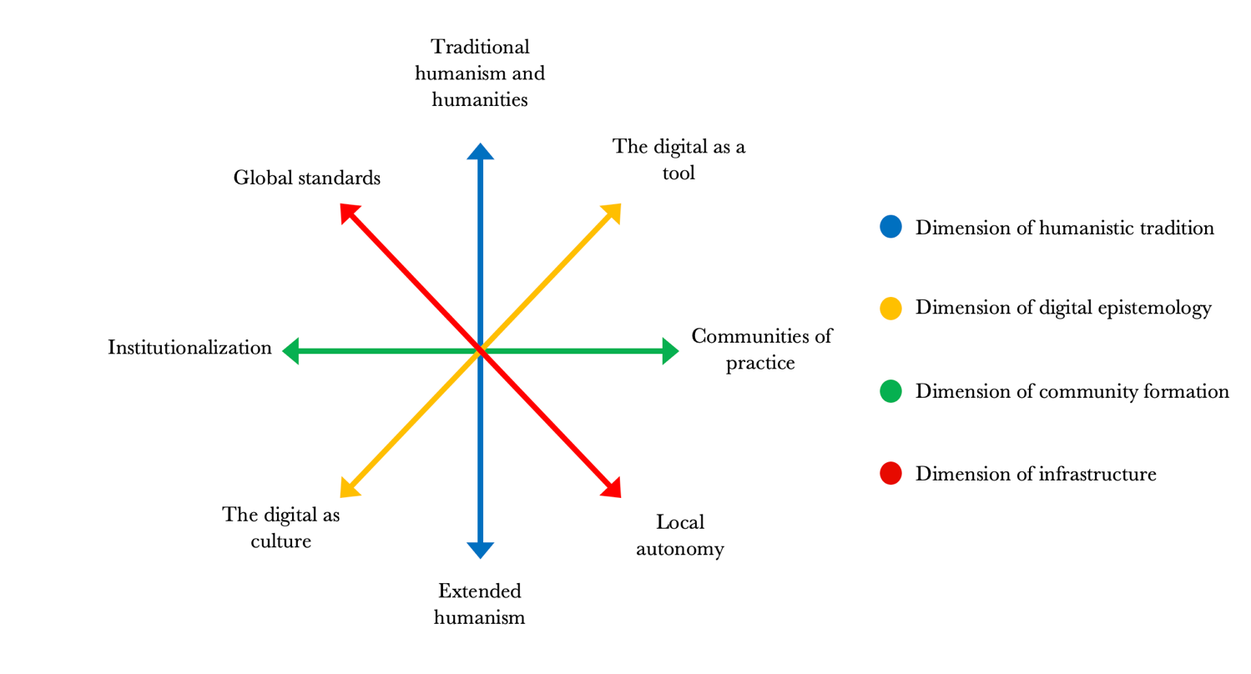

As a comparative insight, I am interested in sketching a mapping of DH practitioners’ positions at UIUC. Mainly to see if there are similar tensions, and also to see differences in infrastructural scale and ways of understanding DH.

QUESTIONS

Background: Can you tell me a general sketch of your background and academic / activist trajectory?

Dimension of community formation. Are the DH projects you are involved in linked to formal institutions, or communities of practice and groups of interest, or both? Are there advantages or disadvantages in one way of organization compared to the other? (For instance, budgets, organizations, prestige, access to tools, etc. in institutions, or more freedom to choose topics, experiment, or try controversial topics in communities of practice?)

Domain of digital epistemology. If you had to position yourself in this axis of DH epistemology, what do you believe your position would be?

A 🡨------------------------------------------------------------------------------------------------------------🡪 B

A: More towards the use of computational tools to study humanities topics

B: More towards studying “the digital” as a cultural phenomenon from a humanistic perspective

Domain of infrastructures. Where do the infrastructures (for instance, standards, software, theories) used in the practices of digital Humanities at UIUC come from? Do they have national or international influence? Are external infrastructures used in DH practices at UIUC? Do these infrastructures come from another language different than English?

Domain of infrastructures. If applies. Are protocols and standards used in your digital humanities practices or research understood in a “universalist” way (i.e. in a way so general that everyone could use it), or are they tailored to particular communities?

Domain of humanistic tradition. Some authors diagnose a crisis in humanities[1] (humanism, as moral guide, being replaced by technocracy and public opinion; humanities becoming irrelevant in contemporary education and academia)? What is the place of DH in this crisis? (For instance, a “savior” that offers more rigorous methods to humanities which, subsequently, put them closer to hard sciences, a way to enhance democracy and participation through technology, an opportunity for speculative knowledge and creation, a menace that increases the crisis of humanities…)

Domain of humanistic tradition. In this line, do you think the Digital Humanities open an opportunity to question problems of the tradition of humanities and humanism? Namely, the distinction between civilization (usually, western greek-latin culture) and barbarism (otherness and difference), or an elitist approach to culture and knowledge.

Dimension of humanistic tradition. How strongly do you think these theoretical or creative fields or practices are related to your conception of DH?:

Media studies (platform studies, software studies…)

STS (Science, Technology and Society)

Media Archeology

Cultural Analytics

Digital Methods[2]

Digital Art & Design

Electronic Literature

Digital editions

Public history

Digital collections’

Coding literacy

Civil society governance of digital policy

Ethical issues in digital representations of society

Community Digital Archives

Hacktivism[3]

**References**

Gombrich, E. H. (1973). Research in the Humanities: Ideals and Idols. *Daedalus*, *102*(2), 1–10.

Keen, P. (2020). *A defense of the humanities in a utilitarian age: Imagining what we know, 1800-1850*. Palgrave Macmillan. https://doi.org/10.1007/978-3-030-32660-9

Najafabadi, M. M., & Domanski, R. J. (2018). Hacktivism and distributed hashtag spoiling on Twitter: Tales of the #IranTalks. *First Monday*. https://doi.org/10.5210/fm.v23i4.8378

Nussbaum, M. C. (2016). *Not for profit: Why democracy needs the humanities* (Updated edition). Princeton University Press.

Small, H. (2016). *The value of the humanities* (First published in paperback). Oxford University Press.

Spellmeyer, K. (2003). *Arts of living: Reinventing the humanities for the twenty-first century*. State University of New York Press.

1. For instance (Gombrich, 1973; Keen, 2020; Nussbaum, 2016; Small, 2016; Spellmeyer, 2003) all reflect on the values of the humanities, the different challenges it needs to overcome, and the effects of erasing humanities from academia and education.
2. The methodological field, developed mostly at the University of Amsterdam, that focuses on studying social phenomena through the digital ‘traces’ societies leave in internet’s social networks.
3. Hacktivism is a “type of largely benign, but disruptive, not destructive, form of political expression. Acts of hacktivism, by definition, do not seek to destroy their targets. It is the act of computer hacking for political purposes and stems from the original meaning of the term ‘hacking’ —utilized since the 1970s— meaning to make use of something for a purpose other than for which it was originally intended” (Najafabadi & Domanski, 2018, p. 6)