**Batch T2**

**Course: Project Management and Ethics**

**Practical No. 02 (Zoho)**

**Student Name: Shreya Rajesh Sharma**

**Student PRN: 22510007**

1. Explain below features of Zoho app.
   1. **Task Management**
2. **Work breakdown structure**

Break your projects down into simpler work items, such as milestones, task lists, tasks and sub tasks to organize your work efficiently.

1. **Issue Management**

List the issues or bugs in your projects, assign them to your team, and track these bugs closely to ensure they're fixed quickly.

1. **Universal add**

If you're in a hurry and want to quickly add a work item, use the universal add tab to add a user, a task, an issue, an event, or a document easily.

1. **Different task views**

The Classic view gives you a detailed task list with all the important task information, while the Plain view shows a simple list of tasks, and the Kanban board displays tasks as cards grouped in different columns based on task statuses.

1. **Gantt chart**

Plan your projects, track progress, visualize dependencies, reschedule tasks if the need arises, and complete your projects on time with Gantt charts.

1. **Dependencies**

Set up dependencies between related tasks according to the order in which they have to be completed.

1. **Recurrence**

Certain tasks have to repeated on a daily or weekly basis. Avoid the hassle of rescheduling those tasks every time by setting up recurring tasks instead.

1. **Reminders**

Set up task reminders so you don't miss out on anything important, even in the middle of a busy schedule.

1. **Critical tasks**

In order to deliver projects as scheduled, identify any critical paths in a project to make sure they aren't delayed and derail the entire project.

**(10) Project baseline**

Create baselines for your project at regular intervals so you can compare your progress to your planned goals and make sure you don't deviate from the initial schedule.

**(11) Sprints**

Integrate Projects with Zoho Sprints, our agile project management tool, to easily handle hybrid projects. Sync projects and tasks, log hours and users, create and view sprint boards, and get detailed sprint reports, all in Zoho Projects.

**(12) Portfolio dashboard**

Get an overall view of projects, tasks, and issues in your portal. See how each project is progressing and get detailed reports on status, ownership, client, and budget health of projects.

**(13) Roll-up**

Summarize the total planned work hours, total actual hours logged, and the aggregate completion percentage of tasks, based on all the tasks and subtasks in a given project.

* 1. **Task automation**

1. **Blueprint**

Design workflows to automate task processes and make mundane work easier. Assign the right people to change the task status, automatically update task fields, and alert teams as task statuses change.

1. **SLAs**

Create an escalation procedure so any issues are promptly fixed. Define the criteria for an issue to be escalated and alert the necessary people.

1. **Business rules**

Build a set of rules to perform certain actions, such as changing the severity of an issue or assigning it to a user, and then define when these rules get triggered.

1. **Webhooks**

Configure your own HTTP URLs and associate them to specific business rules so you can automate notifications to third-party applications from Zoho Projects.

1. **Notifications**

Automate notifications to be sent out to the assignee, clients, or specific users when the status of an issue or task is modified.

1. **Workflow Rules**

Define rules to automate workflows for any work item in your project. This highly flexible and customizable feature helps you automate just about anything.

* 1. **Blueprints**

1. **Do more of what you love**

Do more meaningful work by automating the necessary but mundane tasks. Routine tasks take up a substantial amount of time, often leaving less time and energy for more complicated, rewarding work. Configure email notifications and messages so you can put your creativity and time to the best use.

1. **Follow the right process**

Sometimes you maybe halfway through the project when a new person joins the team. This means that, besides learning the ropes of the company or how the team works, they also have to understand the process workflows in place. However, when you have blueprints already set up, it is easy to make sure everyone follows the right process always.

1. **Reduce project delays**

When a process involves multiple teams, there may be delays sometimes as the task moves forward. This could be because there is not a lot of transparency into the process or because a team is not informed of the task progress promptly. Reduce such delays by automating your notifications and email alerts.

1. **Get the right approvals**

Even when multiple people may be assigned a part of a process, tasks should not move to the next stage until approved by the right person in order to avoid mistakes. Set up a transition owner so only the designated person responsible can push a task from one status to the next.

* 1. **Time tracking**

1. **Timers**

Enable task timers as you begin working on tasks and end them whenever you complete your work so your task hours are automatically recorded as a new timesheet entry.

1. **Timesheets**

Log and track time spent on tasks and issues manually or through automatic timers. Admins can approve or reject employee timesheet entries, as well as use them for payroll and client billing.

1. **Invoicing**

Invoice time logs and record expenses for all your projects by integrating Zoho Projects with Zoho Books or Invoice. Our integration makes it easier than ever to generate estimates and send quotes to clients.

1. **Budgeting**

Plan and manage your project budget to improve cost management and reduce budget overruns. View planned vs. actual cost in real time with detailed budget status reports.

1. **Calendar**

View all your project activities in one place, easily schedule meetings and events, and see what you have planned for the coming week to stay on top of your schedule.

* 1. **Charts and reporting**

1. **Task reports**

View basic or advanced reports on all tasks in a project based on the status, completion percentage, owner, or priority. Projects also gives you global reports across projects.

1. **Issue reports**

Get deeper insights into the status of your bugs or issues with the help of basic and advanced issue reports.

1. **Timesheet reports**

Help your team be more productive: see how work hours are split across your team and what tasks take up the most time so you can delegate routine work accordingly.

1. **Project dashboard**

Your dashboard shows how your project is progressing with the help of multiple reports on the project budget, status of tasks and issues, overdue work items, and team status.

1. **Budget Forecasting**

Forecast the total estimated cost for a project based on its current percentage completion, along with the planned and actual costs.

1. **Planned vs Actual cost**

Plan costs and avoid budget overruns. Projects helps you calculate the planned and actual cost of your projects based on the rate per hour for each project or specific user rates.

1. **Earned value management**

Compare planned vs actual values of schedule, cost and time to measure performance effectively and predict important project parameters.

* 1. **Issue tracking and SLA**

In Zoho People, a service level agreement (SLA) is a contract between the administrative teams (Human Resources or Admin) and the end user that defines the level of service expected.

You can create SLAs in Cases. SLAs define the timelines for the closing of a case and provide actions for escalation when the timelines are not met.

Multiple SLAs can be created for a particular category. The right SLA will be triggered automatically based on criteria and priority.

Within each SLA, you can create up to 5 levels of escalations.

* 1. **Team collaboration**

1. **Feeds**

Get quick updates across all your projects through the interactive feed where you can easily post comments, tag team members, and add attachments.

1. **Mentions**

Mention users, roles, or teams via status updates, comments, chats, or forums to direct people's attention to a task or a discussion.

1. **Chats**

Collaborate better with the help of personal or group chat rooms. Easily converse, get quick feedback, or start a discussion.

Discuss ideas, post a topic, and save important information in a central space with the help of interactive forums.

1. **Documents**

Easily create, store, organize, and share project files with your team. Moreover, the version control system ensures everyone has access to the latest file version.

1. **Email alias**

Manage your projects directly from your inbox. Add notes or associate documents to tasks, post comments, or attach files to forums, file issues and more, all from your email platform.

1. Differentiate in between Zoho and Jira as a project management tool.

|  |  |  |  |
| --- | --- | --- | --- |
| Sr. No. | Feature | Zoho Projects | Jira |
| 1 | Primary Focus | Project management with task tracking, collaboration, and time tracking | Issue tracking and project management with a focus on agile methodologies |
| 2 | Target Audience | Small to medium-sized businesses, teams in various industries | Software development teams, particularly agile teams |
| 3 | |  | | --- | | Agile Support |  |  | | --- | |  | | Limited agile features (supports task boards, sprints) | Extensive agile support (Scrum, Kanban boards, backlogs, sprints) |
| 4 | Customization | High level of customization for workflows, layouts, and fields | Highly customizable workflows, fields, and issue types |
| 5 | User Interface | Intuitive and user-friendly, suited for non-technical users | More complex, suited for technical users and agile teams |
| 6 | Ease of Use | Easier to use for beginners and non-technical teams | Steeper learning curve, especially for non-technical teams |
| 7 | Security | Offers SSL encryption, role-based access control, and GDPR compliance | Strong security with advanced permissions, audit logs, and compliance with multiple standards |

1. **Explain use of Zoho Education Project Management Software. How it is different from Software development Project Management Software.**

Zoho Education Project Management Software is tailored for managing academic tasks in educational institutions. It helps educators and administrators organize assignments, track student progress, and collaborate on academic projects. Key features include task management, collaboration tools, resource allocation, time scheduling, document sharing, and grading. It facilitates smooth communication between students, teachers, and parents.

How it differs from Software Development Project Management Software:

* Focus: Education software emphasizes academic tasks, student performance, and collaboration, while software development tools like Jira focus on issue tracking, sprints, and agile workflows.
* Users: Education tools are designed for students, teachers, and staff, whereas development tools are built for developers, project managers, and IT teams.
* Features: Education software includes grading, assignment tracking, and class scheduling, while development tools have bug tracking, version control, and DevOps integration.

1. Create free account on Zoho and add any 3 members into it as a project team.

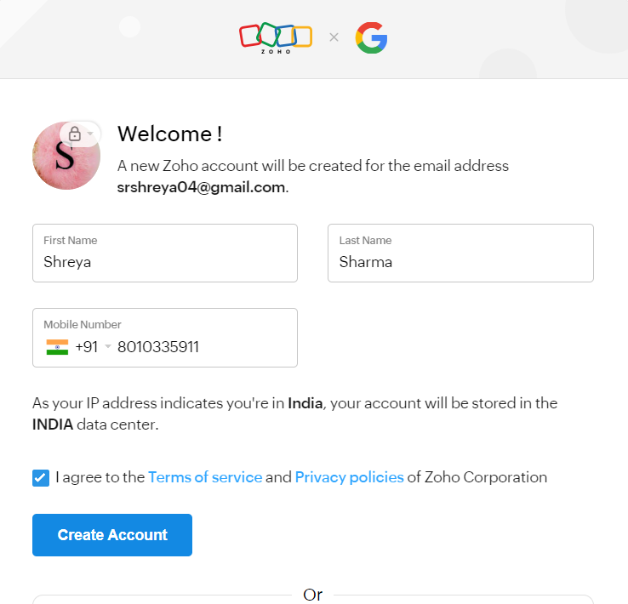

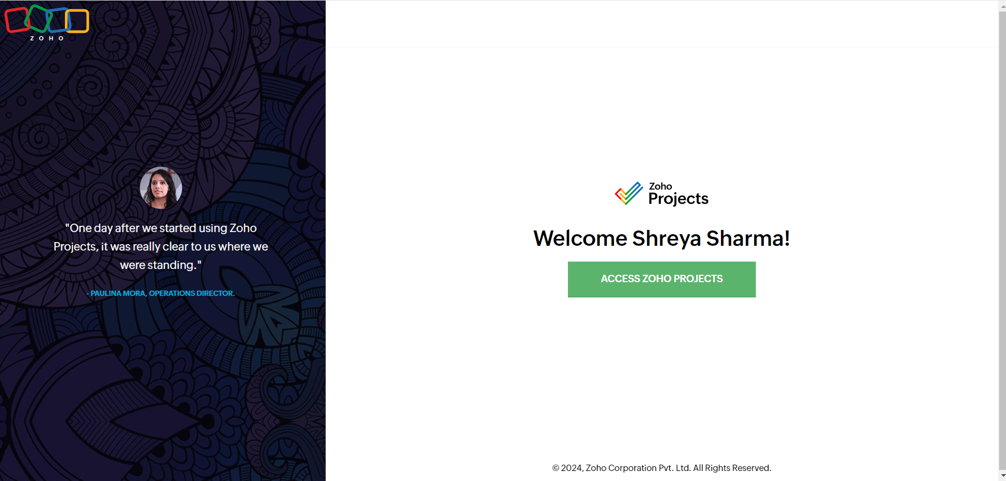

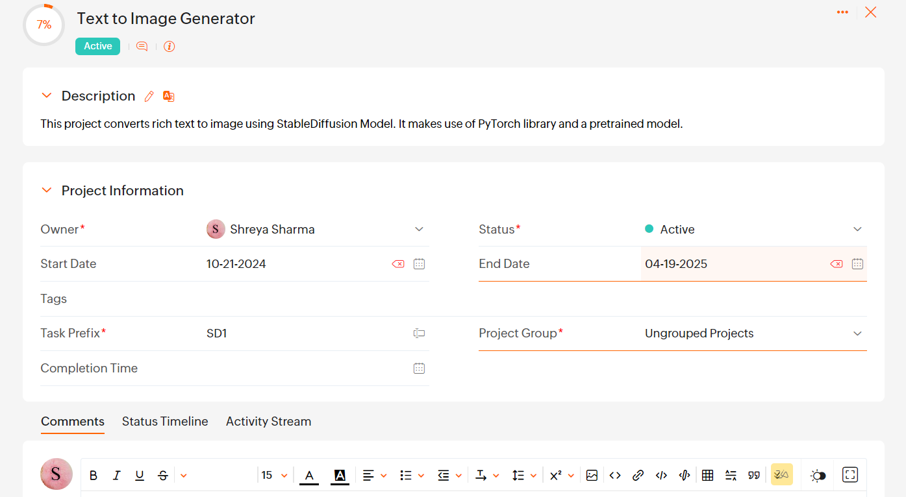

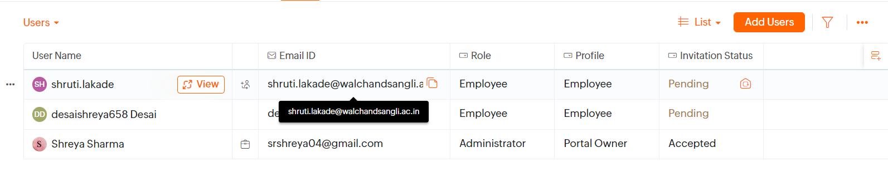

Note: Please use below reference material

<https://www.atlassian.com/agile>

1. <https://www.zoho.com/>