Hibernate/JPA – sprawozdanie
Szymon Piechaczek, nr 283170

II. Basics
Logi:
Hibernate: create sequence hibernate_sequence start with 1 increment by 1
Hibernate: create table Product (dbId integer not null, productName varchar(255), unitsOnStock integer not null, primary key (dbId))
Hibernate: values next value for hibernate_sequence
Hibernate: insert into Product (productName, unitsOnStock, dbId) values (?, ?, ?)

Wygenerowany model bazy danych:
CREATE TABLE PRODUCT
(
DBID int PRIMARY KEY NOT NULL,
PRODUCTNAME varchar(255),
UNITSONSTOCK int NOT NULL
)
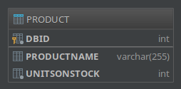
Wynik zapytania:
SELECT * FROM PRODUCTS
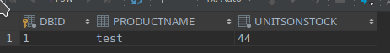

III. Wprowadzenie dostawcy
Operacje wstawianie poprzez Hibernate wygenerowały następujące zapytania do bazy:
Hibernate: values next value for hibernate_sequence
Hibernate: values next value for hibernate_sequence
Hibernate: insert into Supplier (city, companyName, street, dbId) values (?, ?, ?, ?)
Hibernate: insert into Product (productName, supplier_FK, unitsOnStock, dbId) values (?, ?, ?, ?)

Analogicznie – uaktualnienie danych w bazie poprzez interfejs Hibernate:
Hibernate: select product0_.dbId as dbId1_0_0_, product0_.productName as productN2_0_0_, product0_.supplier_FK as supplier4_0_0_, product0_.unitsOnStock as unitsOnS3_0_0_, supplier1_.dbId as dbId1_1_1_, supplier1_.city as city2_1_1_, supplier1_.companyName as companyN3_1_1_, supplier1_.street as street4_1_1_ from Product product0_ left outer join Supplier supplier1_ on product0_.supplier_FK=supplier1_.dbId where product0_.dbId=?
Hibernate: values next value for hibernate_sequence
Hibernate: insert into Supplier (city, companyName, street, dbId) values (?, ?, ?, ?)
Hibernate: update Product set productName=?, supplier_FK=?, unitsOnStock=? where dbId=?

Po wykonaniu programu z wstawianiem i uaktualnieniem w tabelach znajdują się następujące dane:
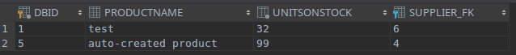
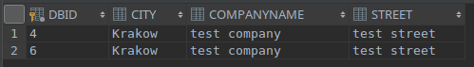
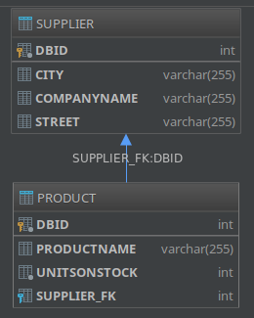
Schemat bazy danych wygenerowany przez Hibernate:

IV. Odwrócenie relacji
Odwrócenie relacji pomiędzy tabelami wymagało migracji, którą Hibernate przeprowadził automatycznie generując na nowo schemat danych (opcja migracji „create”) poniższym zapytaniem języka SQL. Oprócz tego, do bazy danych zostały ponownie wprowadzone przykładowe dane:
Hibernate: create table Product (dbId integer not null, productName varchar(255), unitsOnStock integer not null, primary key (dbId))
Hibernate: create table Supplier (dbId integer not null, city varchar(255), companyName varchar(255), street varchar(255), primary key (dbId))
Hibernate: create table Supplier_Product (Supplier_dbId integer not null, products_dbId integer not null, primary key (Supplier_dbId, products_dbId))
Hibernate: alter table Supplier_Product add constraint UK_oym0t6wcq919k2ipm7o22cu37 unique (products_dbId)
Hibernate: alter table Supplier_Product add constraint FKbyvlmsgr1ky88k595lesbdtm4 foreign key (products_dbId) references Product
Hibernate: alter table Supplier_Product add constraint FKfnu8v5imm94mgimkg8flnix3 foreign key (Supplier_dbId) references Supplier
Hibernate: insert into Supplier (city, companyName, street, dbId) values (?, ?, ?, ?)
Hibernate: insert into Product (productName, unitsOnStock, dbId) values (?, ?, ?)
Hibernate: insert into Product (productName, unitsOnStock, dbId) values (?, ?, ?)
Hibernate: insert into Product (productName, unitsOnStock, dbId) values (?, ?, ?)
Hibernate: insert into Product (productName, unitsOnStock, dbId) values (?, ?, ?)
Hibernate: insert into Supplier_Product (Supplier_dbId, products_dbId) values (?, ?)
Hibernate: insert into Supplier_Product (Supplier_dbId, products_dbId) values (?, ?)
Hibernate: insert into Supplier_Product (Supplier_dbId, products_dbId) values (?, ?)
Hibernate: insert into Supplier_Product (Supplier_dbId, products_dbId) values (?, ?)

Rezultat widoczny w tabelach bazy danych:
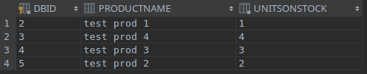
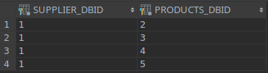
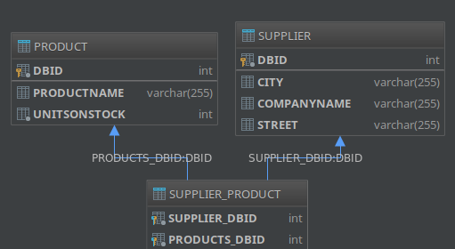
Schemat bazy danych jako rezultat migracji:

Wariant bez tabeli łącznikowej
Aby utworzyć tradycyjną relację jeden-do-wielu należało użyć adnotacji:
@JoinColumn(name = "supplier_FK")

Po kolejnej migracji automatycznie zostały wykonane następujące polecenia:
Hibernate: create sequence hibernate_sequence start with 1 increment by 1
Hibernate: create table Product (dbId integer not null, productName varchar(255), unitsOnStock integer not null, supplier_FK integer, primary key (dbId))
Hibernate: create table Supplier (dbId integer not null, city varchar(255), companyName varchar(255), street varchar(255), primary key (dbId))
Hibernate: alter table Product add constraint FKivv5ae4f47btap8p8pbu37ied foreign key (supplier_FK) references Supplier
Hibernate: insert into Supplier (city, companyName, street, dbId) values (?, ?, ?, ?)
Hibernate: insert into Product (productName, unitsOnStock, dbId) values (?, ?, ?)
Hibernate: insert into Product (productName, unitsOnStock, dbId) values (?, ?, ?)
Hibernate: insert into Product (productName, unitsOnStock, dbId) values (?, ?, ?)
Hibernate: insert into Product (productName, unitsOnStock, dbId) values (?, ?, ?)
Hibernate: update Product set supplier_FK=? where dbId=?
Hibernate: update Product set supplier_FK=? where dbId=?
Hibernate: update Product set supplier_FK=? where dbId=?
Hibernate: update Product set supplier_FK=? where dbId=?
Schemat bazy danych po migracji:
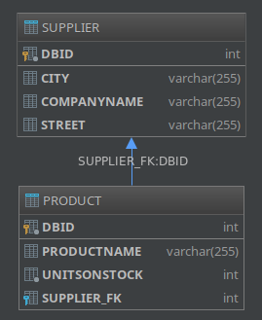
Zmianie uległa tylko zawartość tabeli PRODUCT (kolumna z kluczem obcem);
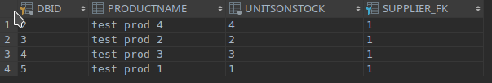

V/VI. Relacja dwustronna
Zamodelowanie relacji dwustronnej wymagało obustronnych adnotacji.
W Product:
@ManyToOne(cascade = CascadeType.ALL, fetch = FetchType.EAGER)
@JoinColumn(name = "supplier_FK")
private Supplier supplier;
W Supplier:
@OneToMany(cascade = CascadeType.ALL, mappedBy = "supplier")
private Set<Product> products = new HashSet<>();

Hibernate: create table Product (dbId integer not null, productName varchar(255), unitsOnStock integer not null, supplier_FK integer, primary key (dbId))
Hibernate: create table Supplier (dbId integer not null, city varchar(255), companyName varchar(255), street varchar(255), primary key (dbId))
Hibernate: alter table Product add constraint FKivv5ae4f47btap8p8pbu37ied foreign key (supplier_FK) references Supplier
Hibernate: insert into Supplier (city, companyName, street, dbId) values (?, ?, ?, ?)
Hibernate: insert into Product (productName, supplier_FK, unitsOnStock, dbId) values (?, ?, ?, ?)
Hibernate: insert into Product (productName, supplier_FK, unitsOnStock, dbId) values (?, ?, ?, ?)
Hibernate: insert into Product (productName, supplier_FK, unitsOnStock, dbId) values (?, ?, ?, ?)
Hibernate: insert into Product (productName, supplier_FK, unitsOnStock, dbId) values (?, ?, ?, ?)

Schemat bazy danych nie uległ zmianie w stosunku do poprzedniego ćwiczenia (tabele wciąż utrzymują relację po kluczu obcym). Podobnie z wynikami zapytań – zwracają identyczne dane testowe.

VII. Kategorie
Wprowadzenie kategorii wymagało dodania nowej klasy Category z odpowiednimi relacjami:
@OneToMany(cascade = CascadeType.ALL, mappedBy = "category")
private List<Product> products;
Zmodyfikowana została klasa Product:
@ManyToOne(cascade = CascadeType.ALL)
@JoinColumn(name = "category_FK")
private Category category;
Napisany został następujący program testujący:
Transaction tx = session.beginTransaction();
Supplier supplier = new Supplier("test company 1", "test street", "Krakow");
Supplier supplier2 = new Supplier("test company 2", "test street", "Krakow");

Category cat = new Category("test category");

supplier.addProduct(new Product("test prod 1", 1, cat));
supplier.addProduct(new Product("test prod 2", 2, cat));
supplier.addProduct(new Product("test prod 3", 3, cat));
supplier.addProduct(new Product("test prod 4", 4, cat));
Product product = new Product("test prod 5", 5, cat);
supplier2.addProduct(product);

session.save(supplier);
session.save(supplier2);

System.out.println("Produkty od " + supplier.getCompanyName());
for (Product p : supplier.getProducts()) {
System.out.println(p.getProductName());
}

System.out.println("Dostawca dla produktu " + product.getProductName());
System.out.println(product.getSupplier().getCompanyName());

tx.commit();
session.close();

Program ten zwrócił następujący rezultat:
Produkty od test company 1
test prod 4
test prod 1
test prod 2
test prod 3
Dostawca dla produktu test prod 5
test company 2

Logi Hibernate:
Hibernate: create table Category (categoryId integer not null, name varchar(255), primary key (categoryId))
Hibernate: create table Product (dbId integer not null, productName varchar(255), unitsOnStock integer not null, category_FK integer, supplier_FK integer, primary key (dbId))
Hibernate: create table Supplier (dbId integer not null, city varchar(255), companyName varchar(255), street varchar(255), primary key (dbId))
Hibernate: alter table Product add constraint FK3gof54o5at4lh3tv3b3ihpdrj foreign key (category_FK) references Category
Hibernate: alter table Product add constraint FKivv5ae4f47btap8p8pbu37ied foreign key (supplier_FK) references Supplier
Hibernate: insert into Supplier (city, companyName, street, dbId) values (?, ?, ?, ?)
Hibernate: insert into Category (name, categoryId) values (?, ?)
Hibernate: insert into Product (category_FK, productName, supplier_FK, unitsOnStock, dbId) values (?, ?, ?, ?, ?)
Hibernate: insert into Product (category_FK, productName, supplier_FK, unitsOnStock, dbId) values (?, ?, ?, ?, ?)
Hibernate: insert into Product (category_FK, productName, supplier_FK, unitsOnStock, dbId) values (?, ?, ?, ?, ?)
Hibernate: insert into Product (category_FK, productName, supplier_FK, unitsOnStock, dbId) values (?, ?, ?, ?, ?)
Hibernate: insert into Supplier (city, companyName, street, dbId) values (?, ?, ?, ?)
Hibernate: insert into Product (category_FK, productName, supplier_FK, unitsOnStock, dbId) values (?, ?, ?, ?, ?)
Hibernate: select category_.categoryId, category_.name as name2_0_ from Category category_ where category_.categoryId=?

Schemat utworzonej bazy:
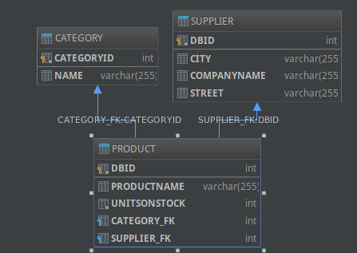
Zawrartość tabel:
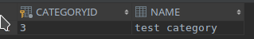
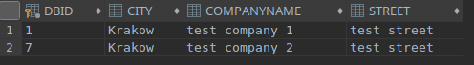

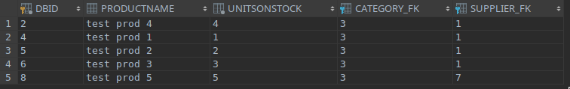

VIII. Transakcje
Wprowadzona została klasa SalesTransaction (nazwa zmodyfikowana z powodu konfliktu ze słowem kluczowym języka SQL):
@Entity
public class SalesTransaction {
@Id
@GeneratedValue ( strategy = GenerationType.AUTO )
private int transactionId;
private int transactionNumber;
private int quantity;
@ManyToMany(cascade = CascadeType.ALL)
@JoinTable(name="product_transaction",
joinColumns=@JoinColumn(name="salesTransactionId"),
inverseJoinColumns=@JoinColumn(name="productId")
)
private List<Product> products = new ArrayList<>();
Rozbudowano klasę Product:
@ManyToMany(cascade = CascadeType.ALL)
@JoinTable(name="product_transaction",
joinColumns=@JoinColumn(name="productId"),
inverseJoinColumns=@JoinColumn(name="salesTransactionId")
)
private List<SalesTransaction> salesTransactions = new ArrayList<>();
Został napisany następujący program testujący:
SalesTransaction testTransaction = session.get(SalesTransaction.class, salesTransaction2.getTransactionId());
Product testProduct = session.get(Product.class, product2.getDbId());
System.out.println("Produkty sprzedane w ramach przykładowej transakcji #"
+ testTransaction.getTransactionNumber() + ":");
for (Product p : testTransaction.getProducts()) {
System.out.println(p.getProductName());
}
System.out.println("Transakcje, w ramach których sprzedany był produkt " + testProduct.getProductName());
for (SalesTransaction t : testProduct.getSalesTransactions()) {
System.out.println(String.valueOf(t.getTransactionNumber()));
}
Wynik działania programu:
Produkty sprzedane w ramach przykładowej transakcji #2314:
test prod 6
test prod 5
Transakcje, w ramach których sprzedany był produkt test prod 6
2313
2314

Wygenerowane logi Hibernate:
Hibernate: create sequence hibernate_sequence start with 1 increment by 1
gru 27, 2017 12:12:49 AM org.hibernate.resource.transaction.backend.jdbc.internal.DdlTransactionIsolatorNonJtaImpl getIsolatedConnection
INFO: HHH10001501: Connection obtained from JdbcConnectionAccess [org.hibernate.engine.jdbc.env.internal.JdbcEnvironmentInitiator$ConnectionProviderJdbcConnectionAccess@56c698e3] for (non-JTA) DDL execution was not in auto-commit mode; the Connection 'local transaction' will be committed and the Connection will be set into auto-commit mode.
Hibernate: create table Category (categoryId integer not null, name varchar(255), primary key (categoryId))
Hibernate: create table Product (dbId integer not null, productName varchar(255), unitsOnStock integer not null, category_FK integer, supplier_FK integer, primary key (dbId))
Hibernate: create table product_transaction (salesTransactionId integer not null, productId integer not null)
Hibernate: create table SalesTransaction (transactionId integer not null, quantity integer not null, transactionNumber integer not null, primary key (transactionId))
Hibernate: create table Supplier (dbId integer not null, city varchar(255), companyName varchar(255), street varchar(255), primary key (dbId))
Hibernate: alter table Product add constraint FK3gof54o5at4lh3tv3b3ihpdrj foreign key (category_FK) references Category
Hibernate: alter table Product add constraint FKivv5ae4f47btap8p8pbu37ied foreign key (supplier_FK) references Supplier
Hibernate: alter table product_transaction add constraint FKktjv2abmpxfd5fhwqqu7wul08 foreign key (productId) references Product
Hibernate: alter table product_transaction add constraint FKs22ahnp38u2dv1ri8tmtqmicj foreign key (salesTransactionId) references SalesTransaction
gru 27, 2017 12:12:50 AM org.hibernate.tool.schema.internal.SchemaCreatorImpl applyImportSources
INFO: HHH000476: Executing import script 'org.hibernate.tool.schema.internal.exec.ScriptSourceInputNonExistentImpl@7bb6ab3a'
Hibernate: values next value for hibernate_sequence
Hibernate: values next value for hibernate_sequence
Hibernate: values next value for hibernate_sequence
Hibernate: values next value for hibernate_sequence
Hibernate: values next value for hibernate_sequence
Hibernate: values next value for hibernate_sequence
Hibernate: values next value for hibernate_sequence
Hibernate: values next value for hibernate_sequence
Hibernate: values next value for hibernate_sequence
Hibernate: values next value for hibernate_sequence
Hibernate: values next value for hibernate_sequence
Hibernate: insert into Supplier (city, companyName, street, dbId) values (?, ?, ?, ?)
Hibernate: insert into Category (name, categoryId) values (?, ?)
Hibernate: insert into Product (category_FK, productName, supplier_FK, unitsOnStock, dbId) values (?, ?, ?, ?, ?)
Hibernate: insert into Product (category_FK, productName, supplier_FK, unitsOnStock, dbId) values (?, ?, ?, ?, ?)
Hibernate: insert into Product (category_FK, productName, supplier_FK, unitsOnStock, dbId) values (?, ?, ?, ?, ?)
Hibernate: insert into Product (category_FK, productName, supplier_FK, unitsOnStock, dbId) values (?, ?, ?, ?, ?)
Hibernate: insert into Supplier (city, companyName, street, dbId) values (?, ?, ?, ?)
Hibernate: insert into Product (category_FK, productName, supplier_FK, unitsOnStock, dbId) values (?, ?, ?, ?, ?)
Hibernate: insert into Product (category_FK, productName, supplier_FK, unitsOnStock, dbId) values (?, ?, ?, ?, ?)
Hibernate: insert into SalesTransaction (quantity, transactionNumber, transactionId) values (?, ?, ?)
Hibernate: insert into SalesTransaction (quantity, transactionNumber, transactionId) values (?, ?, ?)
Hibernate: insert into product_transaction (productId, salesTransactionId) values (?, ?)
Hibernate: insert into product_transaction (productId, salesTransactionId) values (?, ?)
Hibernate: insert into product_transaction (productId, salesTransactionId) values (?, ?)
Hibernate: insert into product_transaction (salesTransactionId, productId) values (?, ?)
Hibernate: insert into product_transaction (salesTransactionId, productId) values (?, ?)
Hibernate: insert into product_transaction (salesTransactionId, productId) values (?, ?)

Program wygenerował następujących schemat bazy danych:
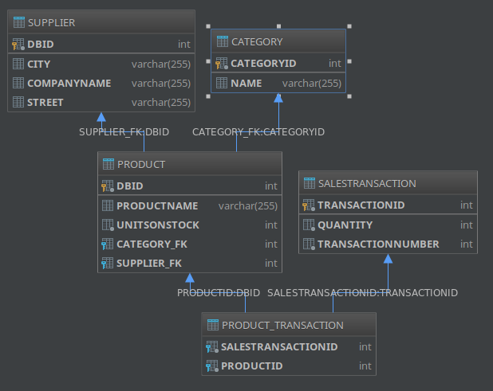
Zawartość tabel po uruchomieniu programu testującego:
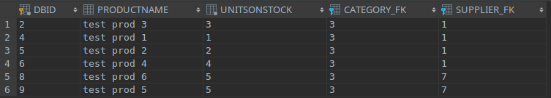
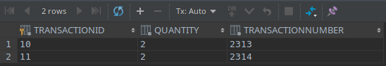
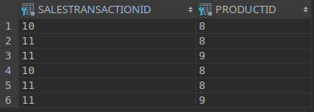
Koniec zadań wykonanych na zajęciach.

IX. JPA
Zmiana polegała na refactoringu programu z punktu VII z interfejsu Hibernate do interfejsu JPA. W repozytorium kod tego ćwiczenia dostępny jest w branchu JPA jako rozgałęzienie commita z ćwiczenia VII. Zmianie uległ plik konfiguracyjny (hibernate.cfg.xml → persistence.xml):
<?xml version="1.0"?>
<persistence xmlns="http://java.sun.com/xml/ns/persistence"
xmlns:xsi="http://www.w3.org/2001/XMLSchema-instance"
xsi:schemaLocation="http://java.sun.com/xml/ns/persistence
http://java.sun.com/xml/ns/persistence/persistence_2_0.xsd"
version="2.0">
<persistence-unit name="myDatabaseConfig"
transaction-type="RESOURCE_LOCAL">
<properties>
<property name="hibernate.connection.driver_class"
value="org.apache.derby.jdbc.ClientDriver"/>
<property name="hibernate.connection.url"
value="jdbc:derby://localhost/SPiechaczekJPAPractice"/>
<property name="hibernate.show_sql" value="true" />
<property name="hibernate.format_sql" value="true" />
<property name="hibernate.hbm2ddl.auto" value="create" />
</properties>
</persistence-unit>
</persistence>
Oraz tworzenie sesji połączenia z bazą danych:
EntityManagerFactory emf = Persistence.
createEntityManagerFactory("myDatabaseConfig");
EntityManager em = emf.createEntityManager();
EntityTransaction tx = em.getTransaction();
tx.begin();
Modele zostały już wcześniej opisane przy użyciu adontacji JPA ze względu na to, iż w nowszych wersjach Hibernate adnotacje „czysto Hibernate’owe” zostały już usunięte bądź zmieniono ich status na „deprecated”.
Program testujący nie uległ zmianie, nie uległ więc również zmianie schemat bazy danych oraz jej zawartość.
Logi JPA natomiast prezentują się inaczej:
Hibernate: create sequence hibernate_sequence start with 1 increment by 1
Hibernate:

create table Category (
categoryId integer not null,
name varchar(255),
primary key (categoryId)
)
Hibernate:

create table Product (
dbId integer not null,
productName varchar(255),
unitsOnStock integer not null,
category_FK integer,
supplier_FK integer,
primary key (dbId)
)
Hibernate:

create table Supplier (
dbId integer not null,
city varchar(255),
companyName varchar(255),
street varchar(255),
primary key (dbId)
)
Hibernate:

alter table Product
add constraint FK3gof54o5at4lh3tv3b3ihpdrj
foreign key (category_FK)
references Category
Hibernate:

alter table Product
add constraint FKivv5ae4f47btap8p8pbu37ied
foreign key (supplier_FK)
references Supplier
Hibernate:

values
next value for hibernate_sequence
Hibernate:

values
next value for hibernate_sequence
Hibernate:

values
next value for hibernate_sequence
Hibernate:

values
next value for hibernate_sequence
Hibernate:

values
next value for hibernate_sequence
Hibernate:

values
next value for hibernate_sequence
Hibernate:

values
next value for hibernate_sequence
Hibernate:

values
next value for hibernate_sequence
Hibernate:
insert
into
Supplier
(city, companyName, street, dbId)
values
(?, ?, ?, ?)
Hibernate:
insert
into
Category
(name, categoryId)
values
(?, ?)
Hibernate:
insert
into
Product
(category_FK, productName, supplier_FK, unitsOnStock, dbId)
values
(?, ?, ?, ?, ?)
Hibernate:
insert
into
Product
(category_FK, productName, supplier_FK, unitsOnStock, dbId)
values
(?, ?, ?, ?, ?)
Hibernate:
insert
into
Product
(category_FK, productName, supplier_FK, unitsOnStock, dbId)
values
(?, ?, ?, ?, ?)
Hibernate:
insert
into
Product
(category_FK, productName, supplier_FK, unitsOnStock, dbId)
values
(?, ?, ?, ?, ?)
Hibernate:
insert
into
Supplier
(city, companyName, street, dbId)
values
(?, ?, ?, ?)
Hibernate:
insert
into
Product
(category_FK, productName, supplier_FK, unitsOnStock, dbId)
values
(?, ?, ?, ?, ?)

X. Kaskady
Jedynymi zmianami były drobne modyfikacje adnotacji @ManyToMany w klasa Product i SalesTransaction.
Product:
@ManyToMany(cascade = CascadeType.ALL)

SalesTransaction:
@ManyToMany(cascade = CascadeType.ALL)

Napisany został następujący program testujący:
Product testProduct = new Product("test prod cascade source", 5, cat);
testProduct.setSupplier(supplier);
testProduct.addTransaction(new SalesTransaction(1234, 1));
testProduct.addTransaction(new SalesTransaction(1235, 2));
session.save(testProduct); // saves product and transactions
SalesTransaction testTransaction = new SalesTransaction(2345, 5);
testTransaction.addProduct(new Product("test prod cascade 1", 3, supplier, cat));
testTransaction.addProduct(new Product("test prod cascade 2", 2, supplier, cat));
session.save(testTransaction); // saves transaction and products
Który po wykonaniu pozostawia w bazie danych następujace dane potwierdzające kaskadowy zapis:
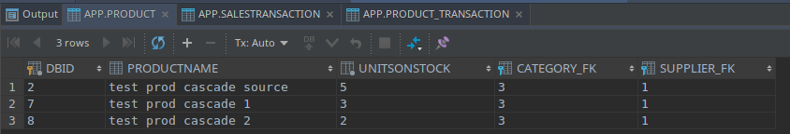
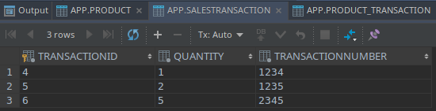
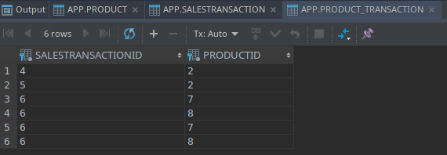
Logi Hibernate z wykonanych operacji:
Hibernate: insert into Supplier (city, companyName, street, dbId) values (?, ?, ?, ?)
Hibernate: insert into Category (name, categoryId) values (?, ?)
Hibernate: insert into Product (category_FK, productName, supplier_FK, unitsOnStock, dbId) values (?, ?, ?, ?, ?)
Hibernate: insert into SalesTransaction (quantity, transactionNumber, transactionId) values (?, ?, ?)
Hibernate: insert into SalesTransaction (quantity, transactionNumber, transactionId) values (?, ?, ?)
Hibernate: insert into SalesTransaction (quantity, transactionNumber, transactionId) values (?, ?, ?)
Hibernate: insert into Product (category_FK, productName, supplier_FK, unitsOnStock, dbId) values (?, ?, ?, ?, ?)
Hibernate: insert into Product (category_FK, productName, supplier_FK, unitsOnStock, dbId) values (?, ?, ?, ?, ?)
Hibernate: insert into product_transaction (productId, salesTransactionId) values (?, ?)
Hibernate: insert into product_transaction (productId, salesTransactionId) values (?, ?)
Hibernate: insert into product_transaction (salesTransactionId, productId) values (?, ?)
Hibernate: insert into product_transaction (salesTransactionId, productId) values (?, ?)
Hibernate: insert into product_transaction (productId, salesTransactionId) values (?, ?)
Hibernate: insert into product_transaction (productId, salesTransactionId) values (?, ?)

XI. Embedded class

„Wbudowanie” klasy
Napisana została klasa Address:
@Embeddable
public class Address {
private String city;
private String zipcode;
private String street;
I zmodyfikowana klasa Supplier:
@Entity
public class Supplier {
@Id
@GeneratedValue(
strategy = GenerationType.AUTO
)
private int dbId;
private String companyName;
@Embedded
private Address address;
Program testowy:
Supplier supplier = new Supplier("test company 1",
new Address("Krakow", "00-999", "Lea"));
session.save(supplier);
Po wykonaniu testowego programu zawartość tabeli Suppliers prezentowała się następująco:
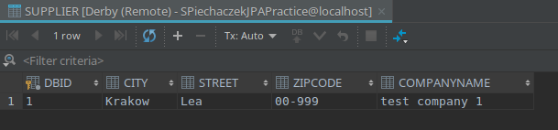
Tak więc pola klasy Address zostały wkomponowane w tabelę Supllier (tzw. Value Object).

Rozdzielenie adresu na dwie tabele
Ćwiczenie to wymagało następującej modyfikacji klasy Supplier:
@Entity
@SecondaryTable(name="SUPPLIER_ADDRESS")
public class Supplier {
@Id
@GeneratedValue(
strategy = GenerationType.AUTO
)
private int dbId;
private String companyName;
@Column(table="SUPPLIER_ADDRESS")
private String zipcode;
@Column(table="SUPPLIER_ADDRESS")
private String city;
@Column(table="SUPPLIER_ADDRESS")
private String street;
@OneToMany(cascade = CascadeType.ALL, mappedBy = "supplier")
private Set<Product> products = new HashSet<>();
Program testowy nieznacznie zmieniono:
Supplier supplier = new Supplier("test company 1",
"Lea", "Krakow", "00-999");
session.save(supplier);
Po wykonaniu programu testowego schemat bazy danych został zmieniony na następujący:
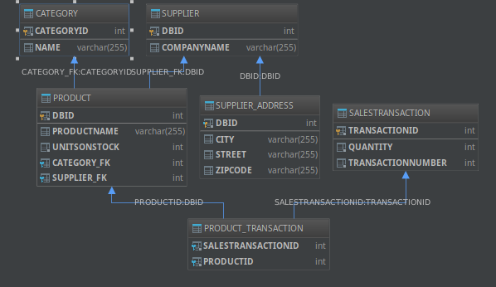
A zawartość tabel Supplier i Supplier_address prezentowała się następująco:
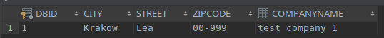
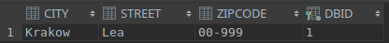
Logi Hibernate:
Hibernate: create table Category (categoryId integer not null, name varchar(255), primary key (categoryId))
Hibernate: create table Product (dbId integer not null, productName varchar(255), unitsOnStock integer not null, category_FK integer, supplier_FK integer, primary key (dbId))
Hibernate: create table product_transaction (salesTransactionId integer not null, productId integer not null)
Hibernate: create table SalesTransaction (transactionId integer not null, quantity integer not null, transactionNumber integer not null, primary key (transactionId))
Hibernate: create table Supplier (dbId integer not null, companyName varchar(255), primary key (dbId))
Hibernate: create table SUPPLIER_ADDRESS (city varchar(255), street varchar(255), zipcode varchar(255), dbId integer not null, primary key (dbId))
Hibernate: alter table Product add constraint FK3gof54o5at4lh3tv3b3ihpdrj foreign key (category_FK) references Category
Hibernate: alter table Product add constraint FKivv5ae4f47btap8p8pbu37ied foreign key (supplier_FK) references Supplier
Hibernate: alter table product_transaction add constraint FKktjv2abmpxfd5fhwqqu7wul08 foreign key (productId) references Product
Hibernate: alter table product_transaction add constraint FKs22ahnp38u2dv1ri8tmtqmicj foreign key (salesTransactionId) references SalesTransaction
Hibernate: alter table SUPPLIER_ADDRESS add constraint FKm2furxmhe8k414hcrgk77ppvu foreign key (dbId) references Supplier
Hibernate: insert into Supplier (companyName, dbId) values (?, ?)
Hibernate: insert into SUPPLIER_ADDRESS (city, street, zipcode, dbId) values (?, ?, ?, ?)

XII. Dziedziczenie

SINGLE_TABLE Inheritance Type
Aby wykonać ćwiczenie należało stworzyć klasę bazowa Company na bazie poprzedniej Supplier i jako jej rozszerzenie stworzyć klasy Supplier oraz Customer.
Klasa Company:
@Entity
@SecondaryTable(name="COMPANY_ADDRESS")
@Inheritance(strategy = InheritanceType.SINGLE_TABLE)
public abstract class Company {
@Id
@GeneratedValue(
strategy = GenerationType.AUTO
)
protected int dbId;
protected String companyName;
@Column(table="COMPANY_ADDRESS")
protected String zipcode;
@Column(table="COMPANY_ADDRESS")
protected String city;
@Column(table="COMPANY_ADDRESS")
protected String street;
Klasa Supplier:
@Entity
public class Supplier extends Company {
private String bankAccountNumber;
@OneToMany(cascade = CascadeType.ALL, mappedBy = "supplier")
protected Set<Product> products = new HashSet<>();
Klasa Customer:
@Entity
public class Customer extends Company {
private int discount;
Kod programu testowego:
Company company = new Supplier("Test supplier", "Lea", "Krakow", "00-999",
"123456789012345");
Company company2 = new Customer("Test customer", "Lea", "Krakow", "00-999", 20);
session.save(company);
session.save(company2);

Po wykonaniu programu schemat bazy danych został przekształcony do nastepującego:
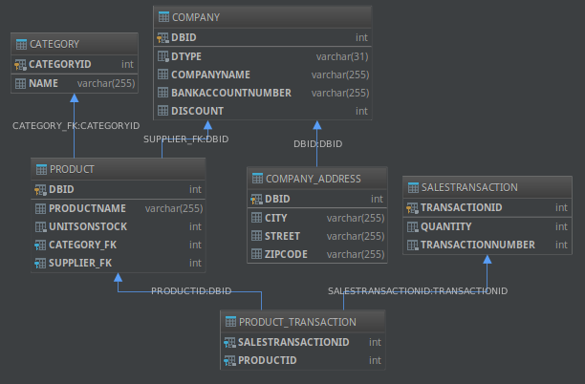
Zawartość tabeli Company i Company_Address:
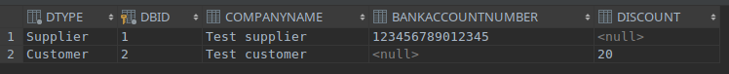
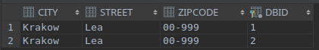

JOINED InheritanceType
Adnotacja w Company:
@Inheritance(strategy = InheritanceType.JOINED)

Struktura bazy dazy danych:
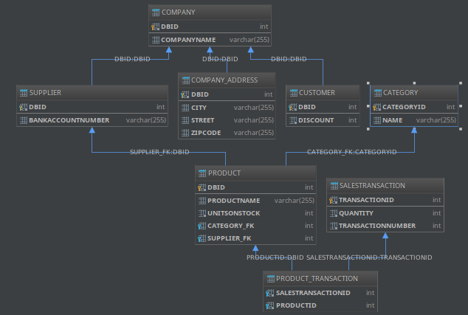
Zawartość tabel:
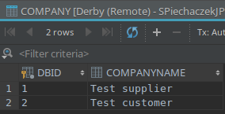
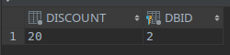
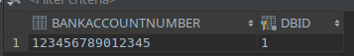

TABLE_PER_CLASS Inheritance Type
Zastosowanie tego typu dziedziczenia wymagało usunięcia odrębnej tabeli dla adresu w klasie Company.
Adnotacja:
@Inheritance(strategy = InheritanceType.TABLE_PER_CLASS)
Uzyskany schemat bazy danych:
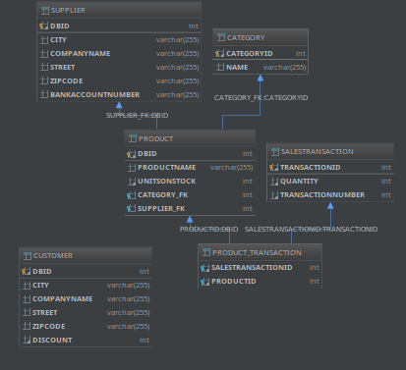
Zawartość tabel Supplier i Customer:

