CS4801 DevOps Lab

CONTINUOUS EVALUATION EXAMINATION
CI/CD PIPELINE LAB ASSESSMENT

POSITIVE BOOKING QUANTITY VALIDATION
- By Sai Pranav S R
IoT – B
23011102086
Repo URL - https://github.com/srsp-dev/Campus-Equipment-Booking

Task 1 — Git Workflow
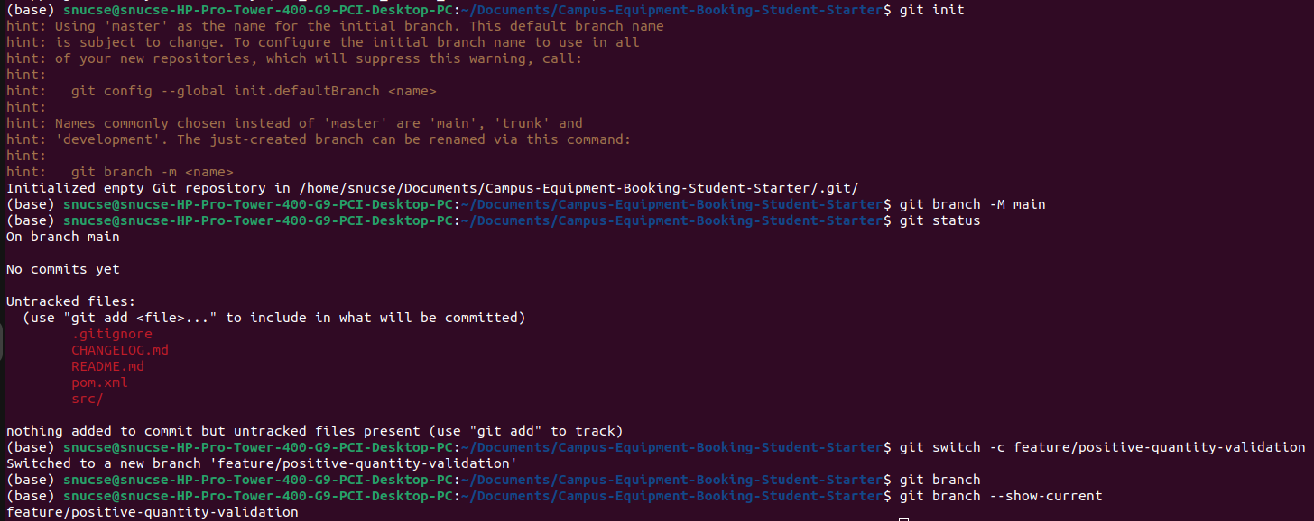
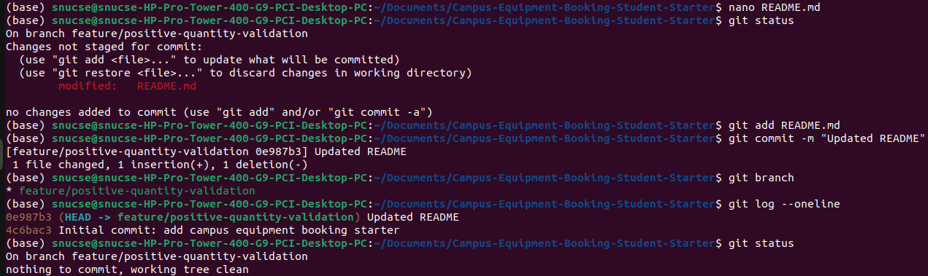

Task 2 — Maven Build and Automated Tests
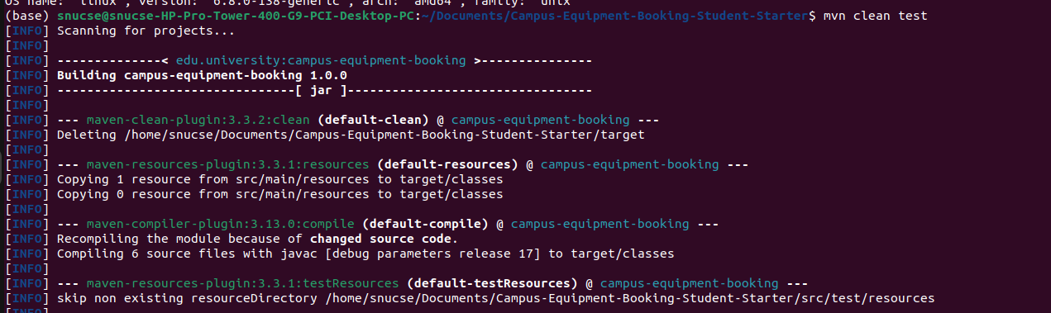

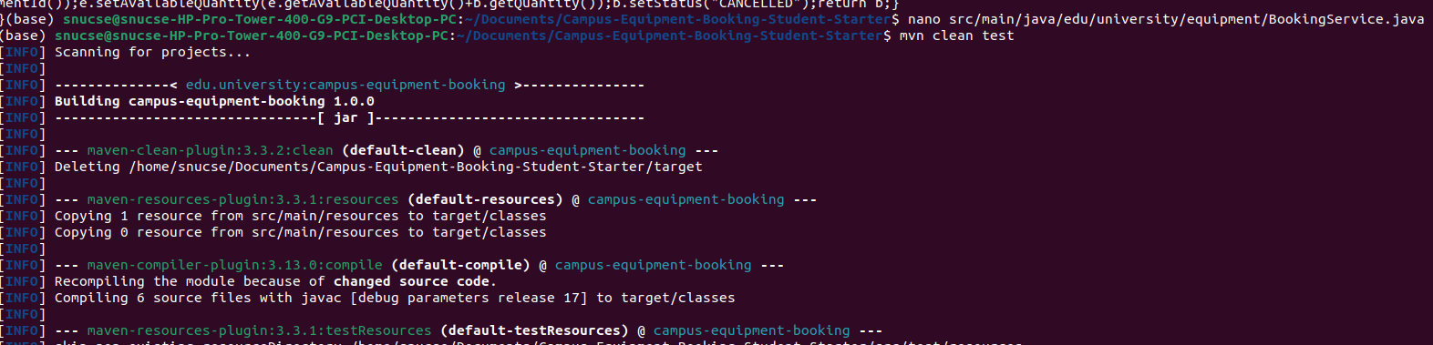
Task 3 — Diagnose and Correct the Booking-Capacity Defect

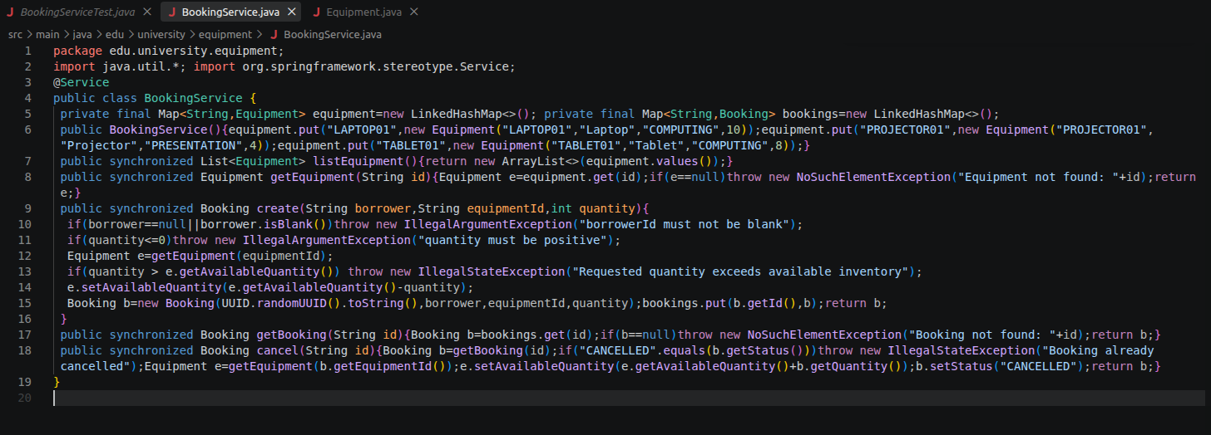

Task 4 — Set E Assigned Change Request

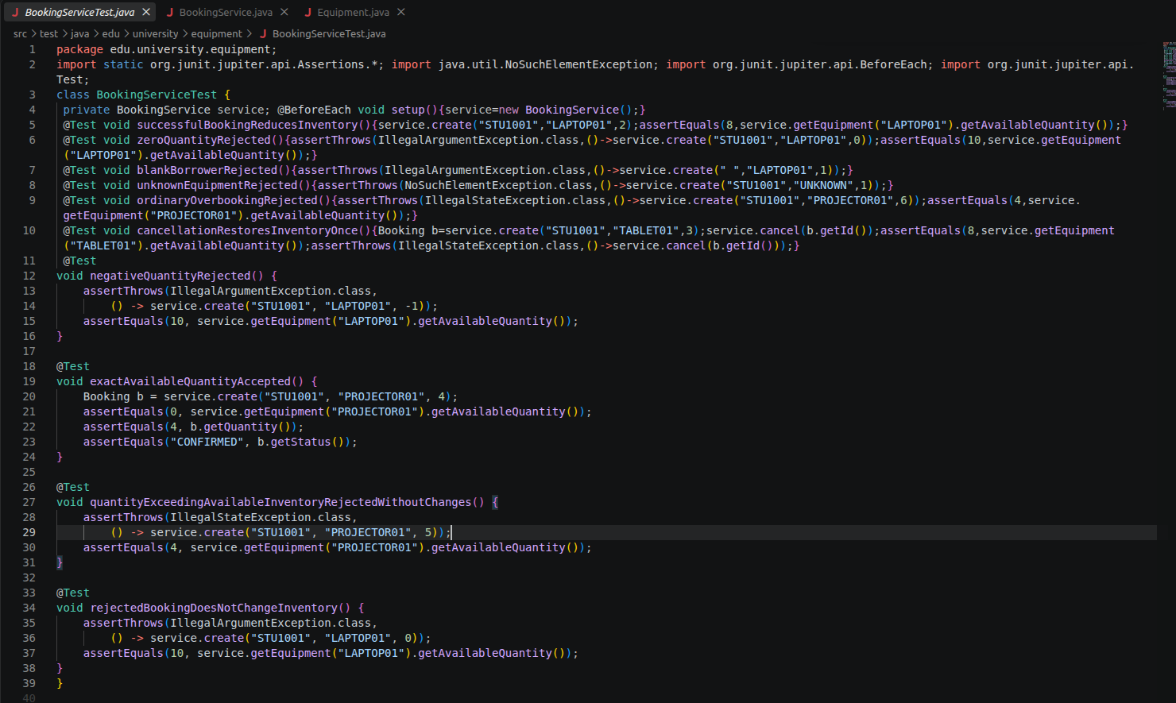

Task 5 — Docker Image and Container Verification

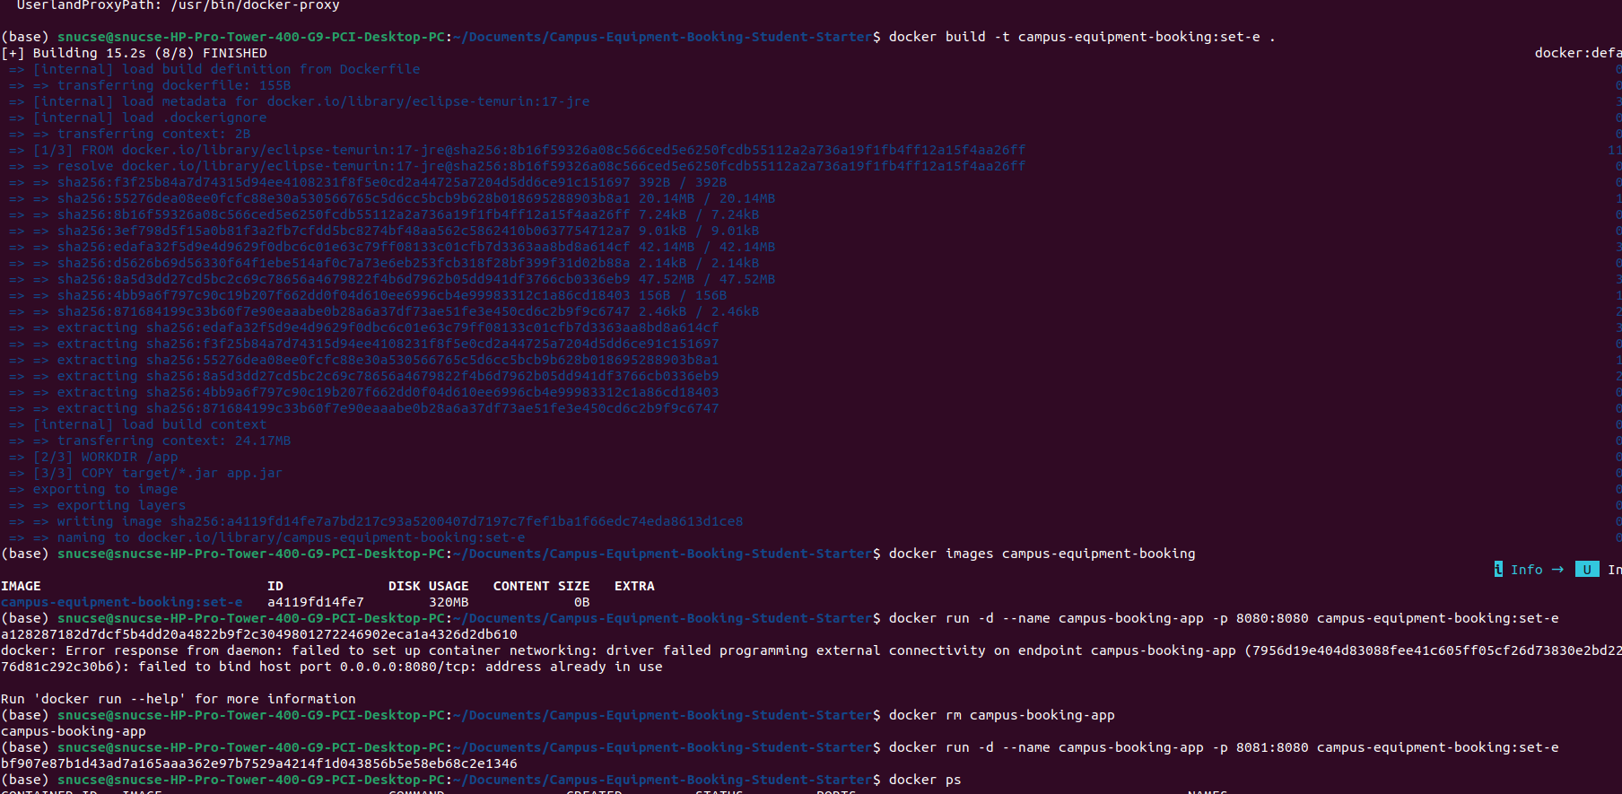

Task 6 — Minikube/Kubernetes Deployment

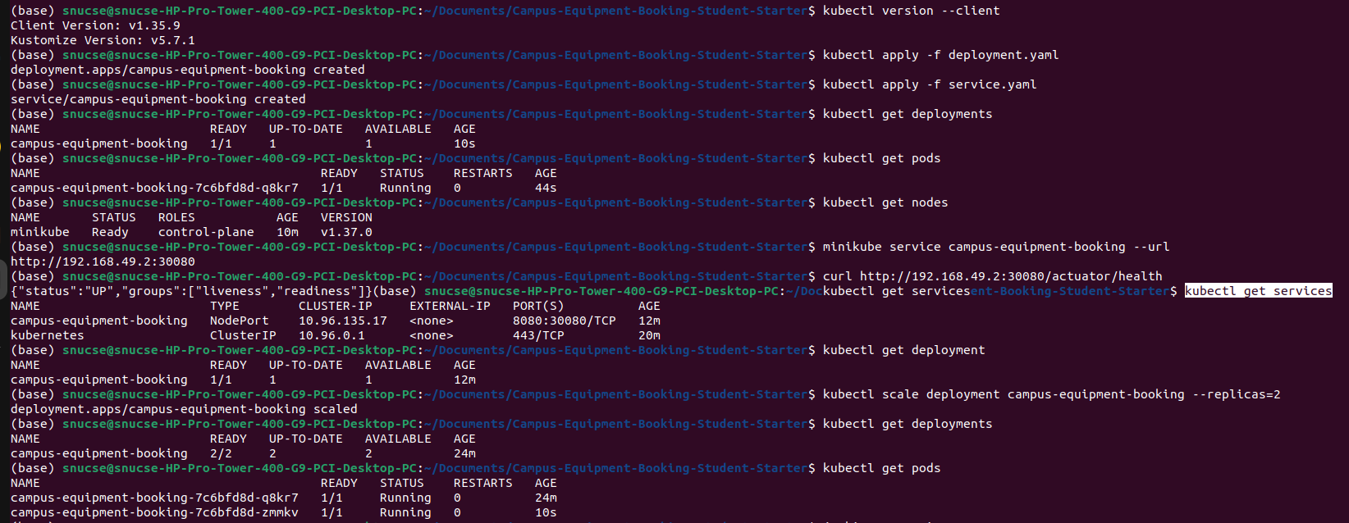

Jenkins

