Is anaemia at 34 weeks of pregnancy linked to higher anxiety and lower well-being in pregnant women in Jaipur
Asha Verma (demo student), MA Psychology, Jaipur

Abstract
Background. A search of OpenAlex and PubMed for 2010 to 2025 found studies of anaemia and of anxiety in pregnancy, but none in Rajasthan that measured haemoglobin and validated anxiety, self-esteem and life-satisfaction scales in the same women in the third trimester. Aim. Is anaemia at 34 weeks of pregnancy linked to higher anxiety and lower well-being in pregnant women in Jaipur? Methods. A cross-sectional survey of 1,240 participants: pregnant women aged 18 or over enrolled at 12 to 16 weeks at two government hospitals in Jaipur (the simulated Janani cohort). Results. Anaemia at 34 weeks affected 520 of 1,240 women (41.9%). Women with anaemia had higher GAD-7 scores (M = 7.26 vs 5.33, d = 0.41). Self-esteem went with higher life satisfaction (r = .45) and anxiety with lower life satisfaction (r = -.35). Mean haemoglobin rose from 10.90 to 11.29 g/dL between 16 and 34 weeks. In 612 couples, partners reported less anxiety than the women (M = 4.73 vs 6.31). Conclusion. Anaemic women in the third trimester carried more anxiety. Antenatal clinics that test haemoglobin could also screen these women with the GAD-7.

1. Introduction
Anaemia is one of the most common health problems of pregnancy, and the burden is highest in South Asia (Kassebaum et al., 2014). In low- and middle-income countries, anaemia in pregnancy goes with a higher risk of low birth weight and preterm birth (Rahman et al., 2016). Daily oral iron, usually given with folic acid, raises haemoglobin and lowers anaemia at term (Peña-Rosas et al., 2015). In India, every pregnant woman is offered iron-folic acid tablets at antenatal visits, yet many still reach the third trimester with anaemia.
Anxiety is also common in pregnancy. A meta-analysis found that about one woman in five reports anxiety symptoms in the third trimester (Dennis et al., 2017), and anxiety in pregnancy is linked to preterm birth and lower birth weight (Grigoriadis et al., 2018). Anaemia brings tiredness, breathlessness and poor sleep, all of which can feed worry, so the two problems may meet in the same women. If they do, antenatal clinics that already test haemoglobin could also look for anxiety in the women who need it most.
A search of OpenAlex and PubMed for 2010 to 2025 found studies of anaemia and of anxiety in pregnancy, but none in Rajasthan that measured haemoglobin and validated anxiety, self-esteem and life-satisfaction scales in the same women in the third trimester (Antony et al., 2022; Francis et al., 2022).
The present study asked: Is anaemia at 34 weeks of pregnancy linked to higher anxiety and lower well-being in pregnant women in Jaipur?
H1: Women with anaemia at 34 weeks will have higher GAD-7 scores than women without anaemia.
H2: Higher self-esteem will go with higher life satisfaction, and higher anxiety with lower life satisfaction.
H3: Haemoglobin will rise between 16 and 34 weeks with iron-folic acid tablets.

2. Materials and Methods

2.1 Design
This was a cross-sectional survey.

2.2 Participants
Pregnant women aged 18 or over enrolled at 12 to 16 weeks at two government hospitals in Jaipur (the simulated Janani cohort). Sampling: consecutive women at the first antenatal visit. The planned sample size was 1,240. The sample size was set as follows: All eligible women registered at the study sites during the data-collection months (a census of the available group), as agreed with the supervisor. All women gave written consent at enrolment. The analysis below uses the 1,240 women with a haemoglobin value at 34 weeks. A sample of 1,200 gives over 95% power to detect a small difference (d = 0.25) between women with and without anaemia at alpha .05.

2.3 Measures
Anxiety. Generalized Anxiety Disorder 7-item scale (GAD-7, 7 items) (Spitzer et al., 2006). Add the seven items. The total runs from 0 to 21. Scores of 5, 10 and 15 mark mild, moderate and severe anxiety symptoms (Spitzer et al., 2006). A score is a screening result, not a diagnosis; a score of 10 or more calls for a clinical assessment.
Life satisfaction. Satisfaction With Life Scale (SWLS, 5 items) (Diener et al., 1985). Add the five items. The total runs from 5 to 35. The bands come from the scale's own scoring guide and describe a score. They do not diagnose anything.
Self-esteem. Rosenberg Self-Esteem Scale (RSES, 10 items) (Rosenberg, 1965). Add the ten items after reverse-scoring items 2, 5, 6, 8 and 9. Higher totals mean higher self-esteem. The owner gives no official cut-off scores.
Anaemia at 34 weeks. Recorded as yes or no.
Haemoglobin at 34 weeks. Measured with the instrument or laboratory method described in section 2.4.
Parity. Recorded as: First pregnancy, Second or later.
Age. Taken from the hospital laboratory report or the antenatal card.
Residence. Recorded as: Urban, Rural.

2.4 Instruments and laboratory methods
Haemoglobin at 34 weeks. Venous blood (EDTA) was run on an automated five-part haematology analyser (model Sysmex XN-550) and haemoglobin was reported in g/dL. The laboratory ran the manufacturer's three-level controls each morning, the analyser was calibrated by the company engineer every six months, and the laboratory takes part in an external quality assurance scheme. Technicians did not see the women's scale scores. Because the data are simulated, these details show how a real study would report them.

2.5 Procedure and ethics
The study was approved by the Institutional Ethics Committee, Department of Psychology, Demo College, Jaipur (reference IEC/PSY/2026/A, 20 October 2026). [how consent was taken, where and when data were collected]

2.6 Analysis
The main hypothesis was tested with an independent-samples t-test. Analyses were run in the Appuscholar Statistics Lab. Two-sided tests used alpha .05. GAD-7 scores of women with and without anaemia were compared with Welch's t-test; associations between scales with Pearson correlations; haemoglobin at 16 and 34 weeks with a paired t-test; and GAD-7 with haemoglobin, age and parity in a multiple regression. Internal consistency was checked with Cronbach's alpha. Missing values were left out test by test.

3. Results
Results for each hypothesis follow.
An independent-samples Welch t-test showed that GAD-7 score differed significantly between women with anaemia (M = 7.26, SD = 5.12) and women without anaemia (M = 5.33, SD = 4.24), t(986.89) = 7.03, p < .001, g = 0.42, 95% CI of the difference [1.39, 2.47].
There was a moderate positive correlation between self-esteem (RSES) and life satisfaction (SWLS), which was statistically significant, r(1238) = .45, p < .001, 95% CI [.40, .49].
There was a moderate negative correlation between GAD-7 score and life satisfaction (SWLS), which was statistically significant, r(1238) = -.35, p < .001, 95% CI [-.39, -.30].
A paired-samples t-test showed a significant difference between haemoglobin at 16 weeks and haemoglobin at 34 weeks (M diff = -0.39, SD = 0.64), t(1239) = -21.50, p < .001, 95% CI [-0.43, -0.36], d = -0.61.
A multiple linear regression with age, haemoglobin at 34 weeks, parity: First pregnancy (vs Second or later) as predictors of GAD-7 score was significant, F(3, 1236) = 11.24, p < .001, R² = .03, adjusted R² = .02. Individual predictors: age (β = .04, p = .120); haemoglobin at 34 weeks (β = -.16, p < .001); parity: First pregnancy (vs Second or later) (b = 0.23, p = .393).
Internal consistency was α = .89, 95% CI [.88, .90], and McDonald's ω = .89, 95% CI [.88, .90] (k = 7 items, N = 1240).
A chi-square test of independence showed no significant association between anaemia at 34 weeks and parity, χ²(1, N = 1240) = 3.29, p = .070, Cramér's V = 0.05.
A paired-samples t-test showed a significant difference between the mothers' GAD-7 scores and the fathers' GAD-7 scores (M diff = 1.58, SD = 4.82), t(611) = 8.12, p < .001, 95% CI [1.20, 1.97], d = 0.33.

Figure 1
Distribution of GAD-7 score by anaemia at 34 weeks
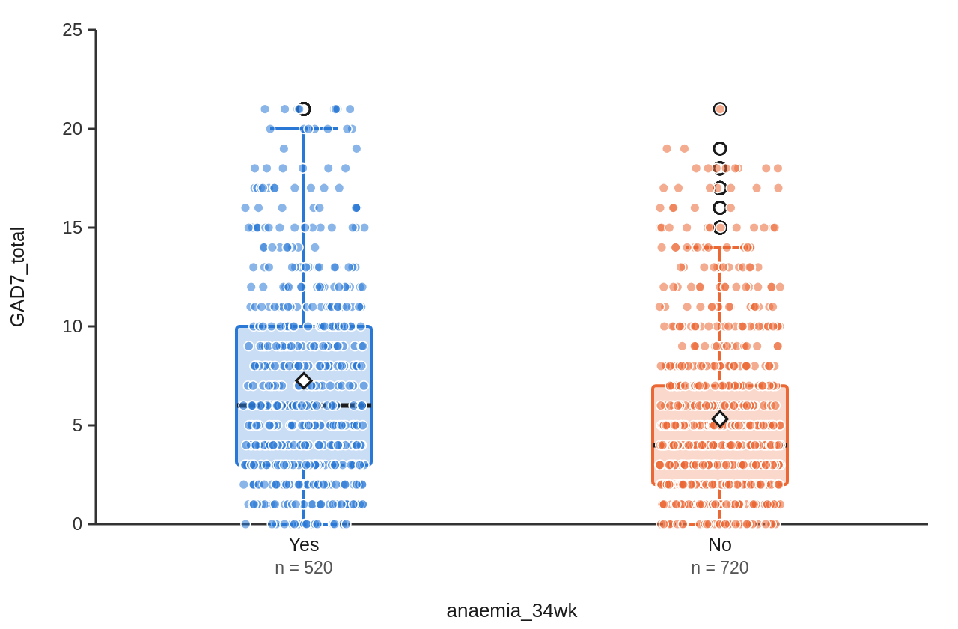
Note. Boxes show the median and interquartile range. Whiskers reach the most extreme values within 1.5 times the interquartile range. Each point is one participant.

4. Discussion
In this simulated cohort, women who were anaemic at 34 weeks reported more anxiety than women who were not, with a small-to-moderate difference, so H1 was supported. The direction matches the meta-analytic evidence that anxiety is common in late pregnancy (Dennis et al., 2017), and the link to anaemia adds a group that antenatal clinics can find easily from a routine blood test. Self-esteem and life satisfaction moved together, and anxiety moved against life satisfaction, which supports H2; the three scales told one consistent story.
Haemoglobin rose between 16 and 34 weeks, supporting H3 and in line with trials of daily iron in pregnancy, but four women in ten were still anaemic at 34 weeks. Partners reported less anxiety than the women, which suggests the worry is not simply shared by the household. The study has clear limits. The data are simulated. Anxiety was measured once, so the order of cause cannot be read from it, and all scales were self-report.
The correlation of r = .45 between self-esteem and life satisfaction means the two measures share about 20% of their variation (r² = .20); the other 80% comes from other things. The negative correlation of r = -.35 means that women with more anxiety tended to report less life satisfaction, with about 12% shared variation. Neither correlation shows cause: low life satisfaction may feed anxiety as easily as anxiety lowers life satisfaction.

5. Conclusion
Anaemia and anxiety met in the same women in the third trimester. Because anaemia is already tested at every antenatal visit, a two-minute GAD-7 for anaemic women is a cheap next step that a real study should test.
References
Antony, A. C., Vora, R. M., & Karmarkar, S. J. (2022). The silent tragic reality of Hidden Hunger, anaemia, and neural-tube defects (NTDs) in India. The Lancet Regional Health - Southeast Asia, 6, 100071. https://doi.org/10.1016/j.lansea.2022.100071
Dennis, C. L., Falah-Hassani, K., & Shiri, R. (2017). Prevalence of antenatal and postnatal anxiety: Systematic review and meta-analysis. British Journal of Psychiatry, 210(5), 315–323. https://doi.org/10.1192/bjp.bp.116.187179
Diener, E., Emmons, R. A., Larsen, R. J., & Griffin, S. (1985). The Satisfaction With Life Scale. Journal of Personality Assessment, 49(1), 71–75. https://doi.org/10.1207/s15327752jpa4901_13
Francis, S., Jagadeesh, N. S., Singaravelu, R., & Subramaniam, A. (2022). The influence of pica practice on nutritional status, stress and anxiety of pregnant women. Clinical Epidemiology and Global Health, 17, 101133. https://doi.org/10.1016/j.cegh.2022.101133
Grigoriadis, S., Graves, L., Peer, M., Mamisashvili, L., Tomlinson, G., Vigod, S. N., Dennis, C. L., Steiner, M., Brown, C., Cheung, A., Dawson, H., Rector, N. A., Guenette, M., & Richter, M. (2018). Maternal Anxiety During Pregnancy and the Association With Adverse Perinatal Outcomes: Systematic Review and Meta-Analysis. The Journal of Clinical Psychiatry, 79(5). https://doi.org/10.4088/jcp.17r12011
Kassebaum, N. J., Jasrasaria, R., Naghavi, M., Wulf, S. K., Johns, N., Lozano, R., Regan, M., Weatherall, D., Chou, D. P., Eisele, T. P., Flaxman, S. R., Pullan, R. L., Brooker, S. J., & Murray, C. J. L. (2014). A systematic analysis of global anemia burden from 1990 to 2010. Blood, 123(5), 615–624. https://doi.org/10.1182/blood-2013-06-508325
Peña-Rosas, J. P., De-Regil, L. M., Garcia-Casal, M. N., & Dowswell, T. (2015). Daily oral iron supplementation during pregnancy. Cochrane Database of Systematic Reviews, 2015(7). https://doi.org/10.1002/14651858.cd004736.pub5
Rahman, M. M., Abe, S. K., Rahman, M. S., Kanda, M., Narita, S., Bilano, V., Ota, E., Gilmour, S., & Shibuya, K. (2016). Maternal anemia and risk of adverse birth and health outcomes in low- and middle-income countries: systematic review and meta-analysis. The American Journal of Clinical Nutrition, 103(2), 495–504. https://doi.org/10.3945/ajcn.115.107896
Rosenberg, M. (1965). Society and the adolescent self-image. Princeton University Press.
Spitzer, R. L., Kroenke, K., Williams, J. B. W., & Löwe, B. (2006). A Brief Measure for Assessing Generalized Anxiety Disorder: The GAD-7. Archives of Internal Medicine, 166(10), 1092. https://doi.org/10.1001/archinte.166.10.1092

