Does paracetamol given after the measles-rubella vaccine lower the antibody response in nine-month-old infants in Jaipur
Asha Verma (demo student), MA Psychology, Jaipur

Abstract
Background. Trials in Europe found lower antibody responses when infants were given paracetamol at vaccination, but a search of OpenAlex and PubMed for 2009 to 2025 found no Indian study of measles antibody response after paracetamol given at home. Aim. Does paracetamol given after the measles-rubella vaccine lower the antibody response in nine-month-old infants in Jaipur? Methods. A cohort study of 1,133 participants: infants born in the simulated Janani cohort, Jaipur, who received the first measles-rubella dose (MR1) at 9 months. Results. Of 1,133 vaccinated infants, 91.4% seroconverted. Seroconversion was lower after paracetamol (85.7% vs 92.7%), and did not differ between boys and girls. Conclusion. Paracetamol after MR1 went with a lower antibody response. Parents should be told to give it only for fever, not as routine prevention.

1. Introduction
Measles still kills children where vaccine coverage is low, and two doses of a measles-containing vaccine prevent almost all cases (Moss & Griffin, 2012). In India, the first measles-rubella dose (MR1) is given at nine months. Fever after vaccination is common, and parents often give paracetamol at home.
In a randomised trial, infants given prophylactic paracetamol at vaccination had lower antibody responses to several vaccines (Prymula et al., 2009). Whether paracetamol given by parents after MR1 lowers the measles antibody response in Indian infants is not known.
Trials in Europe found lower antibody responses when infants were given paracetamol at vaccination, but a search of OpenAlex and PubMed for 2009 to 2025 found no Indian study of measles antibody response after paracetamol given at home (Sil et al., 2017; Homme & Fischer, 2010).
The present study asked: Does paracetamol given after the measles-rubella vaccine lower the antibody response in nine-month-old infants in Jaipur?
H1: Infants given paracetamol after MR1 will seroconvert less often than infants not given paracetamol.
H2: Seroconversion will not differ between boys and girls.

2. Methods

2.1 Design
This was a cohort study.

2.2 Participants
Infants born in the simulated Janani cohort, Jaipur, who received the first measles-rubella dose (MR1) at 9 months. Sampling: all cohort infants with an MR1 dose and a blood sample six weeks later. The planned sample size was 1,133. The analysis uses the 1,133 infants who received MR1 (622 boys and 576 girls were born in the cohort). Low birth weight (under 2,500 g) affected 17.1% of the 1,198 newborns.

2.3 Measures
Seroconversion. Recorded as yes or no.
Paracetamol after MR1. Recorded as yes or no.
Infant sex. Recorded as: Boy, Girl.
Birth weight. Taken from the hospital laboratory report or the antenatal card.
Low birth weight. Recorded as: Yes, No.

2.4 Procedure and ethics
The data are simulated to test Appuscholar; no real infant took part. A real study would need ethics committee approval and parental consent. Measles IgG was measured six weeks after MR1; 120 mIU/mL or more counted as seroconversion. Parents reported fever and any paracetamol given in the three days after vaccination.

2.5 Analysis
The main hypothesis was tested with a logistic regression. Analyses were run in the Appuscholar Statistics Lab. Seroconversion was compared between infants given and not given paracetamol, and between boys and girls, with chi-square tests. A logistic regression related seroconversion to paracetamol, birth weight and sex. Alpha was .05, two-sided.

3. Results
Results for each hypothesis follow.
A chi-square test of independence showed a significant association between paracetamol after MR1 and seroconversion, χ²(1, N = 1133) = 11.42, p < .001, Cramér's V = 0.10.
A chi-square test of independence showed no significant association between infant sex and seroconversion, χ²(1, N = 1133) = 0.05, p = .827, Cramér's V = 0.01.
A logistic regression with birth weight (g), infant sex: Girl (vs Boy), paracetamol after MR1: Yes (vs No) as predictors of seroconversion (Yes versus No) was significant, χ²(3, N = 1133) = 10.72, p = .013, Nagelkerke R² = .021. The model classified 91.4% of cases correctly (AUC = .59). Odds ratios: birth weight (g) (OR = 1.00, 95% CI [1.00, 1.00], p = .474); infant sex: Girl (vs Boy) (OR = 0.97, 95% CI [0.64, 1.48], p = .902); paracetamol after MR1: Yes (vs No) (OR = 0.46, 95% CI [0.29, 0.73], p < .001).
There was a moderate positive correlation between the mother's haemoglobin at 34 weeks and birth weight (g), which was statistically significant, r(1196) = .31, p < .001, 95% CI [.26, .36].
An independent-samples Welch t-test showed that birth weight (g) differed significantly between boys (M = 2955.67, SD = 404.24) and girls (M = 2840.56, SD = 415.40), t(1183.18) = 4.85, p < .001, g = 0.28, 95% CI of the difference [68.59, 161.64].

Figure 1
Distribution of birth weight (g)
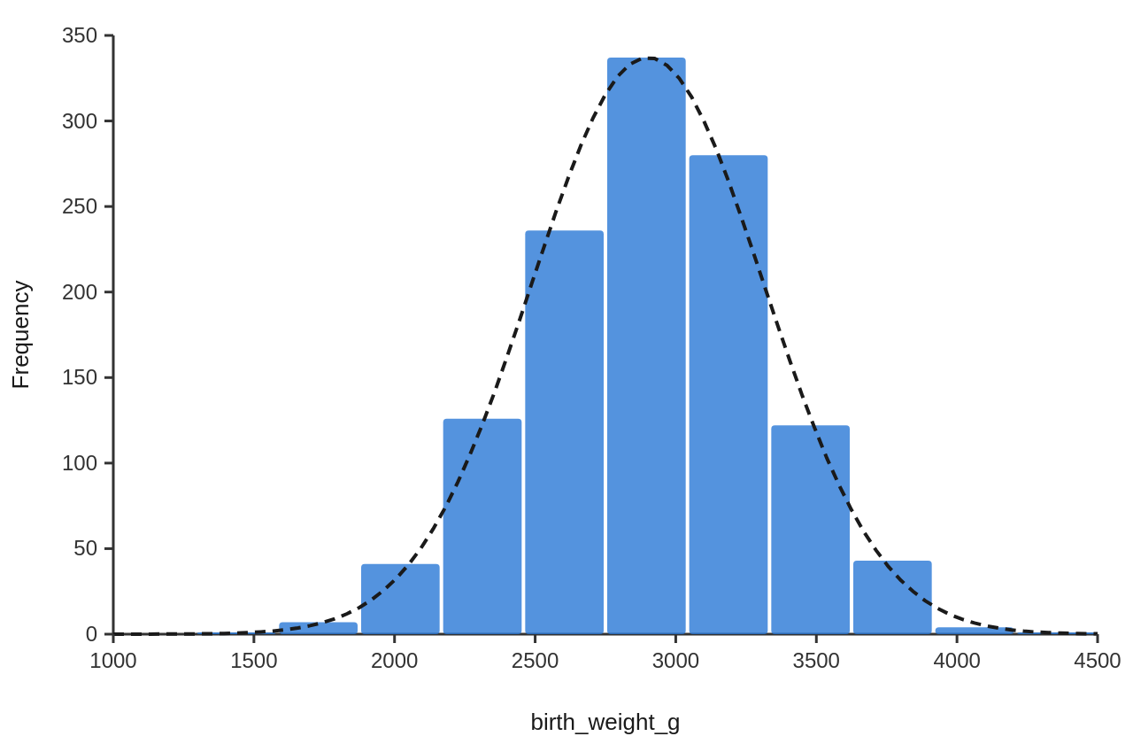
Note. The dashed curve is a normal distribution with the same mean and standard deviation as the data.

4. Discussion
Infants whose parents gave paracetamol after MR1 seroconverted less often, which supports H1 and follows the same direction as the trial of prophylactic paracetamol (Prymula et al., 2009). Boys and girls did not differ, as H2 predicted. Most infants still seroconverted, and the second dose at 16 to 24 months protects many of those who do not.
Paracetamol was given more often to infants with fever, so fever itself or a stronger reaction may explain part of the link. The data are simulated, and paracetamol use was reported by parents.

5. Conclusion
Paracetamol given after MR1 went with lower seroconversion. Advice at the vaccination session should say to give it for fever, not to every infant.
References
Homme, J. H., & Fischer, P. R. (2010). Prophylactic paracetamol at the time of infant vaccination reduces the risk of fever but also reduces antibody response. BMJ Evidence-Based Medicine, 15(2), 50–51. https://doi.org/10.1136/ebm1049
Moss, W. J., & Griffin, D. E. (2012). Measles. The Lancet, 379(9811), 153–164. https://doi.org/10.1016/s0140-6736(10)62352-5
Prymula, R., Siegrist, C. A., Chlibek, R., Zemlickova, H., Vackova, M., Smetana, J., Lommel, P., Kaliskova, E., Borys, D., & Schuerman, L. (2009). Effect of prophylactic paracetamol administration at time of vaccination on febrile reactions and antibody responses in children: two open-label, randomised controlled trials. The Lancet, 374(9698), 1339–1350. https://doi.org/10.1016/s0140-6736(09)61208-3
Sil, A., Ravi, M. D., Patnaik, B. N., Dhingra, M. S., Dupuy, M., Gandhi, D. J., Dhaded, S. M., Dubey, A. P., Kundu, R., Lalwani, S. K., Chhatwal, J., Mathew, L. G., Gupta, M., Sharma, S. D., Bavdekar, S. B., Rout, S. P., Midde, V. J., D’Cor, N. A., Mangarule, S., . . . E, J. R. (2017). Effect of prophylactic or therapeutic administration of paracetamol on immune response to DTwP-HepB-Hib combination vaccine in Indian infants. Vaccine, 35(22), 2999–3006. https://doi.org/10.1016/j.vaccine.2017.03.009

