Joshua Smith
9/11/2026
Project Proposal

Author: Inio Asano
- Book 1:
  - Title: Goodnight Punpun, Vol.1
  - ISBN-13: 978-1421586205
  - Price: $24.99
  - 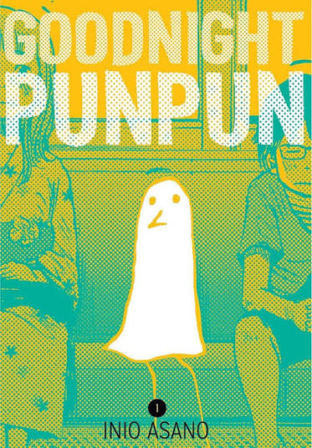

- Book 2:
  - Title: Goodnight Punpun, Vol. 2
  - ISBN-13: 978-1421586212
  - Price: $24.99
  - 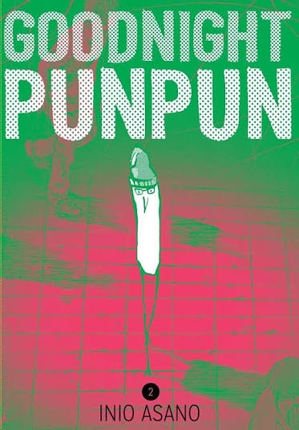

- Book 3:
  - Title: Goodnight Punpun, Vol. 3
  - ISBN-13: 978-1421586229
  - Price: $24.99
  - 

