Server Side Web Development
Student name: Shreeyan Simkhada
Author Name: Caroline Stevermer
Book – 1: When The King Comes Home
Price (Paperback): $89.96
ISBN-13 ‏ : ‎ 978-1504074025
Image:
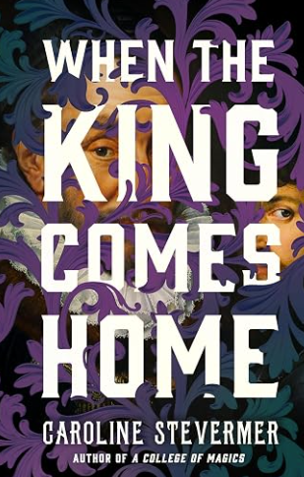
Book - 2: A College of Magics
Price (Paperback) : $7.93
ISBN-13 ‏ : ‎ 978-1466819481
Image:
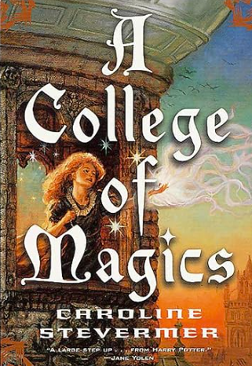
Book – 3: The Serpent's Egg
Price (Paperback): $9.50
ISBN-13 ‏ : ‎ 978-1504074032
Image:


