PART A
(PART A: TO BE REFFERED BY STUDENTS)

Experiment No.01

A.1 Aim:
Write Detail Statement of Problem and create dimensional model (creation star and snowflake schema) for the same.

A.2 Prerequisite:
DBMS concept and ER diagram.

A.3 Outcome:
After successful completion of this experiment students will be able to
⮚ Describe need and design of data warehouse.

A.4 Theory:

Dimension Modeling(From Requirement to data design)
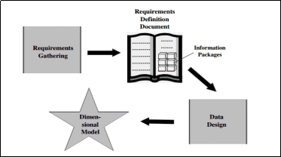

STAR Schema: An arrangement in the dimensional model looks like a star formation, with the fact table at the core of the star and the dimension tables along the spikes of the star. The dimensional model is therefore called a STAR schema.
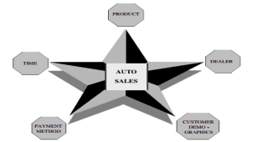

Example:Star schema for order analysis
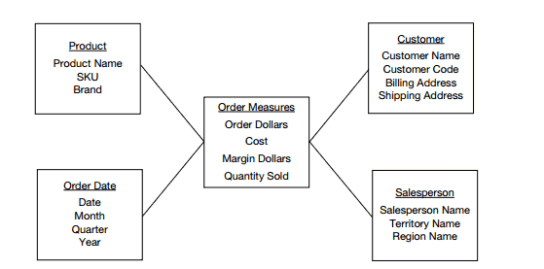

Snow Flake Schema:- “Snowflaking” is a method of normalizing the dimension tables in a STAR schema. When you completely normalize all the dimension tables, the resultant structure resembles a snowflake with the fact table in the middle.

Example:(Sales)
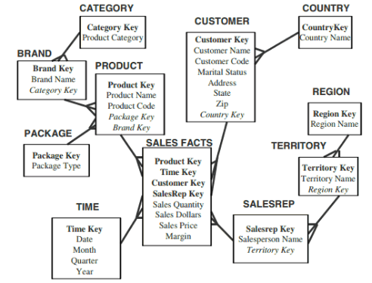

A.5 Algorithm:
Student need to select a problem statement and create a Star schema and snowflake schema for the selected problem statement

Eg: problem statement

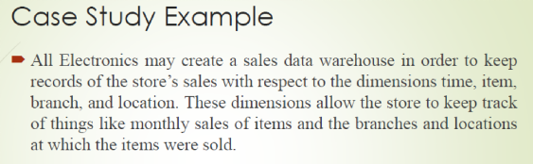

Star schema
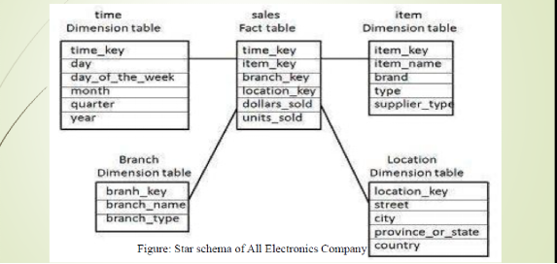

Snowflake schema:

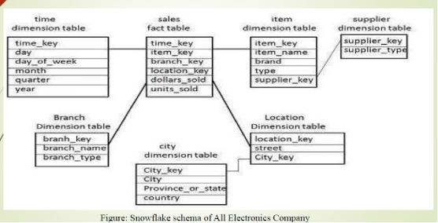

PART B
(PART B: TO BE COMPLETED BY STUDENTS)

(Students must submit the soft copy as per following segments within two hours of the practical. The soft copy must be uploaded on the Blackboard or emailed to the concerned lab in charge faculties at the end of the practical in case the there is no Black board access available)

Roll. No.: A55 | Name: Sarthak Gotad
Class: TE COMP A | Batch: A2
Experiment No.: 01 | Date of Experiment:
Date of Submission: | Grade:

B.1 Software Code written by student:

Problem Statement:-

Online Shopping Sales Data Warehouse
An e-commerce company wants to analyze its sales performance. The company records information about customers, products, sellers, dates, and locations. Management wants reports such as:
- Total sales by product.
- Monthly and yearly sales.
- Sales by customer and city.
- Sales by category.
- Sales by seller.
- Quantity sold and total revenue.
To support analytical reporting, a Data Warehouse is designed using Star Schema and Snowflake Schema.

Star schema Model:

Fact Table
Fact_Sales
- Sales_ID (PK)
- Customer_ID (FK)
- Product_ID (FK)
- Seller_ID (FK)
- Date_ID (FK)
- Location_ID (FK)
- Quantity
- Total_Amount
- Discount

Dimension Tables
Dim_Customer
- Customer_ID (PK)
- Customer_Name
- Gender
- Age
- Email
Dim_Product
- Product_ID (PK)
- Product_Name
- Category
- Brand
- Price
Dim_Seller
- Seller_ID (PK)
- Seller_Name
- Seller_Type
Dim_Date
- Date_ID (PK)
- Date
- Day
- Month
- Quarter
- Year
Dim_Location
- Location_ID (PK)
- City
- State
- Country

Snowflake Model(if applicable):

Fact Table
Fact_Sales
- Sales_ID
- Customer_ID
- Product_ID
- Seller_ID
- Date_ID
- Location_ID
- Quantity
- Total_Amount
- Discount

Customer Dimension
Dim_Customer
- Customer_ID
- Customer_Name
- Gender
- Age
- City_ID
Dim_City
- City_ID
- City
- State_ID
Dim_State
- State_ID
- State
- Country_ID
Dim_Country
- Country_ID
- Country

Product Dimension
Dim_Product
- Product_ID
- Product_Name
- Brand_ID
- Category_ID
- Price
Dim_Brand
- Brand_ID
- Brand_Name
Dim_Category
- Category_ID
- Category_Name

Seller Dimension
Dim_Seller
- Seller_ID
- Seller_Name
- Seller_Type

Date Dimension
Dim_Date
- Date_ID
- Day
- Month_ID
Dim_Month
- Month_ID
- Month
- Quarter
- Year

B.2 Input and Output:
Problem statement:
Design a Data Warehouse for an Online Shopping System using Star Schema and Snowflake Schema to analyze sales based on products, customers, sellers, locations, and time.
Star schema Model:
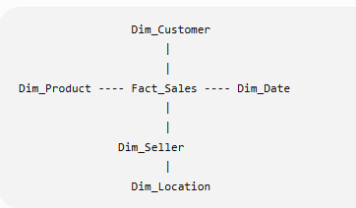
Snowflake Model(if applicable):
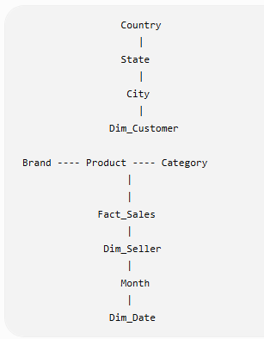
B.3 Observations and learning:
· Star Schema is simple and provides faster query performance.
· Snowflake Schema reduces data redundancy by normalizing dimension tables.
· Fact tables store numerical measures such as Quantity and Total Amount.
· Dimension tables contain descriptive information used for analysis.
· Data Warehouses support efficient decision-making and business intelligence.

B.4 Conclusion:
The experiment helped in understanding the design of a Data Warehouse using dimensional modeling. Star Schema offers simplicity and faster query execution, whereas Snowflake Schema minimizes redundancy through normalization. Both models are useful for analytical processing and business reporting.
B.5 Question of Curiosity
Q1:What is need of Data Warehouse?
->A Data Warehouse is used to collect and store data from multiple sources for reporting and analysis. It enables faster query processing, historical data analysis, trend identification, and supports business decision-making.

Q2: What is Dimension Modeling?
->Dimension Modeling is a data design technique used in Data Warehouses. It organizes data into Fact Tables (containing measurable business data) and Dimension Tables (containing descriptive attributes) to improve query performance and simplify analysis.

Q3: Differentiate between ER modeling and Dimensional Modeling?
->
ER Modeling | Dimensional Modeling
Used for OLTP systems | Used for Data Warehouses (OLAP)
Highly normalized | Denormalized or partially normalized
Focuses on transaction processing | Focuses on data analysis and reporting
Complex joins | Fewer joins, faster queries
Designed to reduce redundancy | Designed for better analytical performance
Uses entities and relationships | Uses Fact and Dimension tables

