1. Download Ganache
2. Install Truffle using the below command

Npm install -g [truffle@5.0.2](mailto:truffle@5.0.2)

1. Install Metamask google extension
2. Check for the version of truffle using

Truffle version

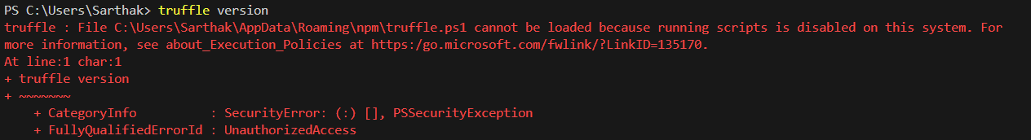

To resolve this run the following command on window prompt

Set-ExecutionPolicy -Scope CurrentUser -ExecutionPolicy Unrestricted

1. Run the command – truffle init

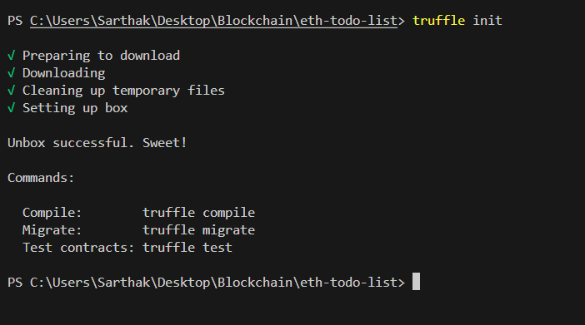

1. Package.json file contains /\*This file contains he dependencies to run this project\*/
2. "bootstrap": "4.1.3",

Bootstrap framework – used for building out client side application

    "chai": "^4.1.2",

    "chai-as-promised": "^7.1.1",

    "chai-bignumber": "^2.0.2"

Dependensies to test the smart contracts

    "lite-server": "^2.3.0",

Server for running the client side application

1. Run the command – npm install