Cross Examination: Teaching Demo
Scenario 1: Drosophila melanogaster — Aggression
Scenario
You want to identify the genetic loci underlying variation in aggression in D. melanogaster. Two resources are available. The DSPR is an 8-founder fully intercrossed population with 50 generations of recombination and can be used as a composite cross for bulk segregant analysis. Two inbred lines that differ substantially in aggression are also available for a biparental QTL cross.
Scoring aggression requires manually annotating 5-minute videos. A single trained observer can score ~200 individuals per day. You have 30 days available for the experiment. With the DSPR, all 30 days can be spent scoring, giving a total budget of 6,000 individuals. Across 4 replicates, the top 500 individuals are selected as cases, and 500 randomly selected non-extreme individuals serve as controls per replicate, for a total of 4,000 individuals. The remaining 2,000 are scored but not pooled to determine the top individuals. Generating F₂ individuals for a biparental cross requires weeks of cross setup, leaving only 2 to 3 days for scoring, enough for 500 F₂ individuals within the same window.

Question 1. Which mapping method and population would you choose, and why?

Answer
Use the DSPR with the MPP tab (bulk segregant analysis). With a daily throughput of ~200 individuals and 30 full days available, the total scoring budget is 6,000 individuals — enough for 4 BSA replicates at pool size 500. The biparental cross requires several weeks of cross setup, reducing the scoring window to only 2–3 days (~500 F₂ individuals), which is too small a sample to reliably detect QTLs of moderate effect size.
The DSPR design has additional advantages beyond sample size. With 8 founders and 50 generations of intercrossing, LD has been broken into short blocks, so association peaks are narrow and well-localized. The founder frequency panel identifies which of the 8 ancestral lines carries the effect allele, providing information a 2-founder cross cannot. The BSA design with multiple replicates also benefits from the CMH test, which stacks signal across independent phenotype draws while noise averages out.

Question 2. What parameters would you set and why?

Answer
MPP tab — DSPR design:
- Teaching Mode: ON. Fixes QTL positions and random seed so all students see the same result.
- Crossing design: Fully intercrossed. The DSPR is a fully intercrossed population — each RIL carries a mosaic of all 8 founder genomes.
- Founders: 8. Matches the DSPR (A1–A8 founder lines).
- Generations: 50. Matches the DSPR. More generations produce shorter LD blocks and narrower mapping peaks.
- Pool size (N): 500. Each replicate scores 1,500 individuals total: 500 cases + 500 controls + 500 scored but not selected. Four replicates × 1,500 = 6,000, exactly on budget.
- Replicates: 4. Maximizes statistical power within the budget. The CMH test combines signal across replicates.
- Architecture: Run first with 1 QTL, then with Polygenic to compare detection under different genetic models.

Biparental QTL tab — F₂ cross (for comparison):
- Teaching Mode: ON.
- N: 500. Reflects the scoring budget available after weeks of cross setup.
- Architecture: Run with 1 QTL, then Polygenic.

Question 3. How does the practical constraint described affect your parameter choices?

Answer
The primary constraint is the 30-day scoring window with a throughput of ~200 individuals per day, giving a hard cap of 6,000 total individuals.
For the BSA design, note that pool size N refers to the number of individuals selected into each pool, not the total number scored. To select the top 500 as cases, you must score enough individuals to identify the extremes. The scenario specifies that the remaining 2,000 individuals (500 per replicate beyond the cases and controls) are scored to determine the extremes but are not pooled. This means each replicate requires scoring 1,500 individuals: 500 cases + 500 controls + 500 additional to identify the top performers. Four replicates × 1,500 = 6,000 exactly.
For the biparental cross, the constraint operates differently. Cross setup requires 3–4 weeks, consuming most of the 30-day window before scoring begins. Only 2–3 days remain for scoring, limiting the F₂ sample to approximately 500 individuals. This is the same number used in the BSA controls — but here it is the entire dataset, with no replication.
The practical effect is that the BSA design uses the full scoring budget efficiently (4 independent phenotype draws), while the biparental cross spends most of its time budget on cross logistics rather than on phenotyping.

Question 4. Run your design with 1 QTL and with polygenic architecture. Does your method detect a signal? How does the output change between the two genetic models?

Answer
DSPR/BSA — 1 QTL:
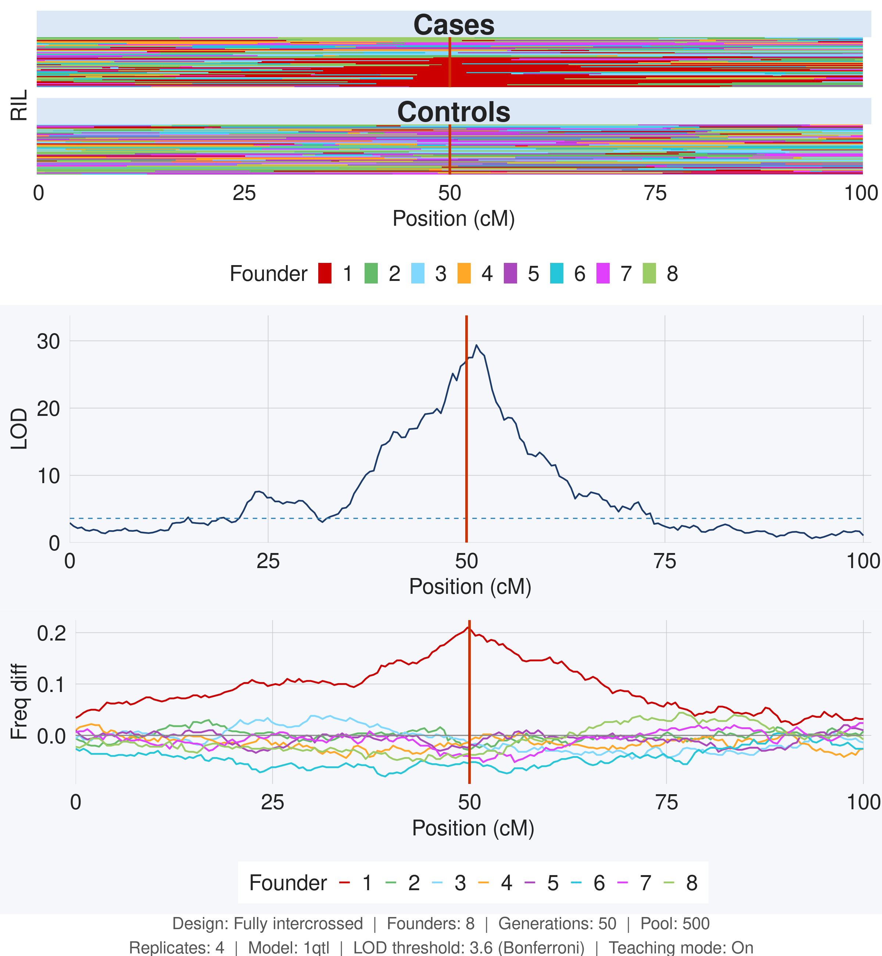
Figure 1. DSPR/BSA result, 1 QTL architecture. Settings: 8 founders, 50 generations, pool size 500, 4 replicates.
A single sharp LOD peak appears well above the significance threshold at the true QTL position (50 cM). The peak is narrow, reflecting the short LD blocks produced by 50 generations of intercrossing. In the founder frequency panel, one founder shows a large positive shift at the QTL position while the others remain near zero, identifying which ancestral line carries the effect allele.

DSPR/BSA — Polygenic:
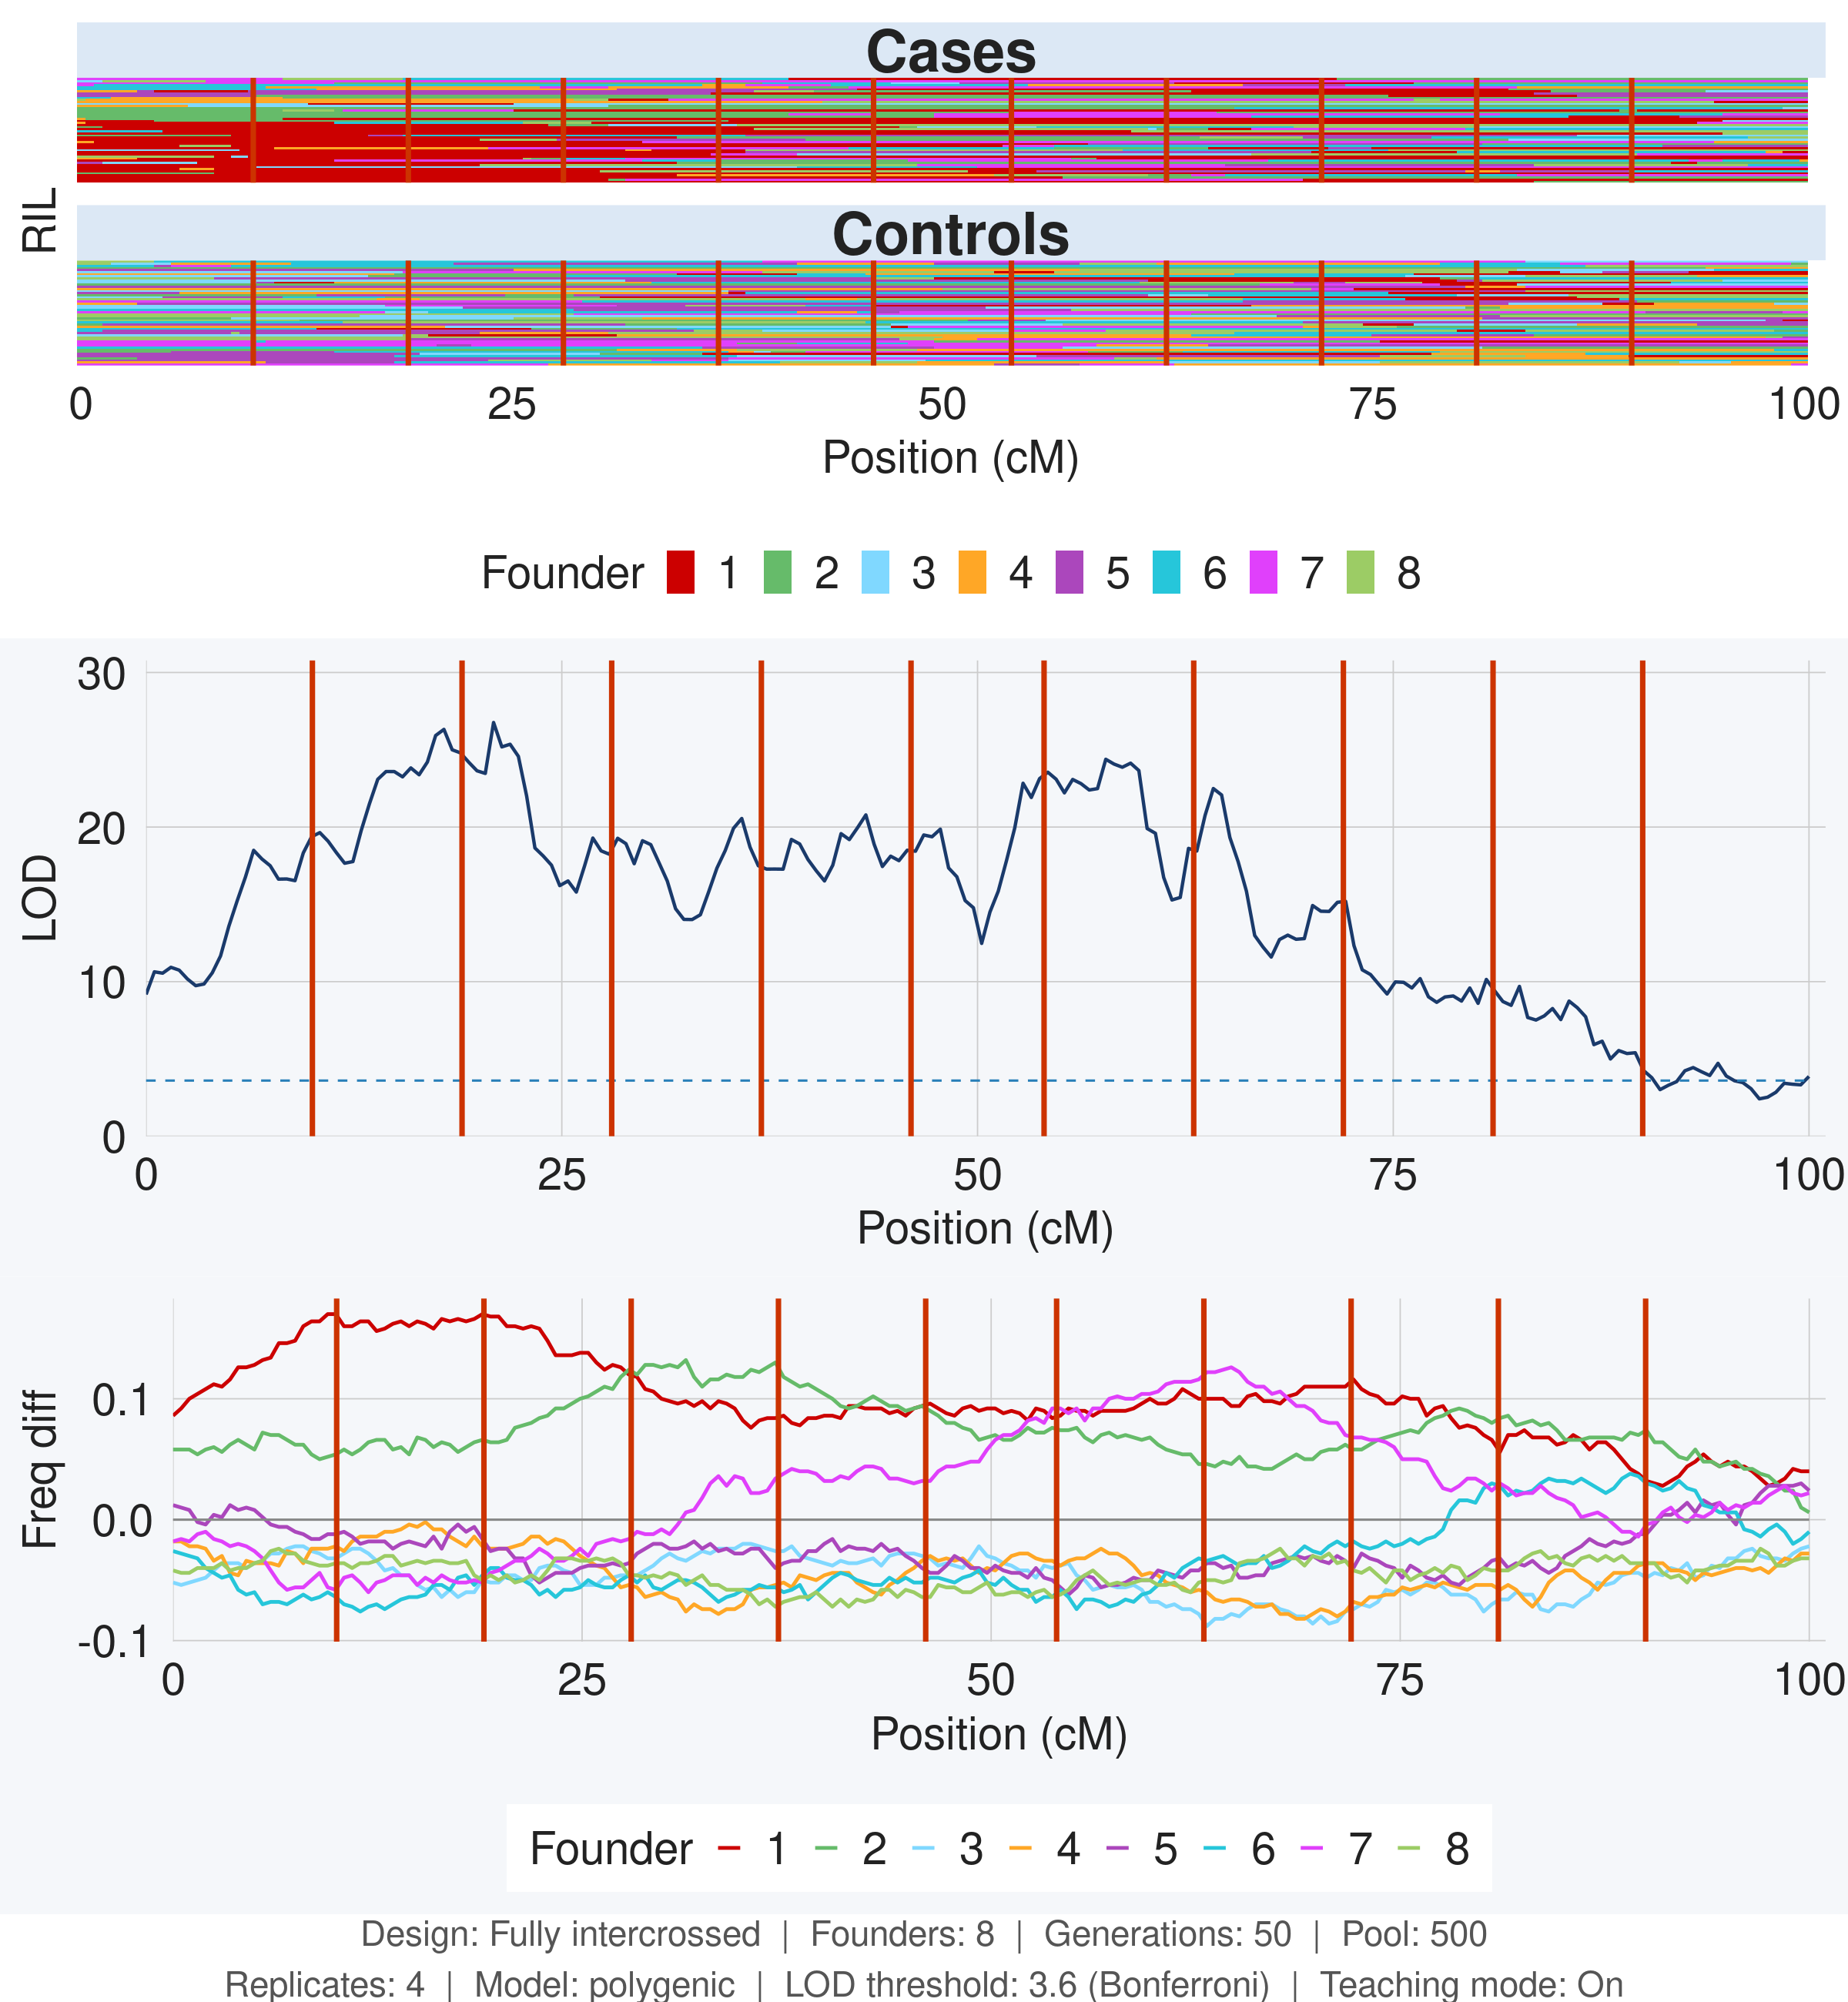
Figure 2. DSPR/BSA result, polygenic architecture. Settings: 8 founders, 50 generations, pool size 500, 4 replicates.
Multiple peaks appear above the threshold at distinct genomic positions, each corresponding to a real locus. The peaks remain narrow and well-separated because short LD prevents signals from different loci from merging. Several founders show modest frequency shifts at different positions — no single founder dominates because the genetic effect is distributed across multiple loci.

Biparental F₂ — 1 QTL:
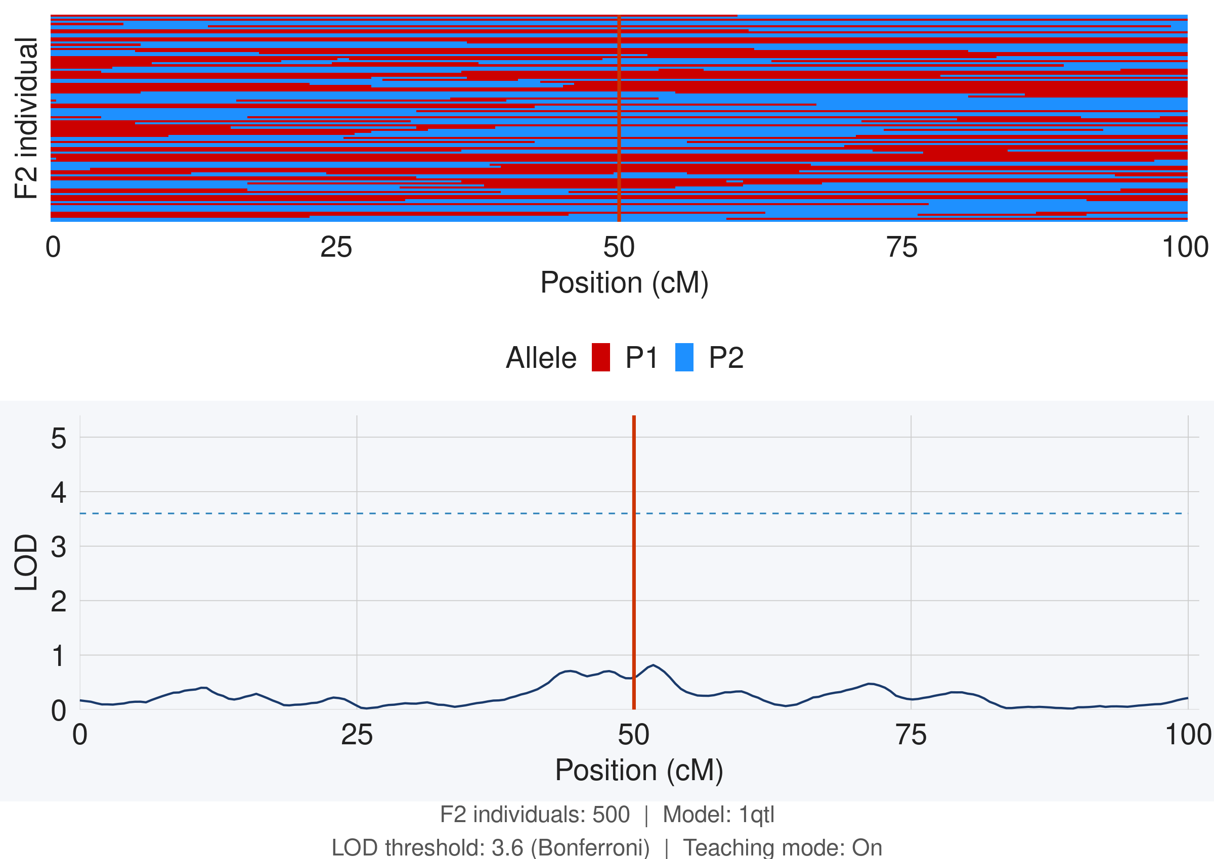
Figure 3. Biparental QTL result, 1 QTL architecture. Settings: 500 F₂ individuals.
The LOD score peaks near the true QTL position but remains well below the significance threshold (~0.8). With only 500 F₂ individuals, there is insufficient power to detect even a large-effect locus. The broad, shallow LOD curve also reflects long LD in the F₂ (only 1 generation of recombination), which reduces resolution even when signal is present.

Biparental F₂ — Polygenic:
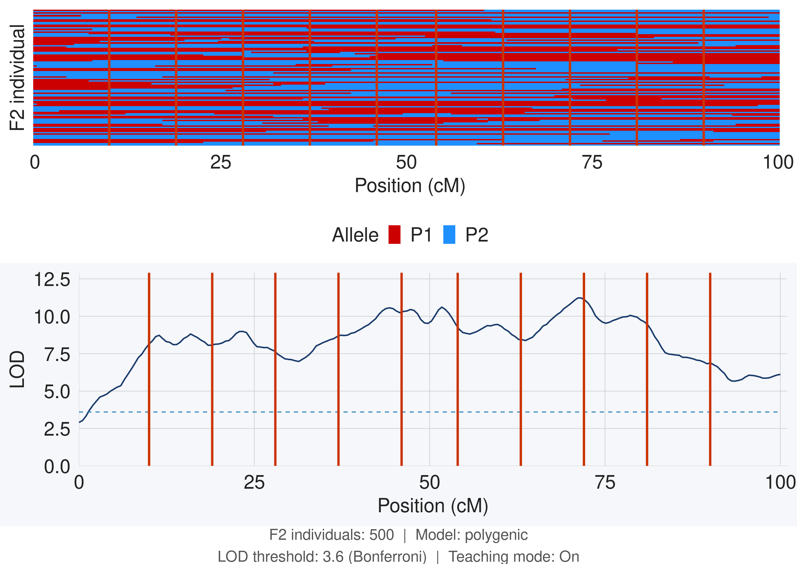
Figure 4. Biparental QTL result, polygenic architecture. Settings: 500 F₂ individuals.
LOD scores are broadly elevated across the genome (roughly 7–12) with no distinct peaks. This pattern looks dramatic but is a failure mode: long LD in the F₂ causes signals from many small-effect loci to bleed together, creating genome-wide inflation rather than localized peaks. The result is uninterpretable — you cannot determine the number of loci or their locations.

Question 5. Would a different method work here? What would you gain or lose? If no alternative is feasible, explain why.

Answer
The biparental cross does not work well for this scenario for two compounding reasons: (1) the cross setup reduces the available scoring time to 2–3 days, leaving an N of ~500 which is insufficient to detect QTLs of moderate effect size; and (2) long LD in the F₂ reduces resolution and causes genome-wide LOD inflation under polygenic architectures.
A GWAS approach is not available here because there is no existing collection of sequenced natural isolates with measured aggression scores, and sequencing 6,000 individuals would far exceed a reasonable budget.

Pool size vs. replicates: same total budget, different allocation
A key design decision in the BSA experiment is how to divide the scoring budget between pool size and number of replicates. Both designs below use the same 6,000-individual total.

1 replicate × pool size 2,000 — 1 QTL:
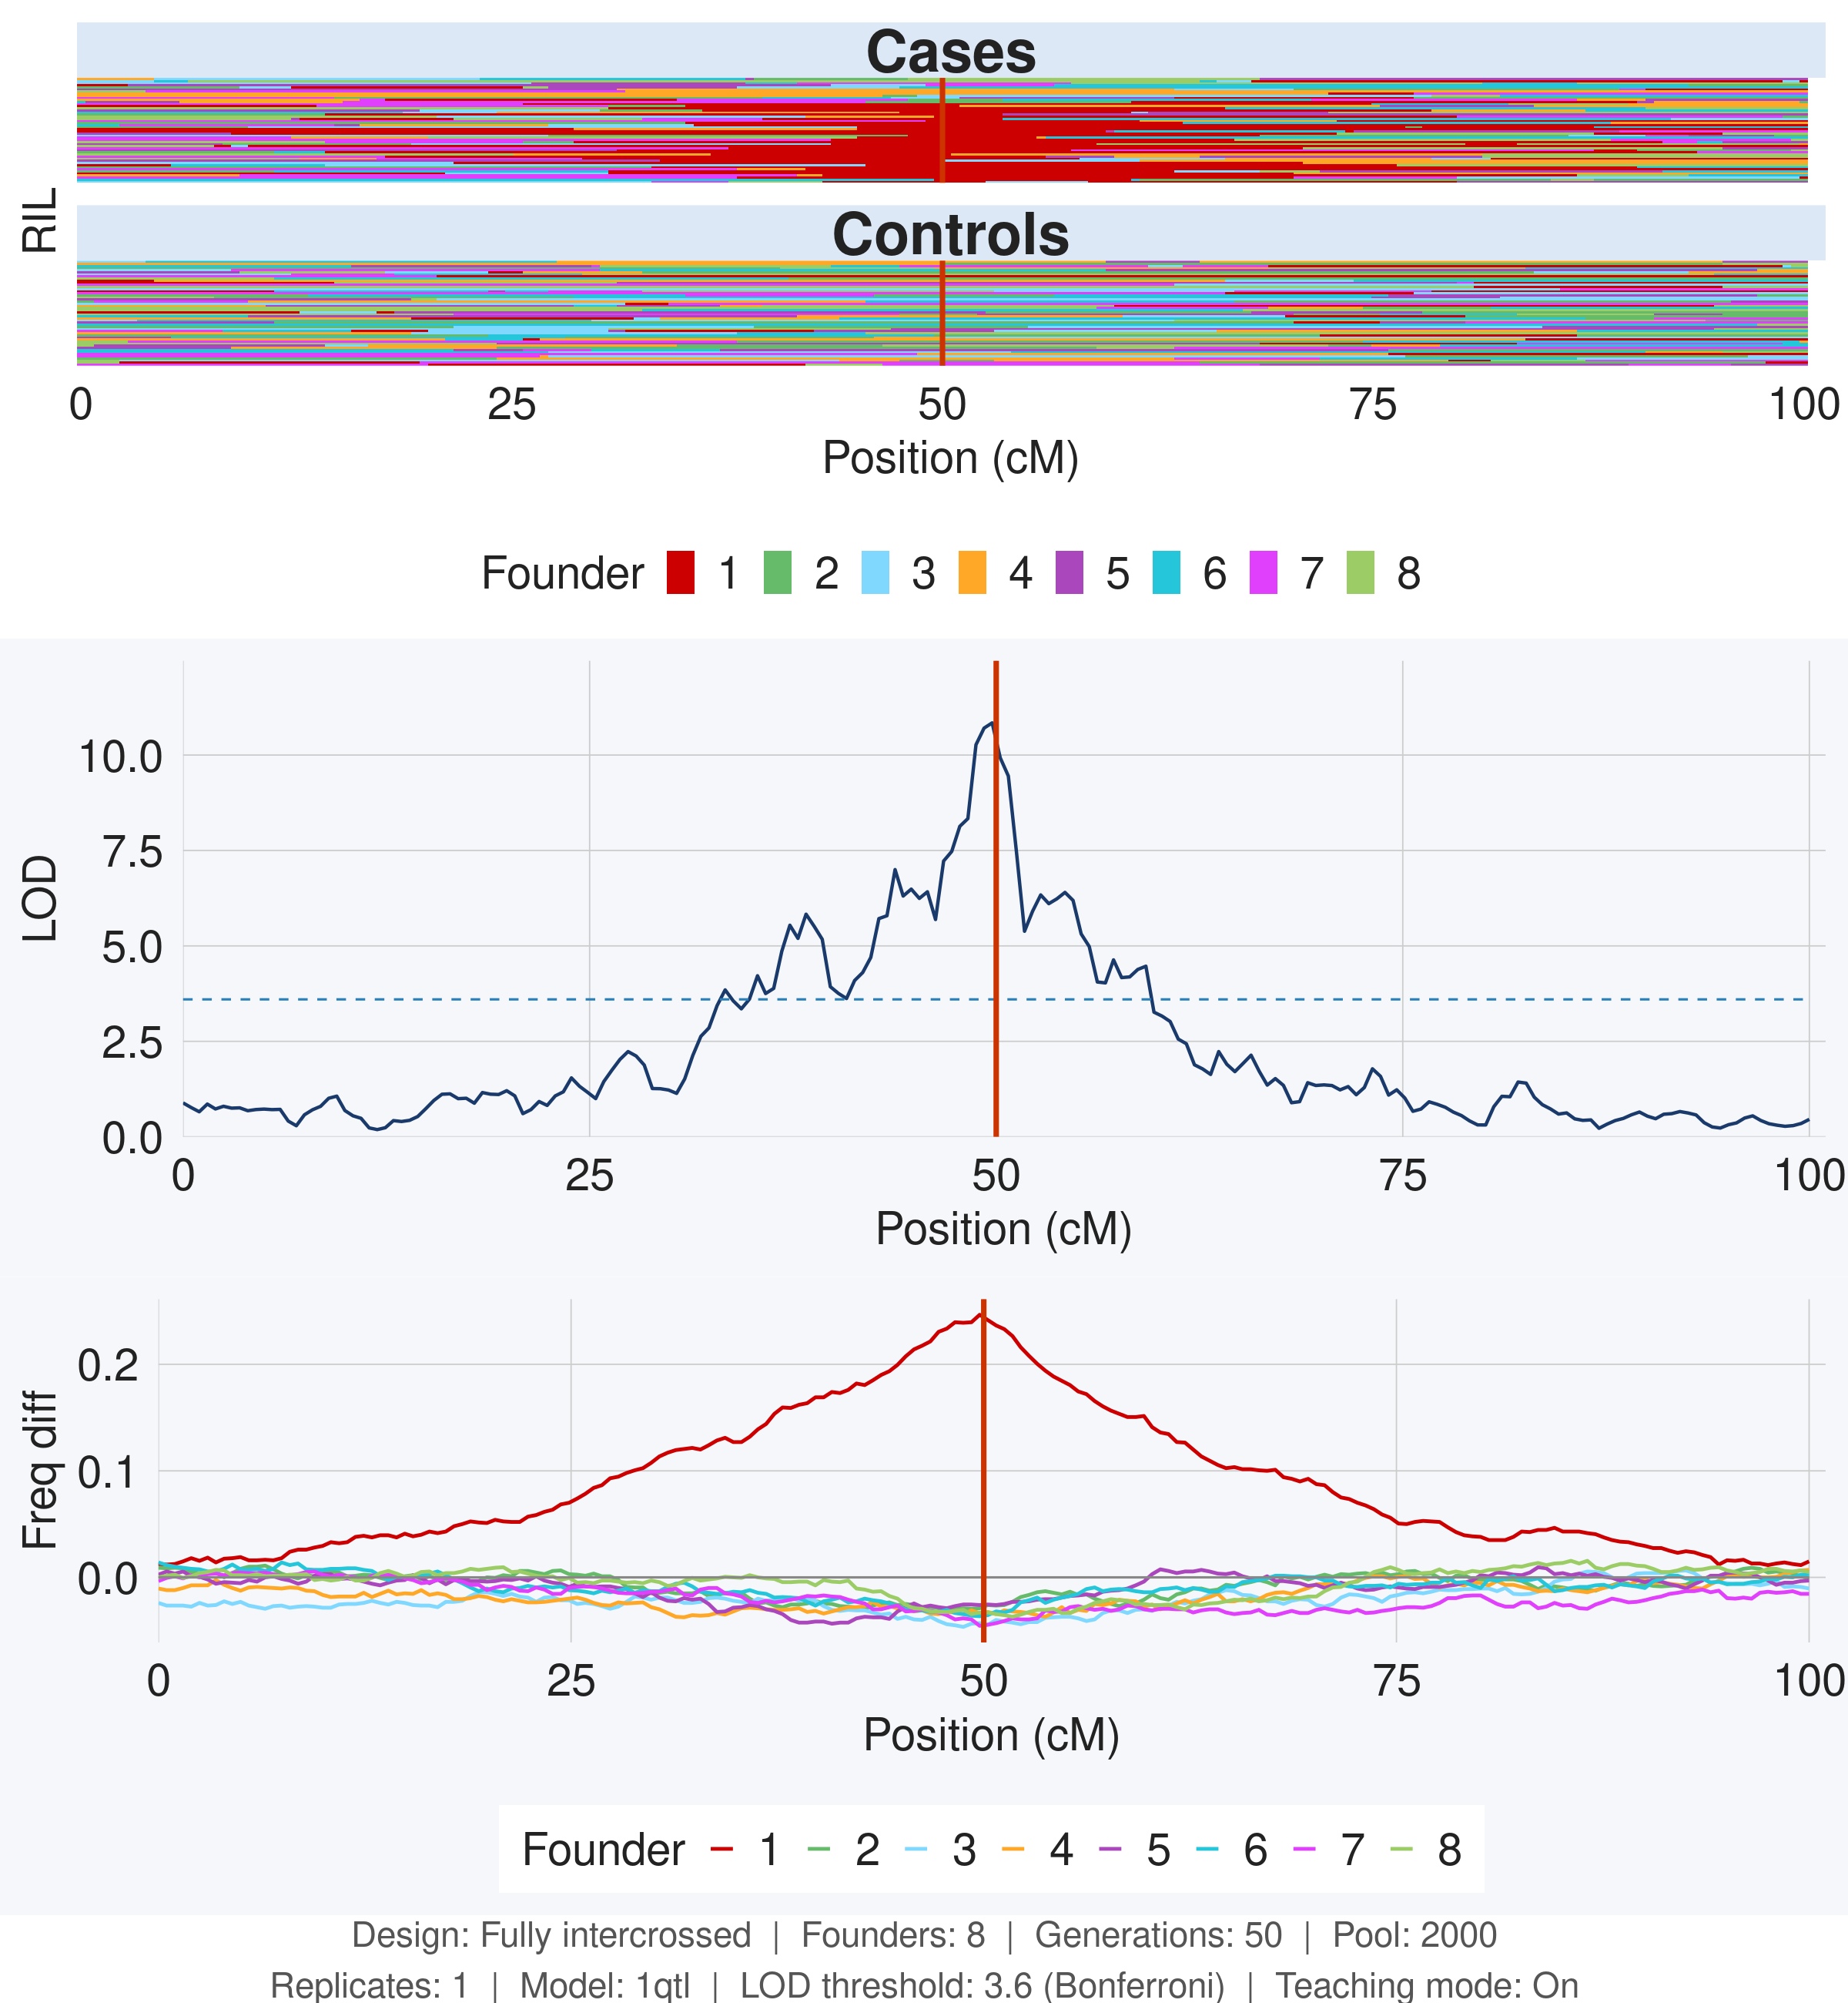
Figure 5. DSPR/BSA, 1 replicate × pool size 2,000 (same 6,000-individual total budget). 1 QTL architecture.

1 replicate × pool size 2,000 — Polygenic:
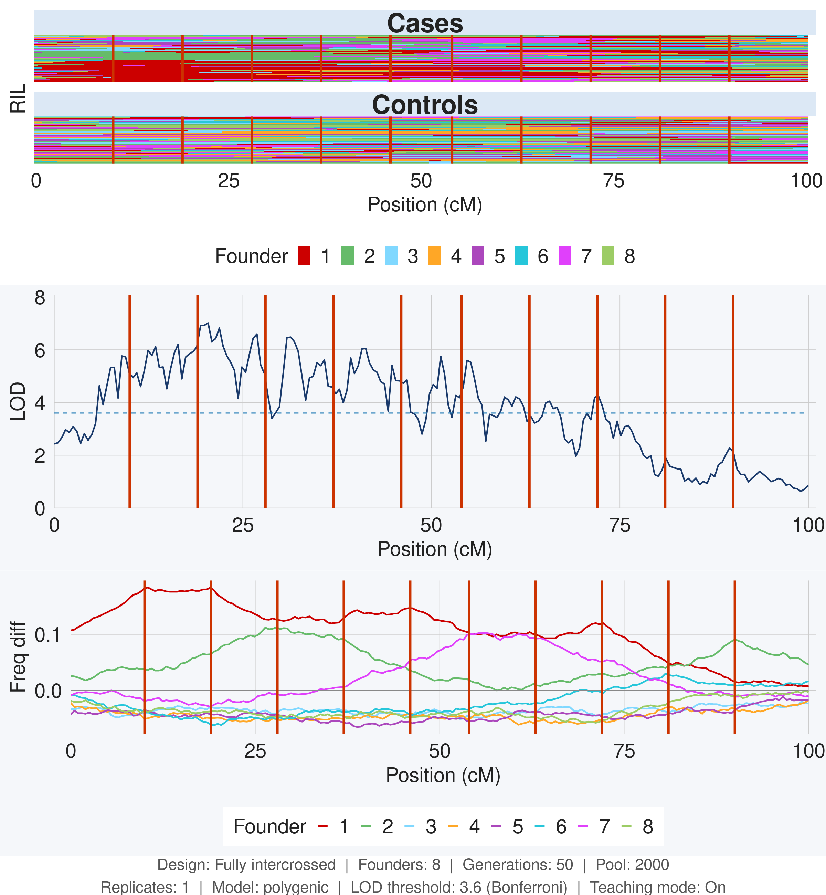
Figure 6. DSPR/BSA, 1 replicate × pool size 2,000 (same 6,000-individual total budget). Polygenic architecture.

Comparing Figure 1 (4 replicates × 500) to Figure 5 (1 replicate × 2,000): the LOD score drops from ~30 to ~10 even though both experiments score the same total number of individuals. Replicates win because each replicate draws an independent sample of phenotype noise. The CMH test stacks signal across replicates while noise averages out — signal compounds but noise does not. Increasing pool size beyond a point of diminishing returns adds more individuals to the same noisy phenotype draw, which helps less than starting a fresh replicate.
The same pattern holds under polygenic architecture (Figures 2 and 6): the 4-replicate design resolves individual loci more cleanly than the single large pool.

Discussion Points for Instructors
The most productive discussion in this scenario centers on why the replicate design outperforms the large-pool design despite identical total cost. Students often assume that more individuals per pool is always better. Redirect them to think about what happens when phenotype noise is not replicated: a single anomalous scoring session, a cage effect, or a temperature fluctuation can inflate the apparent frequency of a founder haplotype at every position. With a single replicate, there is no way to distinguish this noise from a real QTL. With 4 replicates, noise affects each independently and averages out in the CMH test.
A second productive point is the LOD inflation in the biparental polygenic result. Students often interpret the high LOD scores (7–12) as evidence that the method worked. This is a common misconception. The inflation is a consequence of long LD: each SNP is correlated with many others across large genomic regions, so a small polygenic signal spread across the genome creates broad, overlapping bumps. The correct interpretation is that the result is uninterpretable, not that mapping succeeded.
A third point is the budget math. Students who miss the factor-of-3 relationship between pool size and total individuals scored (cases + controls + unselected) often set pool size too high, leaving no budget for replication.

