**STOCK PRICE PREDICTION USING**

**AI & DS**

**STOCK PRICE PREDICTION:-**



The stock market is a complex and dynamic system that is influenced by numerous factors, making it difficult to predict with certainty. However, the emergence of artificial intelligence (AI) has revolutionised the way we analyse and forecast stock market movements. AI algorithms and techniques have proven to be effective in improving prediction accuracy and providing valuable insights to investors. In this article, we will explore how AI contributes to predicting the stock market, the specific techniques used, the benefits it brings, and the limitations and challenges associated with its use.

* **Understanding Long Short Term Memory Network**

Here, you will use a Long Short Term Memory Network (LSTM) for building your model to predict the stock prices of Google .LTSMs are a type Recurrent Neural Network for learning long-term dependencies. It is commonly used for processing and predicting time-series data.

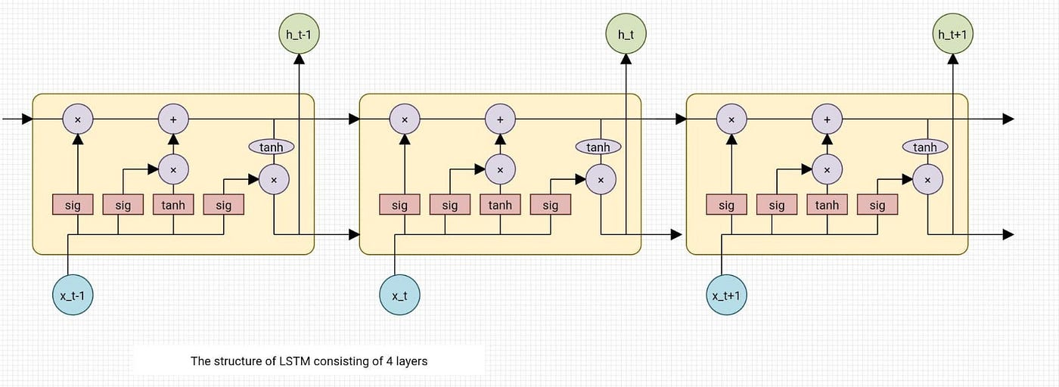

From the image on the top, you can see LSTMs have a chain-like structure. General RNNs have a single neural network layer. LSTMs, on the other hand, have four interacting layers communicating extraordinarily.

**LSTMs work in a three-step process.**

* The first step in LSTM is to decide which information to be omitted from the cell in that particular time step. It is decided with the help of a sigmoid function. It looks at the previous state (ht-1) and the current input xt and computes the function.
* There are two functions in the second layer. The first is the sigmoid function, and the second is the tanh function. The sigmoid function decides which values to let through (0 or 1). The tanh function gives the weightage to the values passed, deciding their level of importance from -1 to 1.
* The third step is to decide what will be the final output. First, you need to run a sigmoid layer which determines what parts of the cell state make it to the output. Then, you must put the cell state through the tanh function to push the values between -1 and 1 and multiply it by the output of the sigmoid gate.

With this basic understanding of LSTM, you can dive into the hands-on demonstration part of this tutorial regarding stock price prediction using machine learning.

* **MICROSOFT STOCK PRICE PREDICTION USING LSTM**

1.Import libraries:-

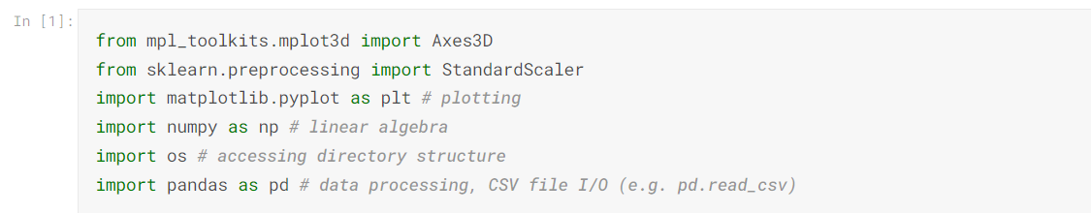

2.Csv File Of Dataset

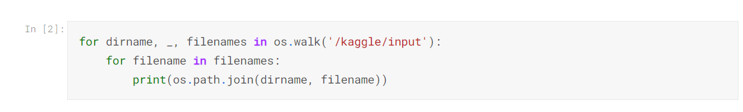

/kaggle/input/MSFT.csv

3. Plotting Dataset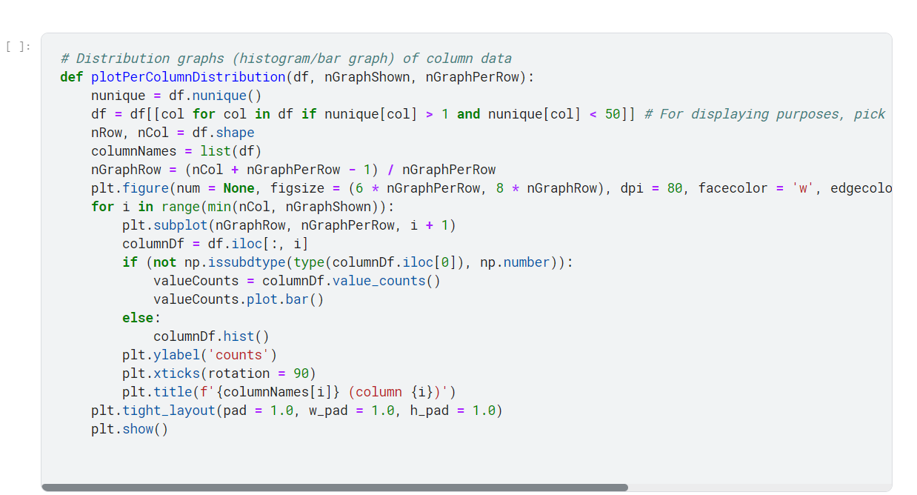

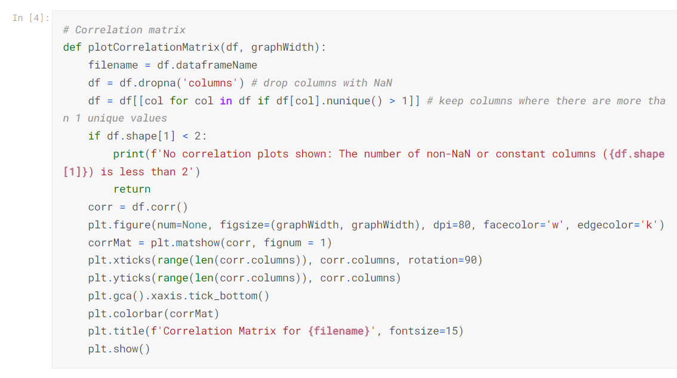

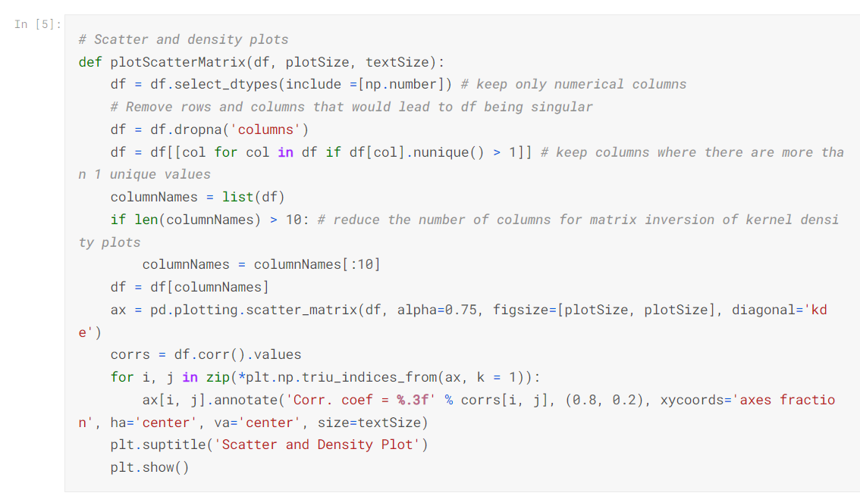

Now I’ts ready to read in the data and use the plotting functions to visualize the data.

### Let's check 1st file: /kaggle/input/MSFT.csv

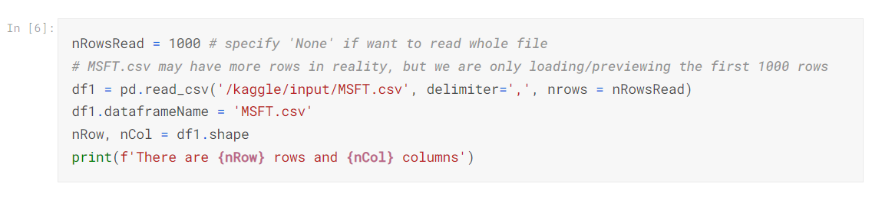

There are 1000 rows and 7 columns

Let's take a quick look at what the data looks like:

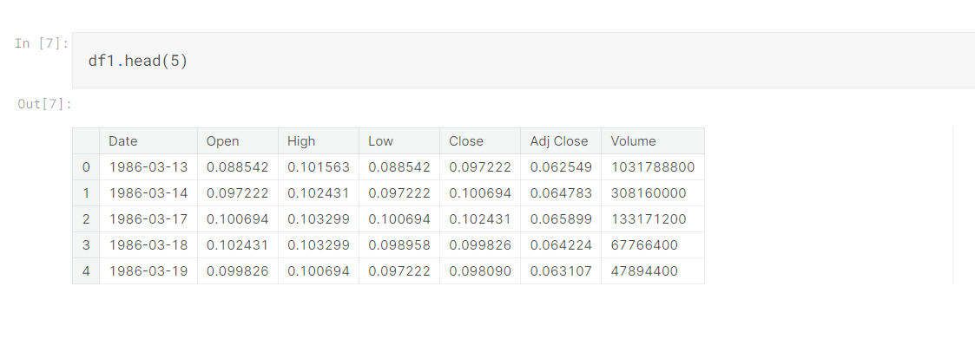Distribution graphs (histogram/bar graph) of sampled columns:

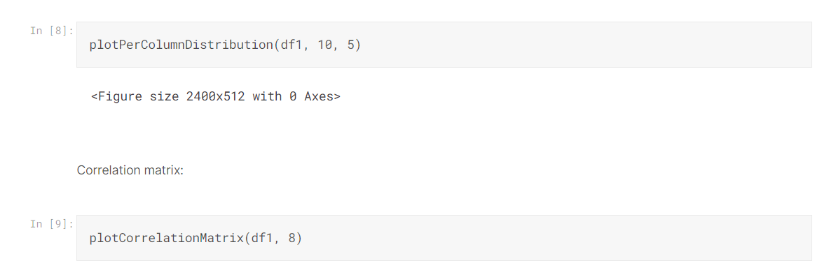

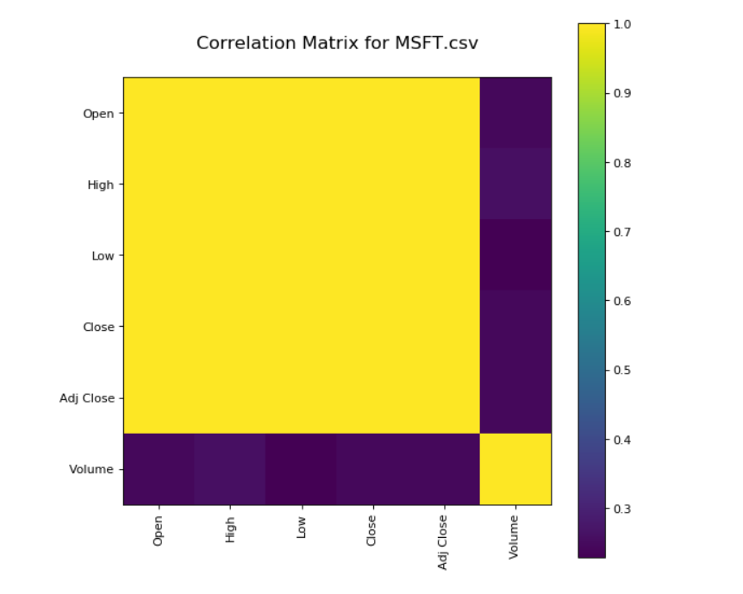

4.Scatter And Density Plot

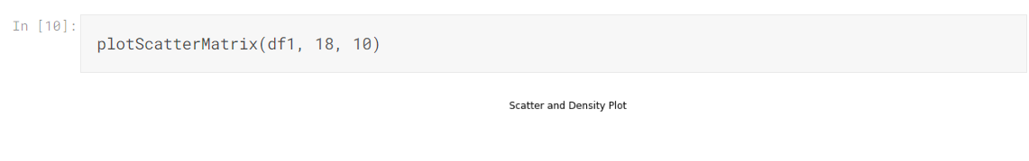

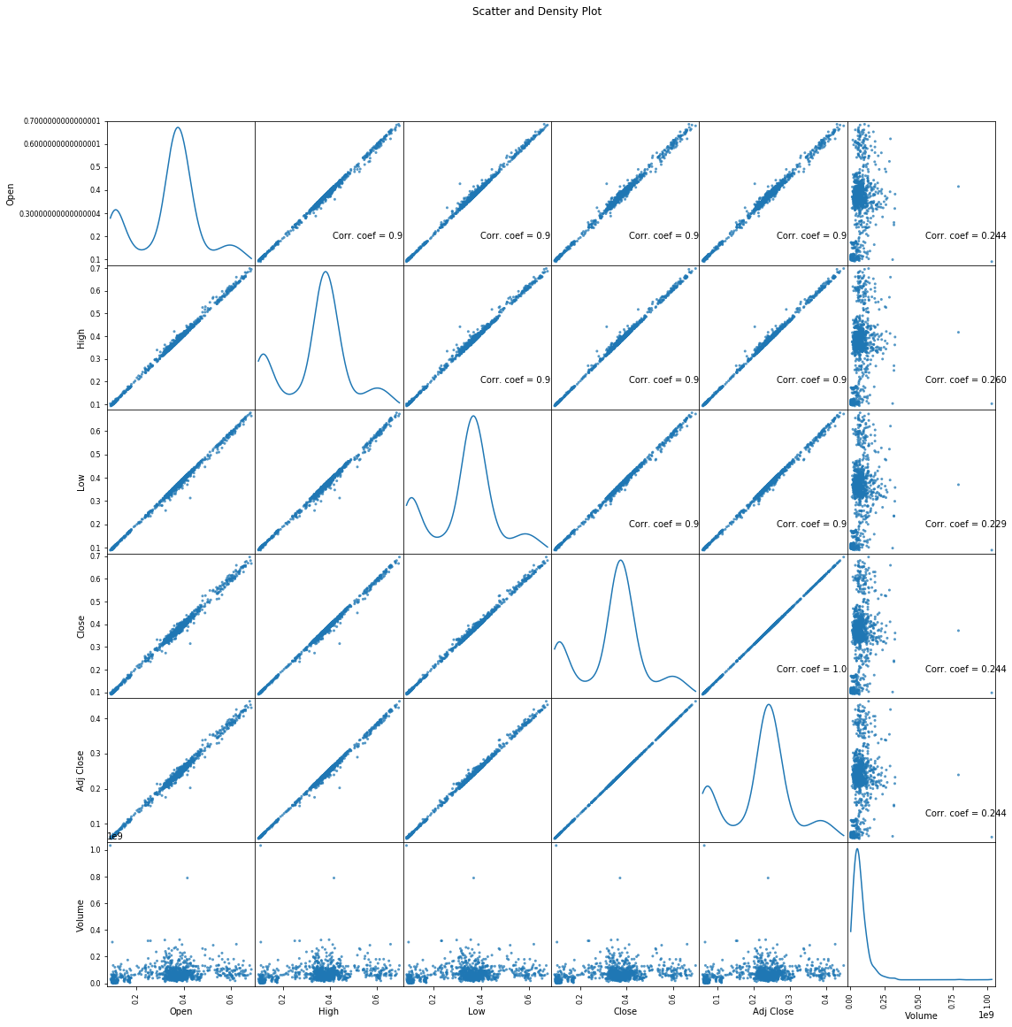

**CONCLUSION:-**

The stock market plays a remarkable role in our daily lives. It is a significant factor in a country's GDP growth. In this tutorial, you learned the basics of the stock market and how to perform stock price prediction using machine learning.

SUBMITTED BY;

1.DEVIKA LAL G B

au720921244014

2. ANAGHA T J

Au72092124006

3.SANDRA SURESH

Au720921240046

4.SRUDHINA M S

Au720921244053

5.PRABITHA N P

Au720921244038

JCT college of engineering and technology