Q1 : Write a Java program to create a new array list, add some elements (string) and print out the collection by using for-each loop. (10 Marks)

import java.util.ArrayList;

public class Que1 {

public static void main(String[] args) {

ArrayList<String> arr= new ArrayList<String>();

arr.add(" hello ");

arr.add(" my");

arr.add(" name ");

arr.add(" is ");

arr.add(" srujak ");

for(String s:arr){

System.*out*.println(s);

}

}

}

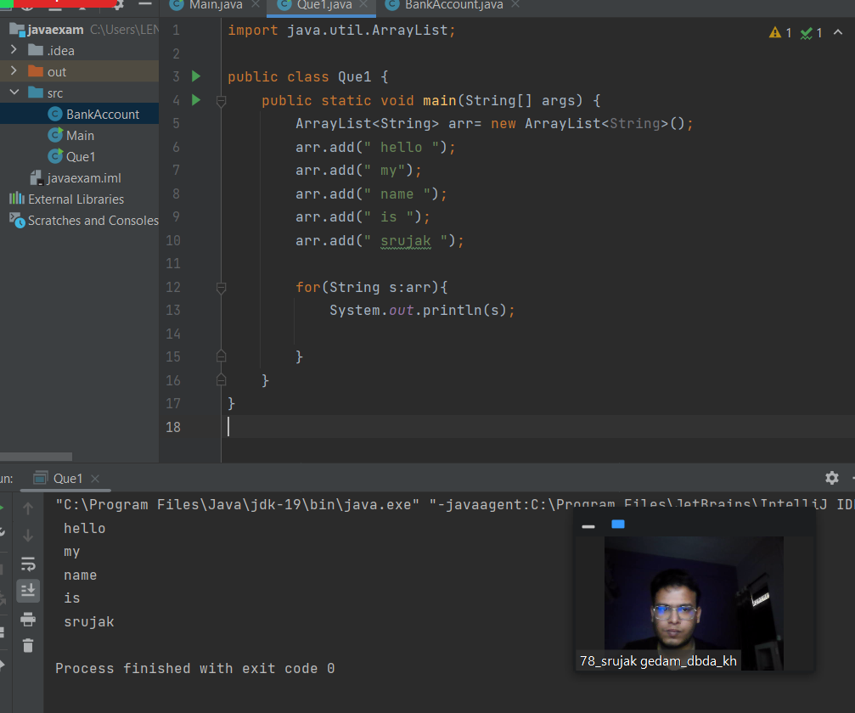

Q2 : Develop a class BankAccount having following data members : (10 Marks)

int accno

double balance

Write appropriate constructors to initialize data members

Define the following functions :

withdraw : balance will reduce

deposit : balance will increase

show : display accno and balance

If user tries to withdraw more than the balance, use exception

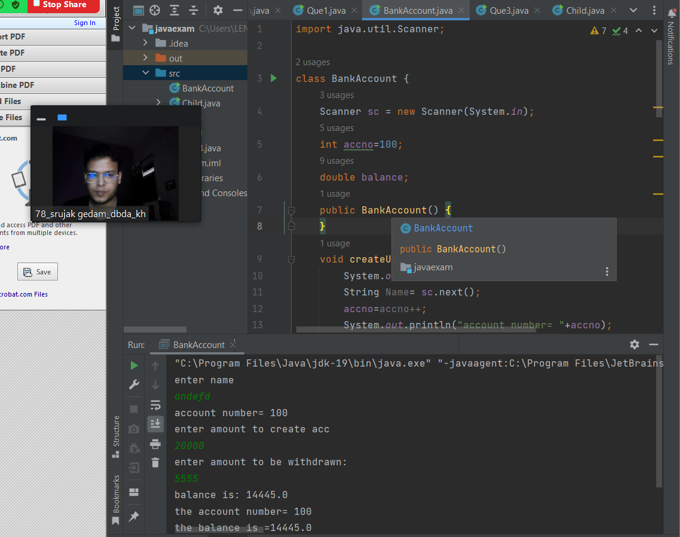

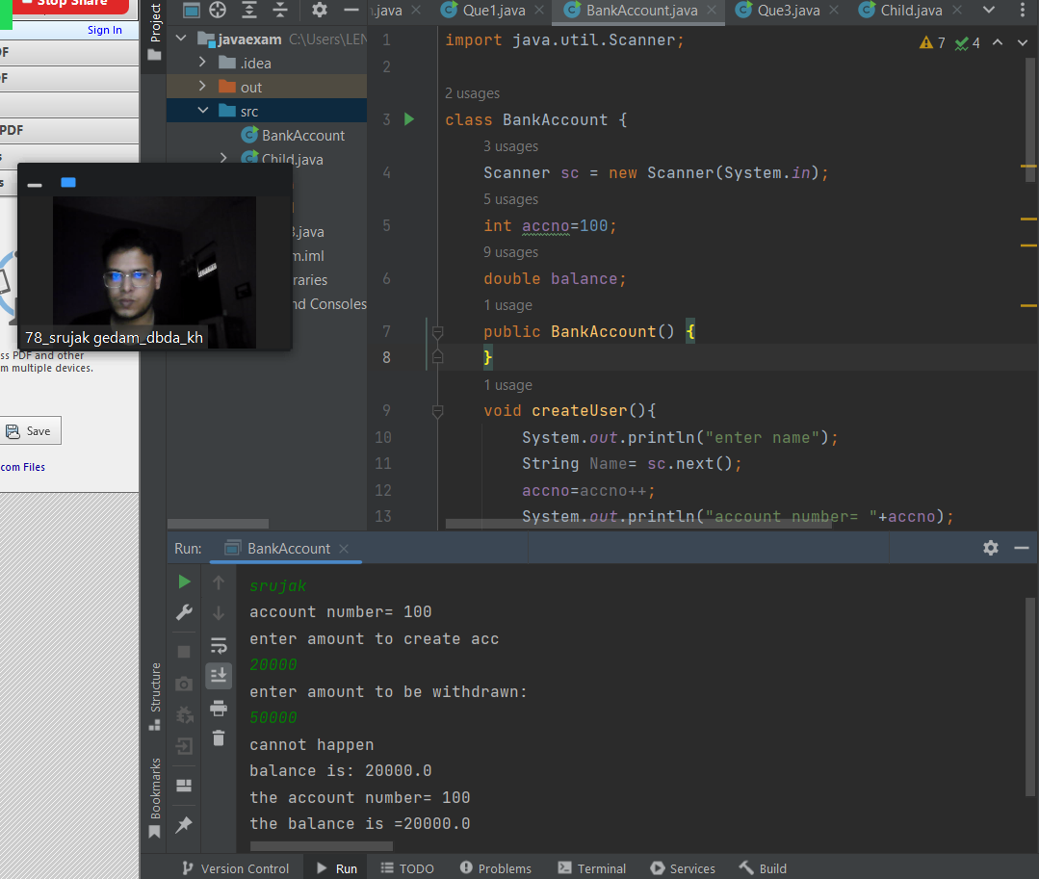

import java.util.Scanner;

class BankAccount {

Scanner sc = new Scanner(System.*in*);

int accno=100;

double balance;

public BankAccount() {

}

void createUser(){

System.*out*.println("enter name");

String Name= sc.next();

accno=accno++;

System.*out*.println("account number= "+accno);

System.*out*.println("enter amount to create acc");

balance=sc.nextDouble();

}

BankAccount(int accno,double balance){

}

void withdraw(int accno){

System.*out*.println("enter amount to be withdrawn:");

double withdraw=sc.nextDouble();

if (withdraw>balance){

System.*out*.println("cannot happen");

}

else {

balance=balance-withdraw;}

}

void deposit(int deposit){

balance=balance+deposit;

}

void show(int accno,double balance){

System.*out*.println("the account number= "+accno);

System.*out*.println("the balance is ="+balance);

}

public static void main(String[] args) {

BankAccount a1=new BankAccount();

a1.createUser();

try{

a1.withdraw(a1.accno);

if (a1.balance<0){

throw new Exception("withdrawn amount is greater than your balance");

}

}

catch (Exception e) {

System.*out*.println("not able to withdraw money");

}

System.*out*.println("balance is: "+a1.balance);

a1.show(a1.accno,a1.balance);

}

}

Q3 : Write a program to create a class named shape. In this class we have three

sub classes circle, triangle and square, each class has two member function

named draw () and erase (). Create these using Runtime Polymorphism concepts. (10 Marks)

public class Que3 {

public static void main(String[] args) {

Shape s;

s=new Circle();

s.draw();

s.erase();

System.*out*.println("***************************************");

s=new Triangle();

s.draw();

s.erase();

System.*out*.println("***************************************");

s=new Square();

s.draw();

s.erase();

}

}

class Shape{

void draw(){

System.*out*.println("this is draw of class shape");

}

void erase(){

System.*out*.println("this is erase of class shape");

}

}

class Circle extends Shape{

void draw(){

System.*out*.println("this is draw of class circle");

}

void erase(){

System.*out*.println("this is erase of class circle");

}

}

class Triangle extends Shape{

void draw(){

System.*out*.println("this is draw of class triangle");

}

void erase(){

System.*out*.println("this is erase of class triangle");

}

}

class Square extends Shape{

void draw(){

System.*out*.println("this is draw of class square");

}

void erase(){

System.*out*.println("this is erase of class square");

}

}

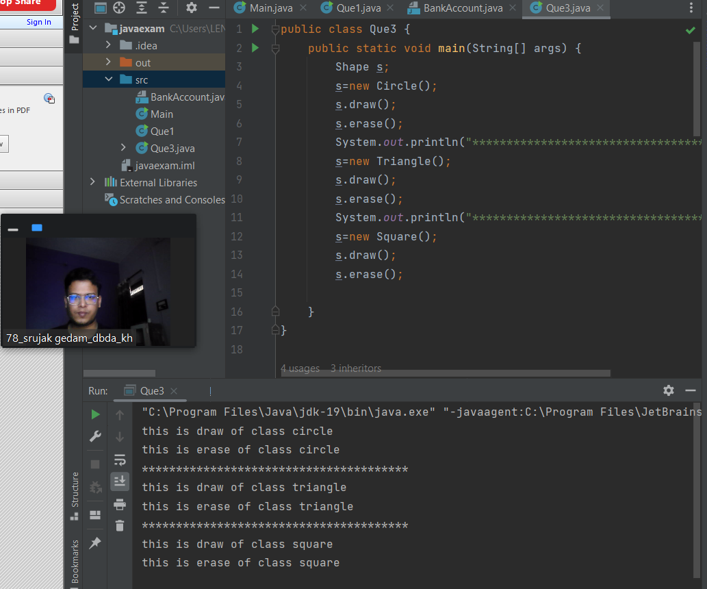

**Que4**

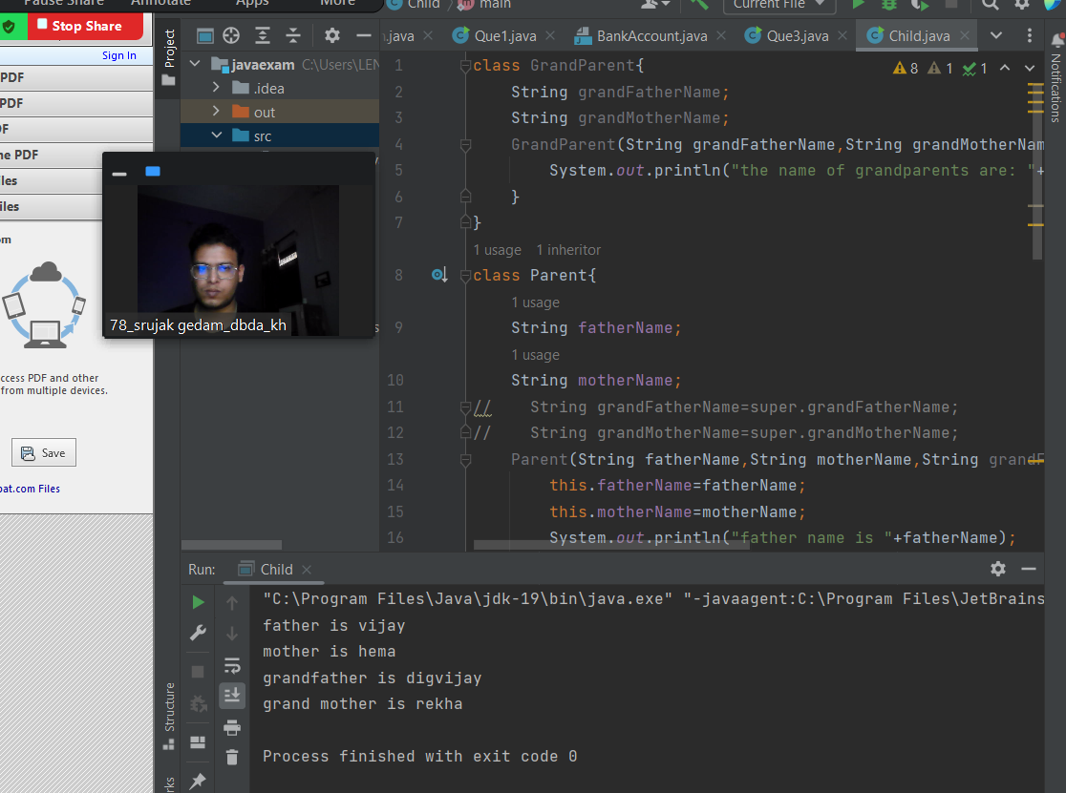

**class GrandParent{**

**String grandFatherName;**

**String grandMotherName;**

**GrandParent(String grandFatherName,String grandMotherName){**

**System.*out*.println("the name of grandparents are: "+grandFatherName+"and "+grandMotherName);**

**}**

**}**

**class Parent{**

**String fatherName;**

**String motherName;**

**// String grandFatherName=super.grandFatherName;**

**// String grandMotherName=super.grandMotherName;**

**Parent(String fatherName,String motherName,String grandFatherName,String grandMotherName ){**

**this.fatherName=fatherName;**

**this.motherName=motherName;**

**System.*out*.println("father name is "+fatherName);**

**System.*out*.println("mother name is "+motherName);**

**}**

**public Parent() {**

**}**

**}**

**public class Child extends Parent {**

**Child(String fatherName, String motherName, String grandFatherName, String grandMotherName) {**

**super();**

**System.*out*.println("father is "+fatherName);**

**System.*out*.println("mother is "+motherName);**

**System.*out*.println("grandfather is "+grandFatherName);**

**System.*out*.println("grand mother is "+grandMotherName);**

**}**

**public static void main(String[] args) {**

**Child c = new Child("vijay","hema","digvijay","rekha");**

**}**

**}**