

INSTITUTE :- TOPS TECHNOLOGIES (BARODA)

NAME :- SRUJAL SOLANKI M

COURSE :- JAVA FULL STACK DEVELOPER

Module 4 : INTRODUCTION TO DBMS

MYSQL QUERY 1

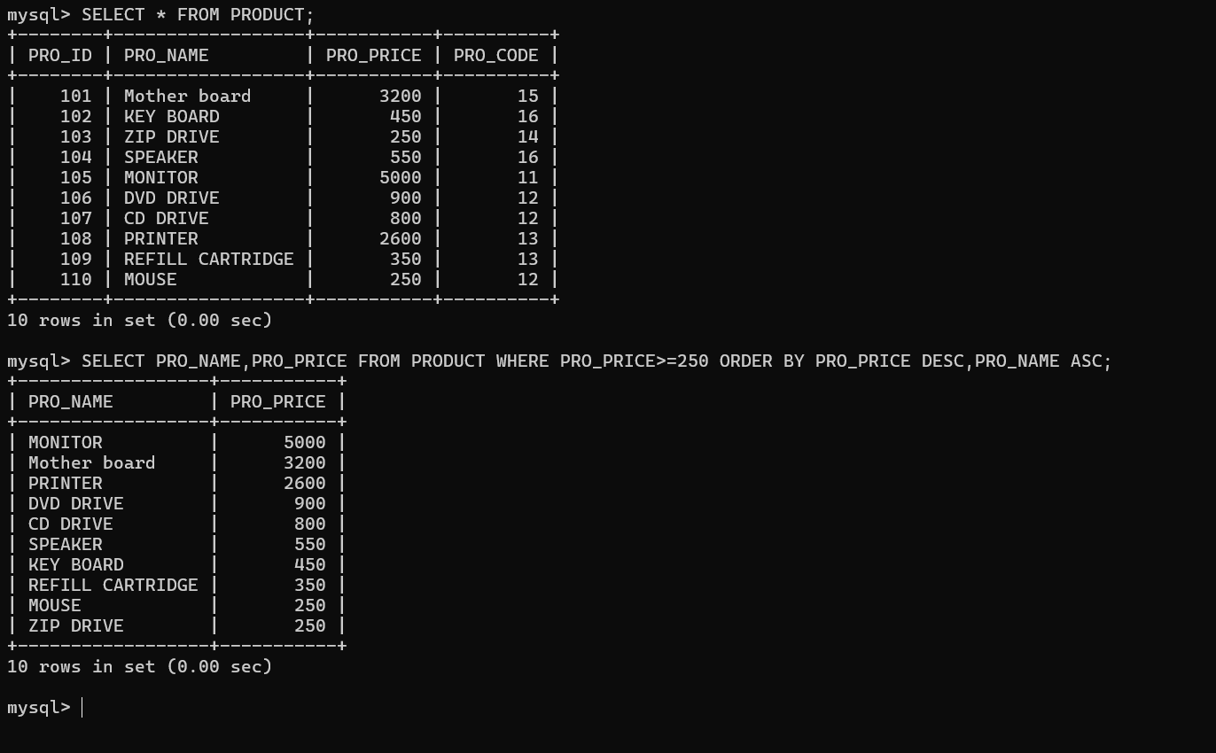

MYSQL QUERY 2 :-

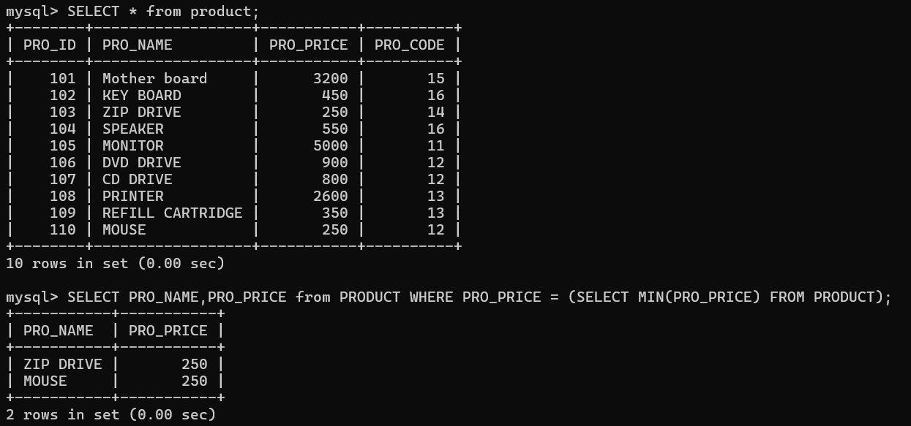

MYSQL QUERY 3 :-

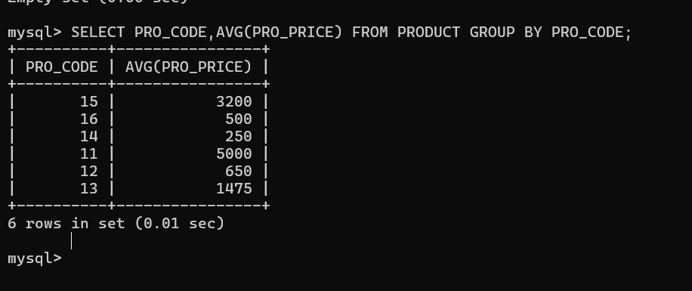

MYSQL QUERY 4 :-

