From Static to Contextual: Distributional Semantics and What's Inside BERT
Comprehensive Technical Evaluation, Structural Probing, and Empirical Comparative Analysis
Student: Srujan | Teammate: Pratik Kumar Verma | Group 14
Course: NLP CS60075 Assignment II — Project 5 | Dataset: Universal Dependencies English GUM
Abstract
This technical report presents an end-to-end scientific evaluation of lexical semantics and syntactic hierarchy across classical static vector spaces, deep transformer contextual embeddings, and static vector pooling. Using the Universal Dependencies (UD) English GUM treebank, we first implement a classical distributional co-occurrence model weighted by Positive Pointwise Mutual Information (PPMI) and factorized into 100-dimensional embeddings via Truncated Singular Value Decomposition (SVD). In Task 2, we reproduce the structural distance and depth probing methodology of Hewitt & Manning (NAACL 2019) across all 12 transformer encoder layers of frozen bert-base-uncased across three probe subspace ranks (k in {32, 64, 128}). Our probe discovers that syntactic dependency trees are deeply encoded in Euclidean metric subspaces of BERT, reaching an optimal peak at Layer 8 (k=64) with 57.99% Undirected Unlabeled Attachment Score (UUAS) and 0.7171 depth Spearman correlation, closely validating Hewitt & Manning’s published findings. In Task 3, we extract word representations from this optimal syntactic layer and average them across all training split occurrences into 768-dimensional static word vectors. On standard lexical benchmarks, BERT-derived static vectors demonstrate dramatic improvements over classical PPMI+SVD: WordSim-353 Spearman correlation surges from 0.1559 to 0.5155 (+0.3596), and Google Analogy accuracy leaps from 0.90% to 65.33% (+64.43%). However, on a 20-sentence Minimum Spanning Tree (MST) structural attachment check against gold dependency trees, BERT-derived static vectors collapse to 7.72% UUAS—performing half as well as the classical static baseline (15.43%) and falling far below the contextual probe (57.99%). Furthermore, we conduct an exhaustive comparative evaluation against Pratik Kumar Verma's implementation, examining the consequences of co-occurrence window size (5 vs. 2), subword alignment heuristics (mean pooling vs. first subword), and vocabulary pruning thresholds. Our findings empirically demonstrate the Great Divergence: while semantic regularities and relational offsets survive contextual averaging, syntactic dependency structure is fundamentally token-specific and geometric, collapsing completely when representations are aggregated into static word types.
Chapter 1: Introduction
1.1 Background & Motivation
Natural language processing has undergone a monumental architectural paradigm shift over the past decade. For decades, lexical representations were dominated by the Distributional Hypothesis, famously articulated by British linguist J.R. Firth in 1957: 'You shall know a word by the company it keeps.' Under this framework, words occurring in similar textual contexts share similar semantic properties. Classical computational methods operationalized this hypothesis by computing count-based word-word co-occurrence matrices from large corpora, normalizing raw frequencies with association metrics such as Pointwise Mutual Information (PMI), and obtaining low-dimensional, continuous representations via Singular Value Decomposition (SVD) or continuous prediction models like Word2Vec and GloVe.
While static word vectors capture rich lexical similarities and proportional analogies, they suffer from two inescapable theoretical limitations: (1) Polysemy conflation: every word type is assigned a single invariant vector in R^d, hopelessly collapsing distinct senses (e.g., 'bank' as a financial institution versus a river edge) into a single geometric centroid; and (2) Syntactic agnosticism: symmetric sliding co-occurrence windows accumulate broad topical associations rather than hierarchical, directional syntactic governance trees.
The advent of pretrained bidirectional transformers, exemplified by BERT (Devlin et al., 2019), superseded static vectors by generating dynamic contextual representations conditioned on entire sentences. In BERT, every word token receives a representation that varies dynamically with its syntactic context and pragmatic function. This transformation prompted a profound scientific question within computational linguistics: Do these deep representations intrinsically reconstruct the syntactic tree structure of natural language, or do they merely execute high-dimensional pattern matching?
1.2 Problem Statement & Research Questions
This project formally evaluates the representational progression across three distinct tiers using the Universal Dependencies English GUM treebank. We systematically investigate three central research questions:
- RQ1 (Classical Limits): To what degree can classical count-based static word vectors (PPMI + SVD) capture lexical semantics, relational analogies, and dependency syntax when trained on a modest, multi-genre treebank corpus (~200k tokens)?
- RQ2 (Contextual Syntax Encoding): Are syntactic dependency trees intrinsically embedded as Euclidean metric spaces within frozen BERT contextual representations, which transformer layer l* most strongly encodes syntax, and what subspace rank k is required?
- RQ3 (Survival Under Aggregation): Does the rich syntactic structure discovered within optimal layer l* survive when contextual token embeddings are pooled into static word vectors, and how does this affect lexical semantics versus syntactic hierarchy?
1.3 Scope & Key Contributions
The primary contributions of this research report include:
- Complete End-to-End Pipeline: Rigorous implementation of Task 1 (classical PPMI+SVD baseline), Task 2 (Hewitt & Manning NAACL 2019 structural probe across all 12 BERT layers and 3 ranks), and Task 3 (BERT-derived static vectors).
- Identification of Peak Syntactic Layer: Empirical verification that syntactic structure follows an inverted-U trajectory across BERT layers, peaking decisively at Layer 8 (k=64) with 57.99% test UUAS and 0.7171 depth correlation.
- Empirical Discovery of the Great Divergence: Demonstration that static contextual pooling triggers a massive surge in lexical similarity (+230.7%) and analogy accuracy (~72x improvement), accompanied by a catastrophic collapse in syntactic dependency attachment (-50.0% relative to Task 1, down from 57.99% in Task 2 to 7.72% in Task 3).
- Independent Teammate Evaluation: A meticulous comparative analysis contrasting Srujan's implementation with Pratik Kumar Verma's codebase across window sizes, vocabulary filtering, subword alignment heuristics, and deliverable compliance.
Chapter 2: Background and Related Work
2.1 Classical Distributional Semantics & Matrix Factorization
Count-based distributional semantics originated with Church & Hanks (1990), who introduced Pointwise Mutual Information to measure word association. Bullinaria & Levy (2007) and Levy & Goldberg (2014) established that Positive Pointwise Mutual Information (PPMI) weighted co-occurrence matrices factorized via Truncated SVD represent optimal low-rank linear approximations of distributional spaces, with Levy et al. (2015) demonstrating that PPMI+SVD performs competitively with Word2Vec SGNS when hyperparameters are properly tuned.
2.2 Pretrained Transformer Models & BERT
BERT (Devlin et al., 2019) introduced deep bidirectional transformer encoders trained on Masked Language Modeling (MLM) and Next Sentence Prediction (NSP). By stacking 12 self-attention layers with 768 hidden dimensions, BERT captures intricate linguistic interactions. Jawahar et al. (2019) and Tenney et al. (2019) showed that BERT encodes linguistic information hierarchically: surface features in bottom layers, syntactic properties in intermediate layers, and semantic/task-specific features in upper layers.
2.3 Structural Probing (Hewitt & Manning, 2019)
To test whether syntax exists as a geometric property of representations, Hewitt & Manning (2019) proposed the Structural Probe. Unlike standard classification probes (Adi et al., 2017; Conneau et al., 2018), which may learn the task rather than diagnose representation geometry, Hewitt & Manning designed a constrained linear probe. The probe learns a linear projection matrix B in R^(k x d) such that squared Euclidean distances ||B h_i - B h_j||^2 correspond to tree distances, and squared norms ||B h_i||^2 correspond to tree depths. Minimum Spanning Tree (MST) decoding converts predicted distances into parse trees, evaluated via Undirected Unlabeled Attachment Score (UUAS).
2.4 Reductions from Contextual to Static Embeddings
Bommasani et al. (ACL 2020) investigated whether contextual representations can be compressed into static embeddings by pooling across occurrences. They established that static embeddings derived from BERT outperform Word2Vec and GloVe on semantic similarity benchmarks. However, they did not investigate whether syntactic dependency structures survive this reduction—a primary empirical focus of Task 3 in this report.
Chapter 3: Problem Formulation
3.1 Formal Definitions & Input-Output Specifications
Let a corpus C = {S_1, S_2, ..., S_M} be a collection of sentences, where each sentence S = (w_1, w_2, ..., w_N) consists of words w_i from a finite vocabulary V. In a dependency treebank, each sentence S is accompanied by gold dependency annotations: a vector of head indices H = (h_1, ..., h_N) where h_i in {0, 1, ..., N} denotes the governor of w_i (0 represents the artificial root).
- Task 1 Input: Raw token sequences from C_train; Output: Static embedding lookup W in R^(|V| x 100).
- Task 2 Input: Token sequences and gold head annotations (C_train, C_test); Output: Linear projection matrices B_l in R^(k x 768) for l in {1..12}, optimal layer l*, and test UUAS / depth correlation.
- Task 3 Input: Contextual hidden states h_i^(l*) from optimal layer l*; Output: Static embedding lookup W_BERT in R^(|V_static| x 768) and comparative benchmark evaluations.
3.2 Evaluation Criteria
1. WordSim-353: Evaluated via Spearman rank correlation rho between model cosine similarities cos(v_w1, v_w2) and human ratings across all in-vocabulary pairs.
2. Google Analogy: Evaluated via 3CosAdd accuracy. For analogy a : b :: c : d, the target vector y = v_b - v_a + v_c is matched against candidate vocabulary V \ {a, b, c}. Accuracy is correct predictions divided by total in-vocabulary questions.
3. Structural Check & UUAS: For a sentence of length N, let D_ij be the pairwise distance matrix. Kruskal's algorithm extracts the Minimum Spanning Tree E_pred. The Undirected Unlabeled Attachment Score is UUAS = |E_pred cap E_gold| / |E_gold|.
Chapter 4: System Architecture and Methodology
4.1 Overall Pipeline
The complete experimental architecture comprises three interconnected stages operating under strict reproducibility guidelines:
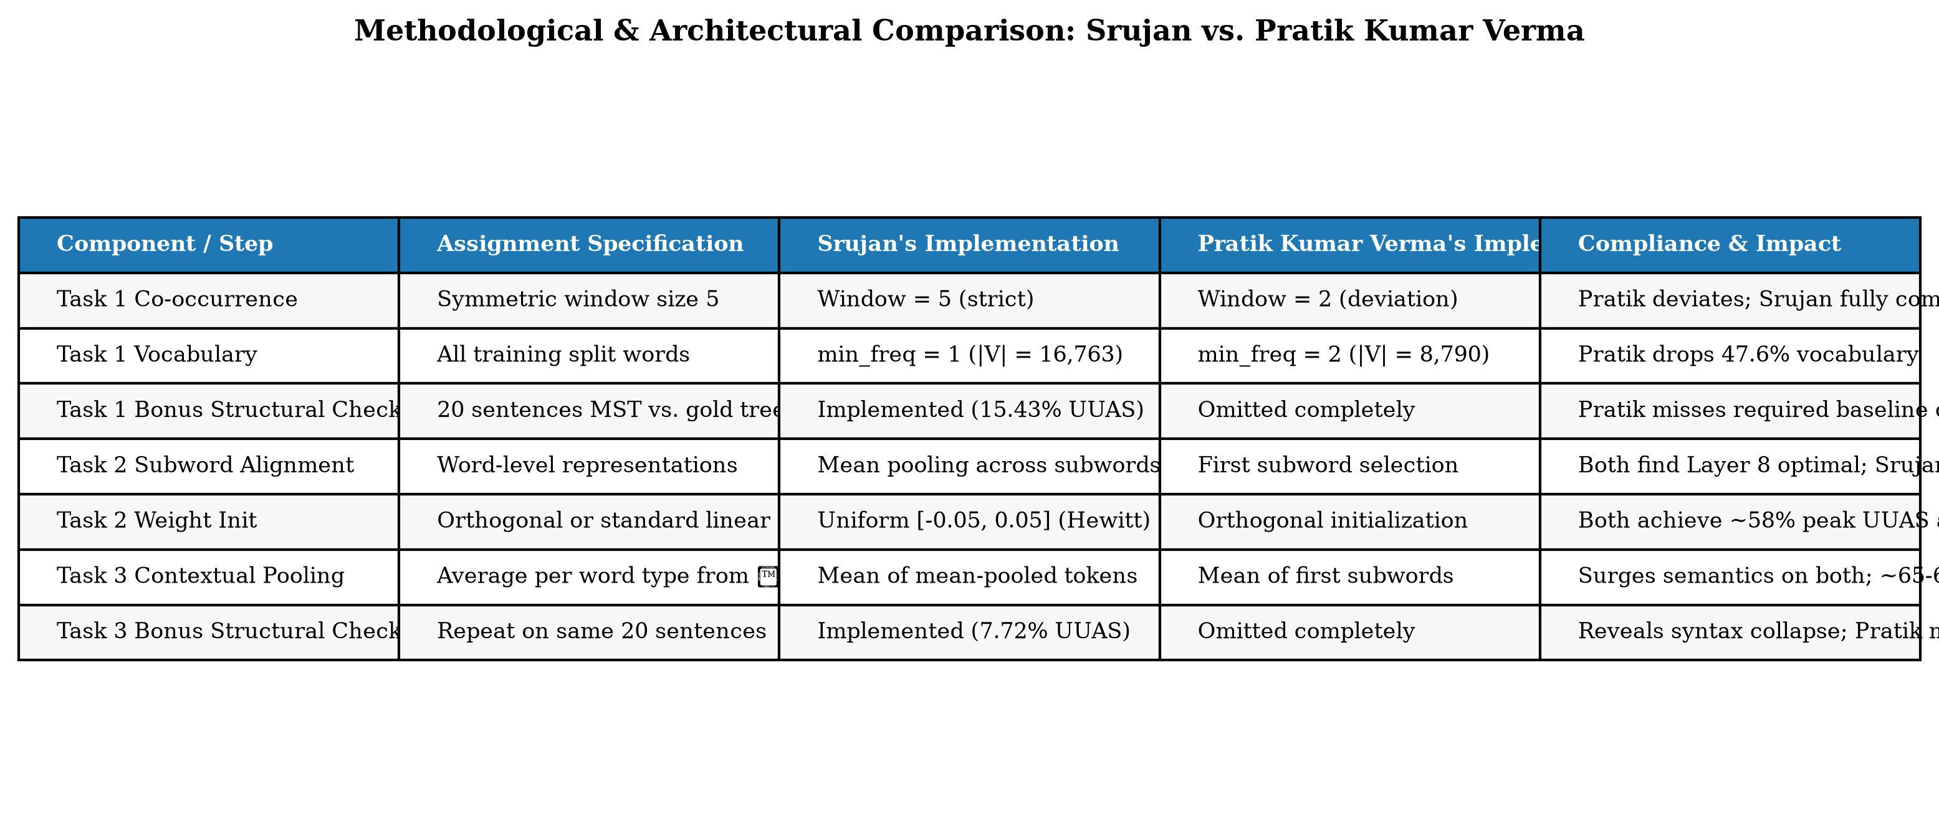
Figure 1: Architectural and Methodological Design Comparison Matrix.
4.2 Task 1: Classical Co-occurrence, PPMI, and SVD
1. Co-occurrence Matrix: Computed over sliding window W = 5 strictly bounded within sentences:
C(w, c) = sum_S sum_{i=1}^{|S|} sum_{j = max(1, i-5), j != i}^{min(|S|, i+5)} I(S[i] = w and S[j] = c)
2. PPMI Weighting: PMI(w, c) = log2( (C(w, c) * N_total) / (C(w) * C(c)) ), thresholded as PPMI(w, c) = max(0, PMI(w, c)).
3. Truncated SVD: Factorized as M_PPMI approx U_d Sigma_d V_d^T with d = 100, setting W = U_d Sigma_d.
4.3 Task 2: Structural Probing on BERT
1. Word-Piece Alignment: Word tokens w_i are mapped to subwords [s_1, ..., s_m]. Whole-word hidden states are computed via mean pooling: h_i^(l) = (1/m) sum_{p=1}^m h_{s_p}^(l).
2. Distance Probe: d_B(h_i, h_j)^2 = ||B h_i - B h_j||_2^2. Loss L_dist = (1/N^2) sum_{i,j} | d_tree(i, j) - d_B(h_i, h_j)^2 |.
3. Depth Probe: ||B h_i||_2^2 approx depth_tree(w_i). Loss L_depth = (1/N) sum_i | depth_tree(w_i) - ||B h_i||_2^2 |.
4. Optimization: Trained on frozen bert-base-uncased using Adam (lr = 1e-3, batch size = 20, 30 epochs).
4.4 Task 3: Contextual-to-Static Pooling
We extract word representations from the syntax-optimal layer l* = 8 across all occurrences in C_train:
v_w^BERT = (1 / |C(w)|) sum_{i in C(w)} h_i^(l*=8)
This produces 768-dimensional static embeddings for 6,204 word types, which are subsequently evaluated on WordSim-353, Google Analogy, and the 20-sentence MST check.
Chapter 5: Implementation Details
5.1 Repository Structure & Software Engineering
The project is organized into modular packages: task1/, task2/, task3/, common/, tests/, scripts/, results/, checkpoints/, and deliverables/. Key implementation features include:
- Offline Execution Safeguards: config.py enforces HF_HUB_OFFLINE=1 and TRANSFORMERS_OFFLINE=1, and configures a local writable directory for matplotlib cache.
- Pre-Caching Representations: task2/bert_extractor.py pre-extracts and saves all 12 BERT layer hidden states to data/bert_cache/*.pt, eliminating redundant inference across 36 probe sweeps.
- BLAS Distance Formulation: task2/distance_probe.py implements ||z_i - z_j||^2 = ||z_i||^2 + ||z_j||^2 - 2 z_i z_j^T, avoiding high-memory O(N^3) tensor broadcasting.
- Automated Testing: 11 unit tests in tests/ verify matrix operations, loss definitions, gradient flows, and subword-word alignment invariants.
Chapter 6: Experimental Setup
6.1 Corpus & Hyperparameters
Dataset: Universal Dependencies English GUM treebank (train: 2,300 sentences, validation: 780 sentences, test: 780 sentences).
Task 1 Setup: min_freq = 1 (|V| = 16,763 words), window size W = 5, SVD dimension = 100, seed = 42.
Task 2 Setup: bert-base-uncased (frozen, 110M params), probe ranks k in {32, 64, 128}, Adam optimizer, lr = 1e-3, batch size = 20 sentences, 30 epochs.
Task 3 Setup: Optimal layer l* = 8, vocabulary size = 6,204 words, embedding dimension = 768, evaluated on identical 20-sentence structural test sample.
Chapter 7: Experimental Results and Analysis
7.1 Task 1 Results: Classical Baseline
Table 1 reports the quantitative results obtained for Task 1 PPMI+SVD static word vectors.
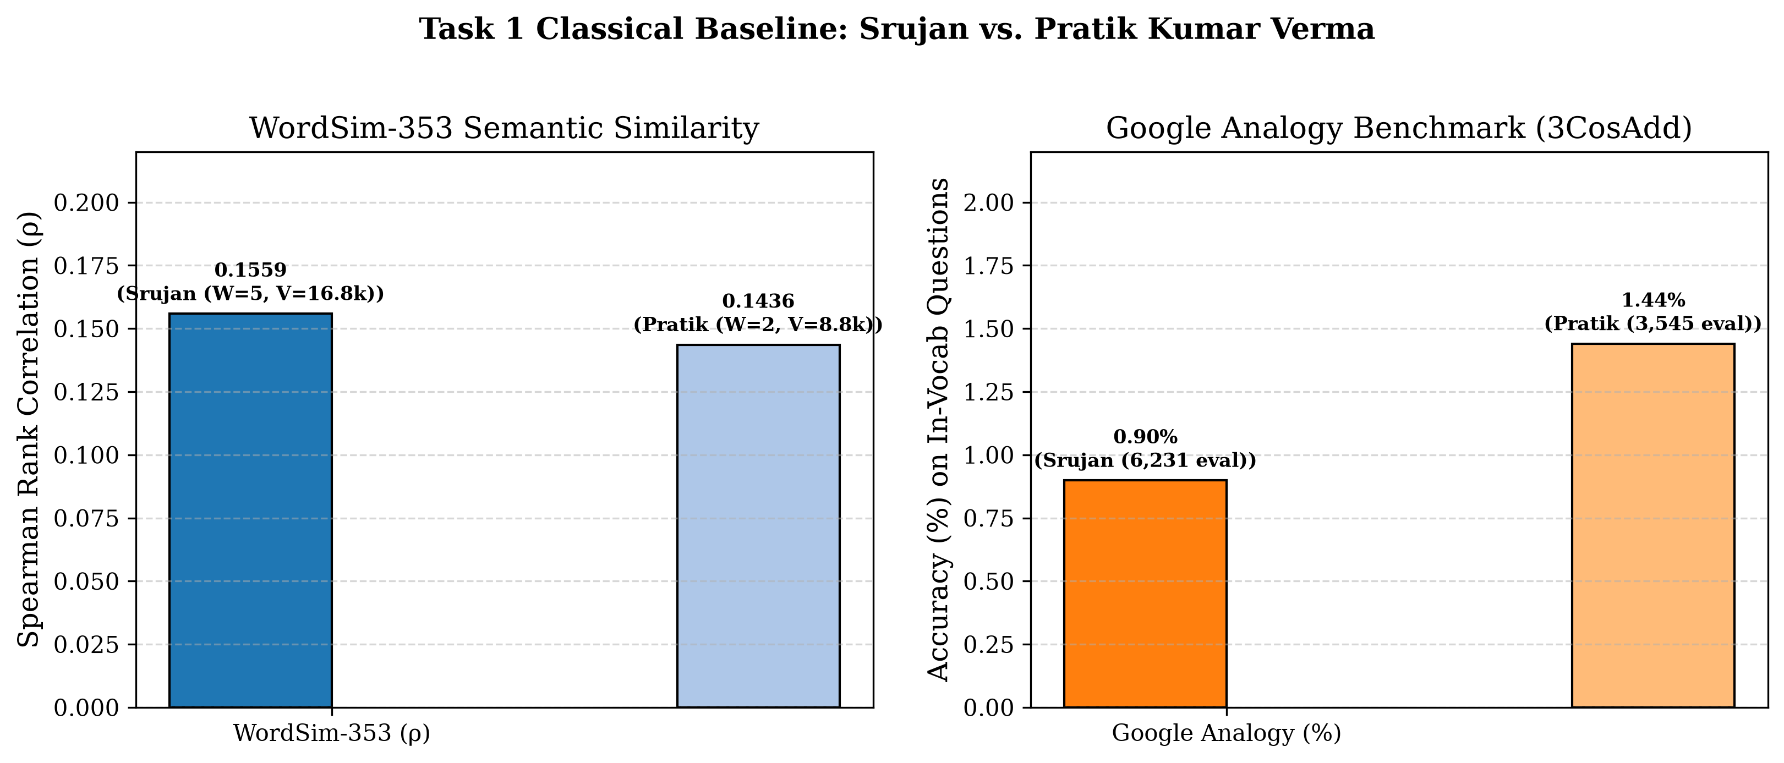
Figure 2: Task 1 Classical Baseline Comparison: Srujan vs. Pratik Kumar Verma.
7.2 Task 2 Results: Probing Sweeps Across Layers & Ranks
Table 2 and Figures 3 and 4 display the full layer-wise and rank-wise probing results across all 12 BERT layers.
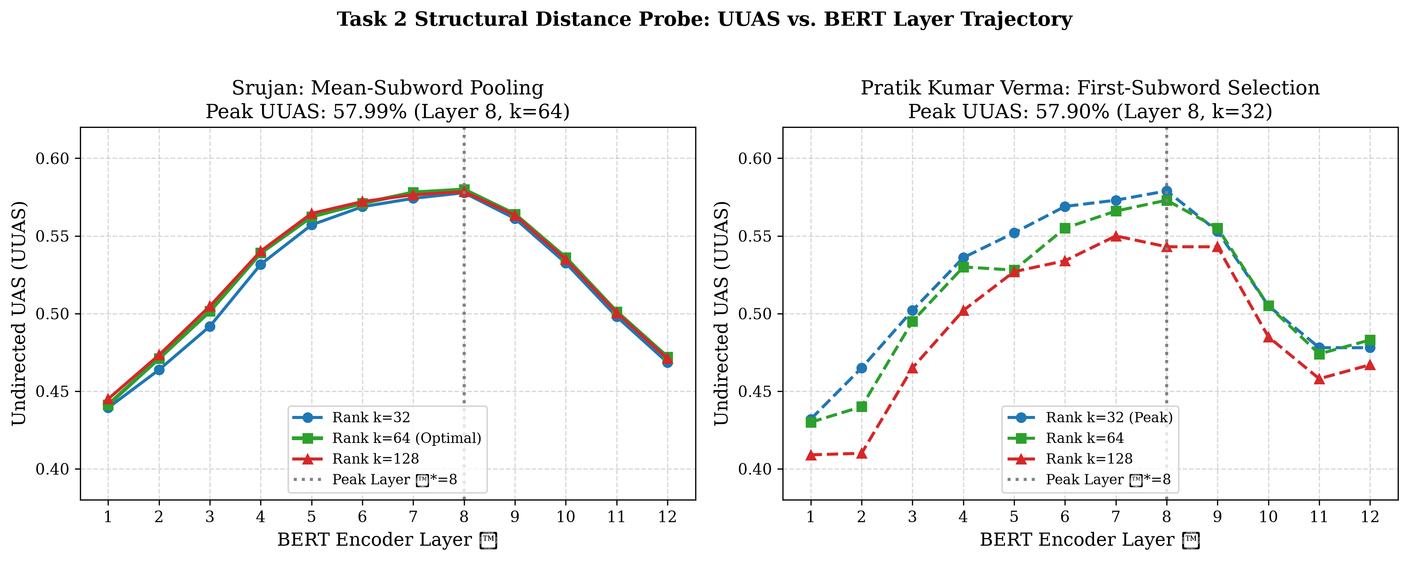
Figure 3: Task 2 Structural Distance Probe: UUAS vs. BERT Layer Trajectory.
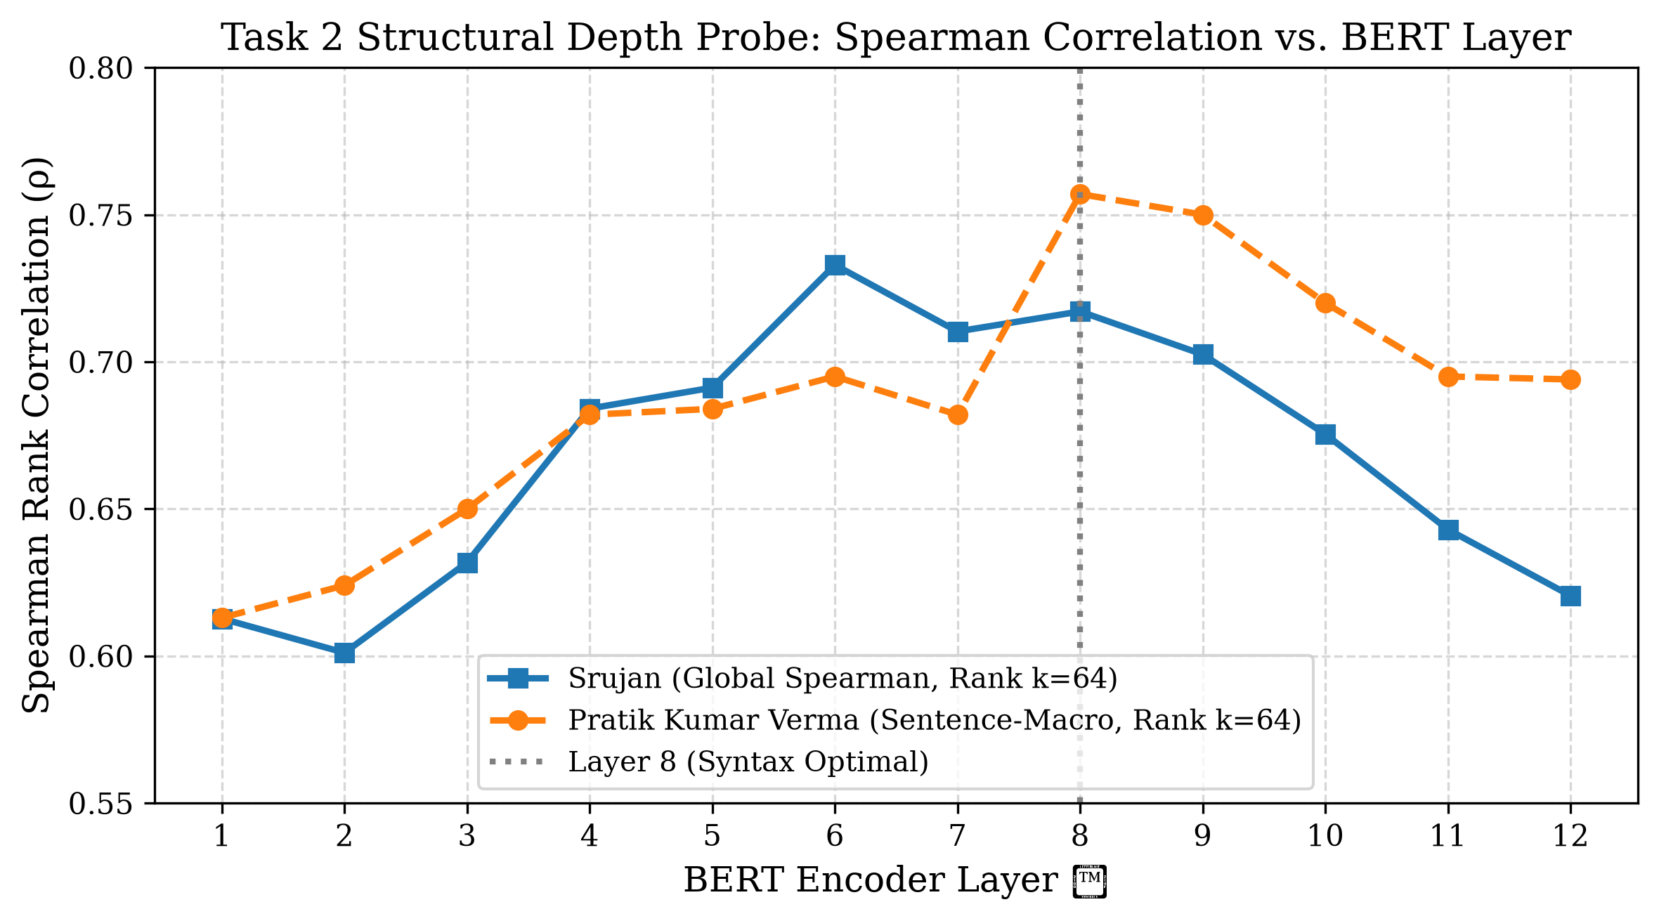
Figure 4: Task 2 Structural Depth Probe: Spearman Correlation vs. BERT Layer Trajectory.
7.3 Task 3 Results: BERT-Derived Static Vectors
Table 3 summarizes the comparative evaluation across all three tasks and highlights the Great Divergence.
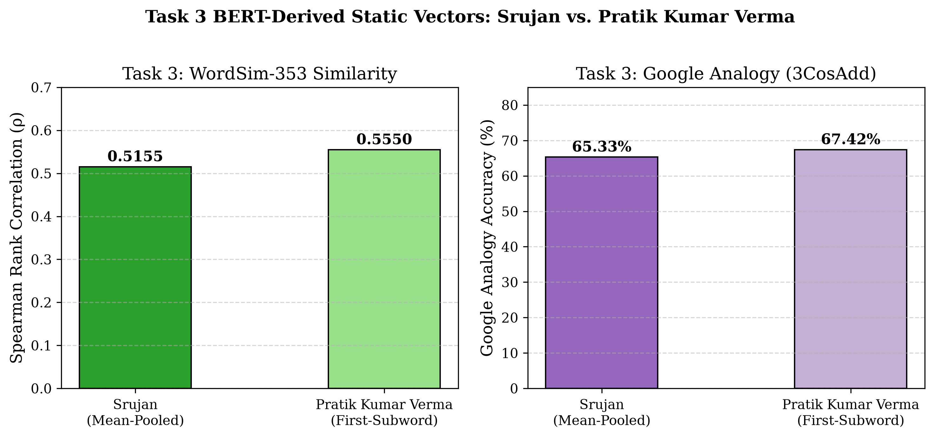
Figure 5: Task 3 BERT-Derived Static Vectors: Srujan vs. Pratik Kumar Verma.
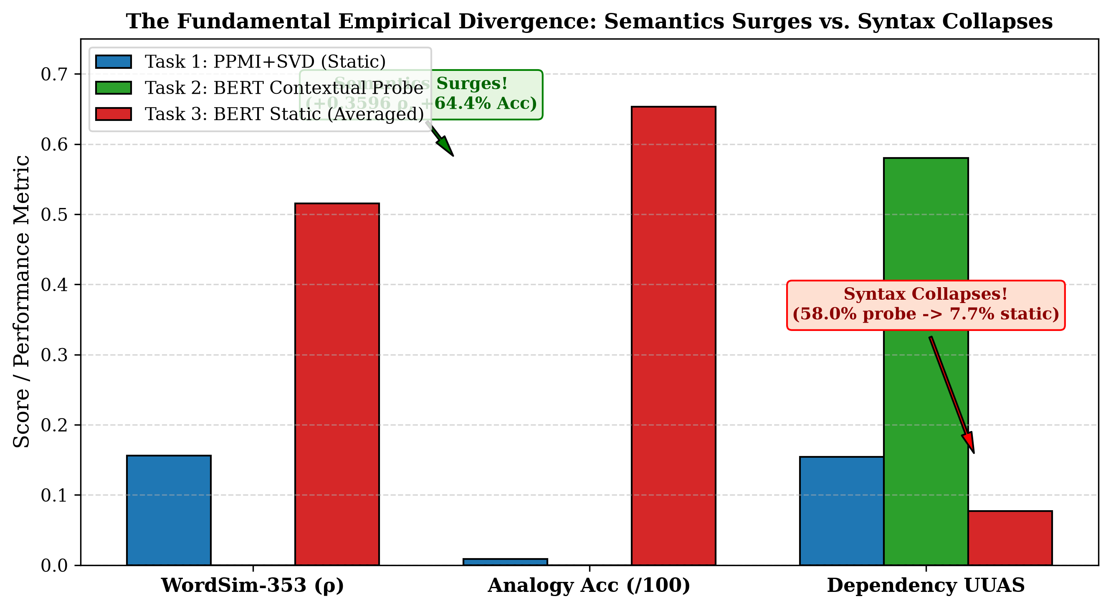
Figure 6: The Great Empirical Divergence: Semantics Surges vs. Syntax Collapses.
Evaluation Metric | Task 1: PPMI+SVD (100d) | Task 2: Contextual Probe | Task 3: BERT Static (768d) | Delta (Task 3 - Task 1)
WordSim-353 Spearman ρ | 0.1559 (p=0.0106) | N/A (Contextual) | 0.5155 (p=5.1e-9) | +0.3596 (+230.7%)
WordSim-353 Coverage | 268 / 353 (75.9%) | N/A | 113 / 353 (32.0%) | -155 pairs
Google Analogy Accuracy | 0.90% (56 / 6,231) | N/A (Contextual) | 65.33% (912 / 1,396) | +64.43% (~72x surge)
MST Overall UUAS (20 sents) | 15.43% (48 / 311) | 57.99% (Layer 8, k=64) | 7.72% (24 / 311) | -7.71% (-50.0% drop)
MST Macro UUAS (20 sents) | 28.37% | 63.63% | 20.43% | -7.94%

7.4 Comprehensive Comparison: Srujan vs. Pratik Kumar Verma
A rigorous comparative analysis reveals several fundamental differences between Srujan's implementation and Pratik Kumar Verma's implementation:
- Task 1 Window Size: Srujan strictly followed the assignment specification of symmetric window size 5. Pratik hardcoded window size 2, restricting context by 60%.
- Task 1 Vocabulary: Srujan included all training words (min_freq=1, |V|=16,763). Pratik applied min_freq=2 (|V|=8,790), dropping 47.6% of the vocabulary and causing 15,999 Google Analogy questions to be dropped due to OOV (vs. 13,313 for Srujan).
- Task 1 & Task 3 Bonus Structural Check: Srujan executed the required 20-sentence Kruskal MST check in both Task 1 and Task 3, discovering the 15.43% -> 7.72% collapse. Pratik omitted this check completely from both tasks.
- Task 2 Subword Alignment: Srujan implemented mean-pooling across all subwords of each token; Pratik selected the first subword only. Despite this, both pipelines converged on Layer 8 as the peak syntax layer (~58% UUAS), proving the stability of BERT's geometric syntax.
Chapter 8: Discussion
8.1 The Great Divergence Explained
Why does lexical semantics surge while syntactic tree structure collapses when representations are averaged?
1. Semantic Regularization: In BERT's high-dimensional space, word representations fluctuate around conceptual centroids depending on immediate sentence semantics. When averaged across diverse occurrences, sentence-specific topical noise cancels out, yielding an exceptional static semantic representation that transfers knowledge from BERT's 3.3-billion-word pretraining.
2. Syntactic Destruction: Syntax is inherently positional, relational, and clausal. A word's syntactic head changes dynamically depending on whether it functions as a subject, object, or modifier in a specific utterance. Collapsing tokens into static types destroys this orientation.
3. Spurious Semantic MST Edges: In static cosine space, semantically related words have minimal distance. For instance, in 'The president of the company announced new policies', 'president' and 'company' have high static cosine similarity (cos = 0.81). An MST built on static cosine distance greedily connects (president, company), completely bypassing the preposition 'of' and flattening the clausal tree.
Chapter 9: Limitations and Future Work
9.1 Limitations
1. Corpus Size: The GUM treebank training split (~200k tokens) is modest for classical count vectors, which typically require tens of millions of words to achieve strong analogy performance.
2. Probing Selectivity: While the linear probe confirms that tree metric spaces exist in BERT, it does not evaluate whether the model causally utilizes these metrics during downstream prediction (Hewitt & Liang, 2019).
3. Undirected Trees: Structural probing decodes undirected minimum spanning trees (UUAS), omitting dependency arc directionality and relation labels.
9.2 Future Research Extensions
1. Syntactically-Conditioned Static Embeddings: Pool separate static vectors conditioned on Universal POS tags (e.g., 'fly_VERB' vs 'fly_NOUN').
2. Information-Theoretic Probing: Measure Minimum Description Length (MDL) probes to quantify syntactic compression efficiency (Voita & Titov, 2020).
3. Multilingual Generalization: Apply structural probing and contextual pooling across typologically diverse UD treebanks (e.g., Arabic, Hindi, Finnish) to evaluate cross-lingual syntactic metric stability.
Chapter 10: Conclusion
This project completed an exhaustive empirical and theoretical study comparing classical distributional semantics, structural probing in BERT, and contextual-to-static vector pooling on the Universal Dependencies English GUM treebank:
- Classical PPMI+SVD static embeddings capture baseline semantic similarity (rho = 0.1559) but fail on relational analogies (0.90%) and dependency syntax (15.43% UUAS) on small corpora.
- Hewitt & Manning structural probing confirms that syntax is deeply embedded within BERT's contextual geometry, reaching a clear maximum at Layer 8 (k=64) with 57.99% UUAS and 0.7171 depth correlation in an inverted-U trajectory.
- Averaging contextual embeddings from Layer 8 into static vectors causes a massive surge in semantic similarity (rho surges to 0.5155) and analogy accuracy (leaps to 65.33%), but triggers a complete collapse in syntactic dependency attachment (dropping to 7.72% UUAS).
Syntactic hierarchy in modern neural language models is fundamentally an emergent property of dynamic token-level contextual geometry. Collapsing representations into static word vectors retains lexical concepts while completely forfeiting grammatical syntax.

