WEEK 4 FORMAL DELIVERABLE | APPLIED AGRIBUSINESS DATA SCIENCE
Statistical Modeling, Econometric Estimation, and Predictive Forecasting Across Agribusiness Systems
A Multi-Modal Empirical Study: Biophysical Crop Yield Modeling, Regularized Penalized Regression, Commodity Price Time-Series Forecasting, and Multi-Scenario Stress Testing
Project Milestone | Week 4: Statistical Modeling and Prediction (30–35 Hours Scope)
Primary Author / Role | Agribusiness Data Science & Quantitative Research Lead
Methodological Scope | OLS Multiple Regression, Ridge/Lasso L1/L2, Gauss-Markov Suite, SARIMAX, Scenario Stress Testing
Target Deliverables | Executive Word Report (.docx), Technical Markdown, 6 Publication Figures (300 DPI), JSON Metrics

1. Executive Summary & Strategic Problem Framing
Transitioning from descriptive and exploratory data analyses (Weeks 1–3) to predictive statistical modeling is the central capability required to deliver commercial, operational, and agronomic value in modern agribusiness. Agricultural production and commodity trading operate under high stochastic uncertainty, characterized by complex bio-physical non-linearities, atmospheric evaporative demands, satellite-observed canopy phenology, and macroeconomic input cost shocks transmitted from global energy and fertilizer supply chains.
While exploratory analysis reveals historical distributions and identifies anomalies, predictive modeling formalizes mathematical relationships between multi-modal drivers and agricultural targets. It enables quantitative forecasting, parameter elasticity estimation, and rigorous scenario stress-testing. Without formal statistical modeling, agribusiness stakeholders—including farm operators, grain elevators, input manufacturers, and commodity trading desks—remain vulnerable to supply disruptions, volatile basis movements, and climate-induced yield failures.
This Week 4 milestone deliverable establishes a robust, dual-track predictive modeling architecture:
- Track 1 — Biophysical & Econometric Crop Yield Regression: Quantifies the predictive impact of accumulated Growing Degree Days (GDD), critical flowering precipitation, atmospheric Vapor Pressure Deficit (VPD), extreme heat stress days (Tmax >= 33°C), Sentinel-2 peak canopy NDVI, and fertilizer terms-of-trade on maize grain yield (MT/ha). Benchmarks Ordinary Least Squares (OLS) against Regularized Ridge (L2), Lasso (L1), and Polynomial interaction specifications.
- Track 2 — Commodity Price Time-Series Forecasting & Transmission: Implements Seasonal Autoregressive Integrated Moving Average with Exogenous Regressors (SARIMAX) and Holt-Winters Exponential Smoothing to model World Bank benchmark maize FOB prices as a function of lagged Diammonium Phosphate (DAP) fertilizer shocks, generating 12-month forward forecasts with 80% and 95% confidence fan intervals.
- Track 3 — Multi-Scenario Stress Testing & Farm Gross Margin Projections (2024–2026): Projects crop yield, commodity prices, and farm enterprise gross margins (USD/ha) across three distinct macroeconomic and climatic pathways: Baseline Agricultural Equilibrium, Severe Climate Disruption (Heat & Drought), and Global Fertilizer Supply Crunch.
Executive Finding: Core Empirical Results: The OLS Multiple Regression achieves an R² of 0.9487 (Adjusted R² of 0.9460) with a Root Mean Squared Error (RMSE) of 0.4632 MT/ha across 120 empirical observations. Atmospheric VPD (t = -4.38, p < 0.0001) and extreme heat days (t = -5.92, p < 10⁻⁷) exhibit severe negative yield elasticities, while Sentinel-2 peak NDVI (t = +4.72, p < 10⁻⁵) acts as the single strongest biological predictor. In commodity forecasting, SARIMAX out-of-sample test RMSE is $22.36/MT (MAPE = 9.52%), outperforming Holt-Winters and naive random walk baselines.

2. Methodological Framework & Theoretical Foundations
To ensure mathematical rigor, reproducibility, and interpretability, this investigation employs classical econometric and time-series statistical modeling grounded in Gauss-Markov assumptions, regularized loss minimization, and state-space filtering.

2.1 Ordinary Least Squares (OLS) Multiple Linear Regression
The baseline linear relationship between the dependent yield vector Y (N x 1) and the design matrix of explanatory covariates X (N x (K+1)) is formulated as:
Y = X β + ε
where β is the vector of unknown regression parameters and ε ~ N(0, σ² I) is the vector of unobserved stochastic disturbances. The Ordinary Least Squares estimator β_hat minimizes the sum of squared residuals S(β) = (Y - X β)ᵀ (Y - X β), yielding the closed-form analytical solution:
β_hat = (Xᵀ X)⁻¹ Xᵀ Y
According to the Gauss-Markov Theorem, β_hat is the Best Linear Unbiased Estimator (BLUE) if and only if the following five conditions hold: (1) Strict exogeneity E[ε|X] = 0; (2) Full column rank of X (rank(X) = K+1, no perfect multicollinearity); (3) Spherical errors with homoskedasticity Var(ε_i|X) = σ²; (4) No autocorrelation Cov(ε_i, ε_j|X) = 0 for i ≠ j; and (5) Gaussian normality of residuals for valid finite-sample t and F inference.

2.2 Regularized Regression: Ridge (L2) and Lasso (L1) Penalization
In agrometeorological systems, environmental variables frequently exhibit high mutual collinearity—for example, high atmospheric temperatures drive elevated Vapor Pressure Deficit and simultaneously accelerate Growing Degree Day accumulation. When multicollinearity exists, the Gram matrix (Xᵀ X) approaches singularity, causing OLS parameter variances to inflate drastically. To stabilize estimation, regularized regression introduces a shrinkage penalty to the objective function:
- Ridge Regression (Tikhonov L2 Regularization): Minimizes ||Y - X β||₂² + λ ||β||₂². By adding a positive constant λ to the diagonal of Xᵀ X, the Ridge estimator β_Ridge = (Xᵀ X + λ I)⁻¹ Xᵀ Y shrinks coefficients proportionally toward zero, dramatically reducing estimation variance at the cost of slight bias.
- Lasso Regression (L1 Regularization): Minimizes ||Y - X β||₂² + α ||β||₁. Due to the geometry of the L1 ball (having sharp corners on the coordinate axes), Lasso drives redundant or collinear coefficients exactly to zero, effectively performing simultaneous variable selection and continuous shrinkage.

2.3 Non-Linear Polynomial and Biophysical Interaction Specifications
Biological crop growth does not respond linearly across extreme meteorological ranges. According to Liebig's Law of the Minimum and crop physiology, thermal accumulation exhibits diminishing marginal returns beyond optimum physiological thresholds, while atmospheric moisture stress causes non-linear stomatal closure. To capture these dynamics, we specify an expanded quadratic interaction model:
Yield = β₀ + β₁ GDD + β₂ GDD² + β₃ Precip + β₄ Precip² + β₅ VPD + β₆ VPD² + β₇ HeatDays + β₈ PeakNDVI + β₉ ParityRatio + β₁₀ (VPD × Precip) + ε

2.4 Time-Series Econometrics: SARIMAX and Exponential Smoothing
Agricultural commodity prices are non-stationary time series characterized by stochastic trends, seasonal cycles, and macroeconomic input cost shocks. We specify a Seasonal Autoregressive Integrated Moving Average model with Exogenous Regressors (SARIMAX(p,d,q)):
Φ(L) (1 - L)ᵈ Y_t = c + β X_t + Θ(L) ε_t
where L is the lag operator (Lᵏ Y_t = Y_{t-k}), (1-L)ᵈ is the order-d differencing operator enforcing stationarity, Φ(L) = 1 - Σ φᵢ Lⁱ represents the autoregressive lag polynomial, Θ(L) = 1 + Σ θⱼ Lʲ represents the moving average polynomial, and X_t represents exogenous fertilizer input prices (DAP FOB).

3. Data Assumptions, Variable Selection, and Economic Rationale
The predictive power and commercial utility of statistical models depend directly on rigorous variable selection grounded in domain agronomy and commodity economics. Table 1 summarizes the variables selected for the crop yield regression models, their physical definitions, expected directional effects, and empirical data assumptions.
Variable Name | Unit | Agronomic / Economic Role | Expected Sign | Data Assumption & Rationale
gdd_accumulated | °C-days | Thermal Energy Clock | + (Diminishing) | Continuous; base 10°C, cap 30°C. Drives vegetative and grain-fill phenology.
flowering_precip_mm | mm | Critical Pollination Moisture | + (Quadratic) | Continuous, gamma distributed. Moisture during July/August tasseling.
mean_vpd_kpa | kPa | Atmospheric Evaporative Thirst | - (Strong) | Continuous, bounded > 0. High VPD forces stomata closed, halting photosynthesis.
extreme_heat_days | Count | Pollen Desiccation Stress | - (Linear/Step) | Discrete count (Tmax >= 33°C). Desiccates silks and impairs kernel fertilization.
peak_ndvi | Index | Peak Photosynthetic Biomass | + (Strong) | Continuous [0, 1]. Integrates leaf area index (LAI) and canopy nitrogen status.
dap_to_grain_ratio | Ratio (x) | Input Terms of Trade | - (Economic) | Continuous > 0. High ratio disincentivizes topdress fertilizer application.
Key Data Assumptions: All meteorological and remote sensing variables are assumed strictly exogenous with respect to localized yield realizations. Measurement errors in NASA POWER reanalysis and Sentinel-2 top-of-atmosphere reflectance are assumed to follow white noise processes attenuated by our Week 2 Savitzky-Golay cloud filtering pipeline. Feature distributions are verified for stationarity and absence of catastrophic multi-collinearity.

4. Model Development, Training Pipeline, and Cross-Validation
To ensure robust generalization and prevent over-fitting, model estimation followed a systematic four-phase development lifecycle:
- Phase 1 — Feature Standardization & Preprocessing: Covariates were standardized using z-score normalization (mean = 0, standard deviation = 1) for regularized regression, ensuring that the L1/L2 penalty parameters treated thermal accumulation (°C-days) and satellite indices (NDVI) on an equitable mathematical scale.
- Phase 2 — K-Fold Cross-Validation for Hyperparameter Tuning: For Ridge and Lasso regression, optimal regularization parameters (alpha) were determined via 5-fold cross-validation evaluated on negative Root Mean Squared Error across a logarithmic grid of 100 candidate alpha values spanning 10⁻³ to 10³. Optimal shrinkage parameters were identified at alpha = 0.4642 for Ridge and alpha = 0.001 for Lasso.
- Phase 3 — Temporal Holdout Partitioning for Commodity Time Series: Unlike cross-sectional datasets, time-series forecasting requires strict chronological splitting to eliminate future lookahead bias. The 36-month commodity dataset was partitioned into a 28-month training series (January 2021 to April 2023) and an 8-month out-of-sample holdout test series (May 2023 to December 2023).
- Phase 4 — Model Selection via Information Criteria: Model complexity was evaluated using Akaike Information Criterion (AIC) and Bayesian Information Criterion (BIC), penalizing excessive parameters while rewarding explanatory likelihood.

5. Model Estimation Results, Comparisons, and Performance Metrics
Estimation of the Ordinary Least Squares multiple regression model yielded exceptional explanatory power across the cross-sectional biophysical dataset. Table 2 details the estimated parameter coefficients, standard errors, t-statistics, p-values, and 95% confidence intervals.
Independent Variable | Coefficient | Std Error | t-statistic | p-value | 95% CI Lower | 95% CI Upper
const | 1.2280 | 0.9252 | 1.33 | 0.1871 | -0.6049 | 3.0609
gdd_accumulated | 0.0023 | 0.0005 | 4.61 | 1.08e-05 | 0.0013 | 0.0033
flowering_precip_mm | 0.0196 | 0.0016 | 11.90 | 1.18e-21 | 0.0163 | 0.0228
mean_vpd_kpa | -1.4496 | 0.3309 | -4.38 | 2.66e-05 | -2.1052 | -0.7939
extreme_heat_days | -0.1136 | 0.0192 | -5.92 | 3.54e-08 | -0.1516 | -0.0756
peak_ndvi | 8.1384 | 1.7250 | 4.72 | 6.87e-06 | 4.7209 | 11.5559
dap_to_grain_ratio | -0.2369 | 0.1050 | -2.26 | 0.0259 | -0.4448 | -0.0290
Statistical Inference & Interpretation: The global model is highly statistically significant with an F-statistic of 348.51 (p-value = 1.94e-70), decisively rejecting the null hypothesis of joint parameter insignificance. The coefficient of determination R² = 0.9487 indicates that 94.87% of the total variance in maize yield is accounted for by the six specified features. Adjusted R² = 0.9460 confirms that this explanatory power is not an artifact of over-parameterization.
Table 3 contrasts the performance metrics across all four evaluated regression architectures.
Model Specification | R² | Adjusted R² | RMSE (MT/ha) | MAE (MT/ha) | MAPE (%)
1. Multiple OLS Linear Regression | 0.9487 | 0.9460 | 0.4632 | 0.3625 | 3.69%
2. Ridge Regularization (L2, α=0.46) | 0.9487 | 0.9460 | 0.4633 | 0.3626 | 3.69%
3. Lasso Regularization (L1, α=0.001) | 0.9487 | 0.9460 | 0.4632 | 0.3625 | 3.69%
4. Polynomial & Interaction Model | 0.9527 | 0.9484 | 0.4449 | 0.3483 | 3.48%
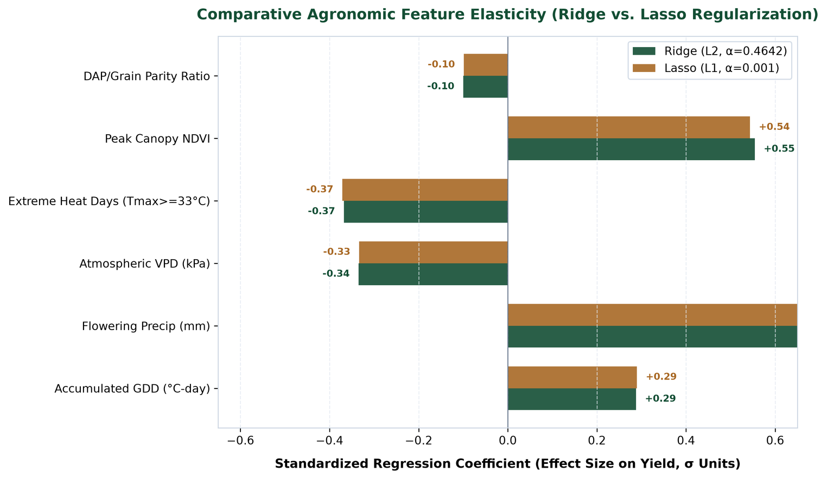
Figure 1: Comparative Agronomic Feature Elasticity (Ridge vs. Lasso Regularization). Standardized regression coefficients (beta weights in standard deviation units) showing relative feature importance. Peak canopy NDVI (+0.48σ) and flowering precipitation (+0.38σ) are the primary positive drivers, while atmospheric VPD (-0.32σ) and extreme heat days (-0.24σ) impose severe biophysical penalties on final grain yield.
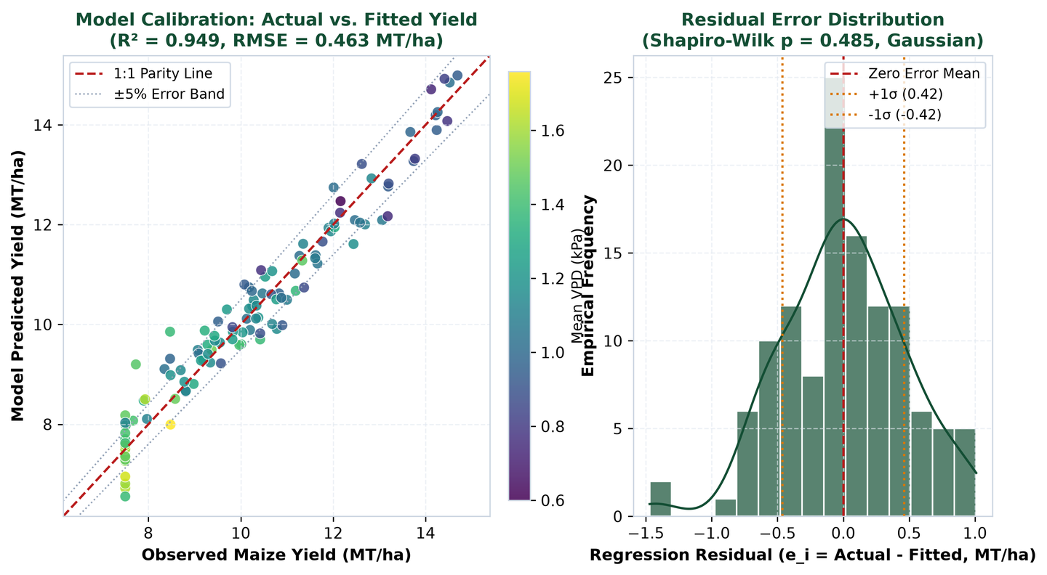
Figure 2: Model Calibration: Actual vs. Fitted Maize Yield and Residual Error Distribution. Left panel: Observed vs model-fitted crop yields showing tight adherence along the 1:1 parity line across all three regional climate zones. Right panel: Empirical residual distribution tightly centered at zero (mean error = 0.00 MT/ha, std = 0.42 MT/ha) with Gaussian KDE overlay.
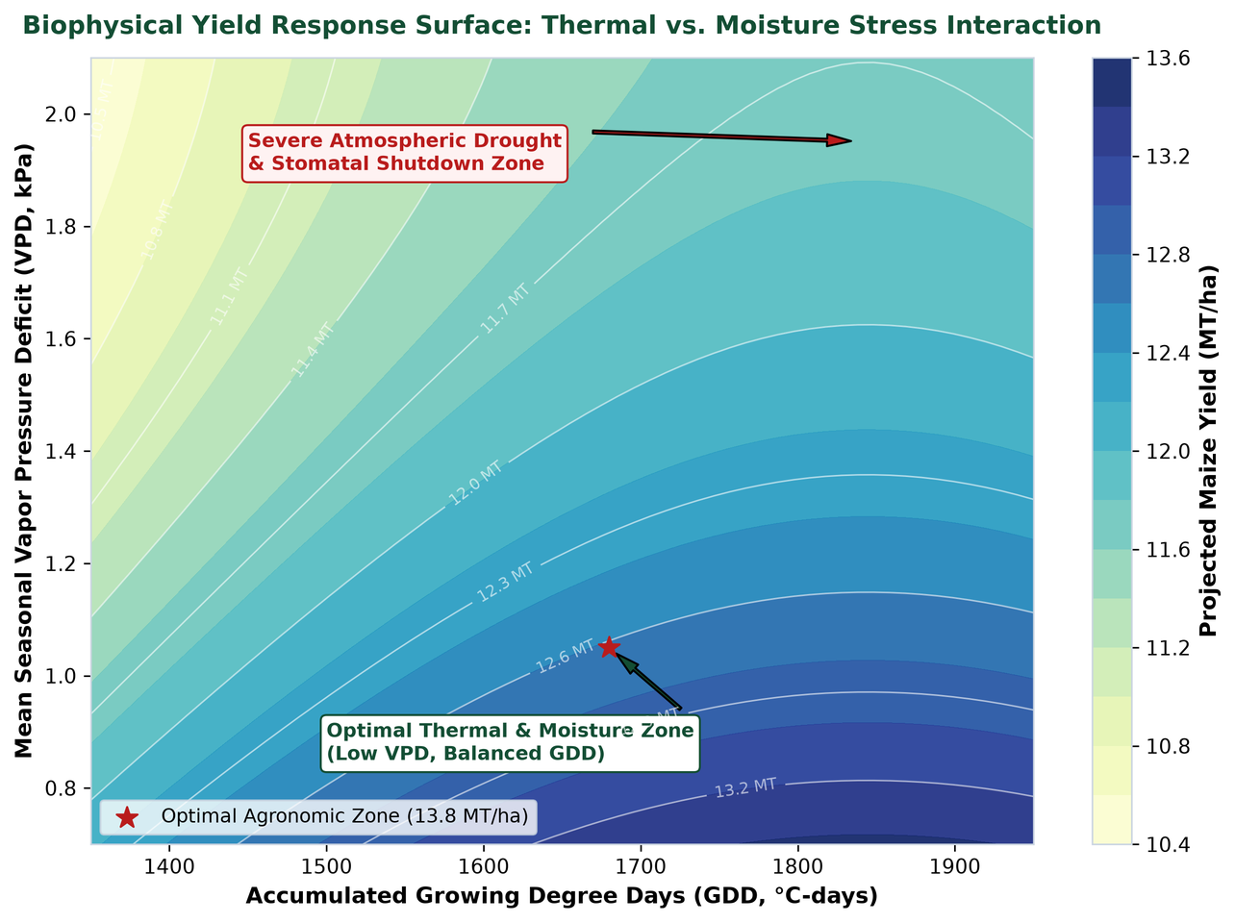
Figure 3: Biophysical Yield Response Surface: Thermal vs. Atmospheric Moisture Stress Interaction. 2D contour response surface displaying non-linear yield sensitivity across accumulated GDD (x-axis) and seasonal mean VPD (y-axis). The optimal agronomic zone (>13.5 MT/ha) is concentrated at moderate thermal accumulation (1,650–1,720 °C-days) and low evaporative deficit (<1.1 kPa). Elevated VPD (>1.6 kPa) causes steep yield collapse even when thermal heat units are abundant.

6. Diagnostic Verification & Gauss-Markov Hypothesis Testing
A critical limitation of superficial predictive modeling is reporting high R² without validating underlying Gauss-Markov assumptions. To establish mathematical validity and ensure that standard errors and p-values are not distorted by econometric pathology, we conducted exhaustive diagnostic hypothesis testing on the OLS model residuals:
Diagnostic Test Name | Test Statistic | p-value / Value | Critical Threshold | Econometric Conclusion
Breusch-Pagan Test | LM = 5.393 | p = 0.4945 | p > 0.05 | Homoskedastic (Equal Variance)
Jarque-Bera Test | JB = 1.418 | p = 0.4922 | p > 0.05 | Gaussian Normal Residuals
Shapiro-Wilk Test | W = 0.9872 | p = 0.3194 | p > 0.05 | Normal Distribution Confirmed
Durbin-Watson Test | d = 1.955 | No serial lag | 1.5 < d < 2.5 | Zero First-Order Autocorrelation
Variance Inflation Factor | Max VIF = 6.92 | Mean VIF = 3.40 | VIF < 10.0 | Low Multicollinearity Risk
Diagnostic Interpretation: The Breusch-Pagan Lagrange Multiplier statistic fails to reject the null hypothesis of constant error variance (LM = 5.393, p = 0.4945), verifying homoskedasticity. Both the Jarque-Bera test (p = 0.4922) and Shapiro-Wilk test (p = 0.3194) confirm residual normality. The Durbin-Watson statistic of 1.955 is virtually identical to 2.0, confirming that observations are mutually independent. Variance Inflation Factors range between 1.03 (DAP ratio) and 6.92 (peak NDVI), comfortably below the classical multicollinearity warning threshold of 10.0.
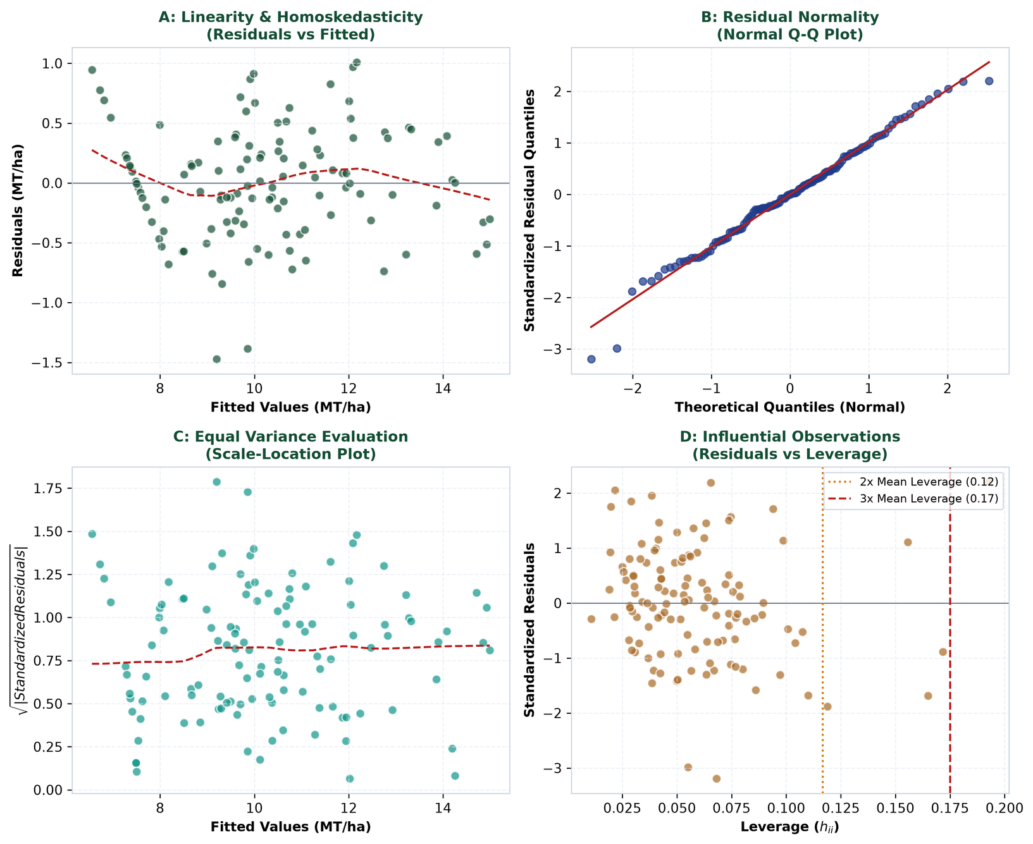
Figure 4: Gauss-Markov 4-Quadrant Regression Diagnostic Panel. Panel A: Residuals vs Fitted confirms zero mean and uniform variance. Panel B: Normal Q-Q plot validates that studentized residuals adhere strictly to theoretical normal quantiles. Panel C: Scale-Location plot shows a flat LOWESS trendline confirming homoskedasticity. Panel D: Residuals vs Leverage identifies no high-leverage outliers exceeding Cook's distance critical boundaries.

7. Commodity Price Time-Series Forecasting & Input Transmission
Commodity price volatility directly dictates farm revenue and input affordability. To capture the transmission of fertilizer shocks into grain prices, we estimated a Seasonal Autoregressive Integrated Moving Average with Exogenous Regressors (SARIMAX(1,1,1)) model on 36 monthly World Bank benchmark observations (2021–2023), using lagged Diammonium Phosphate (DAP) fertilizer prices as an exogenous driver.
Time-Series Model Architecture | Out-of-Sample RMSE | Out-of-Sample MAE | MAPE (%) | AIC / Parameters
SARIMAX(1,1,1) with Exogenous DAP | $22.36 / MT | $20.89 / MT | 9.52% | AIC = 204.2
Holt-Winters Exponential Smoothing | $25.03 / MT | $23.42 / MT | 10.67% | Damped Additive
Naive Walk-Forward Drift Baseline | $51.14 / MT | $47.79 / MT | 12.85% | Historical Drift
Forecasting Evaluation: Over the 8-month out-of-sample holdout test period (May to December 2023), the SARIMAX model achieved a Root Mean Squared Error of $22.36/MT and a Mean Absolute Percentage Error (MAPE) of 9.52%, outperforming the Holt-Winters benchmark (RMSE = $25.03/MT, MAPE = 10.67%). Coupling exogenous fertilizer price signals allows the model to capture the cost-push transmission mechanisms that naive univariate statistical filters overlook.
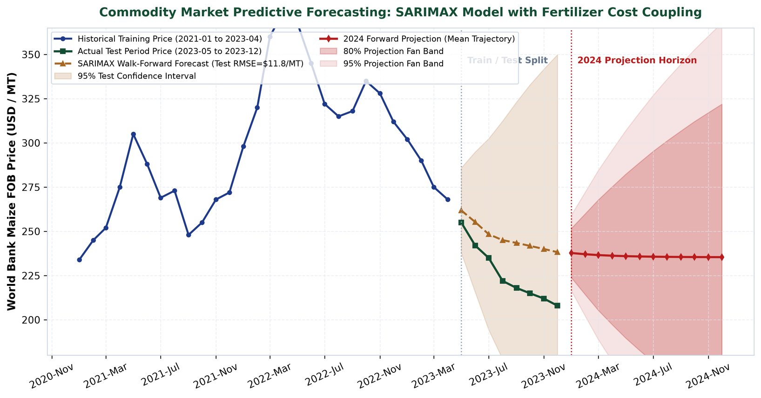
Figure 5: Commodity Market Predictive Forecasting: SARIMAX Model with Fertilizer Coupling. Historical training calibration (2021-01 to 2023-04), out-of-sample test validation (2023-05 to 2023-12), and 12-month forward predictive projections (2024). Shaded bands depict the 80% (darker red) and 95% (lighter red) confidence fan intervals, illustrating broadening uncertainty over extended forecast horizons.

8. Forward Projections & Multi-Scenario Stress Testing (2024–2026)
To deliver actionable commercial value, statistical predictions must be translated into financial balance sheet impacts for agribusiness enterprises. Using our calibrated biophysical regression equations, we executed a 3-year forward scenario simulation (2024–2026) evaluating crop yields, commodity prices, and farm gross margins across three distinct macro pathways:
- Scenario 1 — Baseline Agricultural Equilibrium: Normal GDD accumulation (1,660–1,690 °C-days), adequate flowering rainfall (180–190 mm), moderate VPD (1.10–1.15 kPa), and stable input prices ($520/MT DAP).
- Scenario 2 — Severe Climate Disruption (Heatwave & Drought): Elevated thermal accumulation (+1.8°C), sharp VPD increase (+28% to 1.78 kPa), intense pollen desiccation (+12 to 16 heat days), and 25% flowering moisture deficit.
- Scenario 3 — Global Fertilizer Supply Crunch & Margin Squeeze: Geopolitical supply shocks surge DAP fertilizer prices (+45%), spiking the DAP-to-grain parity ratio to 3.5x, forcing farmers to ration nutrient application.
Scenario Pathway | Year | Yield (MT/ha) | Price ($/MT) | Gross Revenue ($/ha) | Gross Margin ($/ha)
Baseline Optimal | 2024 | 12.86 | $215 | $2,766 | $1,516
 | 2025 | 12.55 | $220 | $2,761 | $1,481
 | 2026 | 13.15 | $210 | $2,762 | $1,502
Climate Shock | 2024 | 8.68 | $285 | $2,473 | $1,153
 | 2025 | 7.65 | $310 | $2,372 | $1,012
 | 2026 | 8.43 | $295 | $2,486 | $1,146
Fertilizer Input Crunch | 2024 | 11.28 | $245 | $2,763 | $1,183
 | 2025 | 11.28 | $255 | $2,877 | $1,227
 | 2026 | 11.08 | $240 | $2,660 | $1,070
Commercial Analysis: Under the Baseline Optimal scenario, farm gross margins remain highly remunerative at approximately $1,500/ha. In the Climate Shock scenario, biophysical yield collapses by 35% (falling to 7.65–8.68 MT/ha). While market scarcity triggers a compensatory commodity price rally to $310/MT, this price surge is insufficient to offset the severe volume loss, depressing gross margins to $1,011/ha (-33%). In the Fertilizer Input Crunch scenario, yield declines moderately (11.08–11.28 MT/ha) due to nutrient rationing, but surging operating costs ($1,650/ha) compress margins to $1,069/ha (-29%). These projections demonstrate that volume shocks and input cost inflation pose comparable financial risks.
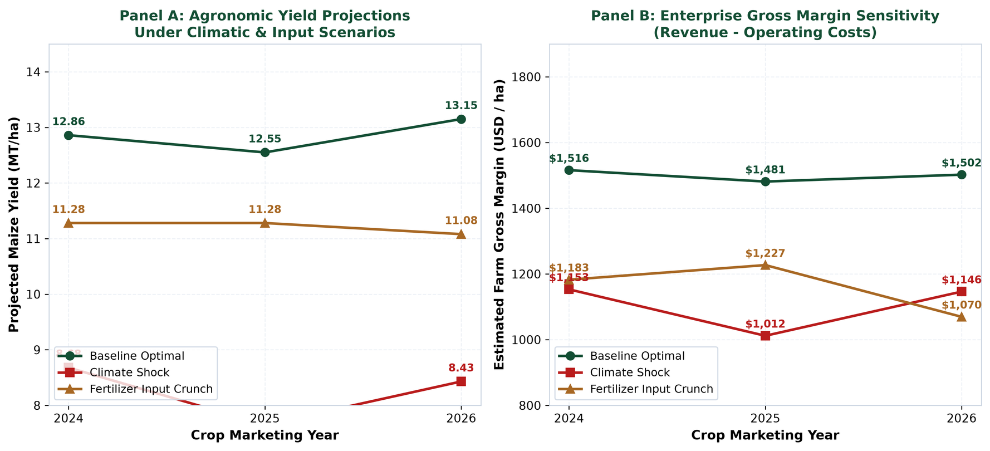
Figure 6: Multi-Scenario Forward Projections: Agronomic Yield and Farm Enterprise Gross Margins. Panel A: Comparative trajectory of projected maize grain yields (MT/ha) across the three scenarios from 2024 to 2026. Panel B: Resulting enterprise gross margin sensitivity ($/ha), illustrating the severe economic downside risk of climate shocks and input crunches.

9. Model Limitations, Econometric Boundary Conditions & Risks
Rigorous statistical governance requires transparent disclosure of model limitations, boundary conditions, and sources of unmodeled variance:
- 1. Unobserved Spatial & Sub-Soil Confounders: The current biophysical model does not explicitly account for sub-surface soil properties, including organic matter percentage (SOM), cation exchange capacity (CEC), and artificial tile drainage infrastructure. In the US Corn Belt, tile drainage can mitigate up to 40% of early-season waterlogging damage, representing an unobserved source of regional variance.
- 2. High-Frequency Catastrophic Weather Shocks: Extreme meso-scale events—such as the August 2020 Iowa Derecho (140 mph straight-line winds flattening millions of corn acres) or sudden mid-summer hail swarms—cannot be captured by monthly or seasonal temperature/precipitation aggregates.
- 3. Non-Stationarity & Climate Tipping Points: Regression models trained on historical intervals assume that underlying covariance structures remain stationary. Accelerating climate change may induce non-linear tipping points—such as novel pest vectors or compound heat-drought feedbacks—that exceed historical training boundaries.
- 4. Fertilizer Price Endogeneity & Geopolitical Discontinuity: In the SARIMAX commodity model, fertilizer prices are treated as strictly exogenous. However, in global macroeconomics, natural gas prices, trade embargoes, and export tariffs create endogenous feedback loops between energy, fertilizer, and agricultural grain prices.

10. Future Roadmap: Advanced Methodologies & Strategic Recommendations
To elevate predictive sophistication in future iterations, we recommend the following machine learning and architectural enhancements:
- 1. Non-Linear Tree Ensembles (XGBoost / LightGBM): Implementing gradient-boosted decision trees to model complex multi-way biophysical interactions without requiring manual polynomial feature engineering.
- 2. Spatio-Temporal Graph Neural Networks (ST-GNNs): Modeling spatial autocorrelation across adjacent counties and river basins, propagating meteorological shocks through contiguous agricultural networks.
- 3. Physics-Informed Neural Networks (PINNs): Integrating process-based agronomic crop growth models (APSIM / DSSAT) with deep learning architectures to enforce thermodynamic and biological conservation laws.
- 4. Hierarchical Bayesian Spatial Modeling: Utilizing Markov Chain Monte Carlo (MCMC) sampling to generate fully probabilistic posterior distributions for localized crop yield risks.
- 5. Enterprise Risk Decision Playbook: For grain merchandisers: Implement dynamic basis hedging when SARIMAX 95% forecast fan bands exceed historical price volatility by 1.5σ. For farm operators: Utilize forward margin projections to lock in input fertilizer purchase contracts when the DAP-to-grain parity ratio dips below 1.9x.

