Technical Write-Up
Design-Space Exploration of a Quad-Core ARM Cortex-A53 Memory Subsystem Using VisualSim Architect
1. Abstract
This project presents a design-space exploration of the memory subsystem of a quad-core ARM Cortex-A53-based SoC using VisualSim Architect. The study investigates the effect of three architectural parameters: L2 cache capacity, system-bus width, and DDR4 memory speed. Multiple configurations were simulated for a fixed simulation duration of 2 ms, and performance was evaluated using L2 hit ratio, L2 latency, bus utilization, DRAM throughput, DRAM delay, and queue usage.
The simulation results show that increasing memory-system resources does not necessarily produce proportional performance improvement. In particular, increasing L2 capacity did not automatically improve the measured hit ratio or latency, while increasing DDR speed produced only a small change in measured DRAM performance. The 256-bit bus also remained lightly utilized. These observations demonstrate the importance of workload-driven architecture exploration before selecting a hardware configuration.

2. Introduction
Modern multi-core System-on-Chip (SoC) architectures contain several processor cores that share a hierarchical memory subsystem. The performance of the processor is therefore influenced not only by the processing cores but also by cache behavior, interconnect bandwidth, memory-controller behavior, and external memory performance.
A common approach to improving memory performance is to increase cache capacity, increase bus width, or use faster memory. However, these changes increase hardware resources and do not necessarily guarantee better workload-level performance.
Therefore, this project investigates the following question:
How do L2 cache capacity, system-bus width, and DDR4 memory speed affect the measured performance of a quad-core ARM Cortex-A53 system?
VisualSim Architect was used to model the architecture and perform the simulations.

3. Objectives
The main objectives of the project are:
- Model and analyze a quad-core ARM Cortex-A53 memory subsystem using VisualSim Architect.
- Explore different L2 cache capacities.
- Explore different System Bus widths.
- Evaluate the effect of different DDR4 memory speeds.
- Measure important performance parameters from VisualSim simulation outputs.
- Identify whether increasing memory-system resources results in meaningful performance improvement.
- Derive an engineering conclusion based on actual simulation results.

4. System Architecture
The selected VisualSim model represents a multi-core ARM Cortex-A53-based system containing four processor cores and a shared memory subsystem.
The major components considered in the study are:
- Four ARM Cortex-A53 processor cores
- L2 cache
- System bus/interconnect
- Memory controller
- Cycle-accurate DRAM
- DDR4 memory
- Bus arbitration and AXI infrastructure
- Statistics collection block
The simplified data path is:
ARM Cortex-A53 Cores → L2 Cache → System Bus → Memory Controller → DDR4
The architecture was implemented and simulated using VisualSim Architect.
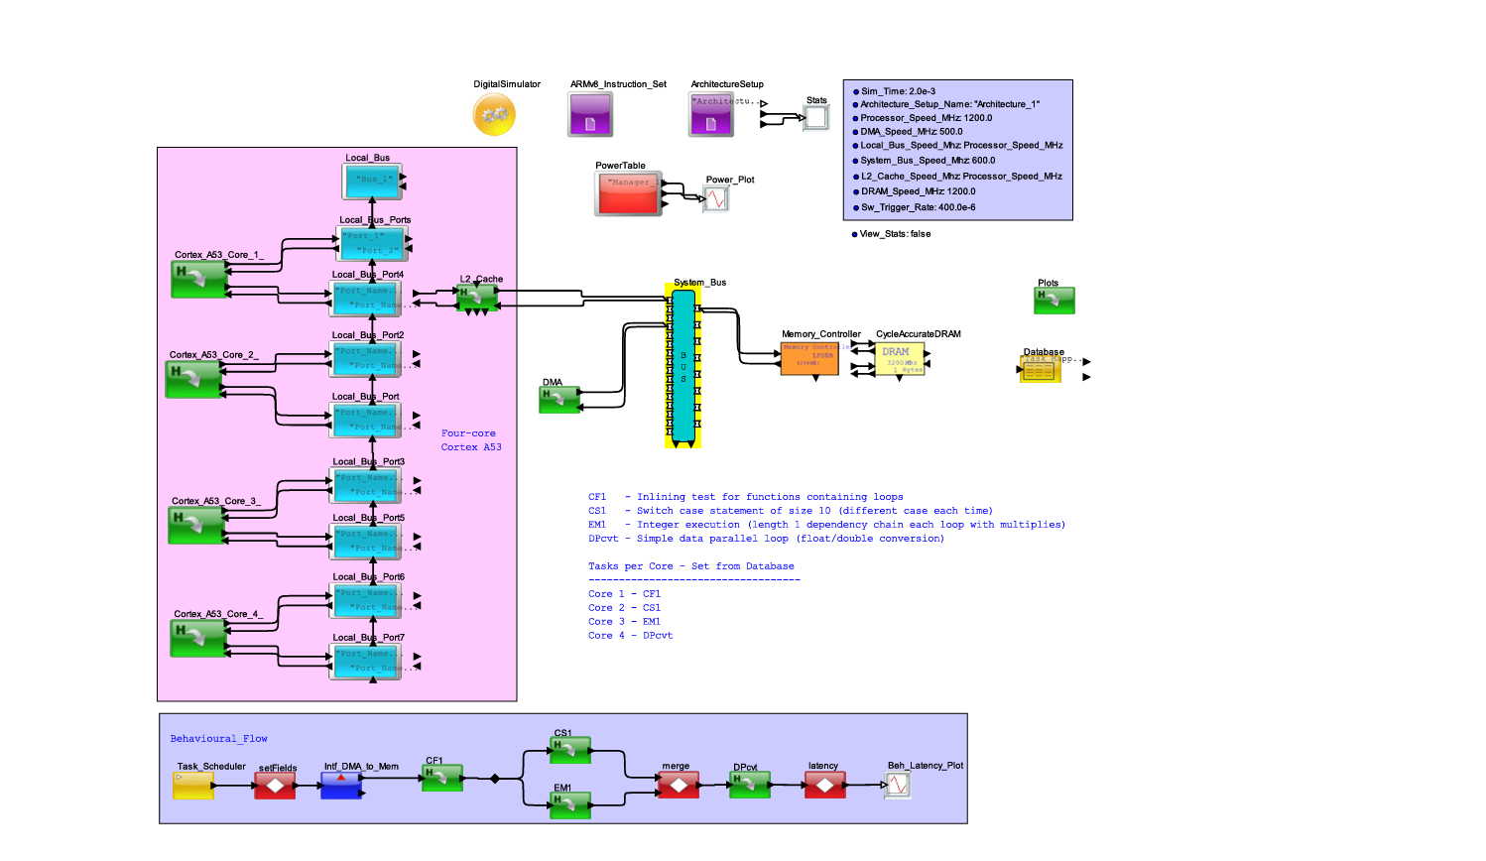
5. Design-Space Parameters
Three major memory-system parameters were investigated.
Parameter | Configurations
L2 Cache Size | 256 KB, 1 MB, 2 MB
System Bus Width | 64 bit, 128 bit, 256 bit
DDR4 Speed | 3200 MHz, 4266 MHz
Simulation Duration | 2 ms
The experiments were performed using the selected VisualSim workload and the resulting architecture statistics were collected for comparison.

6. Performance Metrics
The following metrics were used to evaluate the system:
L2 Cache Metrics
- L2 hit ratio
- L2 miss ratio
- L2 average latency
- L2 utilization
- L2 throughput
Bus Metric
- System Bus utilization
DRAM Metrics
- Total DRAM throughput
- Read throughput
- Write throughput
- Average DRAM delay
- Maximum queue usage
- Request overflow
These metrics provide information about cache efficiency, memory latency, interconnect utilization, and memory-system behavior.

Figure 6.3: L1 I-cache and D-cache hit ratio across the Cortex-A53 cores.
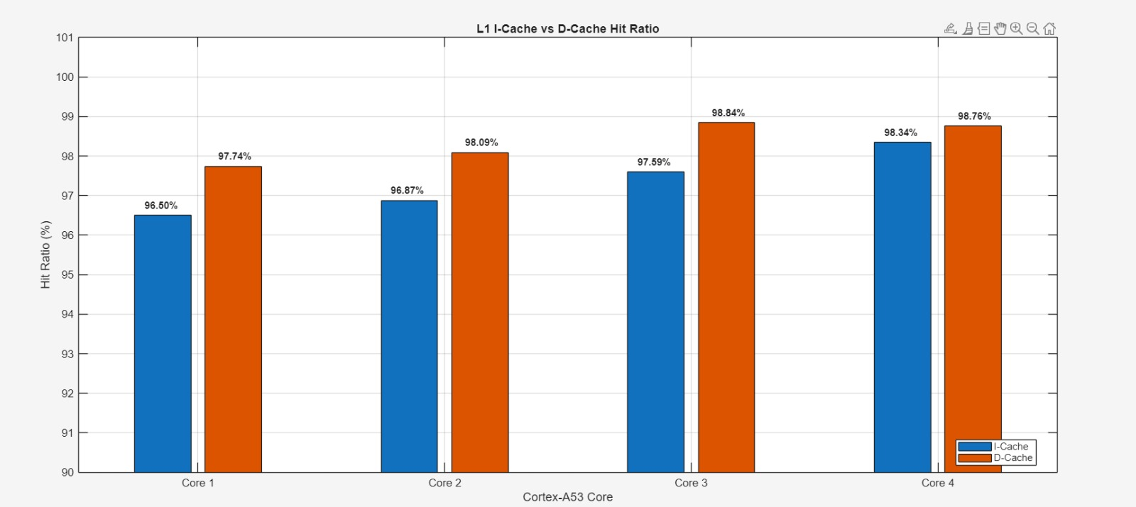
Figure 6.2: Cortex-A53 pipeline utilization across the four cores.
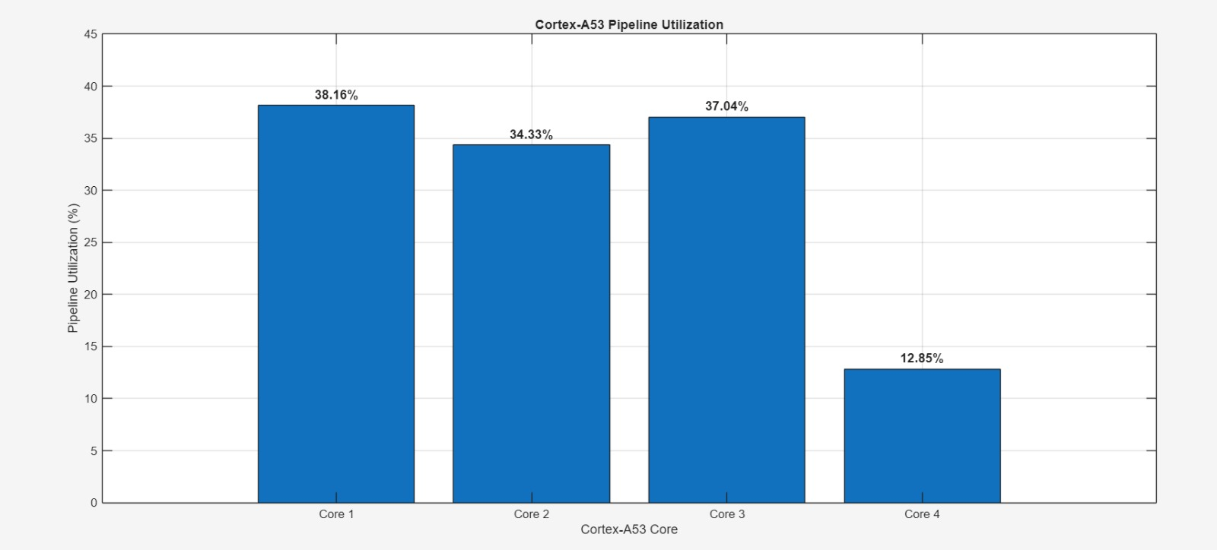
Figure 6.1: Cortex-A53 processor utilization across the four cores.
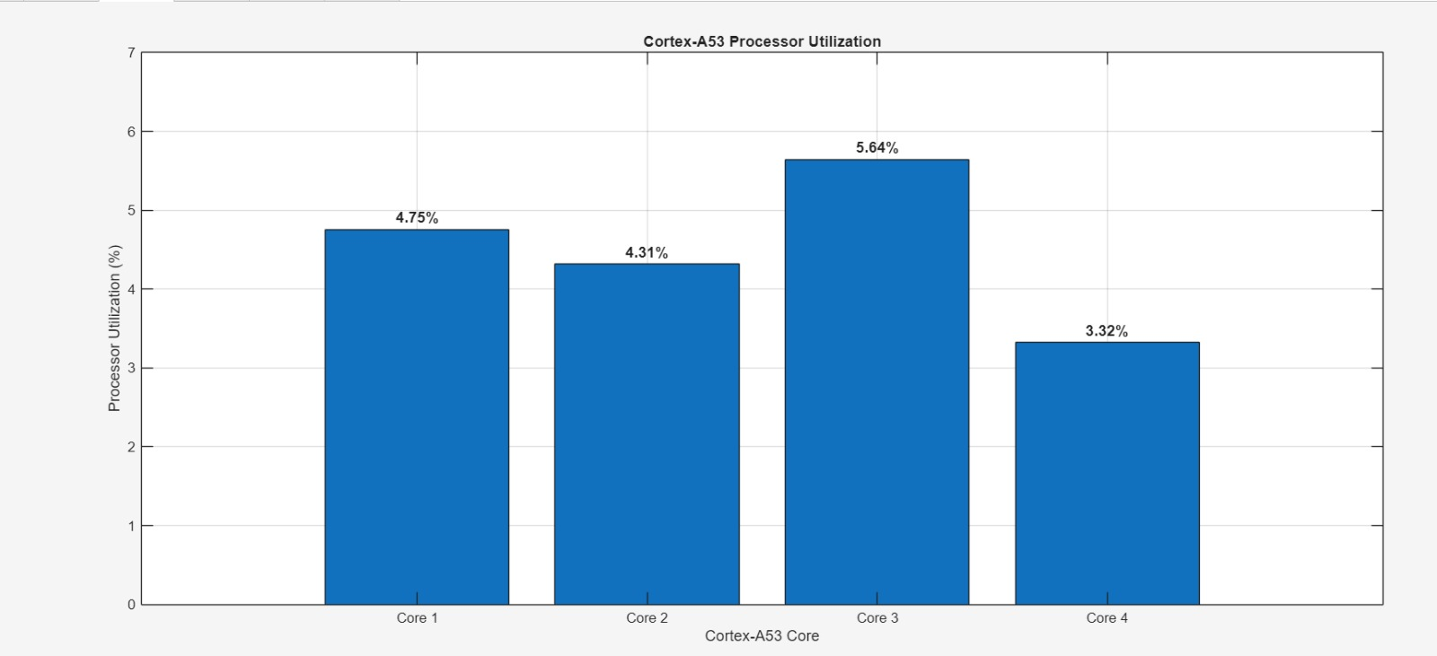
6.1 Additional Architecture Statistics
The VisualSim Architecture Statistics also provide processor, pipeline, and L1-cache utilization data. These results are included as supporting evidence of workload behavior and are not treated as additional design-space variables.
7. Experiment 1 — L2 Cache Capacity
L2 cache capacity was explored using 256 KB, 1 MB, and 2 MB configurations.
A recorded baseline configuration used:
- L2 cache = 1 MB
- System Bus = 64 bit
- DDR4 = 3200 MHz
- Simulation duration = 2 ms
The measured results were:
Metric | Result
L2 Hit Ratio | 48.1891%
L2 Miss Ratio | 51.8109%
L2 Average Latency | 94.9896 ns
L2 Read Throughput | 1040.64 MB/s
L2 Total Throughput | 1606.08 MB/s
L2 Utilization | 4.5494%
For the recorded 2 MB / 64-bit / 3200 MHz configuration:
Metric | Result
L2 Hit Ratio | 43.51%
L2 Miss Ratio | 56.49%
L2 Average Latency | 103.67 ns
L2 Utilization | 8.45%
Observation
Increasing the L2 cache from 1 MB to 2 MB did not automatically improve the measured cache performance. In the recorded runs, the 2 MB configuration showed a lower hit ratio and higher average latency than the 1 MB configuration.
This demonstrates that increasing cache capacity alone is not sufficient to guarantee better performance for a given workload.

8. Experiment 2 — System Bus Width
The System Bus width was explored at:
- 64 bit
- 128 bit
- 256 bit
A recorded 128-bit configuration produced:
Metric | 128-bit
L2 Hit Ratio | 48.4821%
L2 Average Latency | 92.7396 ns
L2 Utilization | 4.5529%
Mean Bus Utilization | 2.7175%
Maximum Bus Utilization | 4.8933%
DRAM Throughput | 66.3691 MB/s
DRAM Average Delay | 14.1913 ns
DRAM Maximum Queue | 77
Request Overflow | 0
A recorded 256-bit configuration produced:
Metric | 256-bit
L2 Hit Ratio | 44.0054%
L2 Average Latency | 101.00 ns
L2 Utilization | 8.4538%
Bus Utilization | 4.8933%
DRAM Throughput | 66.3691 MB/s
DRAM Average Delay | 14.1913 ns
DRAM Maximum Queue | 77
Request Overflow | 0
The following graphs visualize the recorded 128-bit and 256-bit System Bus results shown above.
Figure 8.1: L2 cache performance versus System Bus width.
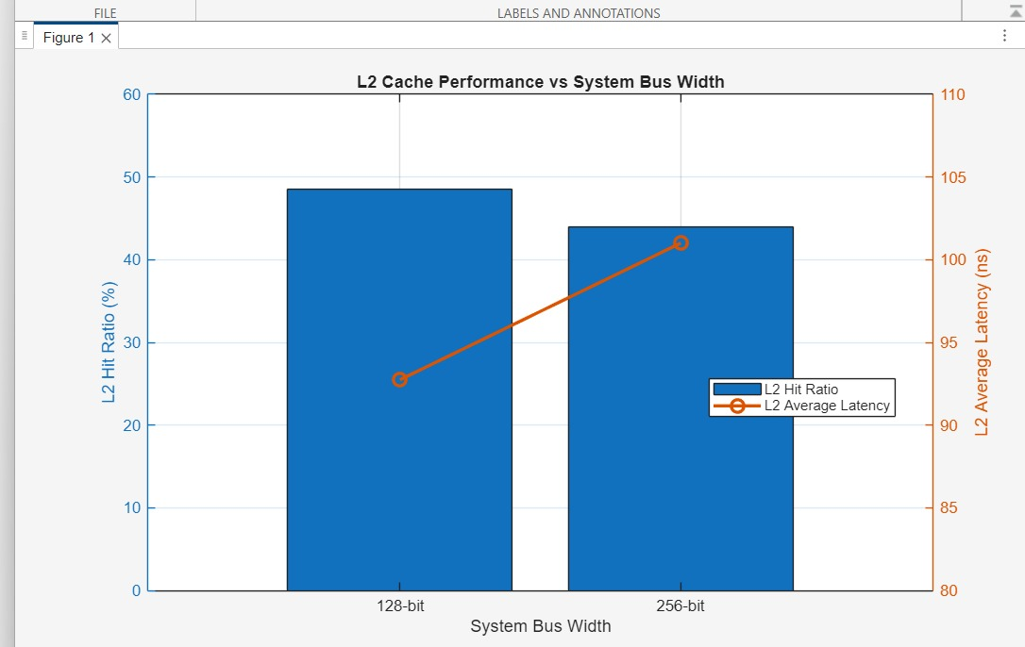
Figure 8.2: Mean bus utilization and DRAM throughput versus System Bus width.
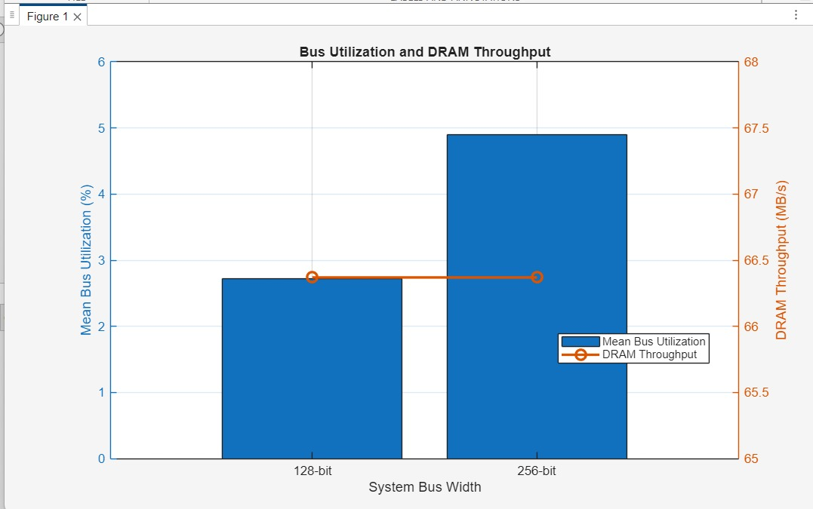
Observation
The 256-bit configuration did not show an increase in measured DRAM throughput compared with the recorded 128-bit result. The bus also remained lightly utilized, with utilization around 4.89% in the recorded 256-bit run.
Therefore, the results indicate that raw bus width was not a dominant limitation for the evaluated workload.

9. Experiment 3 — DDR4 Speed
DDR4 speed was explored using:
- 3200 MHz
- 4266 MHz
For the recorded 3200 MHz baseline, the DRAM results were:
Metric | 3200 MHz
Total DRAM Throughput | 66.3372 MB/s
Read Throughput | 61.2171 MB/s
Write Throughput | 5.12009 MB/s
Average DRAM Delay | 14.1920 ns
Minimum Delay | 13.9345 ns
Maximum Delay | 15.8010 ns
Maximum Queue Usage | 75
Request Overflow | 0
For the recorded 4266 MHz runs, DRAM performance remained approximately:
- Throughput: 66.37–66.40 MB/s
- Average delay: ≈14.19 ns
- Maximum queue: ≈76–77
- Request overflow: 0
Observation
Although the nominal DDR speed was increased from 3200 MHz to 4266 MHz, the measured DRAM throughput remained approximately 66.3–66.4 MB/s, while average DRAM delay remained around 14.19 ns.
Thus, increasing the nominal DDR speed produced only a marginal change in the measured memory behavior for the evaluated workload.

10. Overall Results and Discussion
The experiments provide three important observations.
10.1 L2 Cache
Increasing L2 capacity did not guarantee improved cache performance. The recorded 1 MB configuration achieved a higher L2 hit ratio and lower average latency than the recorded 2 MB configuration under the specified baseline conditions.
10.2 System Bus
Increasing the bus width did not produce a proportional increase in DRAM throughput. The recorded 256-bit configuration had only approximately 4.89% bus utilization.
10.3 DDR4 Speed
Increasing DDR speed from 3200 MHz to 4266 MHz resulted in only a small change in measured DRAM throughput and average delay.

11. Bottleneck Analysis
The simulation results suggest that the evaluated workload is not primarily limited by raw System Bus width or DDR bandwidth.
The main evidence is:
- Low recorded bus utilization
- Nearly unchanged DRAM throughput when DDR speed was increased
- Limited improvement from increasing memory resources
- L2 behavior that did not consistently improve with increased capacity
Therefore, simply increasing the capacity or bandwidth of the memory subsystem is not necessarily the most effective optimization strategy.
The results instead suggest that further optimization should focus on workload-specific behavior and the actual source of memory-system inefficiency.

12. Engineering Insight
The major engineering insight obtained from the study is:
More hardware resources do not automatically translate into better workload-level performance.
A wider bus or faster memory may provide more theoretical bandwidth, but if the workload does not generate enough traffic to utilize that bandwidth, the additional capability provides limited benefit.
Similarly, increasing cache capacity may not improve performance if the workload's access pattern does not benefit from the additional capacity.
Therefore, architecture decisions should be based on measured workload behavior rather than simply selecting larger or faster components.

13. Conclusion
A quad-core ARM Cortex-A53 memory subsystem was successfully modeled and analyzed using VisualSim Architect.
The study explored:
- L2 cache: 256 KB, 1 MB and 2 MB
- System Bus: 64, 128 and 256 bit
- DDR4: 3200 and 4266 MHz
The simulations demonstrated that increasing memory-system resources does not necessarily result in proportional performance improvement.
The L2 cache experiments showed that larger capacity did not automatically improve hit ratio or latency. The System Bus experiments showed low utilization even at 256 bits, while DDR experiments showed only marginal changes in measured throughput and delay when increasing the nominal memory speed.
Overall, the study demonstrates the value of simulation-based architecture exploration for identifying effective system configurations before hardware implementation.

14. Future Work
Future work can include:
- Exploring additional workload types.
- Performing a larger automated design-space sweep.
- Investigating cache associativity and replacement policies.
- Studying memory-controller scheduling algorithms.
- Evaluating power, area and cost alongside performance.
- Performing more detailed workload and trace-based bottleneck analysis.

15. Keywords
VisualSim Architect, ARM Cortex-A53, Quad-Core SoC, L2 Cache, System Bus, DDR4, Memory Subsystem, Design-Space Exploration, Performance Analysis, System Simulation

