**Phase 2: Org Setup & Configuration (Healthcare Project)**

**Create a New Lightning App**

* **App Manager → New Lightning App**.
* **Smart Healthcare CRM**
* *“A Salesforce solution for Patient Engagement & Appointment Management.”*

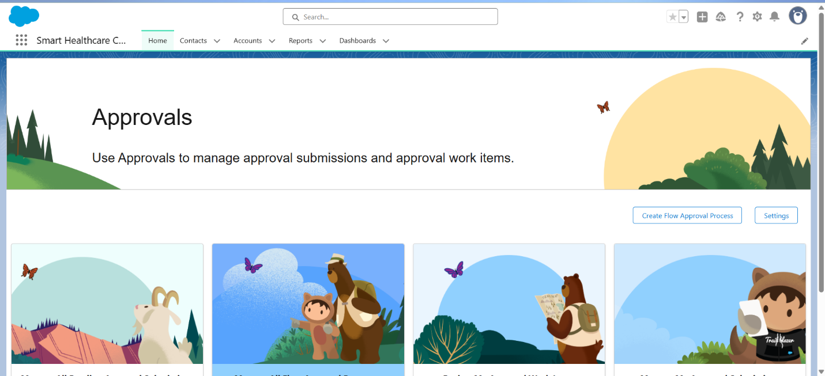

**Custom Objects**

1. **Patient__c**
2. **Appointment__c**
3. **Visit__c**
4. **Prescription__c**
5. **Provider__c** (Doctors)
6. **Notification_Log__c**

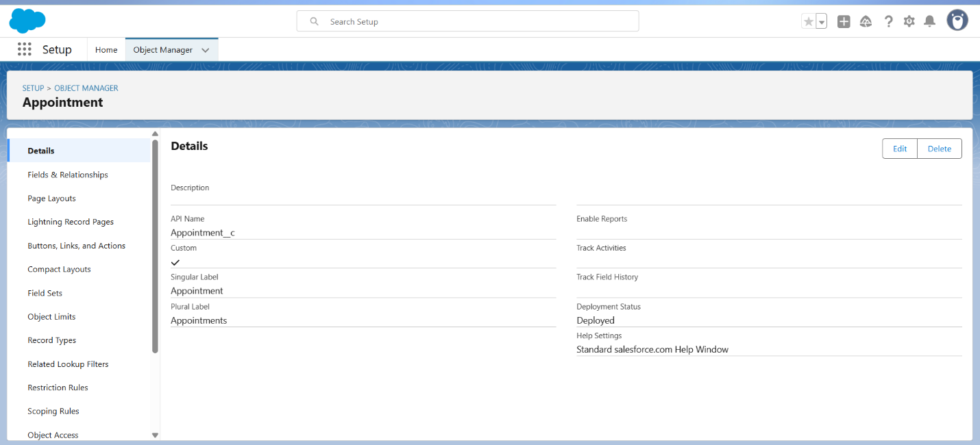

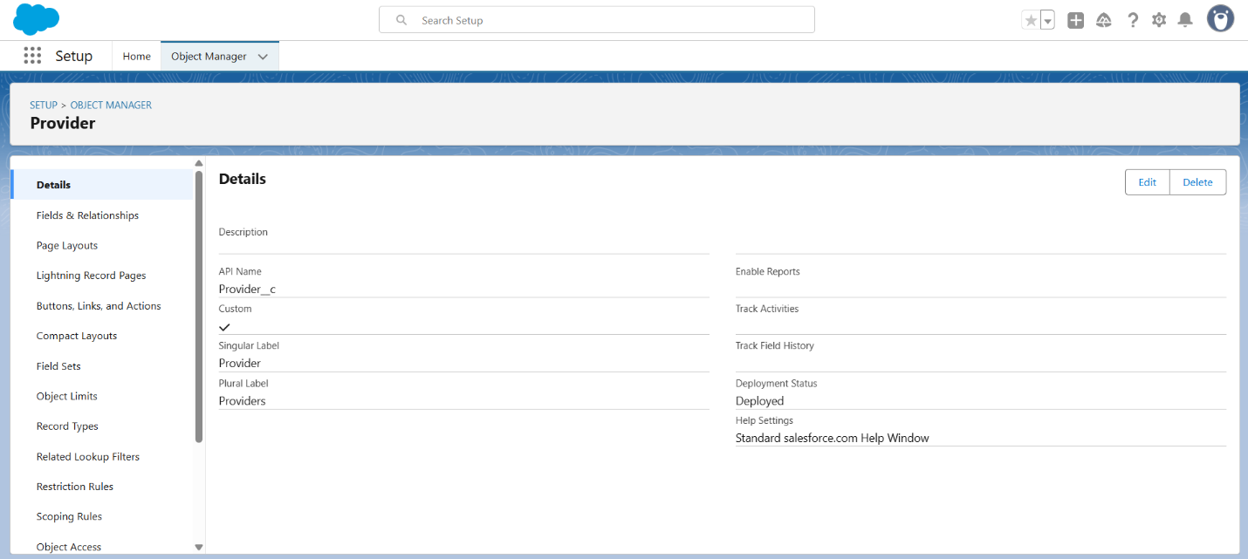

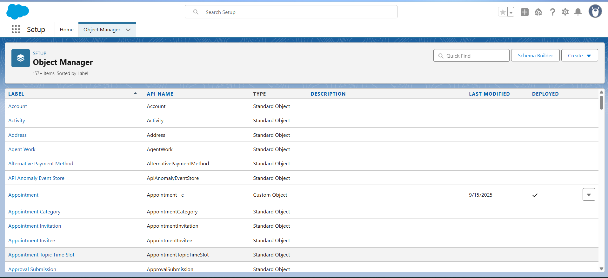

**Custom Fields**

**Appointment__c**

* Appointment_Start__c (Date/Time)
* Appointment_End__c (Date/Time)
* Status__c (Picklist: Scheduled, Completed, Cancelled)
* Patient__c (Lookup → Patient/Contact)
* Provider__c (Lookup → Provider__c)
* Reason_for_Visit__c (Text Area)

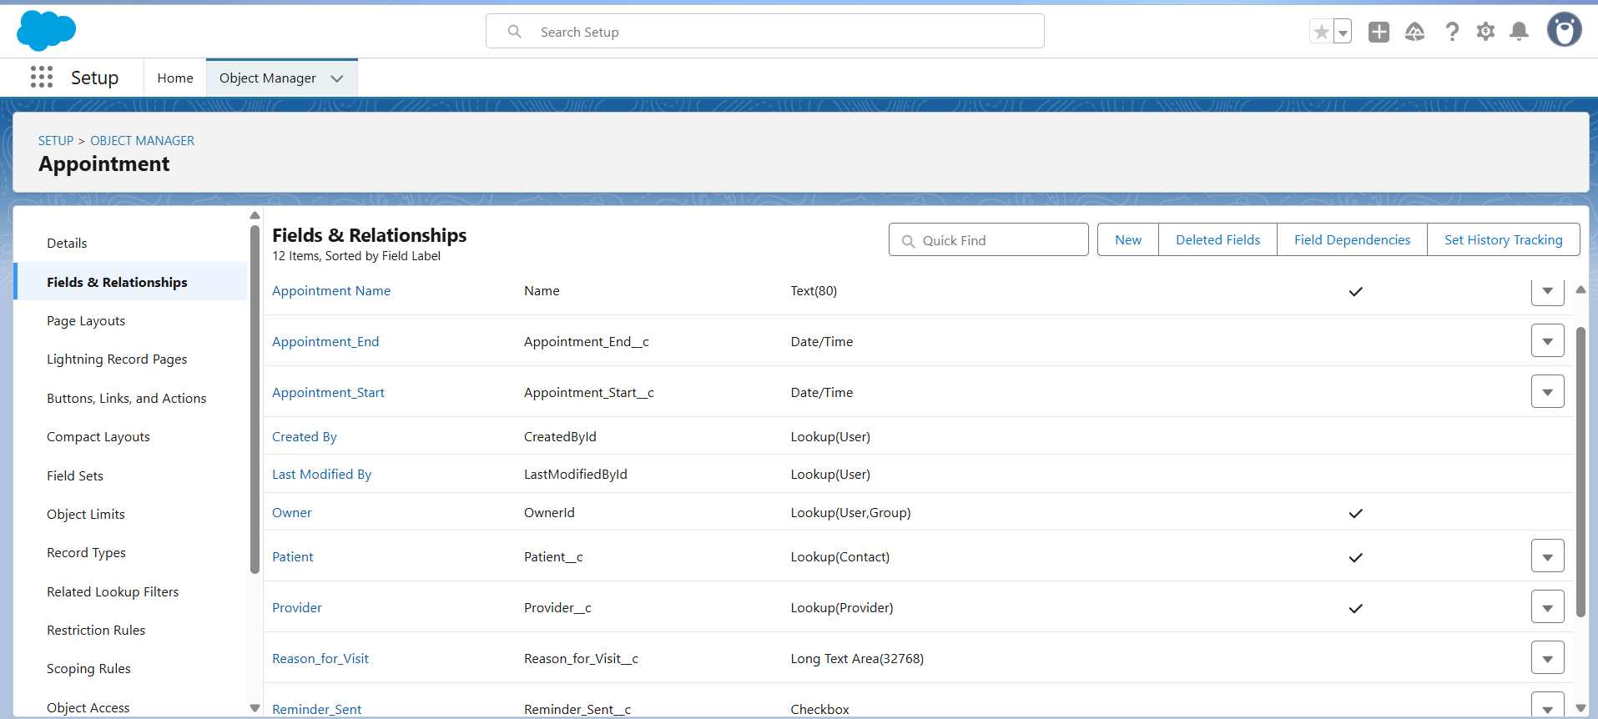

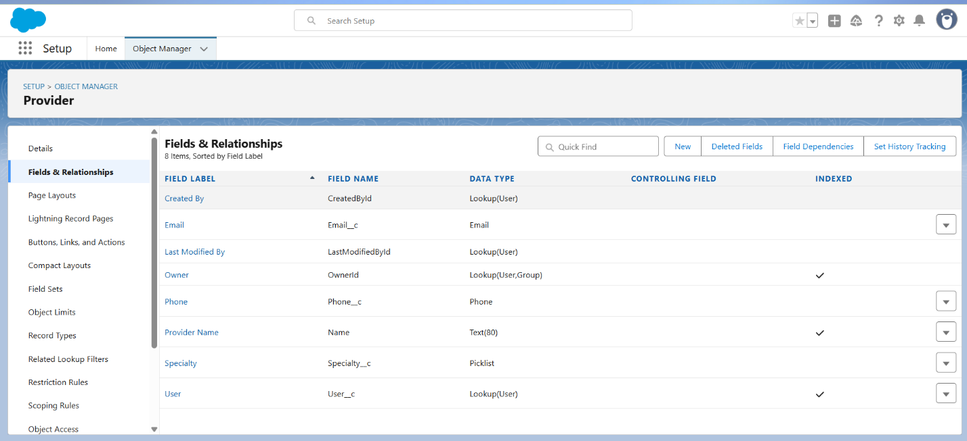

**Tabs for Custom Objects**

