Utilizing Deep Learning Approaches for Text Summarization
Text summarization gives us an overview of large text which help in understanding large text just by seeing its summary. In the past all summaries were given manually which is very time consuming and requires lots of human efforts. To overcome from such issue many text processing techniques like TFIDF, text similarity and many other algorithms were introduced but those algorithms summary detection score is too low.
To enhance summary machine learning algorithms were introduced like Sequence2Sequence which is known for language translation and summary generation. Seq2seq is a family of machine learning approaches used for natural language processing. Applications include language translation, image captioning, conversational models, and text summarization. Seq2seq uses sequence transformation: it turns one sequence into another sequence.
Now world is progressing towards AI and AI also gain very much success in text processing and summarization. Many AI algorithms like Transformers, BERT, OPENAI and many more gain very much success in text summarization. Transformers are a powerful type of neural network that can learn from sequential data, such as text, speech, or images. They have been used to achieve state-of-the-art results in various natural language processing tasks, such as machine translation, text classification, and question answering.
In propose work we are experimenting and evaluating performance of Seq2Seq and transformers algorithm for text summarization. To train algorithm we have utilized CNN-MAIL dataset which contains text mails of CNN. Each algorithm performance is measure in terms of Rouge Score.
ROUGE score, or Recall-Oriented Understudy for Gisting Evaluation, is a metric used to evaluate the quality of machine-generated summaries and document translation models. It compares the output of an NLP model to one or more human reference texts. The higher the Rouge score the better is the summary and its algorithm.
In below screen showing dataset details used to train algorithms
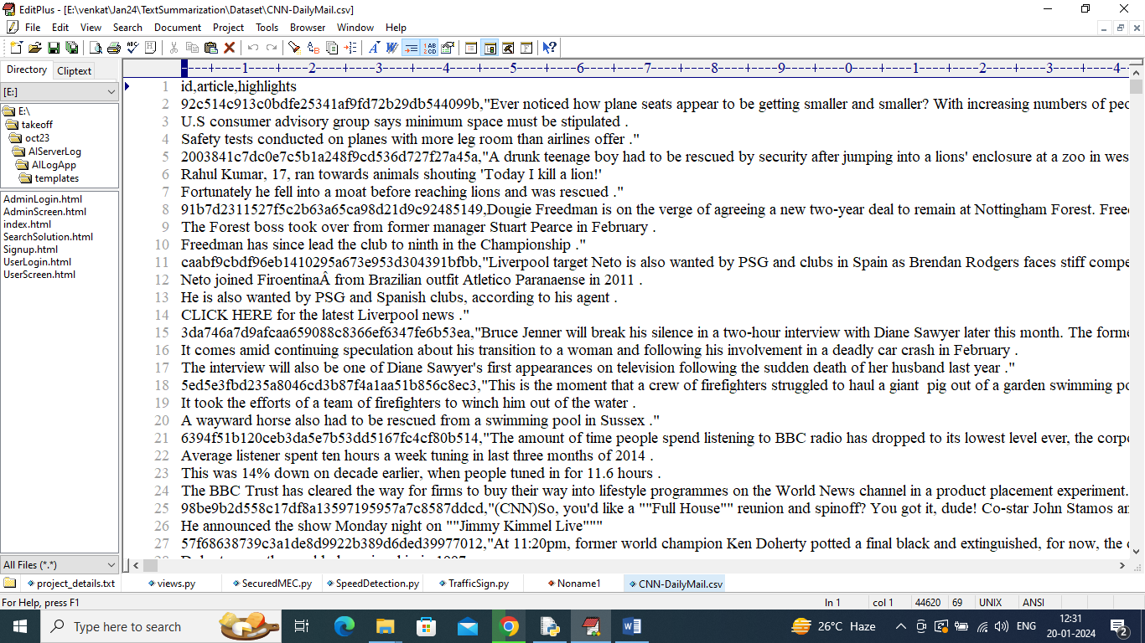
In above dataset first row represents dataset column names and remaining rows represents dataset values. Second column contains articles and 3rd highlight column contains summary and by using both values will train and test both algorithm performance.
To implement this project we have designed following modules
- Upload CNN-Mail Summary Dataset: using this module we will upload dataset to application
- Pre-process Dataset: using this module we will convert both articles and highlight summary into embedding vector which will replace each words with its Unicode ID and then calculate Vocabulary and embedding size. Embedding vector will be split into train and test where application using 80% dataset for training and 20% for testing
- Train Seq2Seq Model: 80% training features will be input to Seq2Seq algorithm to train a model and this model will be applied on TEST articles to generate summary and this generated summary will be compare with original summary using Rouge formula to get summary accurate score
- Train Transformer Model: 80% training features will be input to Transformer algorithm to train a model and this model will be applied on TEST articles to generate summary and this generated summary will be compare with original summary using Rouge formula to get summary accurate score
- Rouge Score Comparison Graph: using this module will plot comparison graph between both algorithms
- Predict Summary from Test Paragraph: using this module we can enter some text and then transformer will predict summary of that text.
SCREEN SHOTS
To run project double click on ‘run.bat’ file to get below screen
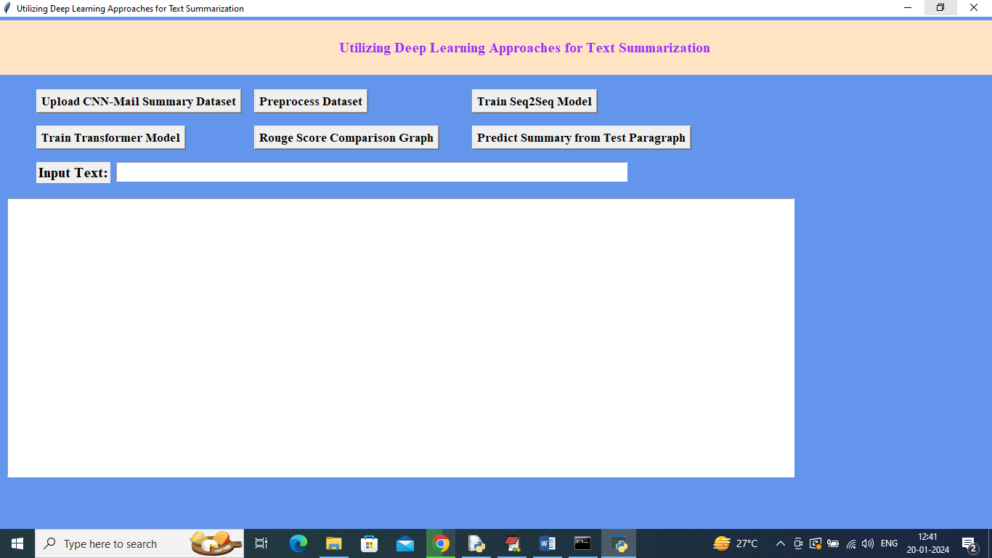
In above screen click on ‘Upload CNN-Mail Summary Dataset’ button to upload dataset and then will get below screen
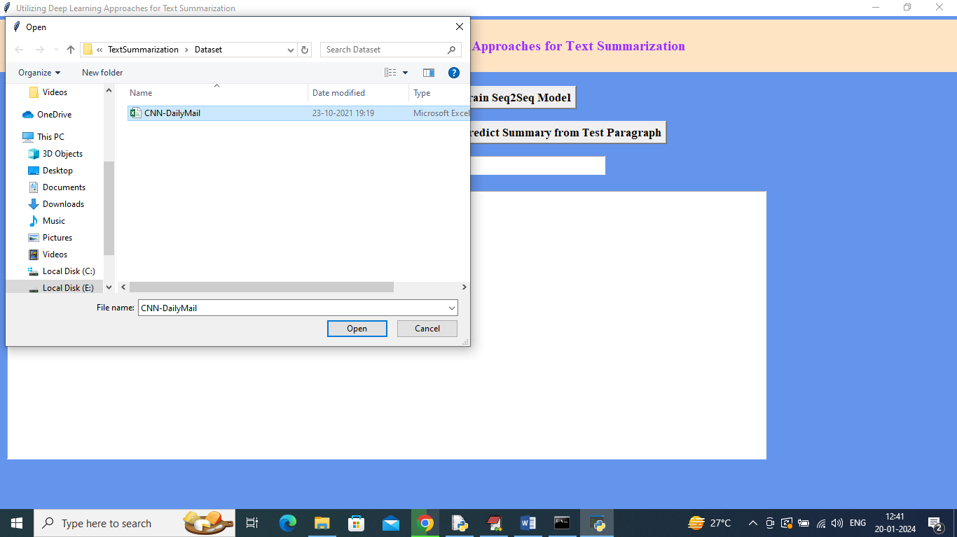
In above screen selecting and uploading ‘Dataset’ file and then click on ‘Open’ button to load dataset and then will get below output
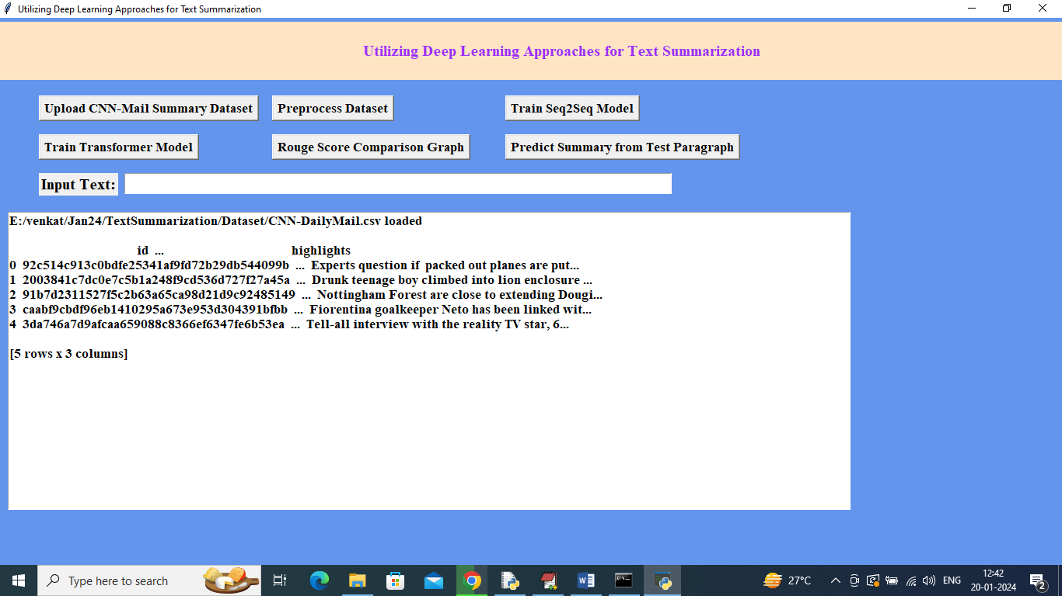
In above screen dataset loaded and now click on ‘Pre-process Dataset’ button to convert text into embedding vector and then will get below output
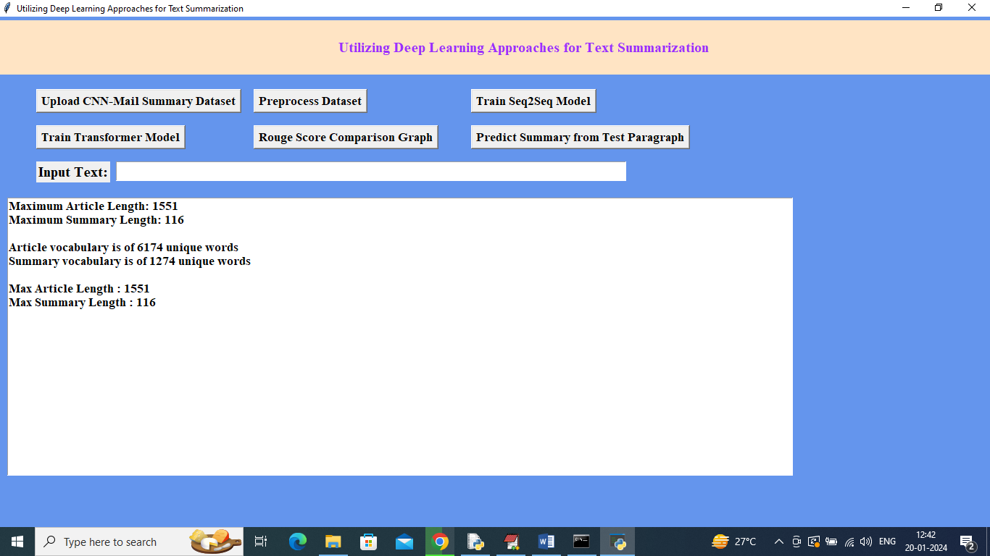
In above screen all text converted into vector and then can see summary and article length of embedding vector and then can see vocabulary size and now click on ‘TrainSeq2Seq Model’ button to train Seq2Seq and get below output
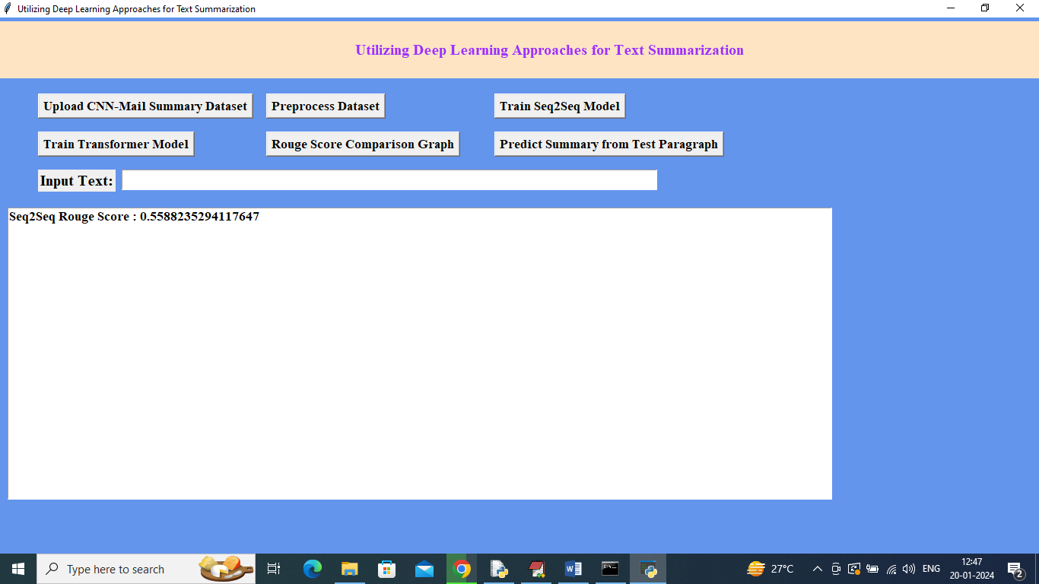
In above screen Seq2Seq algorithm got 55% accurate summary detection and now click on ‘Train Transformer Model’ button to train Transformer and get below output
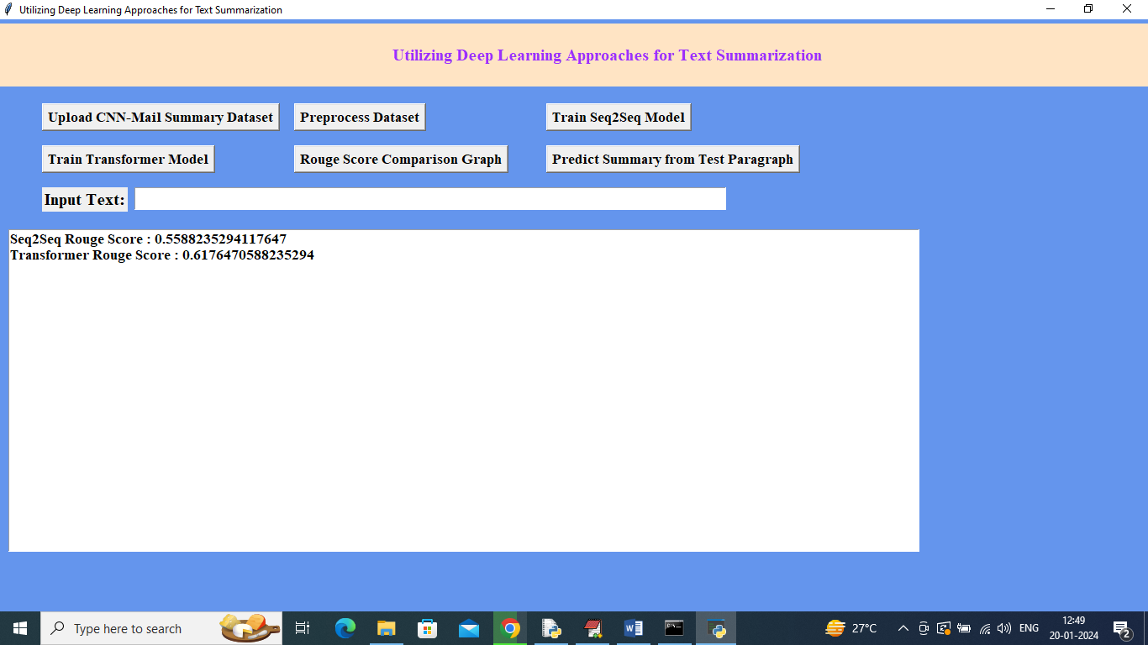
In above screen transformer got 61% Rouge score which means its summary is 62% accurate and now click on ‘Rouge Score Comparison Graph’ button to get below graph
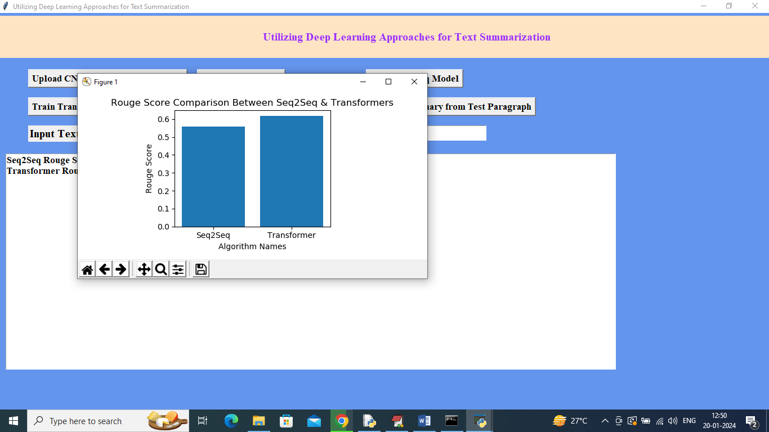
In above graph x-axis represents algorithm names and y-axis represents Rouge score and in both algorithms Transformer got high score and now enter some Text in the text field and then click on ‘Predict Summary from Test Paragraph’ button like below screen
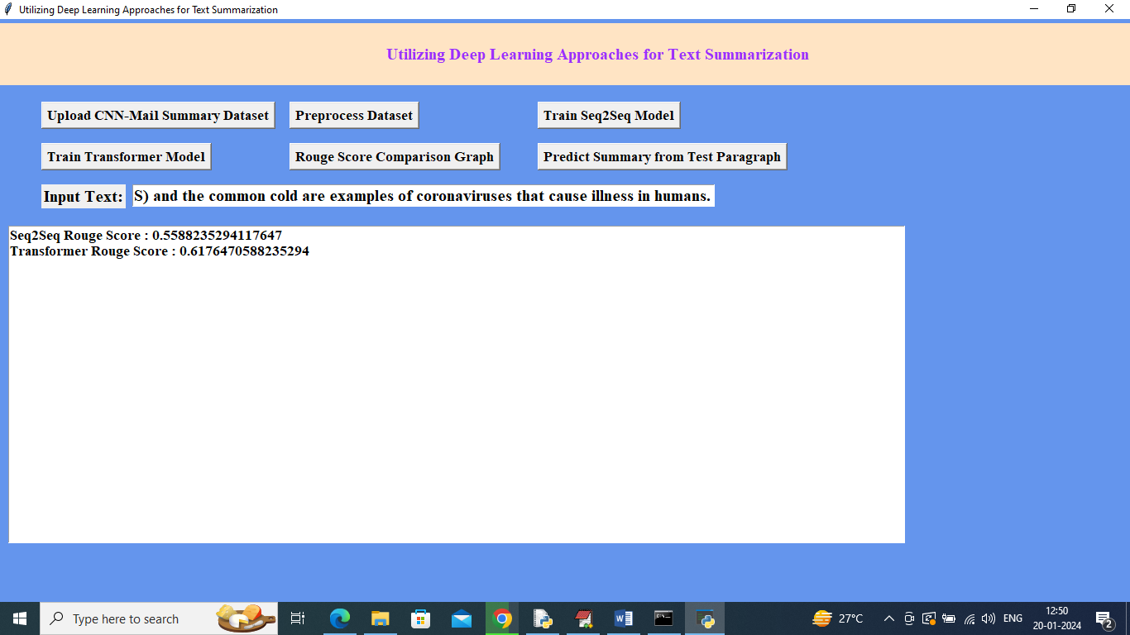
In above screen in ‘Input Text’ field I entered some text and then click on ‘Predict Summary from Text Paragraph’ button to get below output
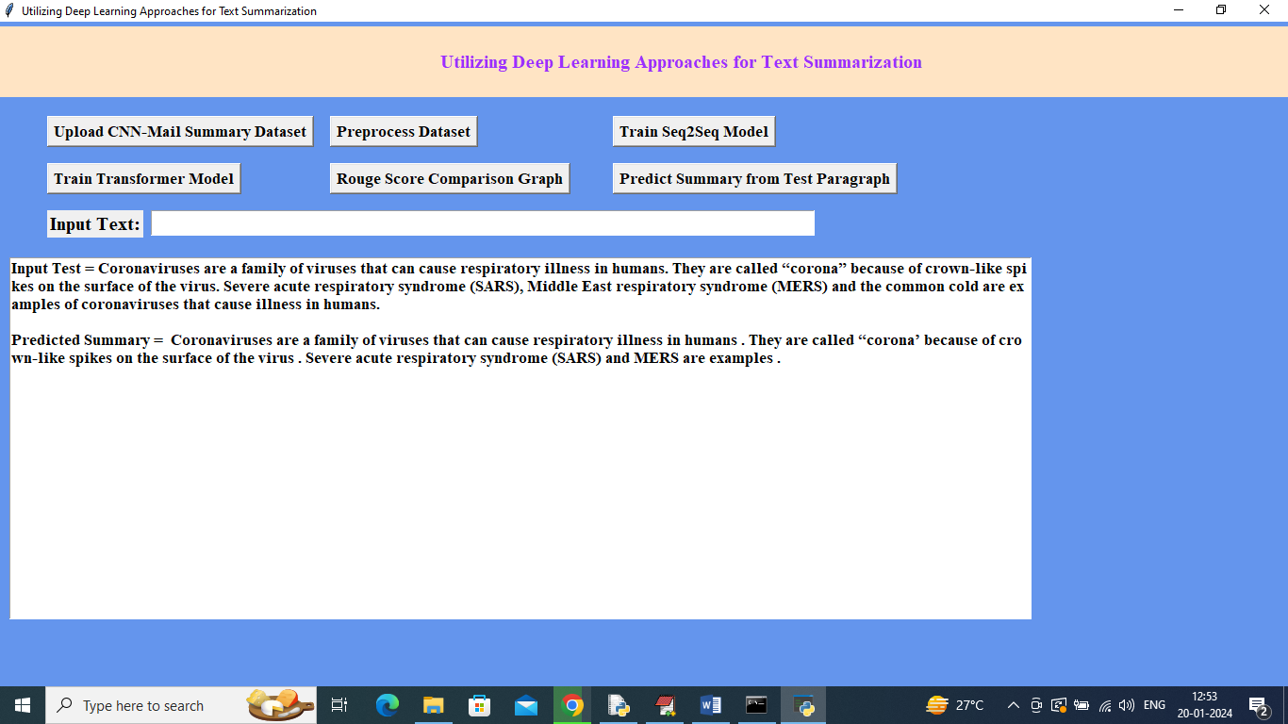
In above screen in first paragraph you can see ‘Input Test Paragraph’ and in second paragraph can see predicted summary. Similarly by entering text in text field we can generate summary from any text

