

**Form 4: RESULT AND CONCLUSION**

**Team no:** 14

**Project Title: CHATBOT IN DIALOGFLOW**

**Experiment Environment:**  In the digital age, businesses aim to improve customer interactions, streamline operations, and offer prompt support. Chatbots are intelligent agents adept at understanding and responding to user inquiries. Dialogflow, a robust platformby Google, excels in creating advanced conversational interfaces.

This aims to provide a foundational understanding of chatbots, elucidate the significance of Dialogflow, and outline the key objectives of utilizing this platform for creating intelligent conversational agents.

Chatbots represent a pivotal advancement in human-computer interaction, enabling users to interact with systems and services using everyday language. By leveraging natural language processing (NLP) and machine learning algorithms, chatbots can comprehend user intents, extract relevant information, and generate contextually appropriate responses. This ability not only enhances user engagement but also facilitates the automation of routine tasks and support services across various domains, including customer support, ecommerce, healthcare, and more.

**1. Development language and framework:**

- Natural Language processing

- Python

- Express.js

**2. Database:**

**-** mysql database

**3. Tools:**

**-** Pycharm

- Fast API

**4. Front-end:**

**-** Dialogflow Api, User Interface

**Frontend Development**:

**1.Define Frontend Architecture**

Decide on the frontend architecture

**2. Set Up Development Environment**

Install necessary development tools and dependencies for your chosen frontend framework.

**3. Create User Interface (UI):**

Design and implement the user interface for the chatbot, incorporating input fields for user queries and space to display chatbot responses.

**Backend Development**:

1. **Database Design**:

Design the SQL database schema to store user information, order details, and any other relevant data.

1. **Implement Dialogflow Integration:**

Develop backend logic to handle Dialogflow interactions, including sending queries to

Dialogflow and processing intent responses

**Experiment 1:**

Visit Dialogflow and sign in utilizing your Google account Concur to the Terms of Benefit and press on the Make Operator button

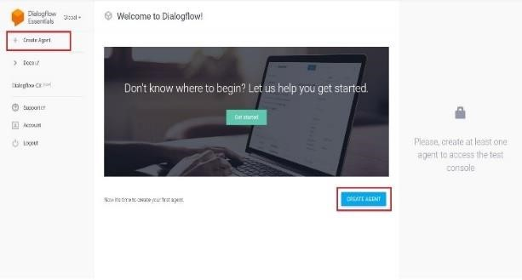

An specialist speaks to the chatbot as a whole.

Enter Specialist Title and tap on the Make button. Note, you cannot utilize whitespaces for naming your agent.

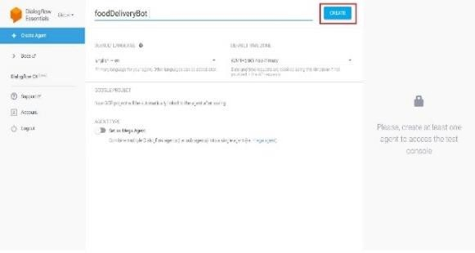

Tap on Bury within the cleared out menu board and tap on Make Expectation. Entomb are categories of discussion you need the chatbot to perform. By default, Google Dialogflow incorporates Welcome aim that welcomes the client and leads the discussion. So also, you'll make an aim that inquires for your individual subtle elements, and the Pizza you need, and arrange it. Add an Intent name and press on Include Preparing Expressions.

There's no one idealize way of discussion. Preparing expressions offer assistance to prepare the chatbot on different real-life illustrations and answer accordingly

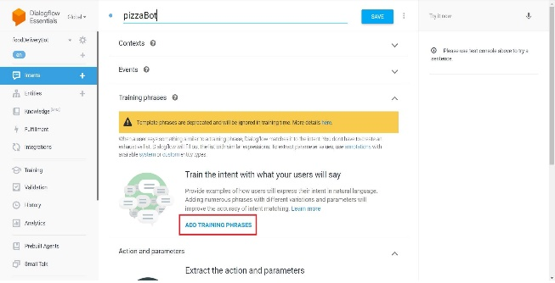

Add a few preparing expressions that the client might inquire the chatbot such as, "Arrange Pizza", "I need a Pizza", and "I need to arrange a Pizza."

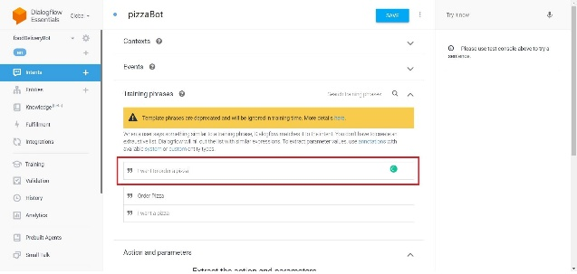

To prepare the chatbot to inquire for emails, sort,"EmailIDPreparing:sampleemail@domainname.com" within the Include client expression field. Doubleclick on the e-mail arrange. A menu shows up. Sort e-mail and select @sys.email.Click on Spare.

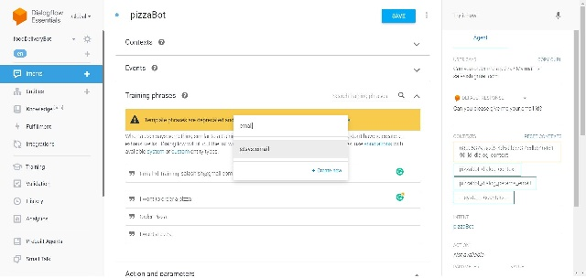

Scroll down and check the box another to the e-mail parameter beneath the Activity and parameters area. At that point, tap on the Characterize provoke alternative found on the right.

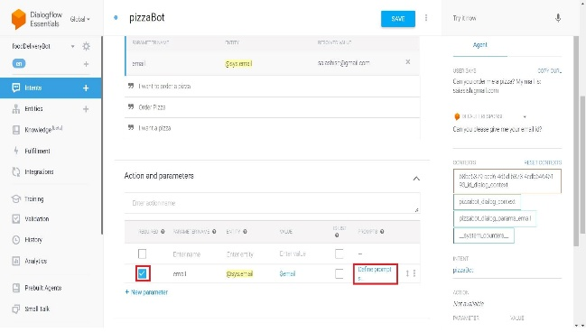

Include the prompts inquiring for the customer's e-mail.

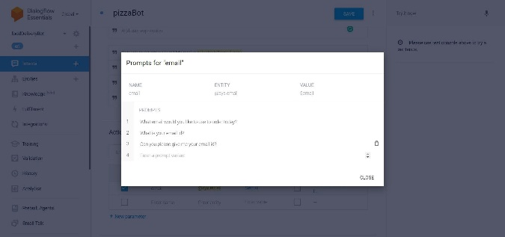

Rehash Steps 7-9 to prepare the chatbot to recognize names, phone numbers, and addresses. Select sort as @sys.givenname, @sys.phone-number, and @sys.address for title, phonenumber, and address respectively.

**Experiment 2:**

Within the cleared out menu board, select Substance and tap on the Make Substance button. Substances are a component that makes a difference to recognize and extricate valuable

information from human conversation.

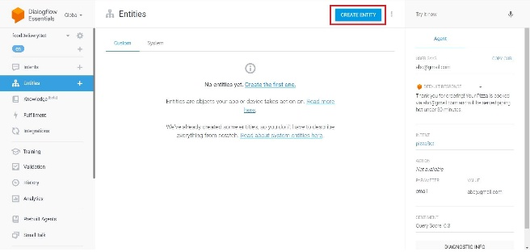

Enter an Substance title and include the alternatives you need to give the client one by one. For case, make an Substance called Estimate and include alternatives as Standard, Little, Medium, Expansive, and Creature. Tap on Save. Repeat this step to make the Topping substance, the Basesubstance, and any other customization you need to offer.

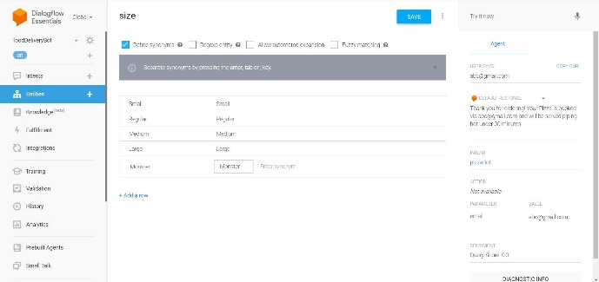

Go back to Bury and include preparing expressions for the substances made in Step 12. For example, to prepare the chatbot to inquire for pizza estimate, sort, "Pizza Measure Preparing: measure" and double-click on estimate. Select @me All the checkboxes and include prompts for all the areas. You'll sort the address arrange of the chatbot by clicking and dragging the double-sided bolt on the furthest right side of each field.

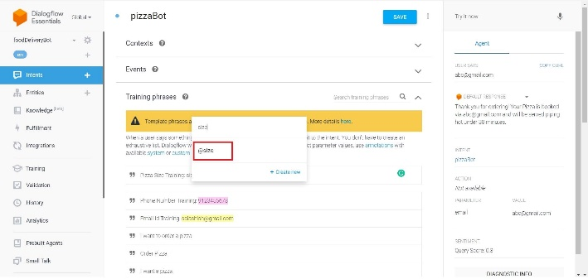

Scroll down and enter a content reaction beneath the Reactions area of the Bury page. Utilize the dollar image $ to embed substances. This will act as the Order Affirmation for this project. asure sort. Additionally, rehash this for the base, and topping as well.

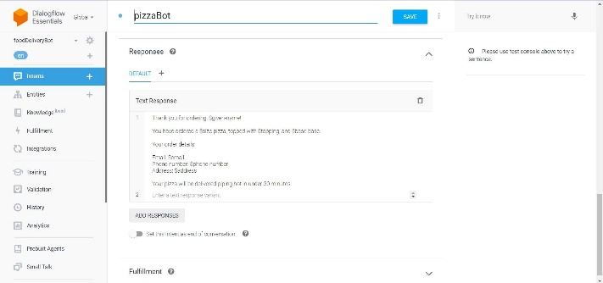

**5. Parameter comparison table**

|  |  |  |
| --- | --- | --- |
| Parameter | Previous methods | Proposed method |
| **Menu Item** | The chatbot used predefined responses | Use of context to maintain the state of the conversation |
| **Ordering** | handle user queries and actions related to food. | provide real-time information about menu items, availability, and nutritional content. |
| **Recommendation** | various food-related actions such as ordering, recommending, and providing information about menu items | Enhanced use of natural language understanding to improve the chatbot's ability to understand and respond to complex queries related to food. |

**Final Conclusion Statements**

Conclusion, implementing a chatbot in Dialogflow for food-related interactions offers several significant advantages. It can enhance customer service by providing instant responses and personalized interactions, leading to improved user engagement and satisfaction. The efficiency of the food ordering process is also enhanced, allowing customers to place orders more conveniently and accurately. Additionally, businesses can benefit from cost savings due to reduced reliance on human customer service representatives. The 24/7 availability of chatbots ensures that customers can place orders at any time, further improving the overall customer experience. Data collected by chatbots can provide valuable insights into customer preferences and behavior, enabling businesses to tailor their marketing strategies and improve customer service. Overall, implementing a chatbot in Dialogflow for food-related interactions can lead to increased efficiency, customer satisfaction, and business success in the food industry.

**Signature Supervisor**