WEEK 2 – SYSTEM ARCHITECTURE DESIGN & MOCKUP
Smart Notes Management System
Internship Role: Junior Software Developer Intern
Organization: YuvaIntern
Architecture: Web-based Three-Layer Application
Backend: Python + Flask
Database: MySQL
Frontend: HTML + CSS + JavaScript

1. System Overview
The Smart Notes Management System is a proposed web application designed to provide users with a centralized platform for creating, organizing, searching, and managing personal notes. Based on the requirements identified in Week 1, the system will use a browser-based frontend, a Python Flask backend, and a MySQL database. The architecture separates presentation, application logic, and data storage so that each layer can be maintained independently. This separation also provides a foundation for testing, security improvements, and future feature expansion.

2. Architecture Approach
A simple three-layer architecture is proposed. The presentation layer handles the user interface and browser interactions. The application layer, implemented using Flask, manages routing, authentication, validation, business rules, and communication with the database. The data layer uses MySQL to persist user accounts, notes, categories, and note metadata. This approach reduces coupling between components and makes the system easier to understand and maintain.
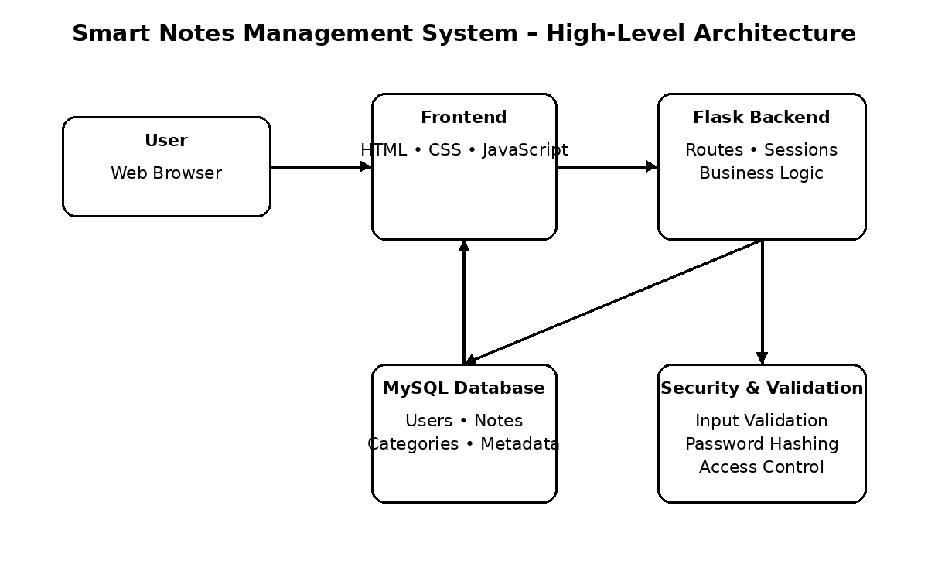
Figure 1. High-level architecture and major communication paths.

3. Main Components and Modules
Component | Responsibility | Technology | Interaction
Presentation Layer | Pages, forms, navigation, note display | HTML, CSS, JavaScript | Sends requests to Flask and displays responses
Authentication Module | Registration, login, logout, session control | Flask sessions, Python | Validates credentials and controls access
Notes Module | Create, read, update, delete, pin and favorite notes | Python, Flask | Applies business rules and calls database layer
Search & Category Module | Search notes and filter by category/status | Flask + MySQL | Processes filters and retrieves matching records
Database Layer | Stores users, notes, categories and metadata | MySQL | Persists and retrieves application data
Validation & Security | Input validation, authorization and password protection | Python/Flask | Protects application operations and data

4. Data Flow
- The user opens the web application through a browser and interacts with forms and dashboard controls.
- The browser sends an HTTP request to the appropriate Flask route.
- Flask validates the request, checks the user session and applies the required business logic.
- For data operations, the backend communicates with MySQL using controlled database queries.
- The database returns the requested data or confirms the operation.
- Flask prepares the response and returns the appropriate page or message to the browser.

5. Database and Integration Points
The MySQL database will contain logically separated records for users, notes, and categories. A note will be associated with its owner through a user identifier. Category and status information can be used to support searching, filtering, pinning, and favoriting. The Flask backend will act as the main integration point between the frontend and database, preventing the browser from directly accessing the database.

6. UI Mockup
The proposed dashboard prioritizes simple navigation. A left-side navigation area provides access to all notes, favorites, pinned notes, and categories. The main area contains a search field, an Add Note action, and note cards showing essential information. Edit, Delete, and Pin actions are placed close to each note to reduce unnecessary navigation.
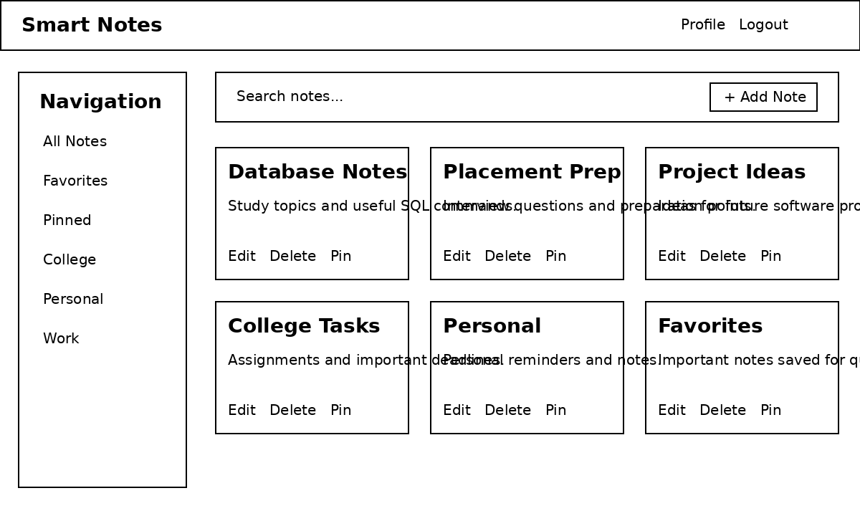
Figure 2. Low-fidelity dashboard mockup for the Smart Notes Management System.

7. Security Considerations
- Passwords should be stored using secure one-way hashing rather than plain text.
- Authentication and authorization checks should be performed before private note operations.
- User input should be validated and safely handled to reduce injection and malformed-input risks.
- Database access should use parameterized queries or an appropriate database abstraction approach.
- Sessions should be handled securely and logout should invalidate the active session.
- Sensitive configuration values should not be hard-coded into the source code.

8. Scalability
The modular architecture allows additional features such as note sharing, reminders, attachments, or an API to be introduced without redesigning the entire application. Database indexes can improve search performance as the number of notes grows. If future usage becomes significantly larger, the application can be deployed behind a production web server and scaled using multiple application instances with a shared database service.

9. Maintainability
Maintainability will be supported through clear separation of modules, meaningful names, reusable functions, documented interfaces, consistent coding standards, and Git-based version control. Configuration should be kept separate from application logic. Tests will be added around important business functions so that future changes can be made with lower risk.

10. External Integrations
The initial version does not require third-party integrations. GitHub will be used for source-code version control and project documentation. Future versions could optionally integrate email notifications, cloud storage, or a REST API, but these are outside the initial scope.

11. Conclusion
The proposed architecture translates the Week 1 requirements into a clear technical design. The three-layer structure provides separation of concerns between the interface, Flask application logic, and MySQL data storage. The module breakdown identifies responsibilities and interactions, while the data-flow description explains how requests and information move through the system. Security, scalability, and maintainability have been considered from the design stage. The low-fidelity dashboard mockup provides a visual representation of the planned user experience. This architecture will serve as the foundation for the implementation roadmap and code structure planning in Week 3.

